**Talent Acquisition (Recruiting) Database Design**

Chayson Comfort, Iram Bakhtiar, Lakshmi Bobbillapati and Lizzy Sterling

**Version:**

**1. Introduction**

This Database Design provides the basis for the Talent Acquisiton database design. It defines the database that will support the recruiting Data Model of posting a requisition based on the need to hire, sourcing candidates, status of applications and final candidate hired as employee. The design is created with expected data volumes, functional and non-functional usage of the tables, and performance considerations and requirements in mind.

**2. Architecture Design**

**3. Database Design**

Only one schema is contained within this database – *mydb*.

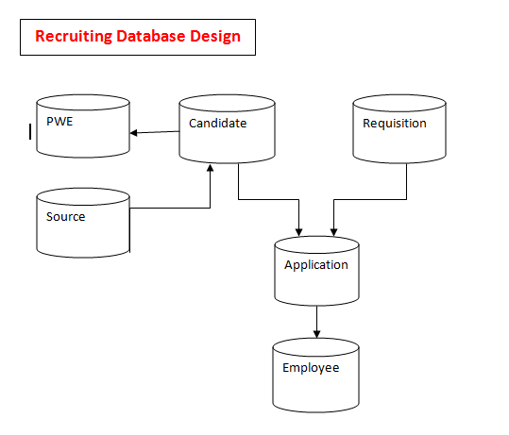

**Tables schemas**

***Candidate:*** *this table contains information regarding potential candidates for open job positions.*

|  |  |  |  |  |
| --- | --- | --- | --- | --- |
| Attributes | Description | Type | Examples of Values | Foreign Key? |
| CandidateID | Unique ID of a particular candidate | VARCHAR(10) | 123456789 |  |
| Last_Name | Last name of the candidate | CHAR(40) | Sterling |  |
| Middle_Name | Middle name of the candidate, if exists | CHAR(40) | Huger |  |
| First_Name | First name of the candidate | CHAR(40) | Elizabeth |  |
| Email_ID | Preferred e-mail address of the candidate | VARCHAR(45) | [lsterling@smu.edu](mailto:lsterling@smu.edu) |  |
| Phone | Preferred phone number of the candidate | CHAR(15) | 555-555-5555 |  |
| Gender | Preferred gender of candidate | CHAR(1) | F |  |
| Ethnicity | Ethnicity of the candidate | CHAR(10) | Caucasian |  |
| Expected_Salary | Anticipated salary of the candidate | DECIMAL() | $70,000 |  |
| Prior_Employer | Previous employer of the candidate | VARCHAR(40) | SMU |  |
| Address_Line | Current address of the candidate | VARCHAR(45) | 123 apple lane |  |
| City | Current city of the candidate | CHAR (20) | Dallas |  |
| State | Current state of the candidate | CHAR (20) | Texas |  |
| Country | Current country of residence of the candidate | CHAR(20) | USA |  |
| LinkedIn_Profile | Link to candidates linkedin, if exists | VARCHAR(40) | /www.linkedin.com/feed/ |  |
| Source | Where did the candidate find this position? | CHAR(25) | S1 | Yes, SourceID of Source Table |

***Application:*** *this table contains information regarding applications to job positions within the company*

|  |  |  |  |  |
| --- | --- | --- | --- | --- |
| Attributes | Description | Type | Example Values | Foreign Key? |
| ApplicationID | Unique ID of the application | VARCHAR(10) | 123456790 |  |
| CandidateID | Unique ID of the candidate filling out the application | VARCHAR(10) | 1234567890 | Yes – Candidate Table |
| RequisitionID | Unique ID of the job itself | VARCHAR(10) | 1234567890 | Yes – Requisition Table |
| Interview_Status | Has the applicant reached the interview stage? | VARCHAR(45) | Yes/no |  |
| Offer_accepted | Has the applicant accepted the job, if it has been offered? | VARCHAR(45) | Yes/no |  |
| Salary | What is the applicant’s current salary? | DECIMAL() | $70,000 |  |
| Sign-on_bonus | How much are they being offered for a sign-on bonus? | DECIMAL() | $10,000 |  |

***Employee:*** *This table contains information regarding current employees.*

|  |  |  |  |  |
| --- | --- | --- | --- | --- |
| Attribute | Description | Type | Example | Foreign Key? |
| EmployeeID | Unique ID of the employee | VARCHAR(10) | 1234567890 |  |
| ApplicationID | Unique ID of their application to their current position | VARCHAR(10) | 1234567890 | Yes – Application Table |
| LastName | Last name of the employee | VARCHAR(40) | Sterling |  |
| MiddleName | Middle name of the employee | VARCHAR(40) | Huger |  |
| FirstName | First name of the employee | VARCHAR(40) | Elizabeth |  |
| SSN | Social Security Number of the employee | VARCHAR(12) | 123-45-6789 |  |
| DOB | Birth date of the employee | DATETIME | 10-06-94 |  |
| HireDate | Data the employee was hired | DATETIME | 2-16-18 |  |
| Company | Company where they are employed | VARCHAR(20) | Southern Methodist University |  |
| Location | Location of the company | VARCHAR(20) | Dallas,TX |  |
| JobTitle | Title of the employee | VARCHAR(40) | Data Scientist |  |
| CandidateID | Unique ID from when they were still a candidate for the job | VARCHAR(10) | 1234567890 | Yes – Candidate Table |

***Requisition:*** *This table contains information regarding the job requirements and the job itself.*

|  |  |  |  |  |
| --- | --- | --- | --- | --- |
| Attribute | Description | Type | Example | Foreign Key? |
| RequisitionID | Unique ID for the job position | VARCHAR(10) | 1234567890 |  |
| JobTitle | Specific Job Title | VARCHAR(45) | Data Scientist |  |
| JobDescription | General description of the job | VARCHAR(45) | This job entails…. |  |
| Exempt |  | VARCHAR(45) |  |  |
| Location | Location of the job | VARCHAR(45) | Dallas, TX |  |
| Company | Company where the job is held | VARCHAR(45) | Southern Methodisty University |  |
| Salary | Salary fo the job | VARCHAR(45) | $70,000 |  |
| ExperienceLevel | Experience Required | VARCHAR(45) | 3 years experience as a data scientist |  |
| PostingJobBoard | Where is this job posted | VARCHAR(45) | GlassDoor |  |

*PWE: This has candidate prior work experience*

|  |  |  |  |  |
| --- | --- | --- | --- | --- |
| Attribute | Description | Type | Example | Foreign Key? |
| Candidate ID | Candidate Id of the candidate | VARCHAR(10) | C1 | Yes Candidate Id to Candidate |
| Prev_Emp | Previous Employer | VARCHAR(45) | SMU |  |
| Job Title | Job title at previous company | VARCHAR(45) | This job entails…. |  |
| Start_date | Start date with Company | Date | 1/1/2000 |  |
| End_date | End date with Company | Date | 1/1/2010 |  |
| Base_Pay | Salary with the company | Number(10,2) | 100000,00 |  |
|  |  |  |  |  |
|  |  |  |  |  |
|  |  |  |  |  |

***Source :*** *This maintains the master list of different sources the candidates can come from.*

|  |  |  |  |  |
| --- | --- | --- | --- | --- |
| Attribute | Description | Type | Example | Foreign Key? |
| Source ID | Source ID Primary key | VARCHAR(10) | S1 |  |
| SourceName | Source Name | VARCHAR(45) | Glassdoor |  |
|  |  |  |  |  |
|  |  |  |  |  |
|  |  |  |  |  |
|  |  |  |  |  |

**Tables Example Data: See able tables and Example column for data example**

**SQL Queries:**

1. Find the candidates who came from source of LinkedIn . This helps to market the jobs more to linkedin to attract Talent.

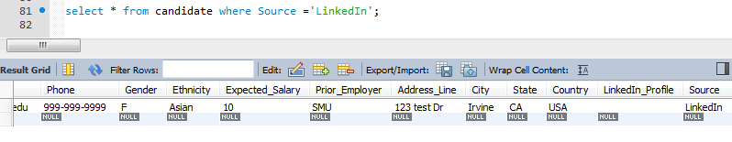

1. Show are Exempt jobs posted in the company.

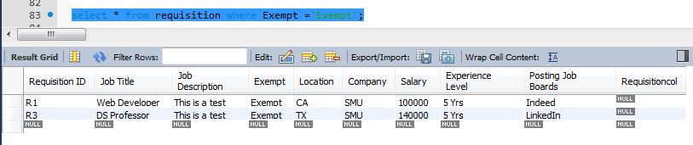

1. Show all candidates details who have applied to Requisition R1.

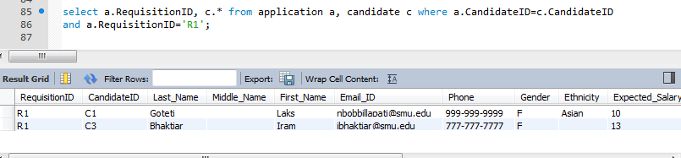

1. Select all jobs opened in California.

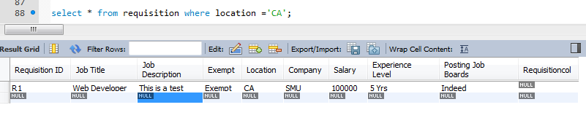

1. Select employees who were paid a sign on bonus

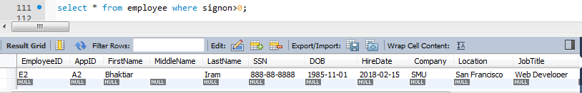

1. Select all employees hired in Dallas location after 2/15/2018.

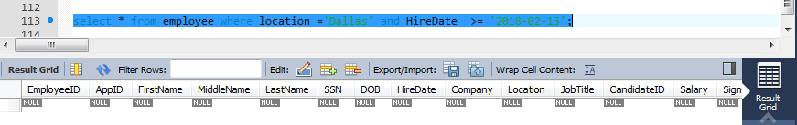

1. Select all applicants who have accepted the offer.

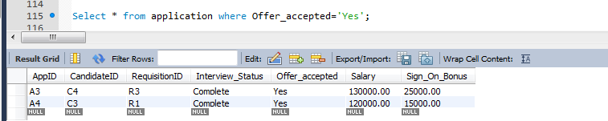

1. **Select all employeers who have worked with SMU before.**

**Select * from pwe where company=’SMU’;**

**Transactions implementation:**

**4. Graphical User Interface**

**5. Class Diagram and Classes**

**6. Design Process**

**7. References**

**8. Appendix**