1. Create schematic (inputs: button and potentiometer, output: speaker)
2. Code the 8 bit timer (0-255)
3. Code each wave form
   1. Sine wave
      1. Use sine wave lookup table generator (creates numbers to use in array form)
   2. Sawtooth wave
      1. Increments until max (255) when max clears to 0.
   3. Triangle wave
      1. increments until max (255) then decrements from 255 to 0
4. Code potentiometer to change frequency of waveform
5. Code button press to interrupt waveform and switch between each

Schematic:

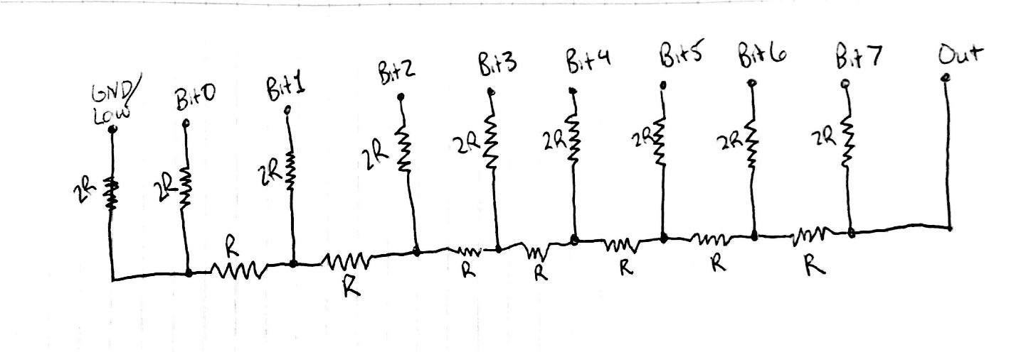

For my own reference:

