CHAPTER 14
The Small Intestine
Anatomy, Physiology and the ROP Approach
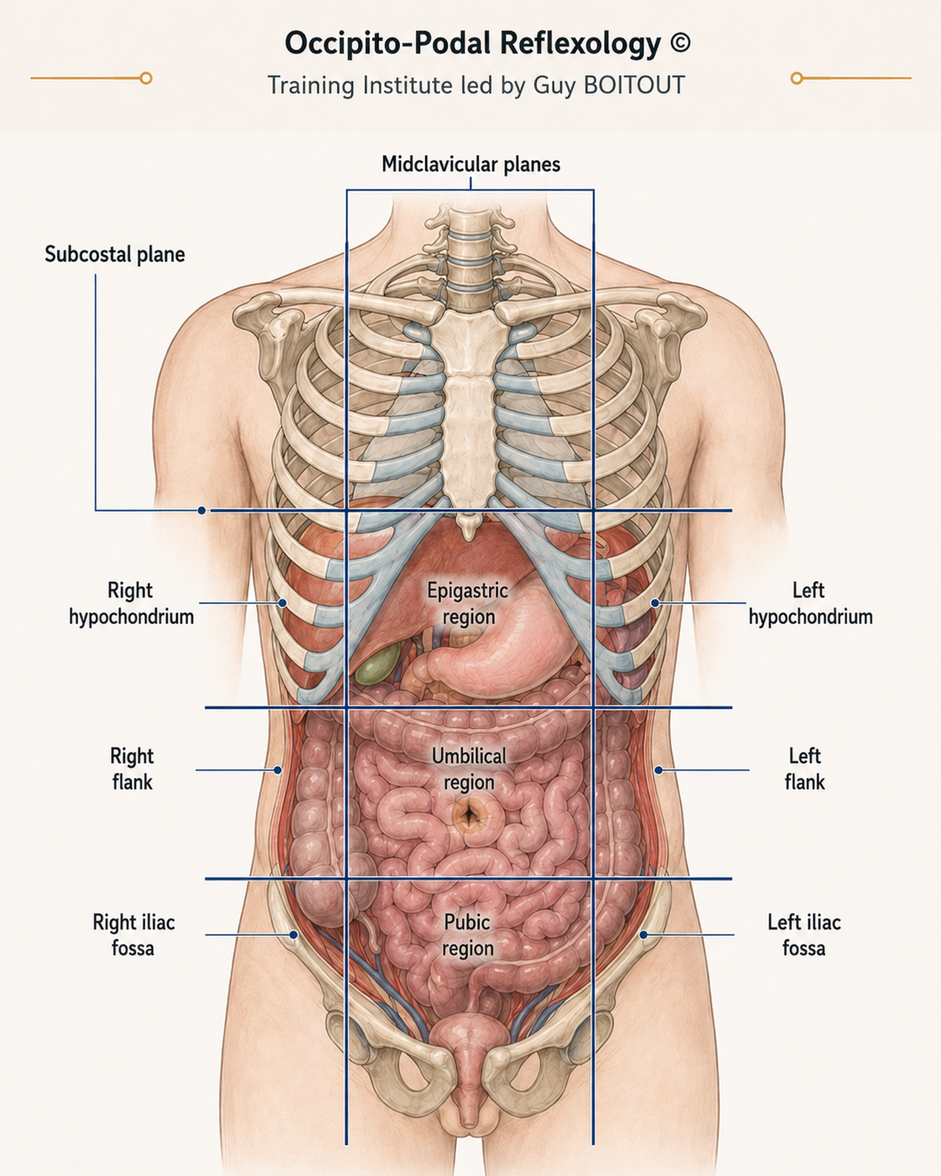
English translation • Codex Translation V2

Scope and clinical perspective
The small intestine is a central anatomical and physiological crossroads. Its loops, mesentery, vascular and lymphatic networks, intrinsic nervous system, mucosal barrier, immune tissue and microbiota cooperate in digestion, absorption, motility and defence. In ROP, these relationships are considered within a global functional assessment that also includes autonomic regulation, somatic correspondences and the patient’s wider clinical context.
Clinical boundary. ROP assessment and care complement — but never replace — medical diagnosis, investigation or follow-up. Warning signs and suspected organic disease require medical referral.

1. Jejunum and ileum within the colonic frame
The jejunum and ileum form approximately 15 to 16 intestinal loops, distributed preferentially into two topographic groups. Their features transition progressively rather than changing at a sharply defined boundary.
Feature | Jejunum | Ileum
Location | Predominantly in the left upper quadrant. | Predominantly in the right lower quadrant.
Orientation | Loops and vascular pattern tend to be more horizontal. | Loops and vascular pattern tend to be more vertical.
Relations | Habitually overlaps the descending colon. | Generally does not overlap the ascending colon.
General feature | Usually the more developed group. | Progressive transition from jejunal characteristics.
Table 14.1. Preferential topography of the jejunum and ileum.

2. The mesentery: root and suspension
The mesentery is a double layer of peritoneum that connects the jejunum and ileum to the posterior abdominal wall. Its short, obliquely oriented root extends from the duodenojejunal flexure to the ileocecal junction. The mesentery suspends the intestinal loops while preserving their mobility and carries the vessels, lymphatics and nerves of the small intestine.
- Proximal landmark: the suspensory muscle of the duodenum (ligament of Treitz) and the duodenojejunal flexure.
- Mesenteric root: approximately 15–18 cm, following an oblique course.
- Distal landmark: the ileocecal junction.
- Functional role: suspension, mobility and conduit for neurovascular and lymphatic structures.

3. Blood supply and portal venous drainage

Arterial supply
The superior mesenteric artery (SMA) is the principal arterial axis of the small intestine. It arises from the abdominal aorta approximately 1 cm below the coeliac trunk, opposite T12–L1. It passes behind the pancreas and then anterior to the third part of the duodenum, between the two layers of the mesentery, where it gives rise to numerous branches. Its territory includes the small intestine, ascending colon and proximal two-thirds of the transverse colon.

Venous drainage
The superior mesenteric vein (SMV), located to the right of the SMA, belongs to the portal venous system. It drains nutrient-rich blood absorbed from the small intestine toward the liver through the portal vein.
The mesenteric pulse can be palpated in the third part of the duodenum, to the right of the umbilicus. It is a vascular landmark, not an isolated functional assessment.

4. Lymphatic transport
Intestinal lymphatics transport dietary lipids, long-chain proteins and the fat-soluble vitamins A, D, E and K. They also participate in immune defence by carrying immune cells and molecules.
- Lacteals within the intestinal villi absorb lipids, long-chain proteins and fat-soluble vitamins.
- The cisterna chyli receives lymph from the small intestine and other abdominal organs.
- The thoracic duct ascends through the thorax alongside the vertebral column.
- The thoracic duct empties into the left venous angle, where the left internal jugular and subclavian veins meet.
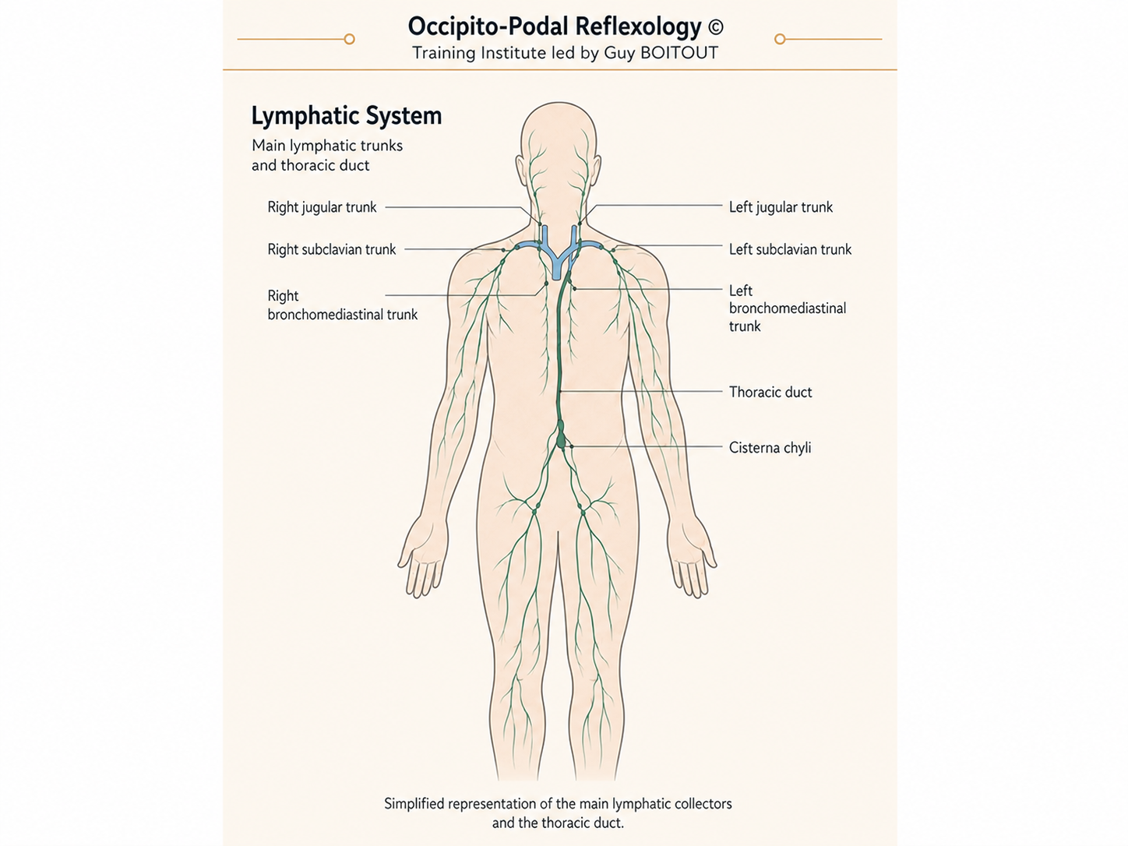
Figure 14.1. Overview of the principal lymphatic collectors and thoracic duct.
ROP perspective. Reflex support directed toward the liver and lymphatic system is presented as a way of supporting absorption, digestive function and immune response; this remains complementary care.

5. Peritoneal and autonomic innervation

The peritoneum has dual innervation
The parietal peritoneum shares somatic innervation with the abdominal wall. Its pathways include the phrenic nerve (C3–C5), the lower six intercostal nerves (T7–T12) and the lumbar plexus (L1–L5). It is sensitive to pain, pressure and temperature; pain may project to cervical, scapular, abdominal or lumbar regions.
The visceral peritoneum shares extrinsic autonomic innervation with the viscera. Sympathetic roots from approximately T8–T11 travel through the greater and lesser splanchnic nerves to the coeliac and superior mesenteric prevertebral plexuses. Visceral sensation is relatively insensitive to touch and temperature but responds particularly to distension and chemical stimuli.

Vagus nerve and sympathetic system
- Sympathetic activity: conveys visceral information related to distension and chemical stimuli, reduces peristalsis and intestinal secretion, and predominates during stress, anxiety, fear and exertion.
- Vagal activity: is predominantly sensory, informs the brain about visceral state, facilitates peristalsis and secretion, and communicates with the enteric nervous system.
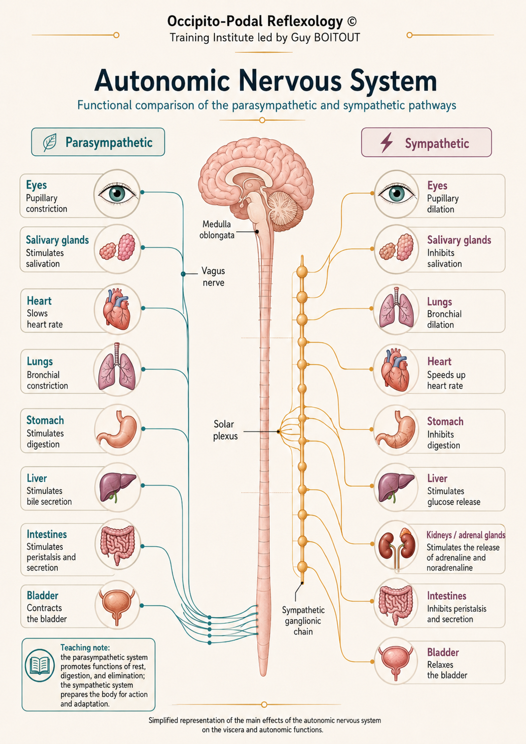
Figure 14.2. Functional overview of parasympathetic and sympathetic pathways.
In summary: sympathetic activity brakes digestive function, while the vagus nerve conveys information and facilitates digestive motility.

6. The enteric nervous system
Often called the ‘second brain’, the enteric nervous system coordinates local motility, secretion and digestive responses. Its intramural plexuses lie within the intestinal wall and function with substantial autonomy from the brain and spinal cord.
- Submucosal (Meissner) plexus: located in the submucosa and closely related to mucosal function and secretion.
- Myenteric (Auerbach) plexus: located between the circular and longitudinal muscle layers and central to motor coordination.
- Functional sensing: integrates neurohormonal signals and the chemistry of the intestinal lumen.
- Neurochemical production: includes serotonin, acetylcholine, noradrenaline and GABA.
- Interstitial cells of Cajal: generate slow waves and contribute to coordinated intestinal motility.

7. Motility of the small intestine
- Segmentation: localised contractions divide chyme into small portions and mix it with secretions.
- Pendular movements: back-and-forth movements mix chyme and increase contact with the mucosa.
- Peristalsis: progressive contractions propel chyme toward the colon.
Motility is modulated by mechanical distension of the intestinal wall, local myenteric coordination influenced by parasympathetic and sympathetic systems, and hormonal or chemical signals, including motilin and luminal nutrients.
Segmentation and pendular movements mix and homogenise chyme; peristaltic contractions move it onward toward the colon.

8. The intestinal ecosystem and barrier
The intestinal mucosa acts as a selective barrier between the digestive lumen and the internal environment. Three interdependent elements form this biological frontier:
- Intestinal mucosa: the interface that supports digestion and absorption; principal components include enterocytes and mucus.
- Gut-associated lymphoid tissue (GALT): including Peyer’s patches, mast cells and Paneth cells; it detects potentially harmful agents and contributes to defence. Paneth cells release antimicrobial peptides.
- Intestinal microbiota: a community of bacteria, fungi, yeasts, viruses and protozoa living in interaction with the host. Each person has a distinctive microbial signature; the microbiota contributes to immunity, digestion, absorption and gut–brain communication.

9. Two complementary routes of micronutrient absorption
Route | Absorbed substances | Destination
Blood capillaries | Water, mineral salts, simple carbohydrates, amino acids, short-chain fatty acids and water-soluble vitamins. | Transported to the liver through the portal system.
Lymphatic lacteals | Fats, long-chain proteins and fat-soluble vitamins A, D, E and K. | Lymphatic network → cisterna chyli → thoracic duct → left venous angle.
Table 14.2. The blood and lymphatic routes of intestinal absorption.

10. Microanatomy of the intestinal barrier
Villi and microvilli greatly increase the exchange surface. When spread out, the small intestine provides an exchange area often compared, in the source material, with the area of a tennis court.
- Enterocytes: form a selective barrier, absorb micronutrients and limit the passage of insufficiently digested macromolecules.
- Goblet cells: produce protective mucus.
- Crypt cells (crypts of Lieberkühn): contribute to mildly alkaline intestinal secretion and enzymatic functions.
- Paneth cells: release antimicrobial peptides.
- Villus core: contains blood capillaries, a central lymphatic lacteal, connective tissue and smooth muscle cells.

11. Intestinal hyperpermeability and dysbiosis
Intestinal hyperpermeability and dysbiosis are often associated and may reinforce one another. Hyperpermeability involves altered intercellular junctions, increased passage of luminal macromolecules and immune or inflammatory activation. Dysbiosis involves reduced microbial diversity, imbalance between commensal and potentially pathogenic species, and impaired mucosal protection.

Common contributing factors
- Infections
- Chronic stress
- An unbalanced diet
- Medication exposure
- Inflammation
- Prolonged intense exercise with transient reduction in splanchnic perfusion

Possible consequences described in the source
- Food-related allergic manifestations
- Immune or inflammatory activation
- Micronutrient deficiencies
- Increased hepatic processing load
These associations are not diagnostic. Symptoms and suspected barrier or microbiome disorders require appropriate medical evaluation.

12. Dysbiosis and the gut–brain axis
The gut–brain axis links the microbiota, enteric nervous system, vagus nerve and central nervous system. Stress, inflammation, infections, dietary imbalance, repeated antibiotic exposure and certain environmental exposures may contribute to dysbiosis.

Features that may prompt further assessment
- Halitosis, belching or aerocoly
- Malodorous gas
- Constipation, diarrhoea or alternation between the two
- Heartburn
- Marked cravings for sugar or raw meat
The source presents dysbiosis as an associated factor in several disorders and notes that possible links with neurodegenerative disease are being studied. Such associations do not establish causation and should not be used as stand-alone diagnoses.

13. ROP indications and criteria for medical referral

Functional indications considered in ROP
Only after urgent or organic disease has been excluded, the source identifies the following functional contexts:
- Dysbiosis: associated functional digestive disorders.
- Post-gastroenteritis sequelae: persistent symptoms after the acute phase.
- Enteroptosis: abnormal tension of the small intestine accompanied by vasoconstriction, venous and lymphatic stasis, and peri-vascular nerve-plexus spasm.
- Functional paralytic ileus: inhibition of motility and secretion attributed to peritoneal irritation with sympathetic predominance, outside an obstructive presentation and only after medical evaluation.

Warning signs requiring medical assessment or exclusion
- Fever
- Red or black blood in the stool
- Marked dehydration
- Substantial unexplained weight loss
- Alternating constipation and diarrhoea
- Vomiting
- Colicky pain around the umbilical region
- Marked abdominal distension
- Suspected mechanical or paralytic intestinal obstruction
- Strangulated inguinal hernia
- Troisier’s node or other oncological concern
- Signs suggestive of an intra-abdominal effusion
Do not initiate or continue complementary management when a warning sign suggests urgent or serious disease. Arrange medical assessment.

14. Crohn’s disease
Crohn’s disease is a chronic inflammatory disorder that commonly affects the ileum and colon. The source identifies genetic background, dysbiosis and environmental influences as associated factors, with emotional factors potentially modulating the lived experience of symptoms and, in some patients, disease flares.
- Digestive symptoms: diarrhoea, abdominal or pelvic pain, weight loss and fatigue.
- Extra-digestive features: oral aphthae, low-back pain, erythema nodosum, pancreatic involvement and depressive symptoms.
- Course: a chronic disorder characterised by flares and remissions. A low-fibre diet may sometimes be required under clinical guidance. Colorectal cancer risk varies with disease duration and extent.
- ROP perspective: may be used only as an adjunct intended to ease some abdominal or pelvic discomfort and support transit; it does not treat intestinal inflammation or replace specialist care.
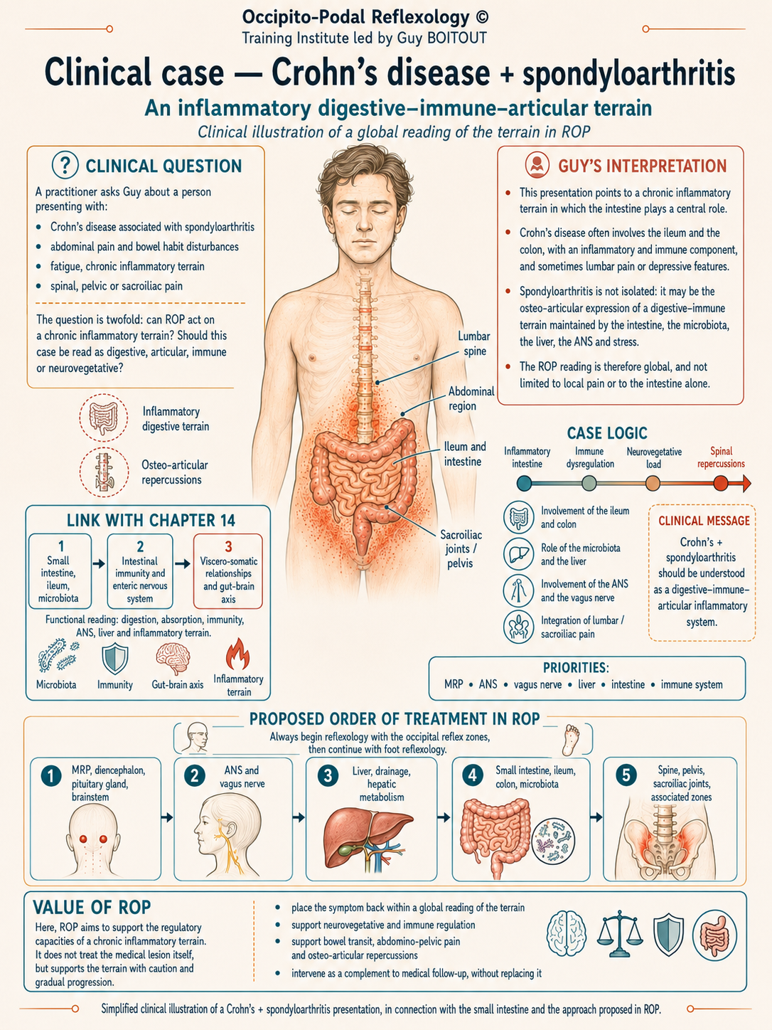
Figure 14.3. Clinical teaching illustration: Crohn’s disease and associated musculoskeletal presentation.

15. Viscerosomatic relationships
The source retains thoracolumbar landmarks as clinical reference points in ROP: T10–T12 for thoracic and corresponding costal assessment, and L1–L2 for the upper lumbar and thoracolumbar junction. These correspondences may guide functional assessment and reflex protocols but do not replace anatomical analysis or differential diagnosis.
- T10–T12: thoracic vertebral restrictions, corresponding ribs and associated thoracoabdominal assessment.
- L1–L2: upper lumbar restrictions, the thoracolumbar junction and associated clinical assessment.

16. Viscero-emotional relationships
The gut–brain axis links stress, autonomic regulation and digestive symptoms. When emotional tension rises, sympathetic activation may increase, vagal regulation may decrease, and motility, secretion and visceral sensitivity may be altered. Possible manifestations include bloating, spasms, digestive discomfort, visceral hypersensitivity, fatigue, irritability, anxiety, sleep disturbance and abdominal or lumbar tension. These manifestations are variable and non-specific.

Clinical approach and advice
- Listen to and acknowledge the emotional context.
- Support autonomic balance.
- Adapt food choices to digestive tolerance.
- Avoid intense exertion immediately after a large meal.
Within ROP, exploration of emotional tension complements the functional assessment; it does not substitute for medical or psychological diagnosis.

17. Clinical ROP protocol for the small intestine
The protocol follows a broad progression: prepare the adaptive terrain, address constraints, and then work with the target organ or function. The four levels are complementary rather than rigidly sequential; history, examination, medical data and contraindications remain decisive.

Level 1 — Regulation of higher centres
- Occipital reflex zones
- Brainstem and visceral integration centres
- Diencephalon and hypothalamus
- Hypothalamic–pituitary axis
- Neuro-meningeal environment and cerebrospinal-fluid circulation
- Associated occipito-podal correspondences
Role: support integration centres and general regulation.

Level 2 — Autonomic regulation
- Vagus nerve (cranial nerve X)
- Thoracolumbar sympathetic pathways
- Coeliac and superior mesenteric plexuses
- Autonomic–enteric nervous system interface
- Diaphragm and breathing
- Functional support, according to testing, for the liver, pancreas and duodenum
Role: prepare adaptive capacity and support autonomic balance.

Level 3 — Local and regional visceral regulation
- Jejunal and ileal loops
- Mesentery and mesenteric root
- Peritoneum and visceral glide
- Relations with the duodenum and colon
- Mesenteric vascular region
Role: support mobility, tissue glide and regional fluid dynamics.

Level 4 — Viscerosomatic and viscero-emotional integration
- Thoracolumbar convergences, with emphasis on T9–T11 and T10
- Abdominal wall, lumbar region and pelvis
- Visceral hypersensitivity
- Gut–brain axis
- Emotional context
Role: support functional integration and recovery.
Clinical principle: assess → prioritise → adapt → treat → reassess. Use a global, prudent approach and always respect contraindications.

Key takeaways
- The jejunum and ileum occupy preferential — not absolute — topographic territories.
- The mesentery suspends the small intestine and carries its blood vessels, lymphatics and nerves.
- Portal blood drainage and lymphatic transport provide complementary absorption pathways.
- Somatic, autonomic and enteric innervation contribute distinct sensory and regulatory functions.
- The mucosal barrier, immune tissue and microbiota form an interdependent intestinal ecosystem.
- ROP assessment is presented as integrative and complementary; it must remain subordinate to medical safety, diagnosis and follow-up.

