Chapter 6 - Polyvagal Theory

Introduction
According to the classical concept of General Adaptation Syndrome (GAS), humans respond to a stressful situation by initially activating the sympathetic nervous system. Dr Stephen Porges proposed an alternative conceptual framework, Polyvagal Theory (PVT), which emphasizes distinct roles for vagal pathways in adaptation to stressful situations associated with fear and anxiety.
Polyvagal Theory remains a theoretical framework that continues to be debated and investigated. Nevertheless, it offers an additional perspective on the mechanisms underlying stress and behavior. (See Chapter 5, Stress Mechanism, page ...)
PVT explores the role of the autonomic nervous system (ANS) in social and emotional behavior. Approximately 80% of the visceral afferent information transmitted to the brain is conveyed through the vagus nerve. (See the chapter on the Autonomic Nervous System, Vagus Nerve, page ...). Changes within the body can influence mental and emotional states. Therefore, in ROP, our role is to support vagal regulation.

Polyvagal Theory (PVT)
According to the model proposed by Dr Stephen Porges, in mammals and particularly in humans, the ANS can be described as comprising three functional subsystems: the sympathetic nervous system and two vagal components. In the presentation adopted here, this organization is related to the phylogenetic sequence described in neurologist Paul D. MacLean's triune-brain model (see Chapter 3, Central Nervous System, page ...):
- the sympathetic nervous system;
- two parasympathetic components: the so-called old (dorsal) vagal branch and new (ventral) vagal branch.
- 2.1. First phase: within the evolutionary sequence proposed by PVT, the old, or dorsal, vagal branch is associated with animal species described in this model as having a predominantly reptilian brain. It is presented as having developed in parallel with the brainstem and cerebellum.
In this model, when escape from a predator through flight or fight (the sympathetic response) is not possible, the organism may respond to threat with freezing, fainting, bradycardia, and other immobilization responses.
- 2.2. Second phase: the sympathetic system is described as having developed during the period when animal species increasingly needed to move in order to find food and to flee from or fight threats in a hostile environment. In the model presented here, this development parallels that of the limbic system and diencephalon.
- 2.3. Third phase: PVT proposes that the new, or ventral, vagal branch emerged later in mammals, particularly in humans, alongside the development of higher cognitive functions. To cope with stress, animals increasingly lived in groups, where social organization supported survival and created conditions in which they could rest and feed with a reduced sense of threat. Higher in this proposed hierarchy, humans developed affective attachment, social engagement, and interpersonal relationships that contribute to a sense of safety and emotional balance (Figure 6.1, Polyvagal Theory).
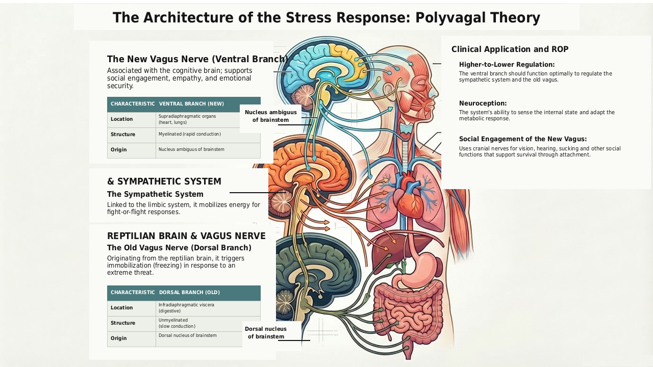
Figure 6.1. Polyvagal Theory

Vasovagal Episode
Distinguishing between two vagal branches helps address the apparent contradiction between, on the one hand, the beneficial effects of parasympathetic activity in counteracting stress associated with sympathetic hyperactivity and, on the other hand, the adverse effects that may occur when the old vagal branch is excessively activated, as in a vasovagal episode. Such an episode may be associated with nausea and vomiting, colitis, fatigue, syncope and, in rare cases, severe complications. (See Vasovagal Syndrome, page ...)
Within Polyvagal Theory, Stephen Porges addressed this apparent paradox by proposing that the new, ventral vagal branch can regulate both sympathetic activity and the activity of the old, dorsal vagal branch.

4. Anatomy of the Two Branches of the Vagus Nerve
Above the tracheal bifurcation, cranial nerve X (the vagus nerve) functions as a mixed cranial nerve carrying both motor and sensory fibers with somatic and visceral components.
Below this bifurcation, it becomes the principal parasympathetic nerve supplying visceromotor and viscerosensory pathways.
- 4.1. Old or dorsal vagal branch (Figure 4.5)
- Origin: the dorsal motor nucleus of the vagus in the medulla oblongata of the brainstem. The fibers are unmyelinated and conduct nerve impulses relatively slowly.
- Distribution: predominantly to the infradiaphragmatic viscera. Within the PVT framework, the dorsal vagal branch is associated with the regulation of vital digestive, genital, and urinary functions
and with responses to life threat when sympathetic mobilization is no longer possible or effective.
- 4.2. New or ventral vagal branch
- Origin: the nucleus ambiguus of the medulla oblongata. The fibers are myelinated and conduct nerve impulses more rapidly.
- Distribution: predominantly to the supradiaphragmatic organs. Myelinated fibers account for only a small proportion of the vagus nerve as a whole. Nevertheless, their faster and more finely modulated conduction contributes to the regulation of cardiac activity. During social interactions in environments perceived as safe, the ventral vagal branch is described as regulating not only heart rate but, in particular, heart rate variability (HRV). Higher HRV is often associated with greater adaptive flexibility and may be associated with a better capacity to cope with socially stressful situations. Conversely, lower HRV has been associated with various states of vulnerability, including depressive presentations.
The ventral vagal branch is anatomically connected with motor nuclei of other cranial nerves located in the brainstem. It functions in coordination with these nuclei to support social interaction and, within PVT, forms a key component of the human social engagement system.

Social Engagement
At birth, human infants are less developmentally mature than many other animals. Their survival and nutritional needs initially depend on affective and protective attachment, particularly to the mother, through responses to:
- Her smell (olfactory nerve, CN I);
- Her voice (vestibulocochlear nerve, CN VIII);
- Visual contact with her (optic nerve, CN II, and oculomotor nerves, CN III, IV, and VI);
- Her gaze, with orientation of the head (accessory nerve, CN XI);
- Facial expressions (facial nerve, CN VII);
- Touch (trigeminal nerve, CN V);
- Sucking and suckling, followed by mastication and swallowing (glossopharyngeal nerve, CN IX), initially during feeding and later during shared meals that support social interaction;
- Vocalization via the hypoglossal nerve (CN XII).
This affective and protective relationship subsequently extends to the family and, more broadly, to the organization and planning of social and interpersonal life. Under optimal conditions, PVT proposes that the ventral vagal branch exerts hierarchical regulatory influence over the other two systems: the sympathetic system and the dorsal vagal branch.

Neuroception
In the framework presented here, neuroception refers to the sensing of our internal state, that is, the nervous system's capacity to detect what is occurring within us. The three autonomic patterns may be summarized as follows:
- Old (dorsal) vagal branch: harmonious regulation of digestive, genital, and urinary functions;
- Sympathetic system: energy, mobilization, and fight-or-flight responses;
- New (ventral) vagal branch: harmonious cardiac and metabolic regulation, emotional balance, and constructive interpersonal relationships.
From childhood onward, physical, psychological, or emotional trauma may contribute to the development of dominant autonomic response patterns.

Clinical Consequences
- Classical ANS concept: within the traditional two-system model, the sympathetic system was considered primarily responsible for the stress response, particularly during the alarm and adaptation phases of GAS. (See Chapter 5, Stress Mechanism, page ...)
- Polyvagal Theory: PVT reframes this process by proposing that the ventral vagal branch can exert regulatory influence over both the sympathetic system and the dorsal vagal branch.
N.B.: "It is essentially the lowering of vagal tone that releases sympathetic activity, rather than an independent increase in sympathetic tone" (Eric Marlien).
- Hierarchical organization: within the PVT framework, optimal function of the infradiaphragmatic viscera associated with the old vagal branch depends on the sympathetic system, situated above it in this hierarchy, not being overwhelmed by threat, emotional conflict, or acute or persistent stress. Above all, the ventral vagal branch should function optimally at both the interpersonal and psychological levels - with feelings of safety, love and trust, empathy, and compassion - in order to regulate the sympathetic system and the old vagal branch.

Relevance to ROP
In light of this proposed three-branch hierarchy of the ANS, the therapeutic approach in ROP should be organized not only on the basis of history taking and clinical examination, but also according to the top-down hierarchy of the three levels described above, corresponding in the author's presentation to the three-brain model.

Clinical Application in ROP
8.1. Occipital Zones
8.2. Upper level: the new (ventral) vagal branch and its connections with higher centers of the nervous system:
- Craniocervical junction, occiput-C1-C2, and foramen magnum;
- Brainstem and cranial nerves, including the trigeminal nerve and its three branches;
- Jugular foramen (cranial nerves IX, X, and XI) and hypoglossal nerve (CN XII);
- Cranial dura mater, falx cerebri, falx cerebelli, and tentorium cerebelli;
- Rebalancing of the sphenobasilar synchondrosis (SBS)-S2 relationship;
- So-called fourth ventricular compression (CV4) and SBS/S2 resynchronization;
- Supradiaphragmatic viscera: cardiac plexus.

8.3. Intermediate level: sympathetic system
- Sympathetic system: sympathoadrenal medullary (SAM) axis and hypothalamic-pituitary-adrenal (HPA) axis (see Chapter 5, Stress Mechanism, page ...)

8.4. Lower level: old (dorsal) vagal branch
- Celiac plexus;
- Infradiaphragmatic viscera;
- Hypogastric plexus.
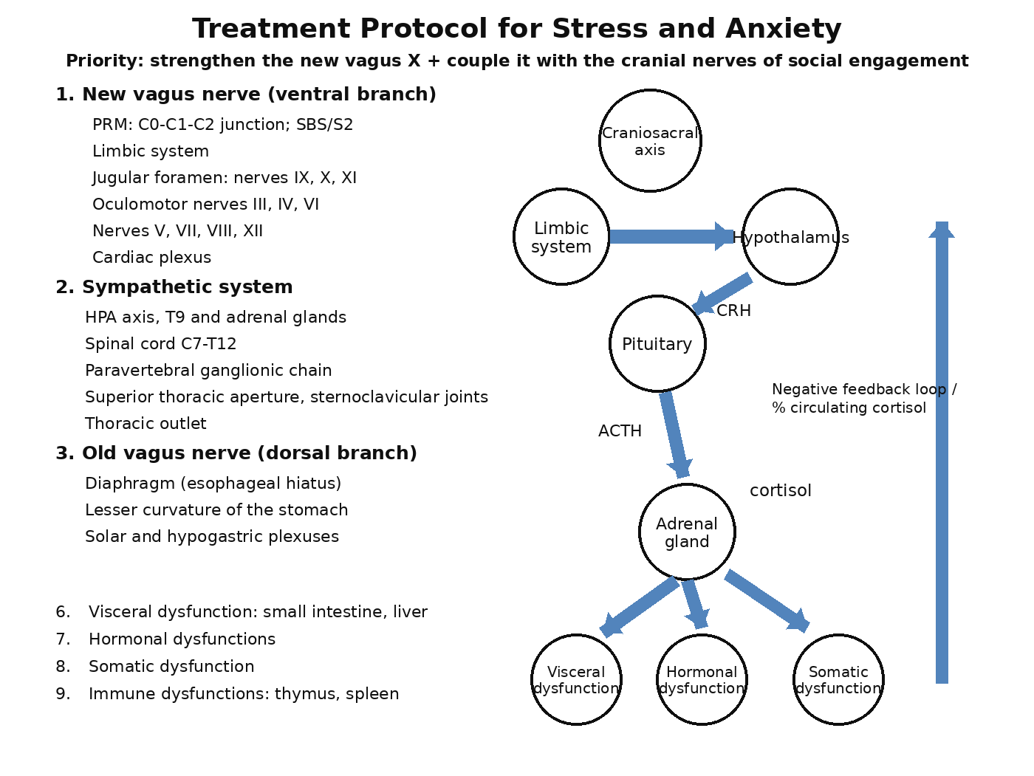
Figure 6.2. ROP within the framework of Polyvagal Theory

