**Mobile to Cloud: Building Distributed Apps (67-328)**

Homework 14 Final Project Model :: Due November 30, 2015

By: Nikita Bokil

**Model**

For my final project I am creating an application called ChefMate. It is an all-encompassing application that assists users in the kitchen by managing their grocery lists and generating recipes based on the ingredients they currently have or want. For this homework I have modeled a user's grocery list so that users can create items, find items, update the quantity of an item given its name, and delete items. The grocery list contains the name and quantity required of an item.

**Testing**

To test my routes and model, I used a combination of cURL and tests in the browser. The cURL tests are located in file called *tests.txt*, and can be copy and pasted into the command prompt. Below are screenshots of tests working for C, R, U, and D operations. Note that not all edge cases are shown below for brevity purposes, however they can be found in the testing file or tested in the browser.

*Figure 1.0 - Create Successful*

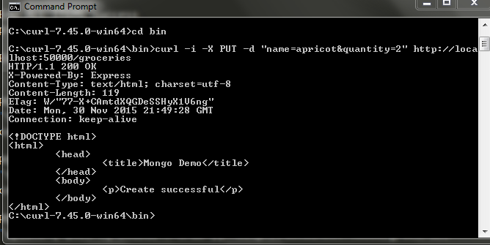

*Figure 2.0 - Read Successful*

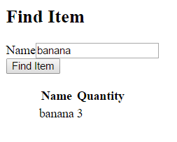

*Figure 3.0 - Update Successful (Modify bananas to be quant: 8)*

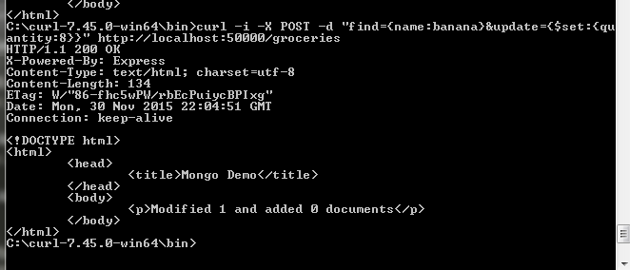

*Figure 4.0 - Delete Successful*

