Title

First author,1,2 Second author,3

1. Institution 1
2. Institution 2
3. Institution 3

# Abstract

## Purpose

…

## Design

…

## Participants

…

## Methods

…

## Main Outcome Measures

…

## Results

…

## Discussion

…

## Conclusion

…

# Introduction

Demonstrate single and multiple references.

Some background information here.1 More background information here.2,3

# Methods

Demonstrate subsections and an equation.

## Subsection

…

## Subsection

Equation:

# Results

Demonstrate referencing figures, and tables.

The geographic (Figure 1) and numerical (Figure 2) distributions of prevalence of key health measures were determined.

The ten cities with the greatest prevalence of lack of access to health insurance in 2016 in this dataset were determined (Table 1).

# Discussion

…

# Conclusion

…

# Figures and Tables

## Figures

Demonstrate including figures

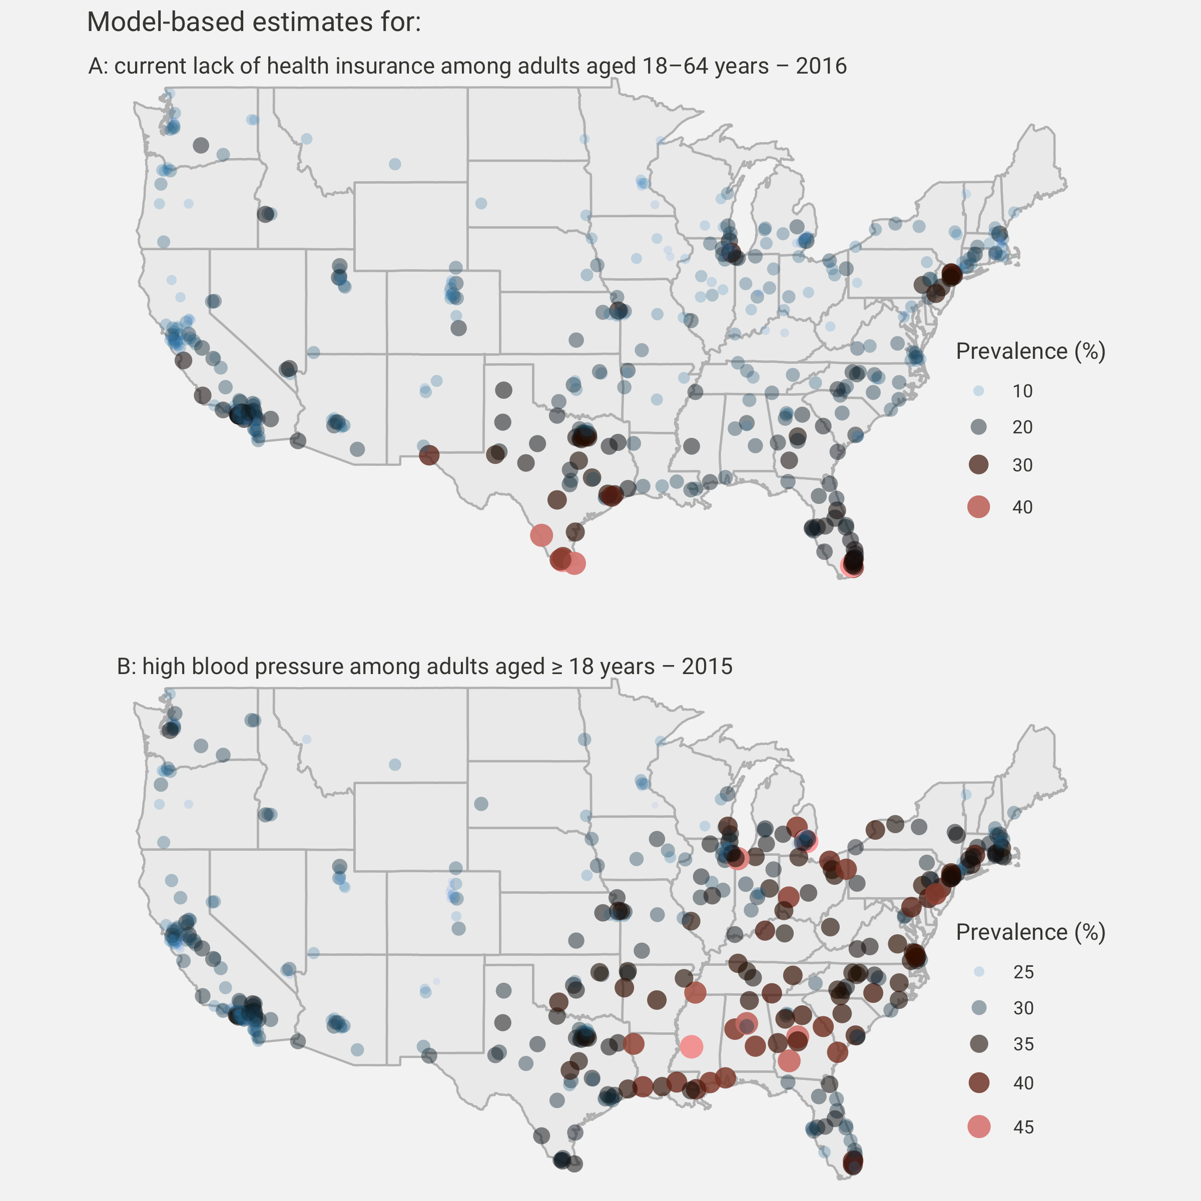

Figure 1 Maps of health insurance coverage and high blood pressure.

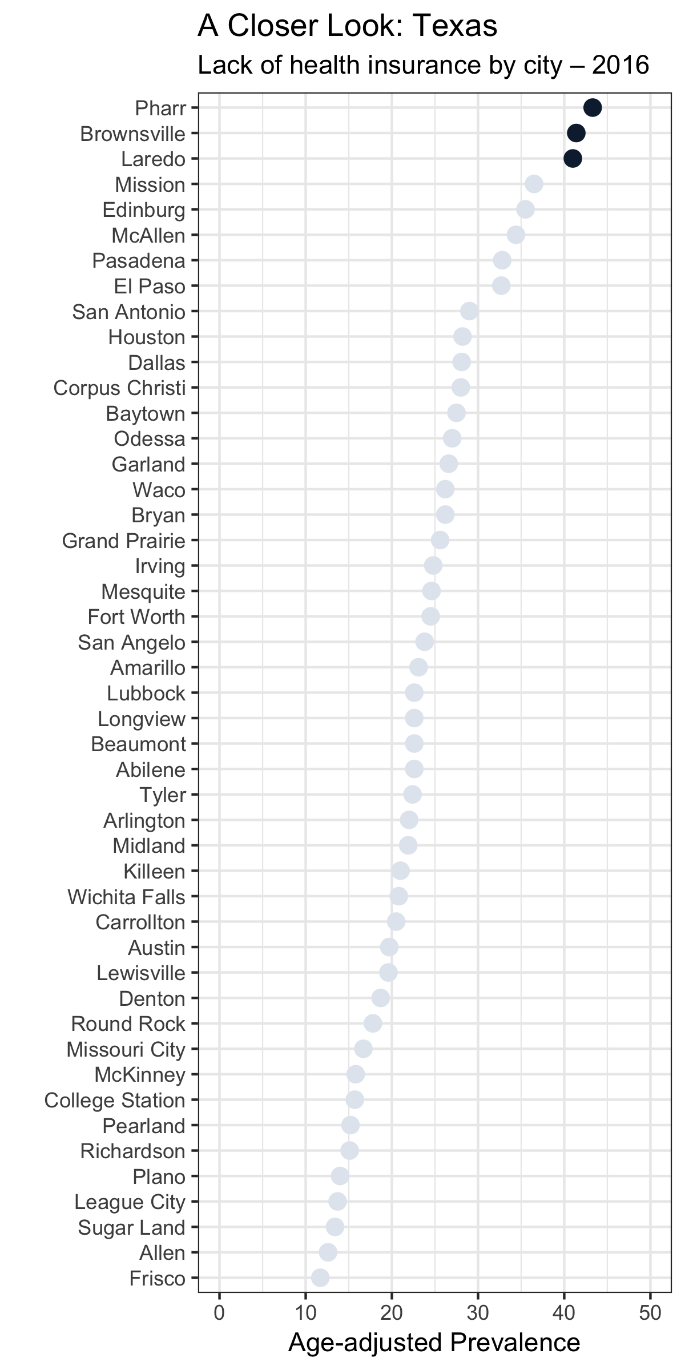

Figure 2 A closer look at access to health insurance in Texas, by city.

## Tables

Table 1 Greatest prevalence of lack of access to health insurance in this dataset

|  |  |  |  |  |
| --- | --- | --- | --- | --- |
| city | state | mean | max | min |
| Hialeah | FL | 43.7 | 43.7 | 43.7 |
| Pharr | TX | 43.3 | 43.3 | 43.3 |
| Brownsville | TX | 41.4 | 41.4 | 41.4 |
| Laredo | TX | 41.0 | 41.0 | 41.0 |
| Mission | TX | 36.5 | 36.5 | 36.5 |
| Miami | FL | 36.3 | 36.3 | 36.3 |
| Edinburg | TX | 35.5 | 35.5 | 35.5 |
| McAllen | TX | 34.4 | 34.4 | 34.4 |
| Pasadena | TX | 32.8 | 32.8 | 32.8 |
| El Paso | TX | 32.7 | 32.7 | 32.7 |

# References

1. Author, 1. & Author, 2. Title 1. (2019).

2. Author, 3. & Author, 4. Title 2. (2014).

3. Author, 1. & Author, 5. Title 3. (2010).