A Strategic Approach to Web Component Integration

1. The Vision
To empower the bank with the agility to innovate and deploy new digital features rapidly and securely across all customer-facing platforms, while ensuring brand consistency and reducing dependency on third-party development cycles.

2. The Approach in a Nutshell
We will build key banking features (like Wire Transfers) as self-contained, reusable "feature modules" (web components). These modules can then be seamlessly "plugged into" our vendor's online and mobile banking applications, giving us direct control over functionality and user experience. This strategy allows us to deliver tailored brand experiences for our multiple tenants (Digital Bank, General Bank) from a single, centrally managed deployment, backed by a robust, secure, and adaptable API layer.

3. Core Pillars of the Strategy
Pillar | Description
1. Agility & Control | We gain direct control to develop and deploy features on our own timeline. A central "manifest" file allows us to roll out updates instantly, bypassing lengthy vendor release schedules.
2. Brand Versatility (Multi-Tenancy) | Deliver a tailored experience for both "Digital Bank" and "General Bank" customers. Each component is brand-aware, automatically adapting its appearance and functionality to match the specific tenant's requirements.
3. Seamless Integration | Our feature modules will look and feel like a native part of the vendor's application. By using modern web standards (Custom Elements), our components integrate smoothly, ensuring a consistent and high-quality user experience.
4. Fort Knox Security | Communication is end-to-end secure, ensuring the highest level of data protection. We use a two-layer protocol where every request is digitally signed for authenticity (JWS) and then fully encrypted for confidentiality (JWE).

4. How it Works: 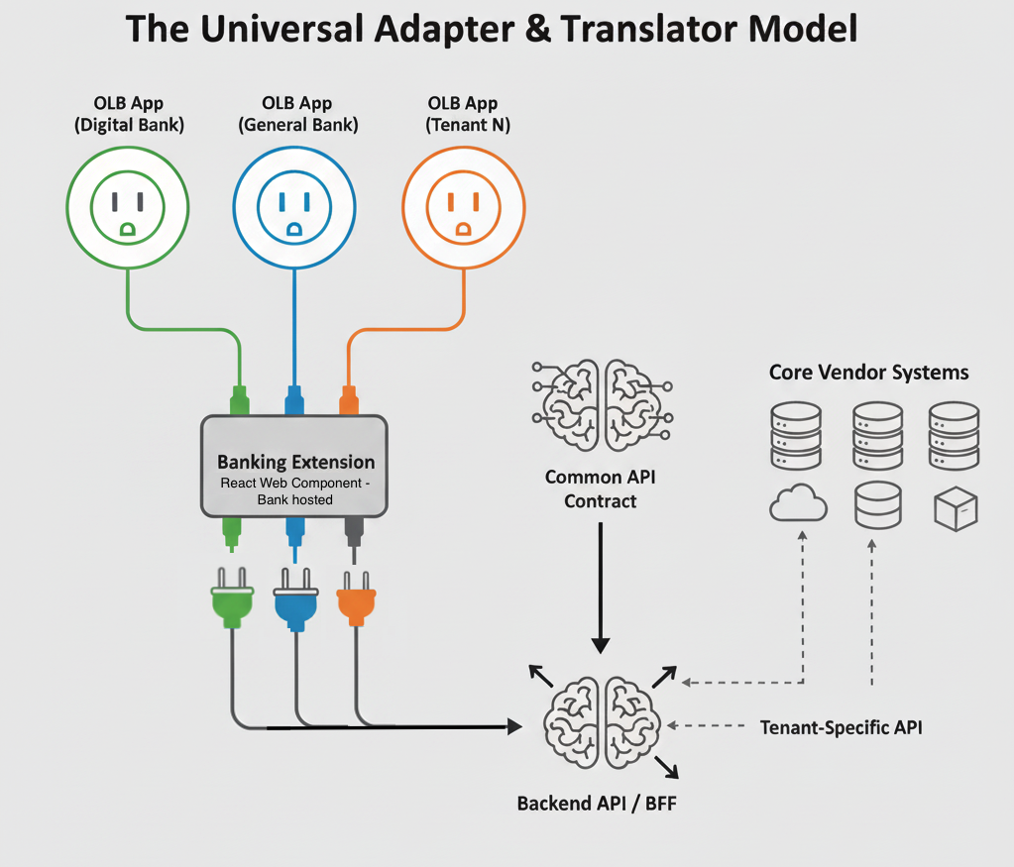
This model illustrates how a single Banking Extension provides diverse experiences while simplifying backend complexity:
- The Online Banking Apps : The Online Banking / Mobile Banking application(OLB App) for each tenant (e.g., Digital Bank, General Bank) acts like a unique power outlet, representing distinct customer environments and brands.
- The Banking Extension (The Universal Adapter): A single web component deployment functions as a "universal adapter." It plugs into OLB Apps for each tenant, visually transforming its "face" to perfectly match the tenant's branding and requirements. This means one codebase delivers a tailored experience.
- The Backend API / BFF (The Universal Translator): The Banking Extension communicates via a "Common API Contract" with its dedicated Backend-for-Frontend (BFF). This BFF acts as a "universal translator." It takes the common request and intelligently translates it into the specific, often complex, API calls required by the various underlying Core Vendor Systems that each tenant uses, abstracting away backend differences from the front-end component.

5. Key Business Outcomes
- Faster Time-to-Market: Launch new features and product updates in weeks, not months.
- Reduced Vendor Dependency: Lower development costs and gain greater control over development and release cycles.
- Enhanced Customer Experience: Deliver highly tailored, consistent, and on-brand experiences for each tenant, driving customer satisfaction and loyalty.
- Future-Proof Architecture: A flexible, modern approach that enables easier adoption of new technologies and scalability.
- Uncompromised Security & Trust: Implement a best-in-class security model for all digital transactions, strengthening customer confidence.

