Noah Boorstin
My graph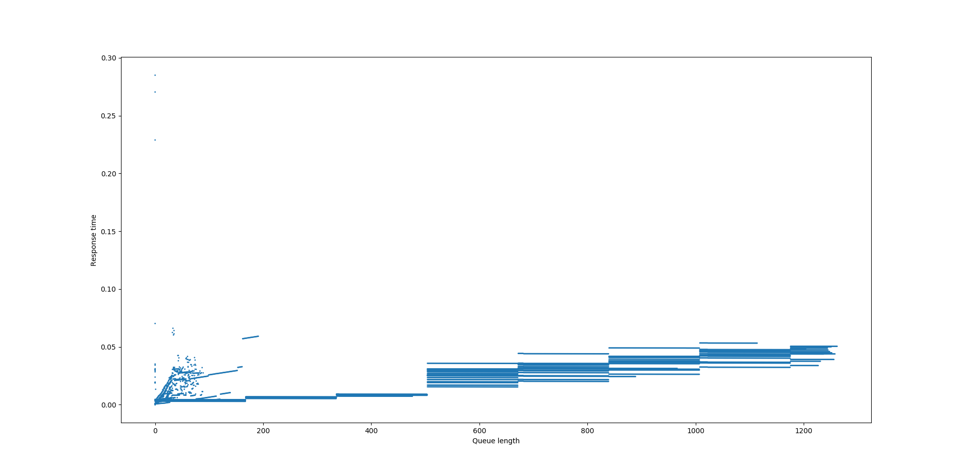
Fall 2017
Research Log
Weeks:

  - Installed blktrace, blkparse, btt, filebench, etc
  - Got traces from Nelll, made some of my own
  - The time scale appears to be way too fast on my and Nelll’s traces, the traces Prof Keunning got from his own computer seem fine
  - Commands used (local computer), in this order:
    - sudo blktrace -d /dev/nvme0n1 -o a.blktrace -w 30
    - blkparse -i a.blktrace -d a.blkparse -O
    - btt -i a.blkparse -p a.btt

  - Nelll’s program to interpret the btt output was in a state of disarray, so she explained to me how it worked and I wrote my own
Nelll's graph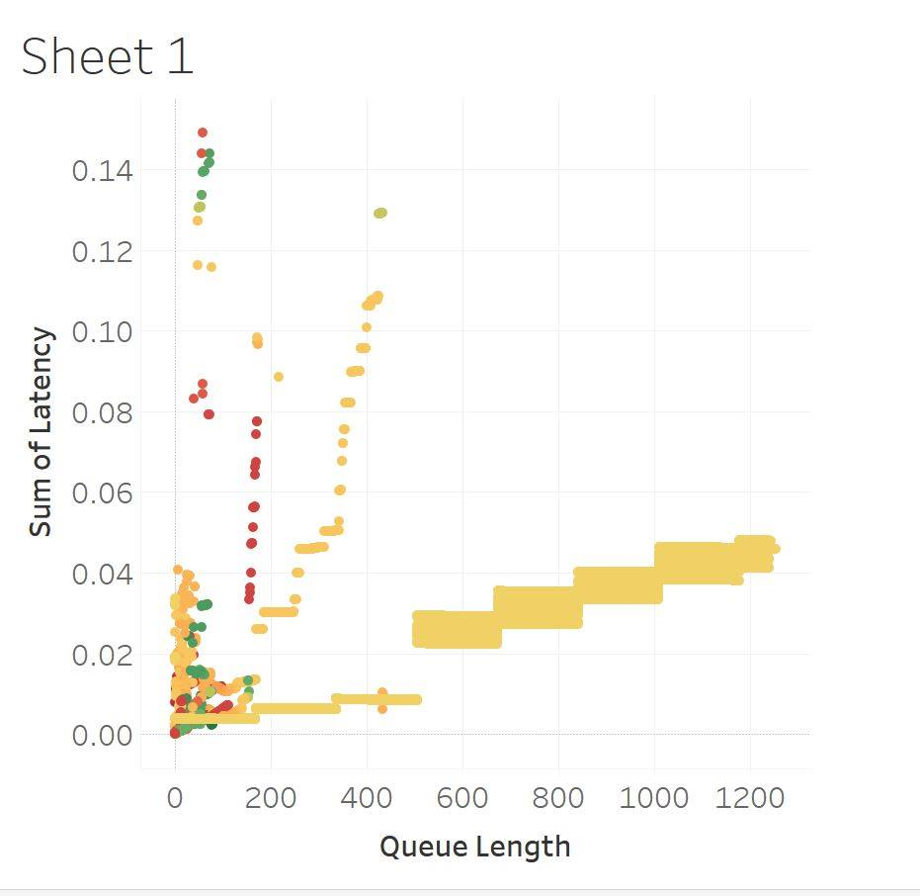
  - I got a very similar graph as she did from my program,
Compared to Nelll’s: (mine is blue, hers is yellow)
  - It’s unclear whether requests should still be counted as individual requests after they’re merged. My first program keps them as individual; by the similarity of the graphs I’m assuming Nelll’s does also.
Merged requests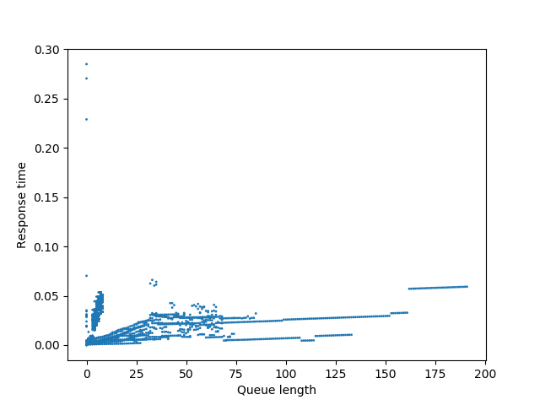
  - When we count merged requests as a single request, we get a different looking graph:

  - Rewrote my program to accept command line arguments, using the docopt library. Took a bit of time to learn how to use it.
  - Added options to seperate hardware from software queues, graph queue length over time, etc
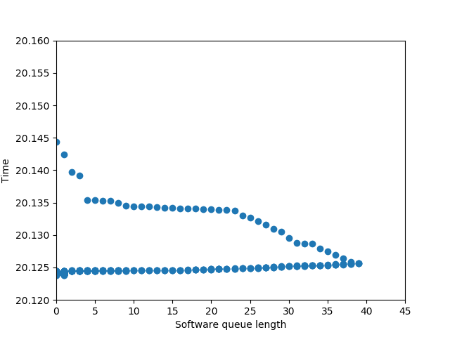
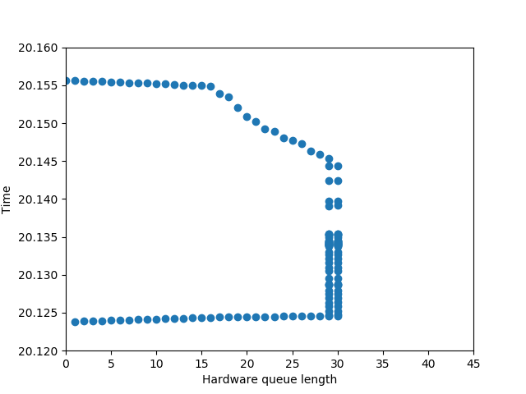
  - Didn’t have much time to do anything else. My weekly meeting with Prof Keunning was interesting:
    - He was interested in pairs of graphs of software and hardware queue lengths vs time. I forgot exactly what we graphed, but pretty much the same thing is here: you can see the software queue passing requests off to the hardware queue, with a slight delay, the sofware queue keeping the hardware queue as full as possible.
      - This is only apparent if you call merged requests one request.
      - Generated using the command:
        - python parserArgs.py -b [20.12,20.16] -d[20.12,20.16] -a [0,45] -c [0,45] -m perIOOutput
    - looked at graphs of just the hardware queue lengh vs response time in relation to queue length vs time, and same for software. Again, if merging requests, this looks exactly as you would expect:
      - You can see the correspondance between the each graph
      - Generated using the commands:
        - python parserArgs.py -h -Q hardware -t D -q D perIOOutput
software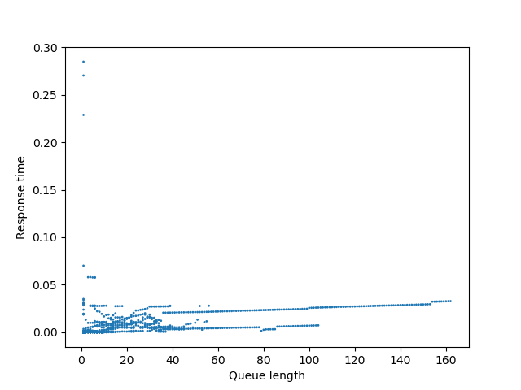
software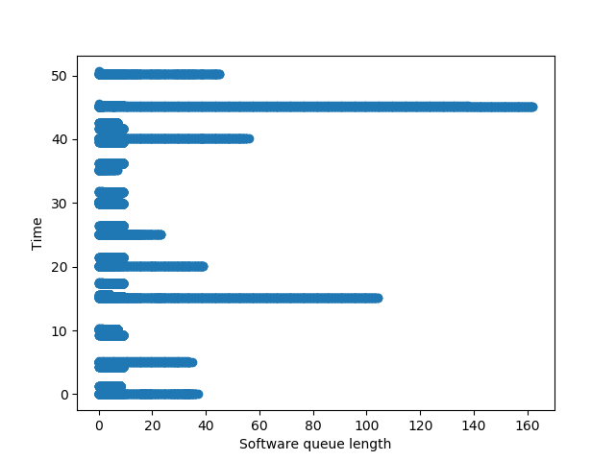
hardware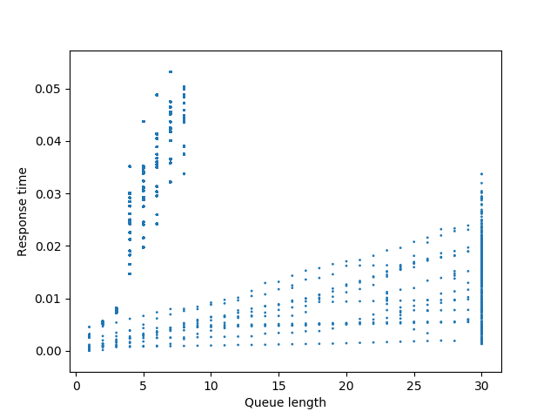
hardware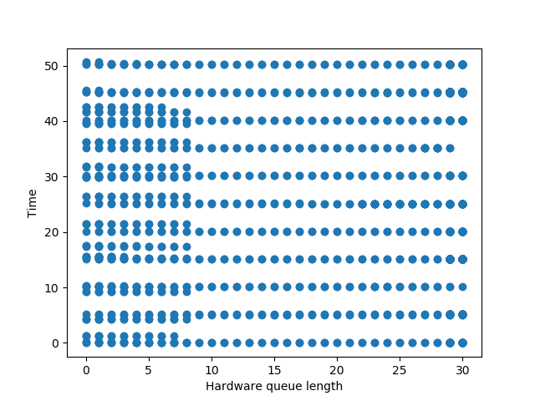
    - This seems to show the weird blocks in the first graph were simply an artifact of ignoring merges, and the proper way to graph this type of data is to consider merged requests one.

  - Started writing this document, retroactively added past weeks, because I should have done this from the start
  - Start using git; I also should have been doing this the whole time.
  - Add a command line switch for limiting the graphs of queue length over time to a certain x and y range
  - Recreated and saved some of the graphs made and discussed during the meeting with Prof Keunning
  - Added options to look at only reads or only writes; this info is not present in the btt per-IO-Output file, so it’s reading the text output from blkparse; to do so, use this chain of commands instead:
    - sudo blktrace -d /dev/nvme0n1 -o a.blktrace -w 30
    - blkparse -i a.blktrace -d a.blkparse -o a.txt
    - btt -i a.blkparse -p a.btt
  - Oddities I noticed in btt/blkparse outputs:
    - In the btt output: some traces made on my computer never have an I entry. I thought this was required.
    - In the blkparse output: there are options more than just W or R; some are WS, N, WFS, FWFS, WM, RM. No idea what that means
  - Using the -s option on btt seems interesting, although it doesn’t really output too much data
    - on that note, I’m not really sure why I’m running btt with the -p switch; I’m just doing that because Nelll did it.
  - Still didn’t have time to look for better graphing software than matplotlib
  - Ideas of what to investigate in the future:
    - Nelll’s idea: profile a bunch of different hard drives
    - Try to look at physical read/write location over time?

