Cepstrum Analysis in Marine Passive Acoustics
Periodic spectral structure, quefrency and cepstrogram interpretation for surface-ship and submarine detection
Technical review draft

1. What cepstrum analysis is
Cepstrum analysis is a second-stage spectral technique designed to reveal periodic structure within a spectrum. Instead of asking only which acoustic frequencies are present, it asks whether peaks, harmonics or sidebands repeat at a regular frequency spacing. A regular spacing Δf in hertz produces a cepstral feature at the reciprocal quantity q = 1/Δf, measured in seconds. This reciprocal spectral coordinate is called quefrency.
The terminology is deliberately unusual: quefrency has units of seconds, but it is not the elapsed observation time. It is a time-like lag associated with periodicity in the spectrum. When multiple short-time cepstra are stacked, the result is a cepstrogram. In the MACS-style convention used here, quefrency is the horizontal x-axis and observation time is the vertical y-axis, increasing downwards.
Quantity | Meaning
Acoustic frequency f | Frequency of a component in the received underwater sound, in hertz.
Spectral spacing Δf | Repeated separation between harmonic lines, sidebands or other regularly spaced spectral components.
Quefrency q | Reciprocal of spectral spacing: q = 1/Δf, in seconds.
Real cepstrum | Inverse transform of the log magnitude spectrum.
Cepstrogram | Successive cepstra displayed versus observation time.

2. Why it matters for marine acoustics
Ship-radiated noise can contain broadband and line-spectrum components. Cepstral processing is useful because repeating spectral spacing can be emphasised even when individual members of the pattern are weak or partially masked. Research has applied cepstrum analysis to underwater ship-radiated noise, including extraction of multipath structure from direct and reflected arrivals, underwater-channel features for target classification, and time-varying cepstral features of moving ships.¹²³

Surface ships
For a surface ship, periodic machinery, propulsion-related line structure, harmonics and modulation sidebands can produce regular spectral spacing. A cepstral peak can condense that family of repeated spacings into a clearer reciprocal-period feature. This is useful as corroborating evidence alongside the original spectrum or LOFARgram.

Submarines
For submarines, the same mathematical principle applies. When acoustic lines are weak, a repeated-spacing pattern may remain informative even if individual lines are difficult to distinguish. Cepstrum should nevertheless be treated as supporting evidence rather than unique source identification: other vessels, machinery, propagation and multipath can also produce cepstral structure.

3. Signal processing step by step

1. Receive and digitise the sound
A hydrophone or array acquires the underwater pressure signal, followed by suitable analogue conditioning, anti-alias filtering and analogue-to-digital conversion.

2. Divide into finite frames
The sampled signal is divided into analysis intervals, commonly with overlap when a continuous time history is wanted.

3. Apply an analysis window
A window such as Hann reduces spectral leakage at frame boundaries.

4. Compute the FFT
The FFT gives the complex spectrum X[k] of each analysis frame.

5. Form a magnitude spectrum
Take |X[k]|, or a suitably scaled amplitude/power representation. Tonals, harmonics and sidebands are visible in the frequency domain at this stage.

6. Take the logarithm
Compute log|X[k]|. The logarithm is fundamental to the classical real cepstrum because it converts multiplicative spectral structure into additive form.

7. Transform the log spectrum back
Take the inverse transform of log|X[k]|. The result is the real cepstrum c[q].

8. Search in quefrency
Look for peaks at non-zero quefrencies. A peak at q indicates repeated spectral spacing approximately Δf = 1/q.

9. Stack successive cepstra
When the cepstrum is calculated frame-by-frame and stacked, a cepstrogram shows how the spectral repetition structure evolves through observation time.
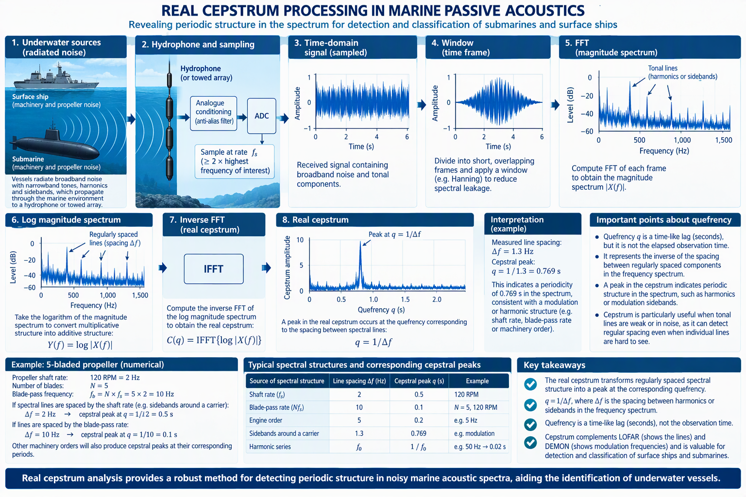
Figure 1. Real-cepstrum processing chain from the underwater acoustic time series to reciprocal spectral-spacing evidence in quefrency.

4. Mathematical basis
Let x[n] be a windowed time record and X[k] its discrete Fourier transform:
X[k] = Σₙ x[n]e^(−j2πkn/N)
A common definition of the real cepstrum is
c[q] = IFFT{ log |X[k]| }
Some implementations use log power rather than log magnitude, which changes scaling but not the central reciprocal-spacing idea. If a spectrum contains a family of regularly spaced components separated by Δf, the cepstrum tends to reinforce a feature near
q = 1/Δf
and conversely
Δf = 1/q
For example, spectral spacing of 1.30 Hz corresponds to q ≈ 0.769 s. The cepstrum therefore maps a repeating structure in frequency into a peak located on a time-like quefrency axis.

5. How to interpret the LOFAR display and the cepstrum together
The LOFARgram remains the primary view of acoustic frequency versus observation time. Identify persistent tonals, harmonic families and sidebands there first. Cepstrum is then a complementary view: rather than reproducing where every line lies in frequency, it highlights the regular separation between those lines.
LOFAR observation | Cepstral question | Combined interpretation
Lines at f₀, 2f₀, 3f₀, … | Is there a peak near q = 1/f₀? | Supports a repeated harmonic spacing f₀.
Carrier with symmetric ±fₘ sidebands | Is there a feature near q = 1/fₘ? | Supports repeated spacing associated with modulation rate fₘ.
Several weak but evenly spaced lines | Does a stable cepstral ridge persist? | Can strengthen evidence that the spacing is real rather than random.
Line spacing changes with time | Does the cepstral ridge move in q? | Reciprocal spacing is changing, potentially consistent with changing periodic source rate.

6. How to interpret a cepstrogram
Figure 2 uses the MACS waterfall style requested for this guide: quefrency is on the x-axis and observation time is on the y-axis, increasing downward. Because time progresses vertically, a constant quefrency becomes a vertical ridge.

Persistent vertical ridge
A stable q means stable repeated frequency spacing Δf = 1/q. This is the cepstral analogue of following a stable relationship through time.

Ridge moving left or right
The quefrency is changing. Because q and Δf are reciprocal, increasing q means decreasing spectral spacing and vice versa.

Multiple cepstral features
Several repetition mechanisms can coexist. Peaks at integer-related quefrencies can also appear because the spectral pattern is not an ideal single sinusoidal comb.

Horizontal transient
A short-duration event affects only a narrow interval of observation time, hence a horizontal feature in this display orientation.

Low-quefrency region
Very low quefrencies are strongly influenced by the broad spectral envelope and usually require different interpretation from higher-quefrency periodic structure.
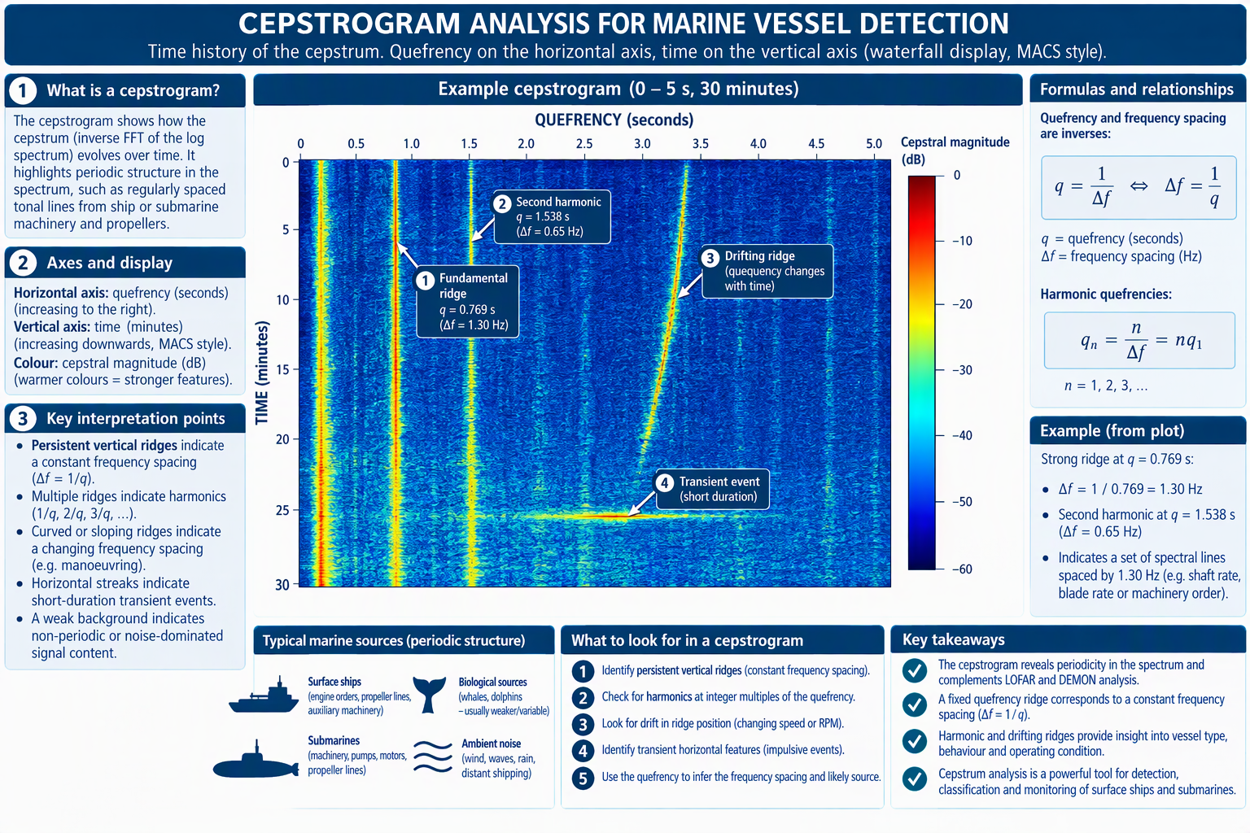
Figure 2. MACS-style cepstrogram: quefrency on the horizontal axis and observation time increasing downward on the vertical axis.

7. Concrete worked example
Suppose a LOFAR spectrum contains a strong carrier at 30.00 Hz with symmetric sidebands at 28.70 Hz and 31.30 Hz. The sideband spacing is
Δf = 30.00 − 28.70 = 31.30 − 30.00 = 1.30 Hz
The corresponding cepstral quefrency is
q = 1/Δf = 1/1.30 = 0.769 s
A persistent cepstral ridge near q = 0.769 s therefore supports the existence of regular 1.30 Hz spacing in the spectrum. If independent evidence suggests that 1.30 Hz is a once-per-revolution shaft rate, the equivalent rotational speed would be
RPM = 60fₛ = 60 × 1.30 = 78 RPM
That mechanical assignment is a hypothesis, not a consequence of cepstrum alone. Cepstrum establishes the repeated spacing; LOFAR shows where the acoustic lines occur; DEMON can independently test whether an acoustic band is amplitude-modulated at 1.30 Hz.
As a second example, consider a 5-bladed propeller rotating at 120 RPM:
fₛ = 120/60 = 2 Hz
fᵦ = Nfₛ = 5 × 2 = 10 Hz
A 2 Hz repeated spectral spacing would correspond to q = 0.5 s; a 10 Hz repeated spacing would correspond to q = 0.1 s. Which feature actually appears depends on the physical acoustic mechanism and the spectral structure present in the received data.

8. LOFAR, DEMON and cepstrum: concise comparison
Method | Domain emphasised | Core interpretation
LOFAR | Acoustic frequency versus observation time | Where are the acoustic tonals, broadband regions, harmonics and sidebands?
DEMON | Envelope modulation frequency | At what low-frequency rates is acoustic energy amplitude-modulated?
Cepstrum | Quefrency / spectral periodicity | What regular frequency spacings exist in the spectrum?
The most convincing interpretation occurs when independent views agree. In the worked example, LOFAR gives ±1.30 Hz sideband spacing, cepstrum gives q ≈ 0.769 s, and a DEMON component near 1.30 Hz would provide additional evidence of envelope modulation at the same periodic rate.

9. Marine-specific cautions
- Do not interpret every cepstral peak as a shaft or blade rate. Regular machinery harmonics, electrical systems, propagation and multipath can also create structure.
- Multipath itself can generate cepstral features. Published underwater ship-noise research has explicitly used cepstrum to extract interference structure caused by direct, sea-surface-reflected and bottom-reflected arrivals.¹
- Quefrency is not ordinary observation time, despite being measured in seconds.
- A reciprocal conversion q = 1/Δf is only meaningful when Δf represents a real repeated spectral spacing.
- Validate candidate periodicities over time and against LOFAR, DEMON, bearing and operational context.

10. Summary
Cepstrum analysis converts regular spacing in an acoustic spectrum into peaks on a reciprocal quefrency axis. For passive marine acoustics, this can consolidate weak harmonic or sideband families into a clearer periodicity cue. The processing chain is: receive sound → frame/window → FFT → magnitude spectrum → logarithm → inverse transform → real cepstrum → quefrency interpretation. A cepstrogram extends this through time. In the MACS-style display used here, quefrency runs horizontally and observation time vertically downward, so stable periodic spectral spacing appears as a persistent vertical ridge.

Selected references and further reading
- ¹ Park, C., Kim, G. D., Yim, G. & Moon, I. (2019). A study on the acoustical inversion method using cepstrum analysis of underwater ship radiated noise. The Journal of the Acoustical Society of Korea, 38(1), 73–81.
- ² Li, X., Jia, H., Dong, J. & Qin, J. (2022). Multisource Target Classification Based on Underwater Channel Cepstral Features. Journal of Ocean University of China, 21(4), 917–925.
- ³ Maeng, I. Y., Choi, J. K., Lee, K. & Park, C. S. (2025). Detailed Analysis of Cepstrum Feature of Ship Radiated Noise. Proceedings of the 31st International Congress on Sound and Vibration.
- Intrinsic mode ensembled statistical cepstral coefficients for feature extraction of ship-radiated noise. Applied Acoustics (2025).

