DEMON Analysis in Marine Passive Acoustics
Modulation, signal formation, processing and interpretation for surface-ship and submarine detection
Technical review draft

1. What DEMON analysis is
DEMON (DEModulation Of Noise) analysis is a passive-acoustic technique that extracts slow, periodic amplitude variations from a higher-frequency band of underwater noise. In maritime work, those variations are often imposed by rotating propellers, cavitation, shafting and other cyclic machinery. The result is an envelope spectrum: instead of asking which acoustic carrier frequencies contain energy, DEMON asks how rapidly that energy is being modulated.
This distinction is important. A conventional LOFAR spectrum can reveal discrete machinery tonals directly. DEMON is especially useful when the useful periodic information is carried as modulation of broadband noise. Propeller-generated broadband energy may therefore look comparatively featureless in an ordinary narrowband spectrum while its envelope contains strong periodic structure.
Quantity | Meaning in DEMON
Carrier / noise band | The higher-frequency acoustic energy whose amplitude is varying.
Modulating frequency | The slow mechanical or hydrodynamic periodicity that changes the carrier amplitude.
Envelope | The time-varying outline of carrier amplitude.
DEMON spectrum | The frequency spectrum of that envelope, showing modulation rates and harmonics.

2. Modulation: what it means physically
Modulation occurs when one process changes a property of another signal. For DEMON the property of greatest interest is amplitude. A slowly repeating mechanical process changes the strength of a broad acoustic source, so the received noise grows and falls in a periodic fashion.
A useful mathematical model is a carrier c(t) multiplied by a modulation function m(t):
x(t) = m(t)c(t)
For simple sinusoidal amplitude modulation,
m(t) = 1 + μ cos(2π fₘ t)
x(t) = [1 + μ cos(2π fₘ t)] c(t)
Here fₘ is the modulation frequency and μ is the modulation index. In a real ship or submarine the carrier need not be a pure sinusoid; it is commonly broadband noise. The multiplication is the key idea: the faster acoustic process carries a slower periodic signature in its amplitude.

3. Marine sources of modulation

Propeller rotation and blade passage
As the propeller rotates, blade loading, wake non-uniformity and cavitation can vary around the revolution. Repetition at shaft rate, blade-passing rate and related harmonics can amplitude-modulate broadband propeller noise.

Cavitation
Bubble formation and collapse produce broadband noise. If cavitation intensity varies systematically with propeller angle or blade passage, this broadband energy acquires a periodic envelope well suited to DEMON processing.

Wake and inflow non-uniformity
A propeller works in a spatially non-uniform wake. Each blade repeatedly encounters different inflow and loading conditions, which can create cyclic variation in radiated noise.

Machinery and transmission paths
Rotating or reciprocating machinery can impose cyclic forces. Structural transmission, shafting and mounts can make broadband or tonal energy vary periodically. These components may contribute to the observed envelope, although an analyst should not automatically label every DEMON line as a propeller line.

Environmental and propagation effects
Multipath, platform motion, changing aspect and unrelated sources can also vary received level. Such effects can generate or distort low-frequency envelope components, so DEMON interpretation should be corroborated with LOFAR, bearing, kinematic and temporal evidence.
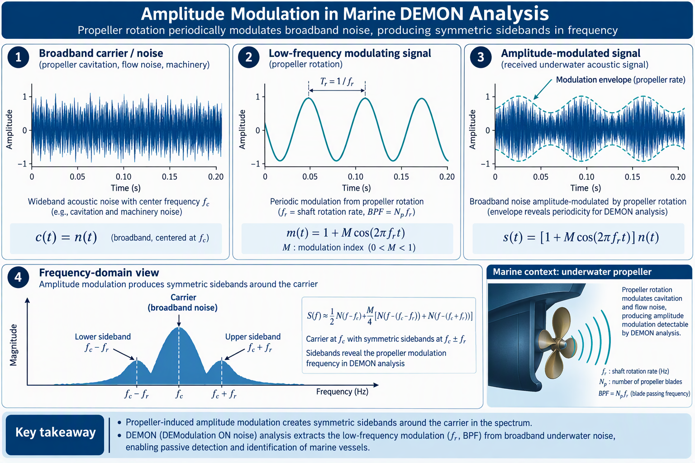
Figure 1. Relationship between broadband acoustic energy, low-frequency modulation, the amplitude-modulated waveform and frequency-domain sidebands.

4. How the original sound becomes a DEMON signal
The received hydrophone signal contains the original acoustic energy plus ambient noise and propagation effects. DEMON does not create a new physical frequency at the target. Instead, demodulation estimates the slow envelope already impressed on the received acoustic energy.

1. Select a carrier band
Band-pass filtering isolates a frequency region in which modulated broadband target noise is prominent and rejects unrelated energy.

2. Recover amplitude
Envelope detection may be implemented using rectification and smoothing or an analytic-signal/Hilbert envelope. The objective is to estimate instantaneous amplitude.

3. Remove the carrier
Low-pass filtering retains the slow envelope variations and suppresses residual high-frequency carrier content.

4. Transform the envelope
An FFT of the envelope converts periodic amplitude variations into spectral lines at their modulation frequencies and harmonics.

5. Display over time
Repeated spectra may be stacked to form a DEMONgram, analogous in concept to a spectrogram, allowing stability, drift and transient behaviour to be assessed.
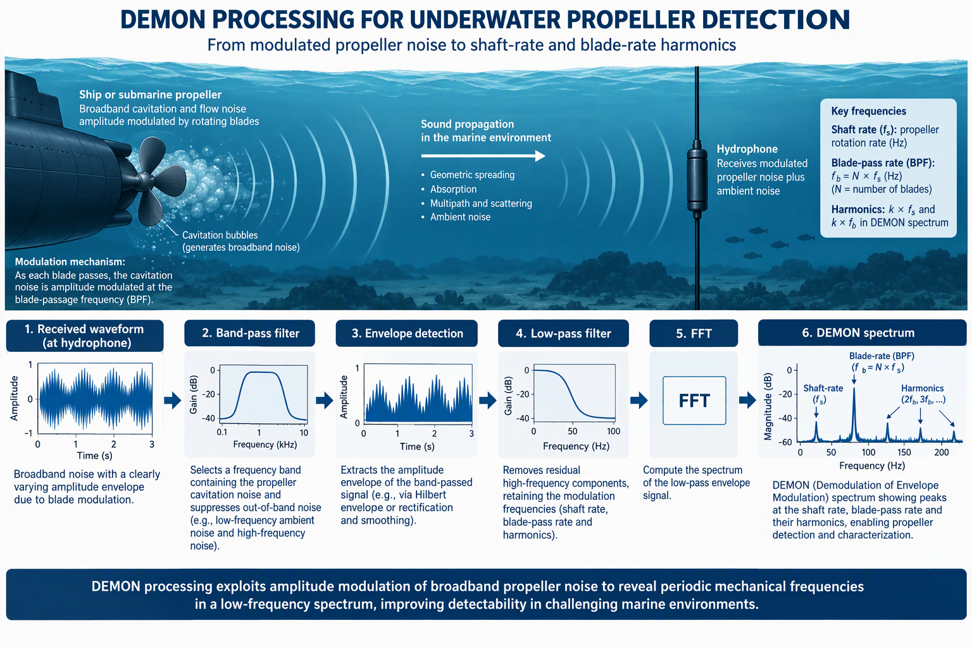
Figure 2. Conceptual DEMON processing chain from an amplitude-modulated underwater signal to a low-frequency envelope spectrum.

5. Relationship between modulation and the original spectrum
For a simple sinusoidal carrier, amplitude modulation makes the relationship especially clear. Let the carrier be
c(t) = A cos(2π f꜀ t)
x(t) = A[1 + μ cos(2π fₘ t)] cos(2π f꜀ t)
Using cos α cos β = ½[cos(α+β) + cos(α−β)], this expands to
x(t) = A cos(2π f꜀ t) + (Aμ/2) cos[2π(f꜀+fₘ)t] + (Aμ/2) cos[2π(f꜀−fₘ)t]
Thus amplitude modulation produces spectral components displaced by ±fₘ from a tonal carrier. With a broadband carrier the picture becomes broadened rather than three ideal lines, but the same principle applies: periodic amplitude variation encodes the modulation frequency in the envelope. DEMON recovers that low-frequency periodicity directly.

6. How to interpret a DEMON display
The horizontal axis is modulation frequency in hertz. The vertical axis of a single DEMON spectrum is envelope magnitude or level. In a scrolling DEMONgram, time is the second display dimension and intensity or colour represents magnitude. Interpretation should focus on families and relationships rather than isolated peaks.

Shaft-rate candidate
A low-frequency line that is stable and consistent with plausible propeller rotation. If shaft speed is RPM, fₛ = RPM/60.

Blade rate / blade-passing frequency
For N blades on a single propeller, fᵦ = N fₛ. A strong line at fᵦ, its harmonics, and a compatible lower-frequency shaft family is strong evidence of propeller-related modulation.

Harmonics
Lines at 2f, 3f, … indicate a non-sinusoidal repeating envelope or repeated events within a cycle.

Sideband spacing
In related LOFAR or spectral data, symmetrical spacing around a tonal or band can indicate modulation. The spacing corresponds to the modulating frequency. DEMON seeks the corresponding envelope periodicity.

Persistence and coherence
True rotating-machinery relationships tend to persist or evolve smoothly with speed. Short-lived or incoherent peaks require caution.

Multiple shafts or sources
More than one shaft, propeller, machinery train or nearby vessel can create overlapping families. Numerical relationships alone are not unique identification.

7. Concrete worked example
Assume a surface ship has a 5-bladed propeller turning at 120 RPM and that propeller cavitation supplies a broadband acoustic carrier. The shaft rate is
fₛ = RPM / 60 = 120 / 60 = 2 Hz
With N = 5 blades, the blade-passing frequency is
fᵦ = N fₛ = 5 × 2 = 10 Hz
Suppose the amplitude of a selected cavitation-noise band is dominated by a 10 Hz blade-related variation. A simplified envelope can be written
m(t) = 1 + 0.4 cos(2π · 10t)
x(t) = m(t)c(t)
If c(t) is the broadband cavitation signal, x(t) is the acoustic signal received before environmental and sensor effects are considered. Envelope detection removes the rapid carrier fluctuations while retaining the 10 Hz rise and fall. An FFT of this envelope therefore shows a component at 10 Hz. If the envelope is not perfectly sinusoidal, components may also appear at 20, 30 Hz and higher harmonics.
A 2 Hz component may also appear when there is once-per-revolution asymmetry, for example a non-uniform wake or unequal blade loading. The analyst can test the relationship 10/2 = 5, giving a blade-count hypothesis of five. This is a hypothesis, not a stand-alone classification: corroboration should include consistency over time, LOFAR observations, target speed/aspect and other acoustic evidence.
Observed DEMON feature | Candidate interpretation | Cross-check
2 Hz | Shaft-rate candidate | Does 2 Hz persist and change smoothly with target dynamics?
10 Hz | 5-blade BPF candidate | 10 Hz / 2 Hz = 5; check harmonic family.
20, 30 Hz | Harmonics of 10 Hz modulation | Look for integer spacing and common evolution.
Irregular isolated peak | Unknown / interference possible | Do not classify from an isolated line.

8. Submarines versus surface ships
The physics of modulation is the same for both. The practical balance of sources can differ markedly with operating condition. A surface ship may present strong propeller and cavitation modulation, particularly when loading promotes cavitation. A submerged submarine operating quietly may suppress cavitation and radiated machinery noise, making DEMON components weaker and increasing the value of long integration, array gain and correlation with other passive-sonar evidence. Conversely, a submarine propeller operating under conditions that produce detectable broadband modulation can still yield shaft/blade relationships in DEMON.
DEMON should therefore be treated as one member of a passive-acoustic evidence set rather than a universal ship-identification display. LOFAR tonals, broadband level, bearing behaviour, spectral sidebands, transient events and DEMON modulation families can reinforce one another.

9. Common interpretation traps
- Assuming the strongest DEMON line must be shaft rate. Blade rate or a harmonic may dominate.
- Inferring blade count from a single ratio without establishing which line is truly shaft rate.
- Confusing a LOFAR tonal frequency with a DEMON modulation frequency. They describe different aspects of the received signal.
- Treating every integer multiple as a separate machine. Harmonics can arise from one non-sinusoidal modulation process.
- Ignoring changes in operating state, aspect, cavitation regime, propagation and nearby traffic.
- Choosing a carrier band without checking its signal-to-noise and modulation content; DEMON performance depends strongly on the band being demodulated.

10. Concise comparison: LOFAR versus DEMON
Aspect | LOFAR | DEMON
What is analysed | Acoustic frequency content of the received signal itself. | Low-frequency amplitude modulation (the envelope) of a selected acoustic-noise band.
Typical display | Frequency versus time/intensity (LOFARgram), or a spectrum. | Modulation frequency versus time/intensity (DEMONgram), or an envelope spectrum.
Strong clues | Discrete machinery tonals, harmonics, broadband structure and spectral sidebands. | Shaft/blade-related modulation rates, blade-passing frequency, harmonics and other periodic envelope components.
Key question | “What acoustic frequencies are present?” | “At what rates is the acoustic energy being amplitude-modulated?”
Relationship | LOFAR can show a tonal with sidebands spaced by a modulation rate. | DEMON can recover that modulation rate directly from the envelope of a suitable carrier band.
Best use together | Establish the carrier tonals and broadband acoustic structure. | Test whether periodic modulation supports shaft, blade-rate or related mechanical hypotheses.
In practice the two displays are complementary rather than interchangeable. A LOFAR line is an acoustic component at that frequency; a DEMON line is an envelope-modulation component at that frequency. This distinction is fundamental when correlating shaft rate, blade rate and LOFAR sideband spacing.

11. Concise comparison: Cepstrum versus DEMON
Aspect | Cepstrum | DEMON
What is analysed | Regular spacing or periodic structure in a spectrum, commonly via the inverse transform of a log spectrum. | Periodic amplitude variation in the envelope of a selected acoustic-noise band.
Horizontal quantity | Quefrency (seconds), representing a repetition period in spectral spacing. | Modulation frequency (Hz).
Strong clues | Repeated harmonic or sideband spacing that may be difficult to recognise line-by-line in the spectrum. | Shaft/blade-related modulation rates, blade-passing frequency and harmonics in the envelope.
Key question | “Is there a regular frequency spacing, and what repetition period produces it?” | “At what rate is the acoustic energy being amplitude-modulated?”
Frequency relationship | If spectral components have spacing Δf, the corresponding cepstral peak is expected near q = 1/Δf. | A periodic envelope at f_m produces a DEMON component at f_m.
Best use together | Estimate or confirm repeated spacing/harmonic structure in LOFAR or another spectrum. | Test whether the same periodicity is physically present as amplitude modulation of broadband acoustic energy.
Cepstrum and DEMON therefore provide different but complementary evidence. Cepstrum emphasises periodic spacing in the frequency domain, whereas DEMON emphasises periodicity in the amplitude envelope. For example, LOFAR sidebands spaced by 1.3 Hz imply a cepstral feature near 1/1.3 ≈ 0.769 s, while a DEMON component at 1.3 Hz would indicate that the selected acoustic band is actually amplitude-modulated at that rate.

12. Summary
DEMON converts periodic changes in the amplitude of underwater acoustic noise into a low-frequency envelope spectrum. Marine propellers are a particularly important source because shaft rotation, blade passage, wake interaction and cavitation can repeatedly modulate broadband noise. A useful conceptual chain is therefore: rotating mechanism → periodic change in radiated noise amplitude → modulated received waveform → envelope extraction → FFT of envelope → shaft/blade/harmonic candidates. The strongest analysis comes from recognising families of physically consistent frequencies and validating them against independent acoustic and kinematic evidence.

Selected references and further reading
- Guo, W., Wu, Y., Zhang, B. & Zhu, J. (2025). Research on DEMON spectrum analysis of long horizontal array. Applied Acoustics.
- Adaptive Weighted Envelope Spectrum: A robust spectral quantity for passive acoustic detection of underwater propeller based on spectral coherence. Mechanical Systems and Signal Processing, 212 (2024), 111265.
- Kalman-Enhanced DEMON Processing for Multi-Hydrophone Passive SONAR Detection in Offshore Environments. IEEE conference publication.

