LOFAR Analysis in Marine Passive Acoustics
Signal processing, display interpretation and worked examples for surface-ship and submarine detection
Technical review draft

1. What LOFAR analysis is
LOFAR (Low Frequency Analysis and Recording) is a passive-sonar spectral-analysis technique used to reveal how the low-frequency content of received underwater sound changes with time. In its familiar form, sequential short-time spectra are arranged as a time–frequency display called a LOFARgram. Narrowband tonal lines that may be difficult to distinguish in the raw waveform can then become visually persistent tracks.
For marine acoustic analysis, the important point is that LOFAR operates on the received acoustic signal itself. The frequencies displayed are acoustic frequencies. They may arise from rotating or reciprocating machinery, electrical systems, pumps, gears, propeller/shaft phenomena and other periodic sources. Broadband energy from flow, cavitation, sea noise and shipping forms the background against which discrete lines must be detected.
Concept | Meaning
Tonal | A relatively narrow spectral component at an acoustic frequency.
Fundamental | A candidate repetition frequency from which harmonically related lines may occur.
Harmonic | An integer multiple n f₀ of a fundamental.
Sidebands | Spectral components displaced from a carrier by a modulation frequency.
LOFARgram | A sequence of spectra displayed against time; intensity/colour represents level.

2. Why LOFAR is useful in the marine environment
Passive sensors do not need the target to return an active transmitted pulse: they analyse sound already present at the receiver. Research literature uses processed multi-beam LOFAR data for passive underwater-target tracking, and current work continues to treat ship-radiated line-spectrum features and their continuity as important passive-sonar information. The practical value for an analyst is that persistent line structure can be followed over time rather than assessed from a single spectrum.

Surface ships
A surface ship can contribute machinery tonals, propeller/shaft-related components and broadband hydrodynamic or cavitation noise. A LOFARgram helps separate stable or smoothly varying narrowband tracks from the broadband background and makes harmonic or sideband relationships easier to measure.

Submarines
For a submerged submarine, the same signal-processing principles apply. Quiet operating states can make discrete components weak relative to ambient and self-noise, so long-duration continuity and coherent relationships between lines are especially valuable. A detected line alone should not be treated as unique identification; bearing behaviour, multiple frequencies, DEMON/cepstral evidence and operational context should be combined.

3. Signal processing step by step

1. Acoustic reception
A hydrophone or array converts pressure fluctuations into an electrical signal. The receiver contains the target sound together with ocean ambient noise, other vessels and sensor/platform contributions.

2. Analogue conditioning
The signal is amplified as required and band-limited. An anti-alias filter limits content above the usable digital bandwidth before sampling.

3. Sampling
The conditioned analogue signal is digitised at sampling frequency Fₛ. For a retained highest frequency Fmax, the sampling rate must exceed twice that frequency in the ideal Nyquist sense, with practical anti-alias filtering providing transition margin.

4. Divide into analysis frames
The continuous sample stream is split into finite-duration frames, normally overlapping when a smooth time history is required.

5. Apply a window
A taper such as Hann is applied to reduce spectral leakage caused by analysing a finite record. The window changes the detailed spectral response, so frequency resolution, leakage and amplitude calibration should not be confused.

6. FFT each frame
For each frame, the discrete Fourier transform, normally computed using an FFT algorithm, produces complex frequency bins.

7. Form magnitude or power
The bins are converted to magnitude, power, power spectral density or a calibrated level as appropriate. Logarithmic dB presentation greatly expands useful display dynamic range.

8. Stack spectra in time
Successive spectra become columns or rows of a time–frequency image. Frequency is one axis, time the other, and colour/intensity represents spectral level. This image is the LOFARgram.
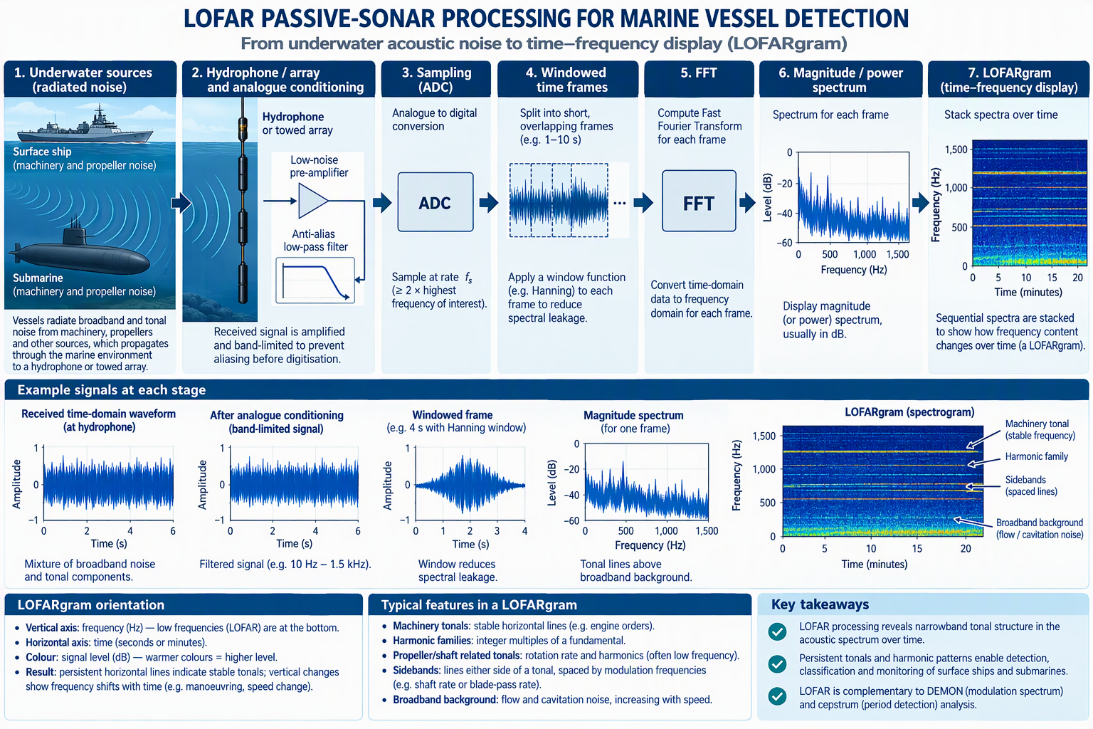
Figure 1. Conceptual marine LOFAR processing chain from radiated sound to the time–frequency LOFARgram.

4. Core processing formulae
For a frame containing N samples acquired at sampling frequency Fₛ, the DFT frequencies are
fₖ = kFₛ/N, k = 0, 1, …, N − 1
The frequency-bin spacing is
Δf = Fₛ/N
Because a frame of N samples lasts T = N/Fₛ seconds, this can also be written
Δf = 1/T
This is the fundamental time/frequency trade-off: a longer analysis frame gives finer bin spacing, but it averages the signal over a longer interval and therefore reduces responsiveness to rapid changes.
A common windowed DFT expression is
X[k] = Σₙ₌₀ᴺ⁻¹ x[n] w[n] e^(−j2πkn/N)
where x[n] is the sampled signal and w[n] is the analysis window. A displayed spectrum is derived from |X[k]| or |X[k]|², with the exact scaling depending on whether magnitude, power, PSD or calibrated sound level is required.

5. How to interpret a LOFAR display
First establish the orientation. In this guide, frequency increases vertically and time runs horizontally. Some sonar systems rotate these axes, so always read the labels rather than relying on appearance. Colour or brightness represents spectral level.

Persistent narrow line
Evidence of a stable acoustic tonal. Its physical source is a hypothesis to be tested, not established by frequency alone.

Harmonic family
Lines near f₀, 2f₀, 3f₀, … support a common periodic source. Missing members do not automatically invalidate the family.

Symmetric sidebands
Lines at f꜀ ± fₘ, and sometimes further orders, suggest modulation of a carrier f꜀ at rate fₘ. Measure spacing, not merely absolute sideband frequencies.

Slow frequency drift
May reflect a changing source frequency and/or relative motion. Correlate changes across several lines before attributing the cause.

Broadband elevation
A wide frequency region becomes stronger. Candidate causes include hydrodynamic/cavitation noise, sea-state changes, biological sound, shipping or receiver/platform effects.

Transient feature
Short-duration energy can cross many frequencies. Treat it separately from long-lived machinery tracks.
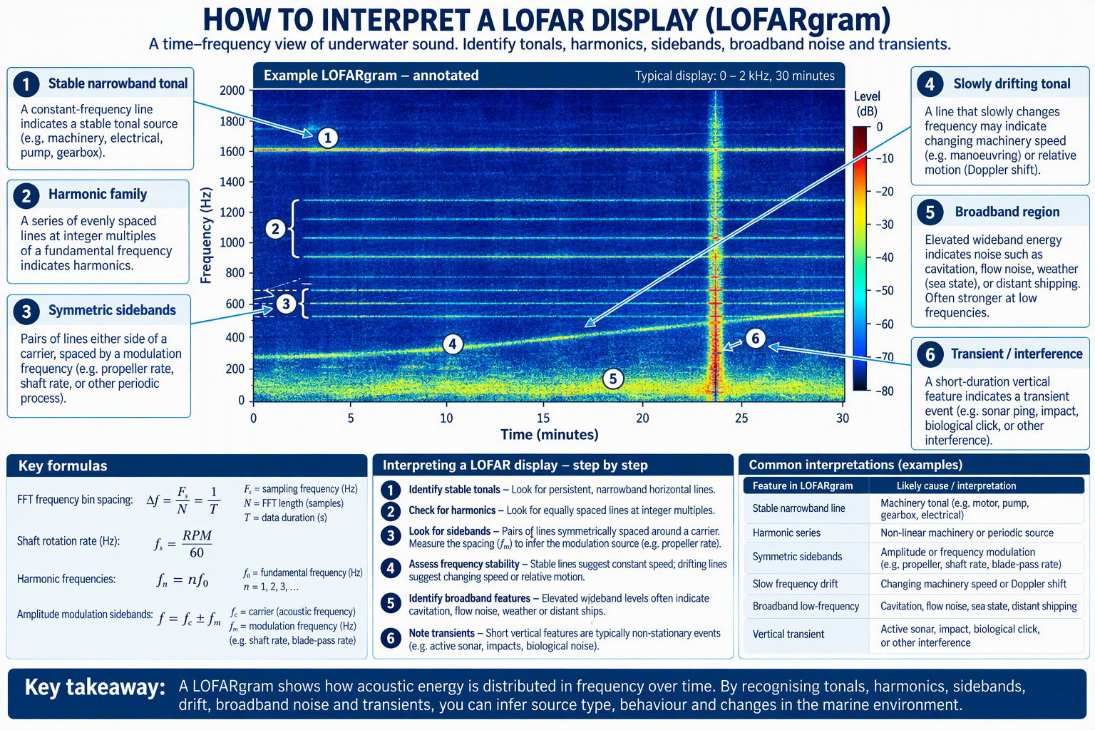
Figure 2. Annotated example showing common features encountered when reading a LOFARgram.

6. Important frequency relationships
If a tonal family has fundamental f₀, its ideal harmonic positions are
fₙ = n f₀ for n = 1, 2, 3, …
If a rotating shaft turns at RPM revolutions per minute, its rotational frequency is
fₛ = RPM/60
A simple N-bladed propeller relationship is
fᵦ = N fₛ
where fᵦ is blade-passing rate. These mechanical rates may appear directly in acoustic data in some circumstances, or may modulate another acoustic component; the analyst must establish which interpretation fits the observations.
For amplitude modulation of a tonal carrier f꜀ by a periodic rate fₘ, first-order sidebands occur at
fsideband = f꜀ ± fₘ
Therefore, symmetric LOFAR sidebands spaced ±1.3 Hz around a tonal carry a candidate modulation rate of 1.3 Hz. DEMON can be used independently to ask whether an acoustic-noise band contains envelope modulation at approximately the same rate.

7. Concrete worked example
Assume a 60-second analysis frame is sampled at Fₛ = 2,000 Hz. The number of samples is
N = FₛT = 2,000 × 60 = 120,000 samples
The FFT bin spacing is therefore
Δf = Fₛ/N = 2,000/120,000 = 0.01667 Hz
Equivalently, Δf = 1/T = 1/60 = 0.01667 Hz. Now suppose a persistent LOFAR tonal is measured at 30.00 Hz, with weaker lines close to 60.00 and 90.00 Hz. The integer relationships are
60/30 = 2, 90/30 = 3
This supports a harmonic-family hypothesis with a 30 Hz fundamental. It does not by itself identify the machine. Suppose the 30 Hz line also has symmetric sidebands at 28.70 Hz and 31.30 Hz. Their spacing from the carrier is
30.00 − 28.70 = 1.30 Hz, 31.30 − 30.00 = 1.30 Hz
The LOFAR evidence therefore supports a candidate modulation frequency fₘ = 1.30 Hz. The corresponding period is
Tₘ = 1/fₘ = 1/1.30 ≈ 0.769 s
If a physically plausible once-per-revolution mechanism is suspected, 1.30 Hz would correspond to 78 RPM because 1.30 × 60 = 78 RPM. That is a hypothesis to be cross-checked. A matching DEMON line near 1.30 Hz would strengthen the interpretation that the selected noise band is amplitude-modulated at this rate, while a cepstral feature near 0.769 s can independently highlight the regular 1.30 Hz spectral spacing.
Observation | Numerical relationship | Interpretation to test
30, 60, 90 Hz | 2× and 3× 30 Hz | Common harmonic family.
28.70 and 31.30 Hz around 30 Hz | ±1.30 Hz | Symmetric sideband/modulation hypothesis.
1.30 Hz candidate rate | 1.30 × 60 = 78 RPM | Possible once-per-revolution mechanical rate if physically consistent.
Cepstral quefrency | 1/1.30 ≈ 0.769 s | Independent evidence of repeated 1.30 Hz spectral spacing.

8. LOFAR, DEMON and cepstrum: concise comparison
Method | What it emphasises | Useful question
LOFAR | Acoustic frequency content versus time. | What frequencies are present, and how do they evolve?
DEMON | Periodic amplitude envelope of a selected acoustic band. | At what rate is acoustic energy being modulated?
Cepstrum | Regular spacing/periodicity within a spectrum. | Is there repeated spectral spacing, and what is its corresponding period?
The three methods are strongest when they agree on a coherent physical story. For example: LOFAR shows ±1.30 Hz sidebands; cepstrum highlights about 0.769 s quefrency; DEMON shows a 1.30 Hz envelope component. Together these are mutually supportive observations of a common 1.30 Hz periodicity, although assigning that periodicity to a particular shaft or machine still requires contextual validation.

9. Common interpretation traps
- Treating every strong narrowband line as a uniquely identifiable machine.
- Reading harmonic spacing without checking whether the supposed fundamental is actually present or physically plausible.
- Confusing FFT bin spacing Δf with the practical ability to resolve two nearby components; window response, SNR and observation time matter.
- Treating a LOFAR sideband as though it were automatically a DEMON line. A LOFAR sideband is an acoustic spectral component; a DEMON line is an envelope-modulation component.
- Ignoring non-target interference, platform/self-noise, biologics, sea-state changes or other shipping.
- Inferring target identity from one snapshot instead of studying persistence and common evolution across time and multiple features.

10. Summary
LOFAR analysis turns a passive underwater time series into a sequence of frequency spectra and then into a time–frequency history. For marine targets, the analyst looks for persistent tonals, harmonic families, sidebands, drift and broadband changes that remain coherent over time. The mathematical foundation is straightforward: sample the received sound, divide it into frames, window each frame, compute an FFT, form a level spectrum and stack successive spectra. The difficult and valuable part is interpretation: relating observed acoustic frequencies and their relationships to physically plausible ship or submarine sources while cross-checking with DEMON, cepstrum, bearing and operating context.

Selected references and further reading
- Wang, M., Qiu, B., Zhu, Z., Ma, L. & Zhou, C. (2022). Passive tracking of underwater acoustic targets based on multi-beam LOFAR and deep learning. PLOS ONE 17(12): e0273898.
- Liu, Z., Li, C., Zhou, B., Ma, Q. & Xie, L. (2026). Automatic LOFAR Line-Spectrum Extraction with Hybrid Dataset Construction and a Continuity-Aware U-Net. Journal of Marine Science and Engineering, 14(16), 1511.

