Mperps DeFi
Technical Walkthrough — Onboarding, Deposit, Withdraw
Scope: How the Frontend, Exchange Backend and Mperps Backend (canton-backend-lambda) collaborate for user onboarding (Keycloak and Loop wallet), deposits, and withdrawals on Canton testnet. This is a system-level overview — not API reference.

1. Components
Three independent services collaborate; each is owned by a different team.
Component | Role | Hosted at
Frontend | User-facing SPA. Renders trading terminal, deposit/withdraw modals, dropdown. Issues all user-initiated API calls. | https://testnet.mperps.xyz
Exchange Backend (be.mperps.xyz) | Owner of the user account ledger, KYC, futures + funding wallets, withdraw approval state machine. Surface for everything except on-chain Canton calls. Also: login endpoints for Keycloak users and Loop wallet users. | https://be.mperps.xyz
Mperps Backend (canton-backend-lambda) | Bridge between the exchange and Canton. KYC, deposit, withdraw APIs. Submits on-chain transactions (USDCx transfers, vault deposits/withdraws). Watcher is a separate long-running process that observes incoming USDCx on the vault pool. | AWS Lambda + a long-running watcher process under pm2 on the validator host

The Frontend never talks to the Canton ledger directly. Every on-chain action goes through Mperps Backend (which has the operator JWT + party keys) or through the user's Loop wallet popup.

2. User Types and Identity
Two user types coexist on the same exchange account, distinguished by where their Canton party is hosted.
User Type | Auth | Canton party hosted on | How we identify them
Internal (Keycloak) | Username + password against our validator's Keycloak realm | Our testnet validator | partyId hint = Keycloak user UUID; suffix matches our validator's participant fingerprint
External (Loop wallet) | Ed25519 signature from the Loop wallet popup | Loop's validator | partyId hint = whatever Loop assigned; suffix differs from ours

Canton partyId format: <hint>::<participant-fingerprint>. The fingerprint is a stable 64-char identifier of the validator hosting that party — comparing it to our own fingerprint is how the Frontend decides which code path to take (internal vs external).
The exchange backend stores the partyId in the email field (with :: substituted as .). All client code reads it back from /v1/user/info and derives the user type from the suffix.

3. User Onboarding
Mperps Backend owns the Keycloak signup (since creating a Canton party is part of it). Exchange Backend owns subsequent logins for both user types — Keycloak username/password and Loop wallet signature verification.
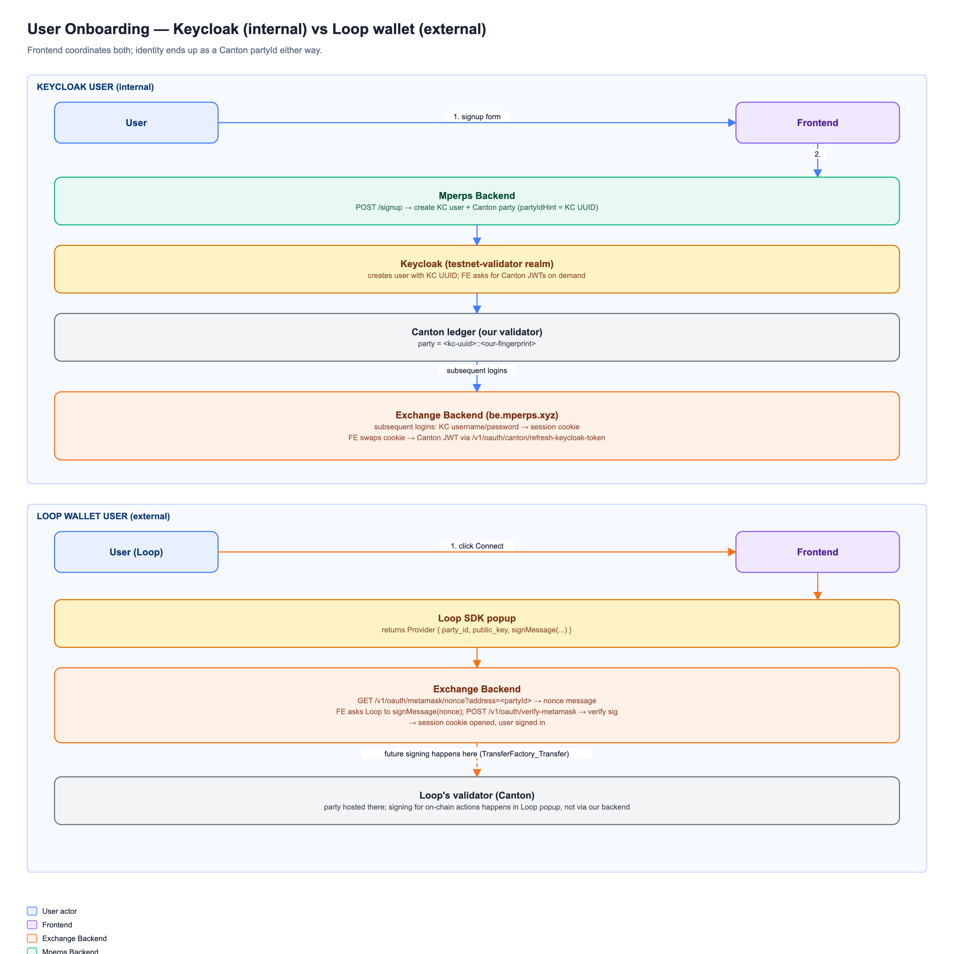
Diagram 1 — User onboarding (Keycloak left lane, Loop wallet right lane)

3.1 Keycloak (internal) signup + login
- User clicks Sign Up on the Frontend, enters invite code + username + email + password.
- Frontend → Mperps Backend POST /signup.
- Mperps Backend:
  - Validates the invite code (Postgres).
  - Creates the Keycloak user via the master-realm admin-cli (KC_ADMIN_USERNAME + KC_ADMIN_PASSWORD).
  - Allocates a Canton party with partyIdHint = the new user's KC UUID. partyId is therefore <kc-uuid>::<our-fingerprint>.
  - Creates a Canton user (linking KC UUID → partyId) and grants CanActAs + CanReadAs on the party.
  - Upserts a row into the local users table.
  - Marks the invite code redeemed.
- On subsequent logins, the user authenticates against Keycloak via the exchange backend's standard login. The exchange backend issues a session cookie used for all /v1/* APIs.
- When the user needs to submit a Canton command (deposit, withdraw, peer-to-peer USDCx send), the Frontend calls POST /v1/oauth/canton/refresh-keycloak-token on the exchange backend — this returns a fresh Canton-ledger JWT (signed for the user). That JWT is forwarded to Mperps Backend as the Bearer header.

3.2 Loop wallet (external) connect
Loop wallet handles signature provenance; the exchange backend just verifies the signature and opens a session.
- User clicks Log in → Loop in the Frontend. The Loop SDK opens its hosted popup.
- Loop returns a Provider object: { party_id, public_key, signMessage(...) }. The party_id is hosted on Loop's validator (different fingerprint from ours).
- Frontend calls GET /v1/oauth/metamask/nonce?address=<partyId> on the exchange backend, receives a nonce message.
- Frontend asks Loop to sign the nonce message via provider.signMessage(message).
- Frontend posts { address, message, signature, publicKey } to POST /v1/oauth/verify-metamask. Exchange backend verifies the Ed25519 signature against the supplied public key, opens a session cookie, and the user is signed in.
Loop users do NOT have a Keycloak JWT. For any operation requiring on-chain signing they sign a canonical envelope in the Loop wallet at submission time (see Withdraw § 5.2). For ACS reads on their behalf, Mperps Backend cannot help — Loop users go through Loop's own wallet UI.

4. Deposit Flow
USDCx is the only deposit asset on testnet. The user must already hold USDCx on their Canton party. Bridging from Ethereum Sepolia → Canton happens in the xreserve dApp (out of our scope). Once the user has USDCx, depositing into the trading account is a CIP-56 TransferFactory_Transfer to the vault pool party.
KYC gate: Mperps Backend's /me reports the user's KYC status. The frontend blocks the Deposit button until KYC is approved, and the watcher (step 4 below) ALSO checks KYC server-side — if it's missing, the deposit is observed and recorded on chain but never credited to the trading wallet.
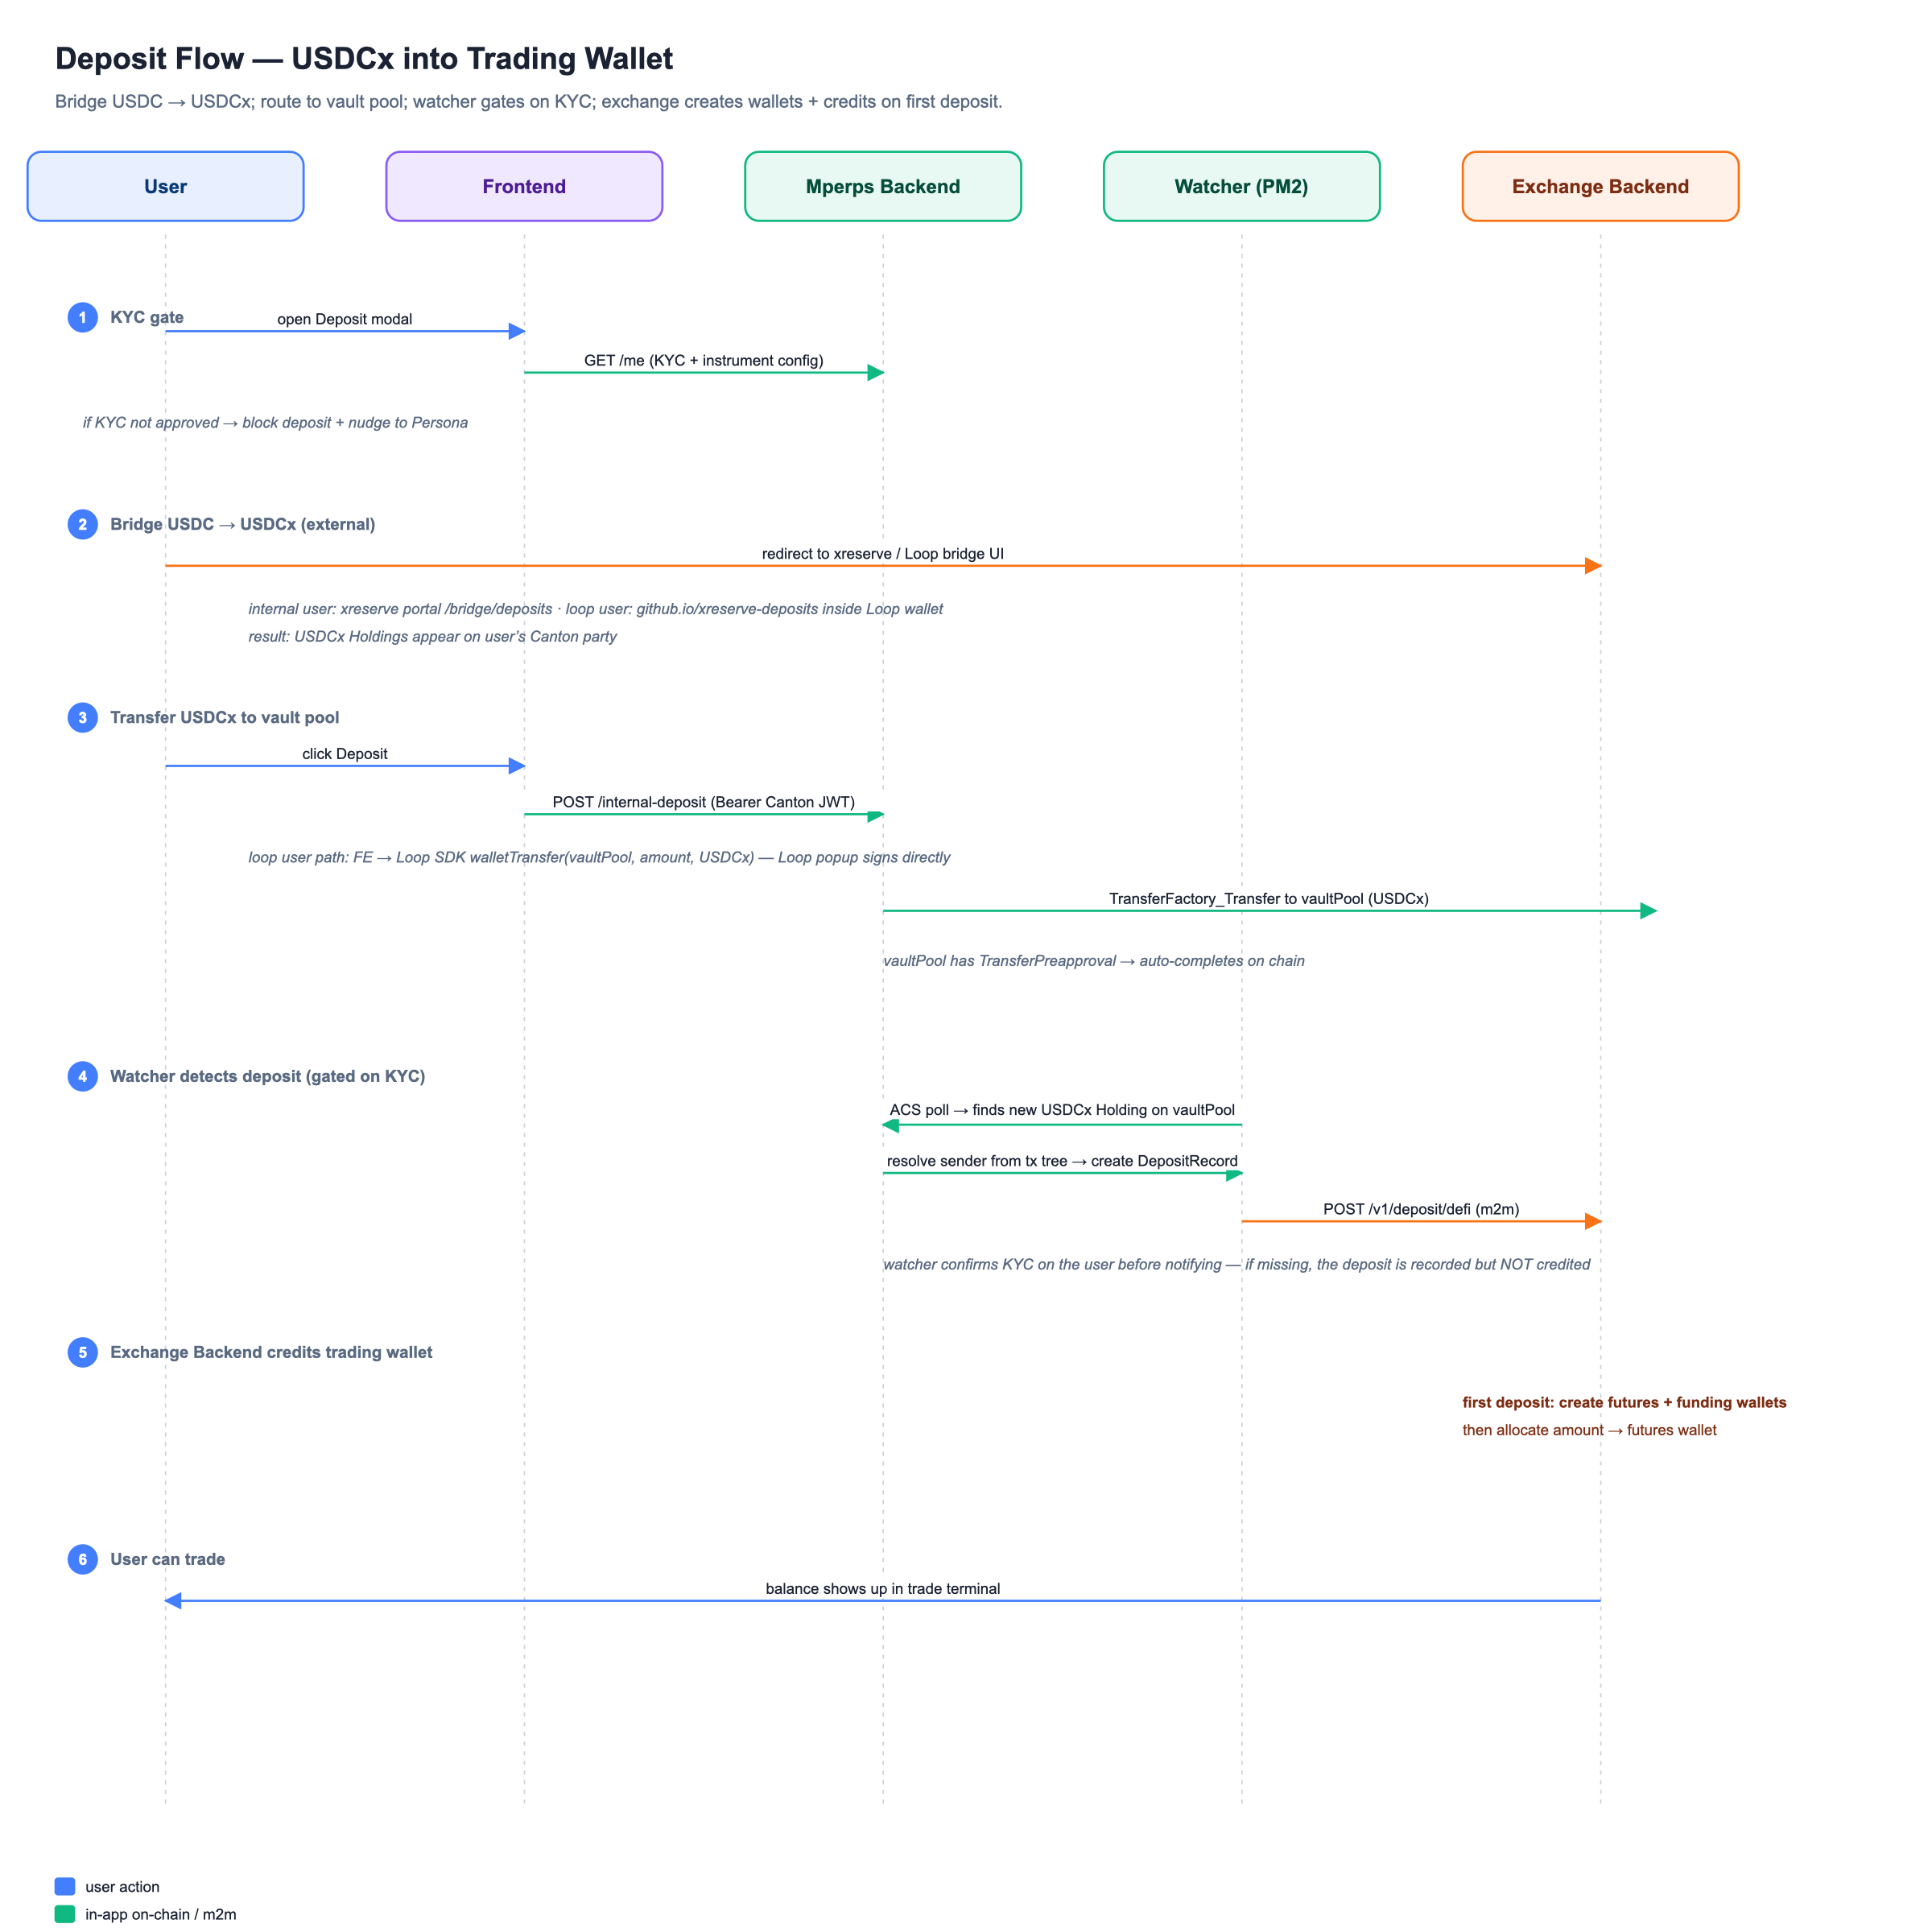
Diagram 2 — Deposit flow (USDCx → vault pool → trading wallet)

4.1 Acquiring USDCx (one-time per user)
This step happens outside our app — we just deep-link to the right UI.
User type | Where they go | What happens
Internal | xreserve portal → /bridge/deposits | Request a BridgeUserAgreement (one-time), bridge USDC from Sepolia, then mint the resulting DepositAttestation into USDCx Holdings on the user's party.
Loop | digital-asset.github.io/xreserve-deposits | Loop wallet handles agreement + accept + mint internally.

4.2 USDCx → trading wallet (the actual deposit)
Once USDCx Holdings exist on the user's party, the user opens the Deposit modal in the Frontend, enters an amount, and clicks Deposit.

Internal user path
- Frontend calls POST /v1/oauth/canton/refresh-keycloak-token to get a fresh Canton JWT for the user.
- Frontend POST /internal-deposit on Mperps Backend with { sender, amount } and Authorization: Bearer <canton-jwt>.
- Mperps Backend reads the user's USDCx Holdings via the Canton ledger ACS (as the user, using the supplied JWT).
- Mperps Backend POSTs to the DA per-admin Token Standard registry to obtain a TransferFactory + choice context for the configured instrument:
POST {UTILITY_BACKEND_URL}/api/token-standard/v0/registrars/{USDCX_ADMIN}/registry/transfer-instruction/v1/transfer-factory
Body: { choiceArguments, excludeDebugFields: true }
- Mperps Backend submits TransferFactory_Transfer via the JSON Ledger API with actAs = [user], inputHoldingCids = the user's holdings, receiver = vault pool. The transfer auto-completes if the receiver has TransferPreapproval (vault pool does).

Loop user path
- Frontend asks the Loop SDK to walletTransfer(recipient=vaultPool, amount, instrument). The Loop popup signs and submits the CIP-56 transfer directly to the Canton ledger.
- Mperps Backend is not in the request path — Loop handles signing and submission.

Watcher (always runs, regardless of user type)
The Mperps Backend deposit watcher is a long-running pm2 process on the validator host that polls the Canton ledger for incoming USDCx Holdings owned by the vault pool. When it observes one:
- Resolves the originating sender via the transaction tree (TransferFactory_Transfer exercise).
- Creates a DepositRecord contract on Canton (signed by operator only), recording {user, amount, sourceTransferId}.
- Checks the sender's KYC status. If not approved, the deposit is recorded in our DB as held but NOT notified to the exchange — no wallet credit happens until KYC clears.
- If KYC is approved: posts the deposit to the Exchange Backend at POST /v1/deposit/defi (m2m). Exchange creates the futures + funding wallets on first deposit, then allocates the amount to the futures wallet.
- Marks the deposit row in our Postgres as credited.
DepositRecord is the on-chain proof of the deposit. The Frontend's Vault deposits section reads it back via Mperps Backend's /api/balance (operator-side ACS read) so the user can see their stake even if our Postgres is reset.

5. Withdraw Flow
Withdraw is the most coordinated flow — all three components participate, in a specific order, with a state machine on the exchange side.
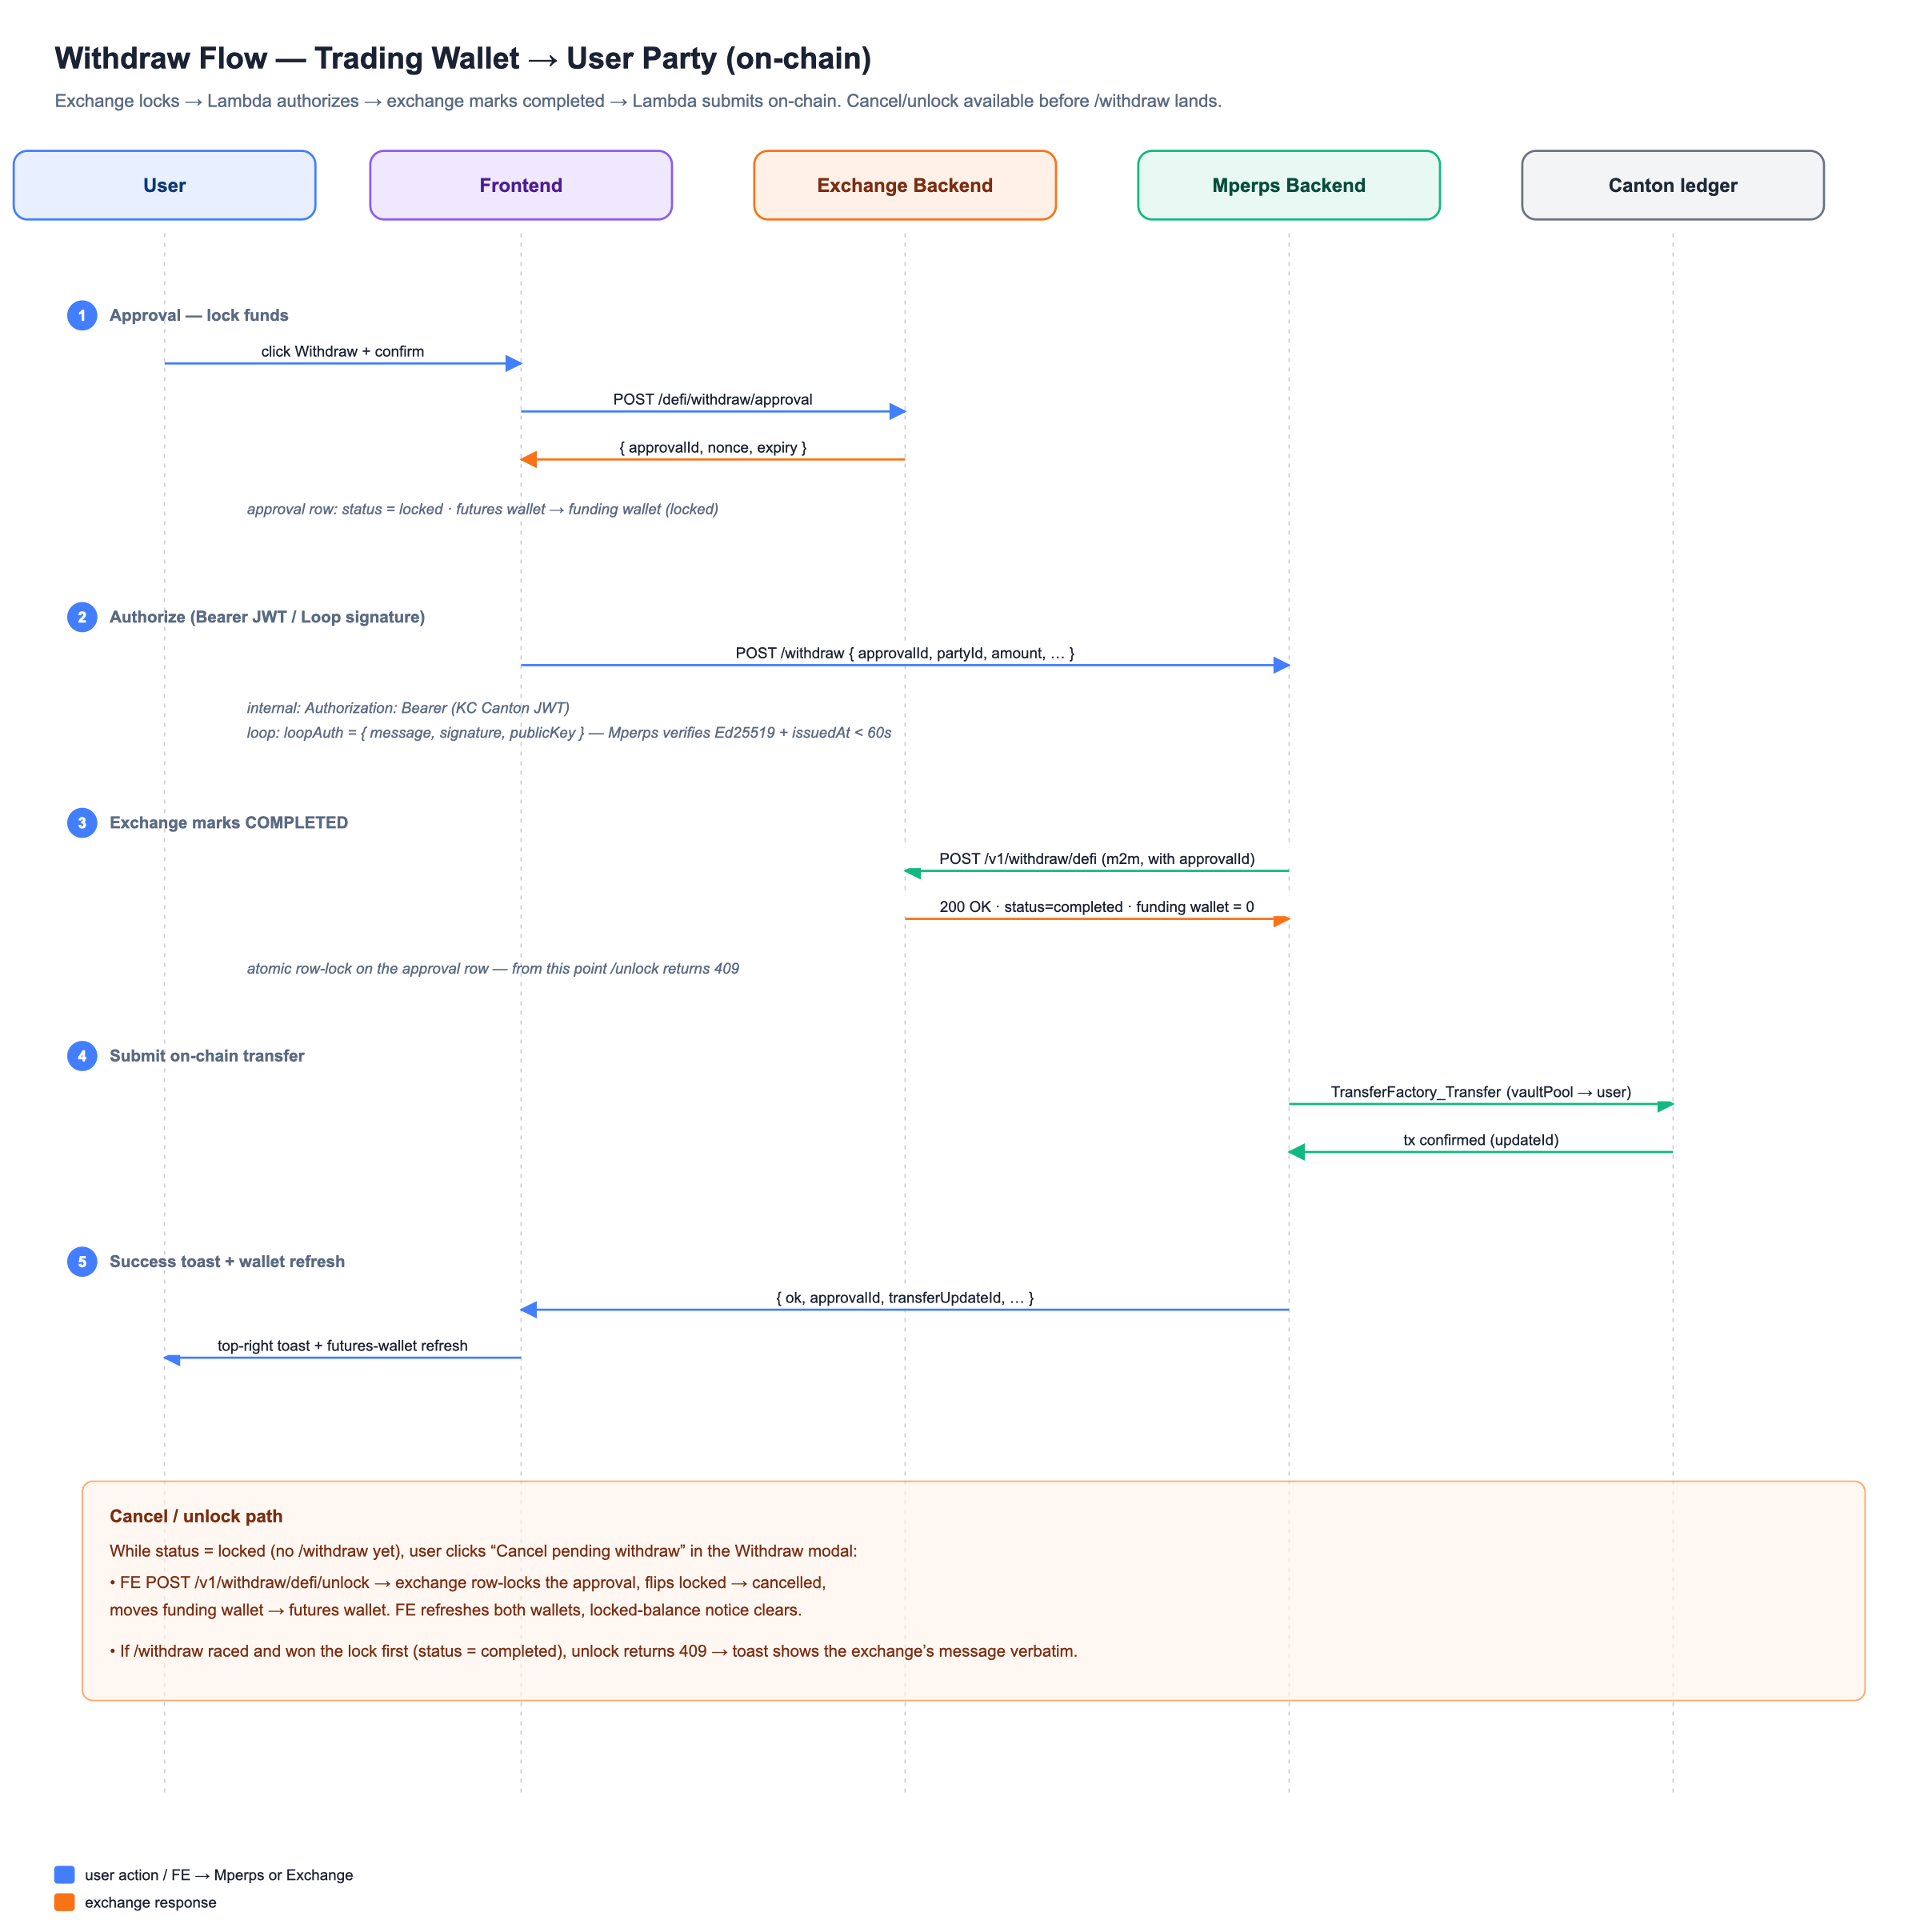
Diagram 3 — Withdraw flow (with cancel/unlock path)

5.1 Order of operations
- Frontend POST /v1/withdraw/defi/approval on the Exchange Backend.
  - Exchange creates an approval row (status = locked), moves the requested amount from the user's futures wallet to the funding wallet. Returns { approvalId, nonce, expiry }.
  - Only one approval can be locked per user at a time — the API rejects if a previous one is still open.
- Frontend authorizes the withdraw and calls Mperps Backend POST /withdraw with { approvalId, partyId, amount, nonce, expiry }.
  - Internal user: Authorization: Bearer <fresh Canton JWT> from /v1/oauth/canton/refresh-keycloak-token.
  - Loop user: loopAuth = { message, signature, publicKey } where message is a canonical envelope { type: 'mperp-withdraw-v1', approvalId, partyId, amount, nonce, issuedAt } signed in the Loop popup. Mperps Backend Ed25519-verifies against the supplied public key and checks issuedAt freshness (60s).
- Mperps Backend POST /v1/withdraw/defi (m2m) on the Exchange Backend with the approvalId.
  - Exchange validates approval status = locked (rejects 409 if cancelled or completed) and not expired. Atomically flips status → completed, deducts funding wallet → 0. The approval is now terminal.
- Mperps Backend submits TransferFactory_Transfer on Canton: vault pool → user. Same DA registry path as deposit. On success, Mperps Backend records the on-chain update id in our Postgres.
- Frontend's withdraw tracker polls the futures wallet balance, sees the debit, and turns the in-progress toast into the success toast (showing the on-chain tx id chip).

5.2 Ordering matters
Exchange /withdraw runs BEFORE the on-chain submission. This closes the race with /unlock — once status = completed, /unlock returns 409 and the user can't double-claim. If we reversed the order (on-chain first), a user could /unlock during the on-chain window and end up with funds both on-chain AND back in their futures wallet.

5.3 Cancel (unlock) a pending approval
If the user closes the tab between /approval and /withdraw — or the signing step is skipped — the approval sits in funding wallet as a stuck locked balance. The user can recover via the Cancel pending withdraw button in the Withdraw modal.
- Frontend POST /v1/withdraw/defi/unlock on the Exchange Backend.
- Exchange atomically validates approval status = locked, flips to cancelled, moves funding → futures.
- Frontend refreshes both wallets; the Cancel CTA disappears.
If Mperps Backend has already raced past /withdraw (status = completed), exchange returns 409 and the Frontend surfaces the message verbatim. There's no double-spend — the row lock on the approval guarantees exactly one of {/withdraw, /unlock} wins.

5.4 Failure modes and recovery
Failure | What happens | How the user recovers
/approval fails (network / 4xx) | No state change anywhere | Retry
Mperps Backend's call to exchange /withdraw fails | Approval is still in locked state. Funding wallet has the locked amount. No on-chain transfer. | Click Cancel pending withdraw → /unlock returns funds to futures.
Exchange /withdraw OK but on-chain submission fails | Approval is completed at exchange (funding = 0). User has nothing on-chain. | Manual recovery — contact support; Mperps Backend's failed_withdraw_attempts table tracks these. Retry script can re-submit on-chain.
Approval expired before /withdraw is called | Exchange /withdraw returns expired error. Approval is left in a terminal expired state. | Cancel + retry.
User session expired (refresh-keycloak-token 401) | Global SessionExpiredModal pops; in-flight call aborts cleanly | Sign in again → retry

6. State Reference

6.1 Withdraw approval (Exchange Backend)
locked ──/v1/withdraw/defi──► completed (Mperps Backend wins the row lock)
│
├──/v1/withdraw/defi/unlock──► cancelled (user wins the row lock)
│
└──(expiry)──► expired (no caller; sweeper or next call)
Both /withdraw and /unlock take a SELECT … FOR UPDATE on the approval row. Exactly one wins the lock; the other gets 409. There is no third outcome.

6.2 Deposit (Mperps Backend Postgres)
pending_exchange ──watcher posts to /v1/deposit/defi──► credited
│
└──watcher cannot resolve sender / KYC missing──► held (recorded in held_deposits)

7. Glossary
Term | Meaning
partyId | Canonical Canton identity for a user, of the form <hint>::<participant-fingerprint>.
Vault pool | Operator-controlled Canton party that holds all user-deposited USDCx. Withdraws move out of it.
DepositRecord | Operator-signed Canton contract recording {user, amount, sourceTransferId}. On-chain audit trail of the deposit credit.
TransferFactory_Transfer | CIP-56 choice on a TransferFactory contract. The single primitive we use to move USDCx (auto-completes if receiver has a TransferPreapproval, else falls back to a 2-step TransferInstruction).
TransferPreapproval | Per-receiver contract granting auto-acceptance of incoming USDCx — eliminates the manual Accept step for the receiver.
BridgeUserAgreement (BUA) | Per-user Canton contract required to mint bridged USDCx from a Sepolia DepositAttestation. Created at the xreserve portal.
Approval (exchange-side) | Row in the exchange backend's approvals table tracking a locked-funding withdraw. State machine: locked → completed | cancelled | expired.
Funding wallet vs Futures wallet | Two ledger buckets on the exchange backend. Approving a withdraw moves the amount Futures → Funding (locked). /withdraw zeroes Funding. /unlock moves Funding → Futures.

Appendix A — Endpoint Quick Reference
Endpoint | Owner | Caller | Purpose
POST /signup | Mperps Backend | Frontend (anonymous) | Onboarding for internal users — creates Keycloak user + Canton party.
POST /v1/oauth/verify-metamask | Exchange Backend | Frontend (Loop user) | Verify Loop signature → open session cookie.
POST /v1/oauth/canton/refresh-keycloak-token | Exchange Backend | Frontend (internal user) | Mint a Canton-ledger JWT for the signed-in Keycloak user.
POST /internal-deposit | Mperps Backend | Frontend (internal user) | Submit USDCx → vault pool transfer using the user's Canton JWT.
POST /v1/withdraw/defi/approval | Exchange Backend | Frontend | Lock the requested amount: Futures → Funding. Returns approvalId.
POST /withdraw | Mperps Backend | Frontend | Authorize the withdraw (Bearer or loopAuth), then orchestrate exchange /withdraw + on-chain transfer.
POST /v1/withdraw/defi | Exchange Backend | Mperps Backend (m2m) | Mark approval completed, deduct funding wallet → 0.
POST /v1/withdraw/defi/unlock | Exchange Backend | Frontend | Cancel a stuck approval — Funding → Futures, status → cancelled.
POST /v1/deposit/defi | Exchange Backend | Mperps Backend watcher (m2m) | Credit the user's trading wallet after the watcher observes the on-chain deposit. Gated on KYC.

