**For backend architecture and reference this is the full master technical doc I created to explain and provide context for what these major front end sections need to do or connect with and what the dual storage ruleset of Vault will be for encrypted files and for vectorized versions.** [**https://docs.google.com/document/d/16EQFObEx2VUfBCZBp7WG8jHgvlzt7cHP8Eh0t8fCeZ4/edit?tab=t.0**](https://docs.google.com/document/d/16EQFObEx2VUfBCZBp7WG8jHgvlzt7cHP8Eh0t8fCeZ4/edit?tab=t.0)

**Here are the notes on the module by module Front end changes for 1245.**

**Dashboard** (all items are from top to bottom in the current layout)

1. Change the far right box text on the top row from the word “New” to “Matters In Process”
2. Change “Executive” to “Advisor” on the box on the left below the top left box
3. Change “Closing Soon” to “Pipeline” and make it by phase of customer journey summary (Leads, Consults, Engagements, Service, Fulfilled)
4. On the bottom left box change “Alerts” to “KPIs”
5. On the bottom right box change that from Global Timeline to “Current Site Preview” and suck in a small graphical image of the current site home page from sitebuilder and make it click through to the editor if they wish.

**Sidebar** (changes to names and order from top to bottom (if we can implement icons in a future rev tht would be great once we nail the layout

1. Logo
2. Dashboard
3. Calendar
4. Sitebuilder
5. Formbuilder (need to add this functionality to create custom forms with drag and drop question types and contact info fields that can be saved as custom lead forms that map to the contact records and details in the CRM
6. Document Library (need this to be able to add their boiler plate or customized documents for each service matter, engagement letter type, intake form, and have the ability to make them check box for google e-sign capability or not (for forms that aren’t needing a signature and are just disclosures.
7. Vault (this is for completed client work and is secure and encrypted)
8. Change “Nurture” to “Workflows”
9. CRM (merge “pipelines” into CRM and change it to “Pipeline” not plural
10. Audit Trail
11. Modules
    1. advisorIQ
    2. legalIQ
    3. insuranceIQ
    4. financialIQ
       1. cryptoIQ (merge this into financialIQ module as an asset class and feature set)
    5. valuesIQ
    6. healthIQ
12. vCTO (only available in the God mode (not the advisor mode tier)

Below vCTO Leave the rest the same on the sidebar

**CRM Module**

1. **Just have it say “CRM” across the top**
2. Need to add action buttons across top that are inviting that look something like this (even if square) in the color scheme for these actions “Add Contact”, “Add Lead Form”, “Add Service Type” “Add Sequence” also please leave the “Import CSV” where it is.

Example screen designs we like of CRM look and feel from competitors site

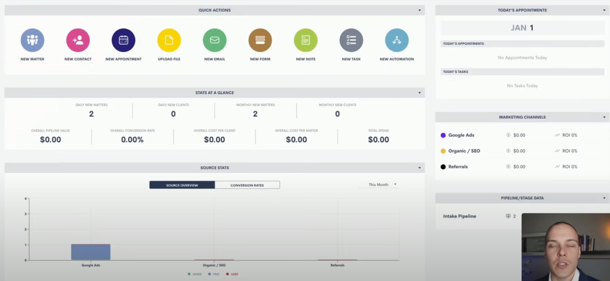

Example contact details page from competitors sites

**SITEBUILDER**

1. Need to add a way to “edit site” and have it map to the content area forms in this engine that include testimonials, services, etc.

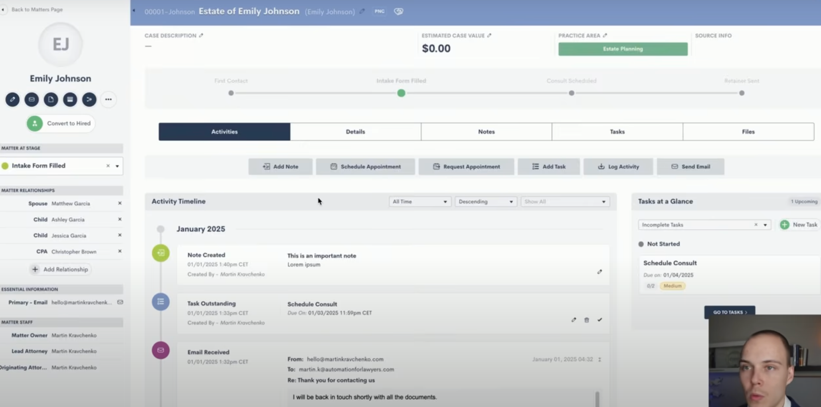

Example “Pipeline” summary by stage from competitors site

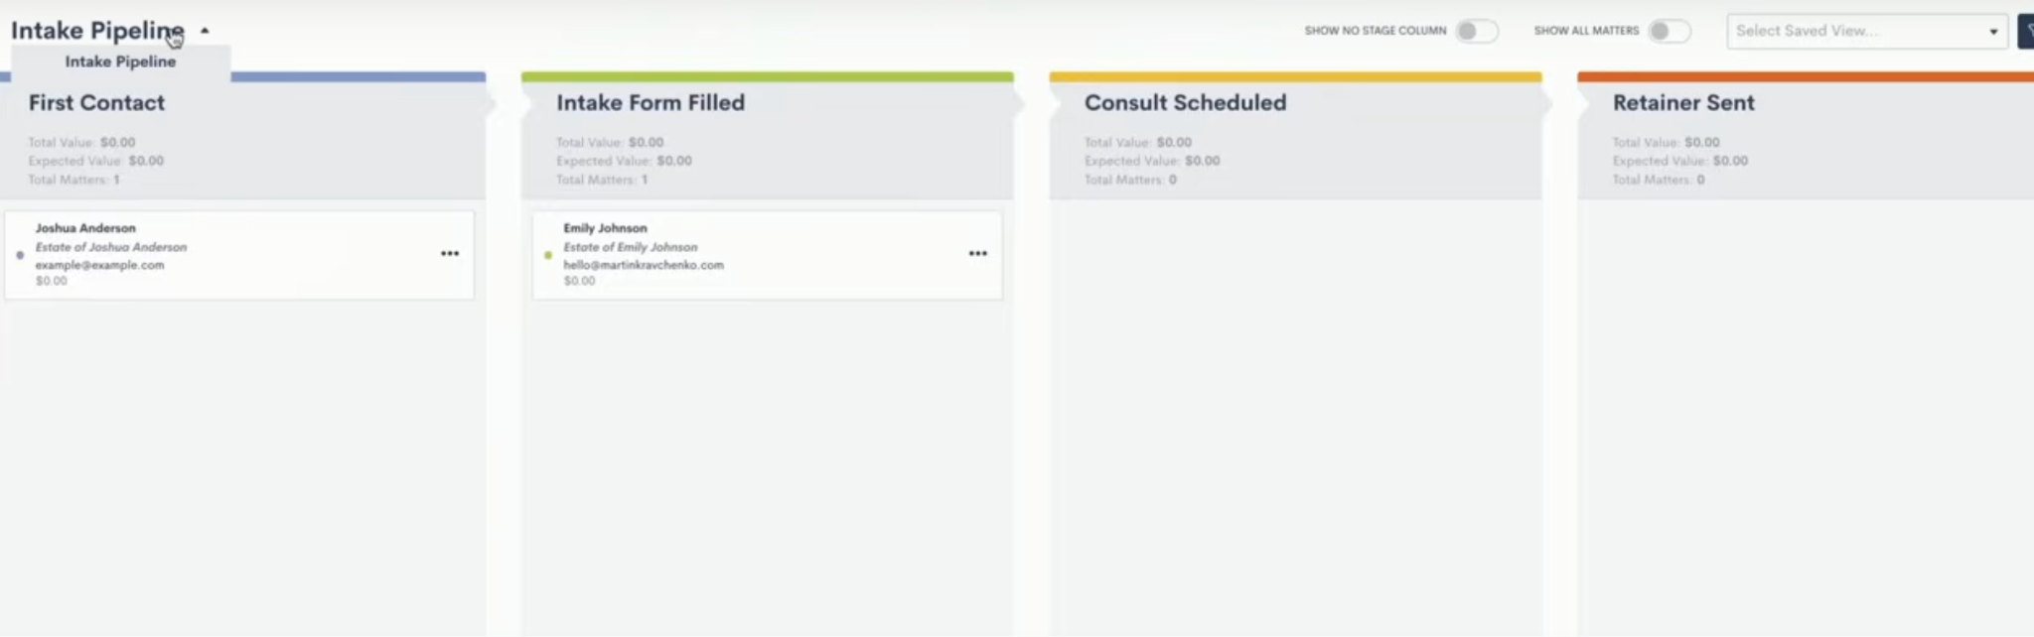

All Contacts (search by name, email etc. section) below here

**Nurture (rename this module to “Workflows”**

1. **I**nside of “Create New Sequence” button popup need to add a button next to “add steps” that says “Add rule”(we will map these to the “add automations” to help them designt the catalyst for the next step to go or for the sequence to start) an option
2. In the Add Steps dropdown choices please add these to the existing options
   1. Email
   2. SMS
   3. Form send
   4. eSign request
   5. Alert Advisor
   6. Document send
   7. Manual Review/Edit

**advisorIQ**

1. Make the “overview” section say my web content
2. Add “my blog” and a section to create an seo optimized article and blog post for the site
3. Leave all other sections the same but make the boxes “editable” by hovering over them with a click

**legalIQ backend technical doc context**

View here https://docs.google.com/document/d/1MW0ZWWSTMLEoKEtaUR2UFui2SCdRJDvHonHibPwK4zs/edit?tab=t.0