* Also for now make this page not indexed or viewable after login or accessible until we decide how to fix it <https://agentiq-vfo-frontend.onrender.com/welcome> since it isn’t necessary for tomorrow and we can just land right on the dashboard page at login
* Need this to have the pipeline laid out as a priority above the fold in a format style like this but with these phases instead of the ones in the Alliance example

So replace the current way it looks here and add 2 more boxes on the top of KPIs that says these things left to right “Leads”, “Booked”, “Show up Ratio” “Signed” “Avg $ per Matter” “Matters In Process” and these should roll in thirty day increments (month to date default) and also be able to be viewed with a toggle of Inception to date. Then below the top KPI boxes and between the next level down should be a Pipeline between them and the “Advisor Daily Brief and Next 24 hours box line

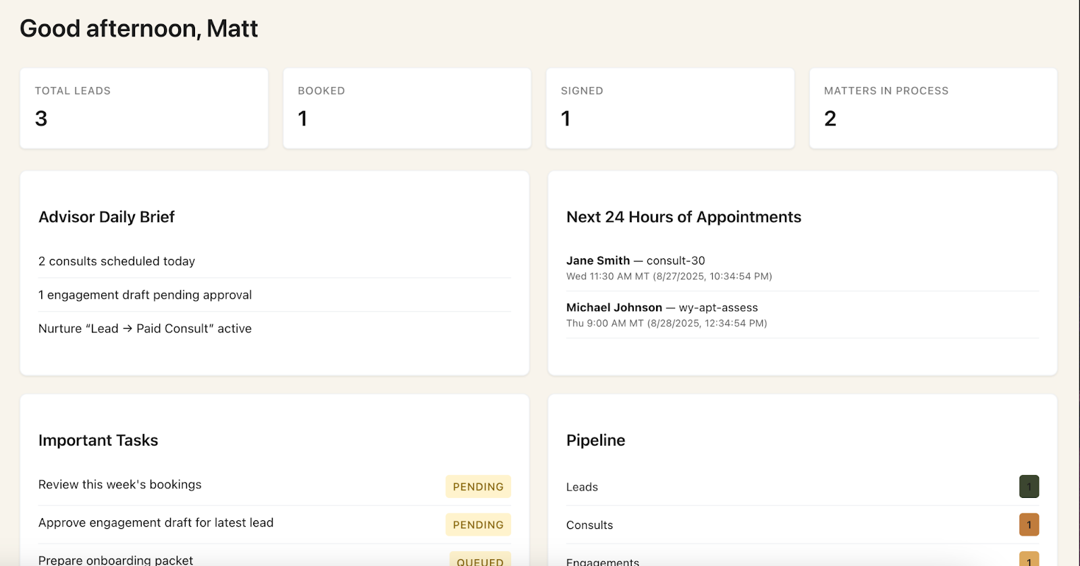

* Style of the pipeline module should look like what we did for Alliance but be customized by these stages in place of the ones in their example.
* Change “Onboarding Pipeline” to “LIFTed Advisor Pipeline” and the menus across the top should read “Pipeline Overview” “Clients” “Automation Status” “Analytics”
* Inside of “Pipeline Overview” the phases of the journey should replace “Pre-Hire” with “Book Consults” (two types, free and paid), Pre-Engagement, Engaged, Questionnaire Received, Matter in Process, Matter Fulfilled

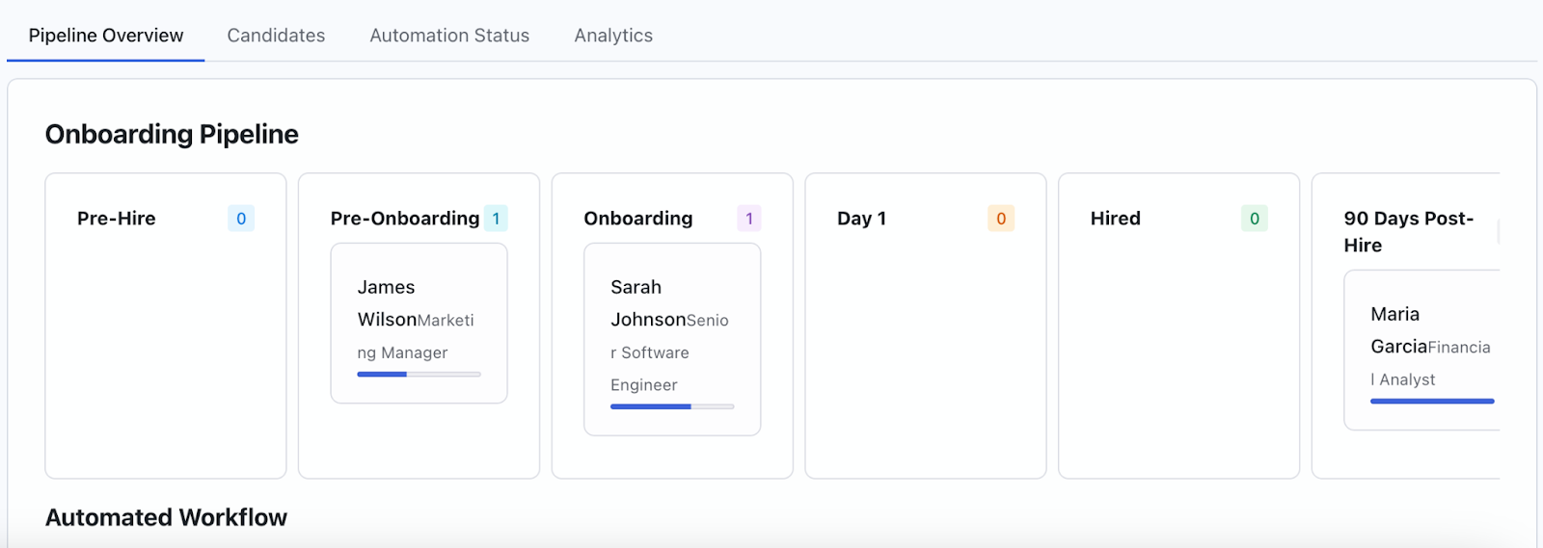

* Under the Candidates tab it should look like this but for VFO brand and all these should be able to click and view details from here like in Alliance and map to the contact record and update with each new form or document filled in the master CRM contact record. Need to change the 2nd column that says “position” to “candidate type and the options there would be “Lead” “Free Consult” “Paid Consult” “Engaged LLPS”, “Engaged WYDAPT” and then under “status the choices should match the pipeline stages of *Booked Consult, Pre-Engagement, Engaged, Questionnaire Received, Matter in Process, Matter Fulfilled.* Progress bar would be 100% when they get through all those 6 phases to matter fulfilled. Start date stays and time stamps and all these actions should map into the “Audit” module in the system too for timestamp trail of action by client and be searchable and exportable into a csv. Lastly on this replace the Manager column with “Advisor” and this will be the user who is on that client account (so in advisor mode this will always be them unless they have multiple lawyers in the firm, and in God mode Ali could see all her advisors and who has the most clients ever when they are from 700 different firms)

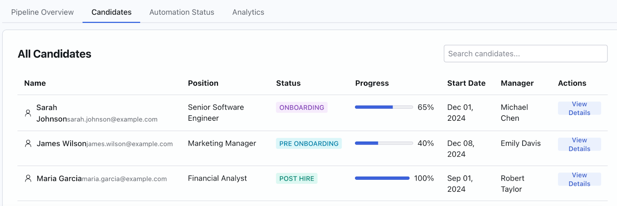

* On the “view details” popup and screen we just need cleaned up versions of these and it should map to the actual documents, forms, and tasks of the workflows in the formbuilder and documents library as they get personalized and sent for esignature etc in the various workflows we create and attach docs and actions to. The HR Bot becomes the “LIFTed Bot” and the “Advisor” gets all the other tasks for now. Replace the persons   
  “Position” with their “candidate type” and also if we can make the appearance of the first section of details look like it does now and much cleaner in this section that would be great so its easier to read than the Alliance UI.

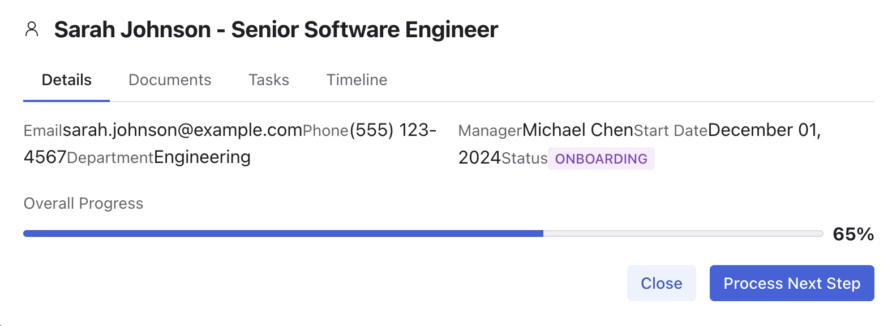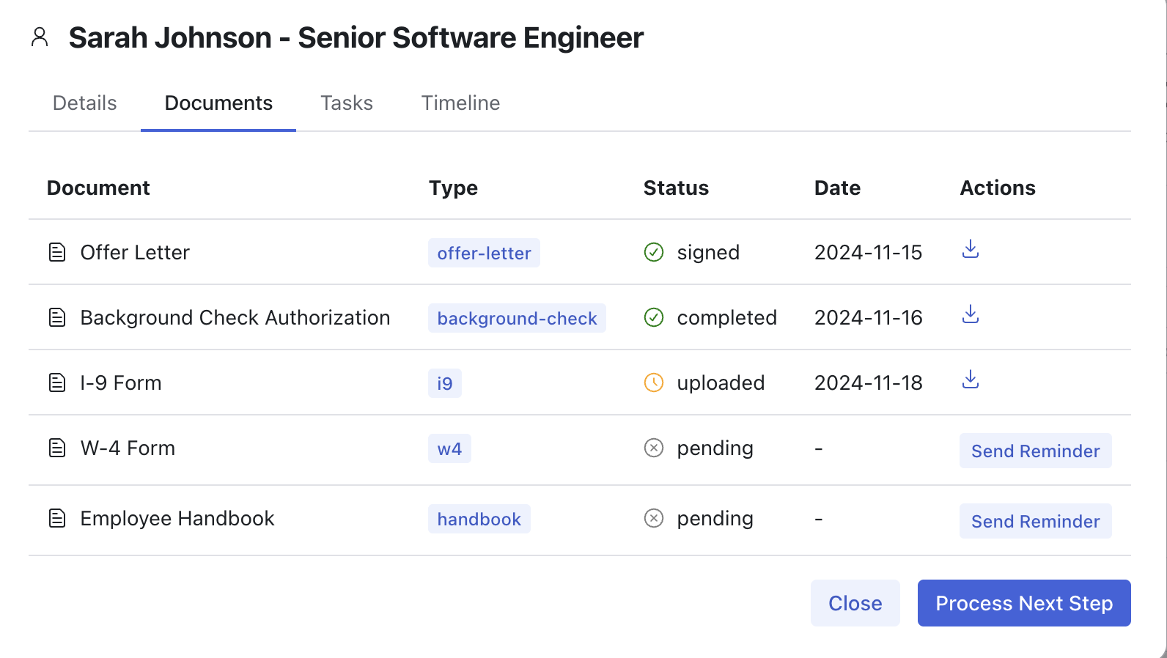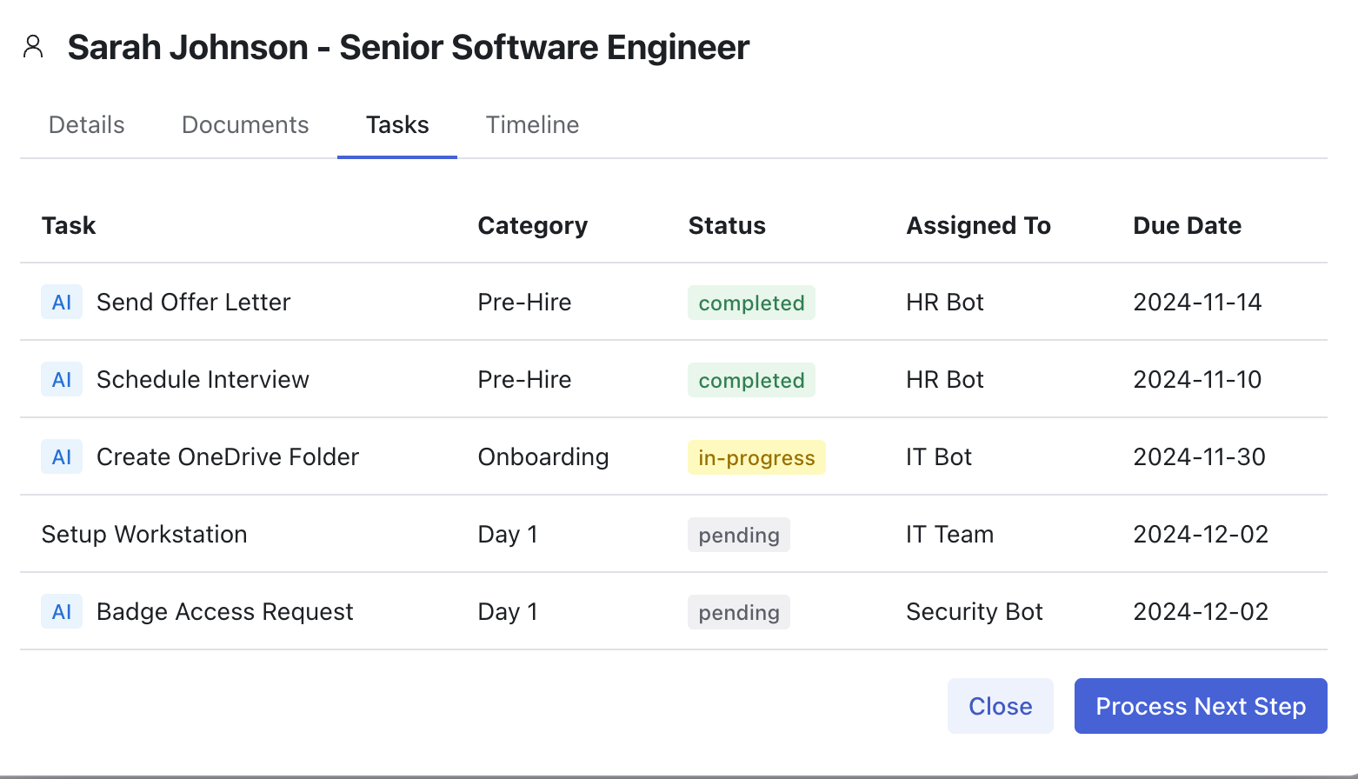

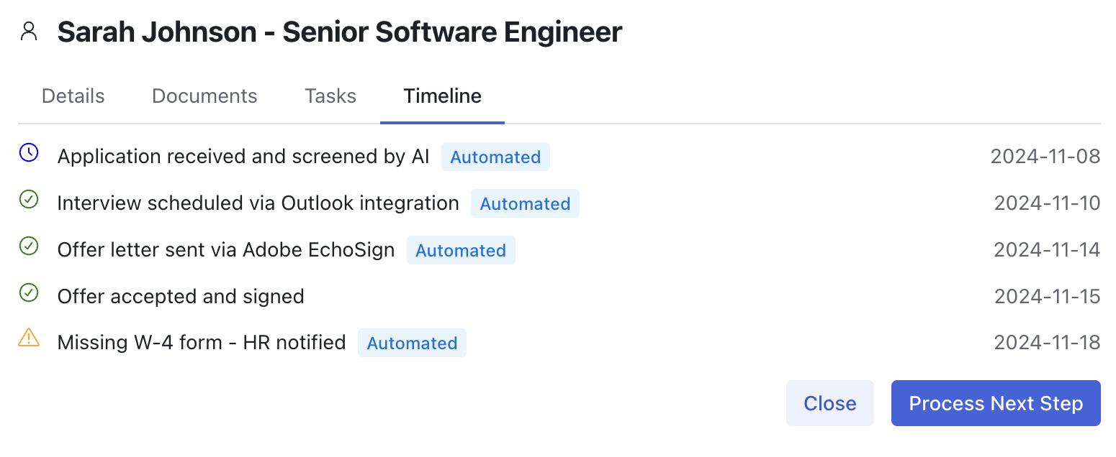

* Need the Google Calendar connection to show here and embed so that they can book appointments, see and edit all within here and have it sync to all google

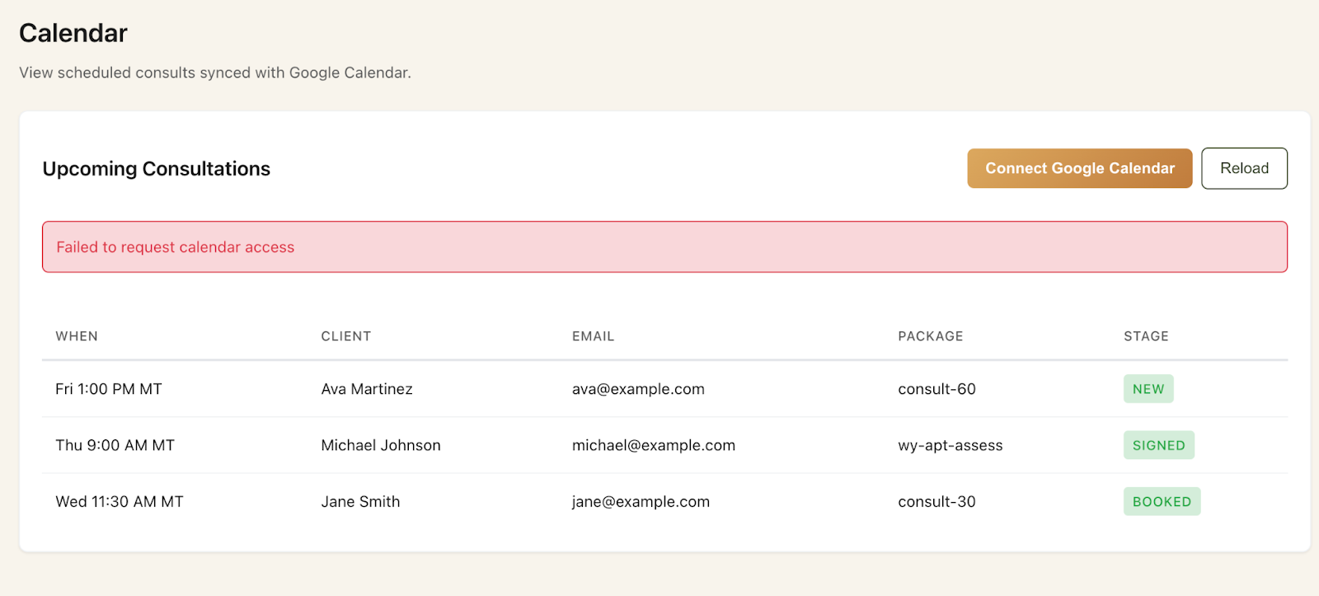

* On the sitebuilder page we need it to properly “save” the box checked for “enabling payments for booked consults” and it also should probably have an easy way on here to connect their lawpay account credentials or maybe edit them if needed so we know where that connection gets setup technically and managed. Otherwise this page is fine for now.

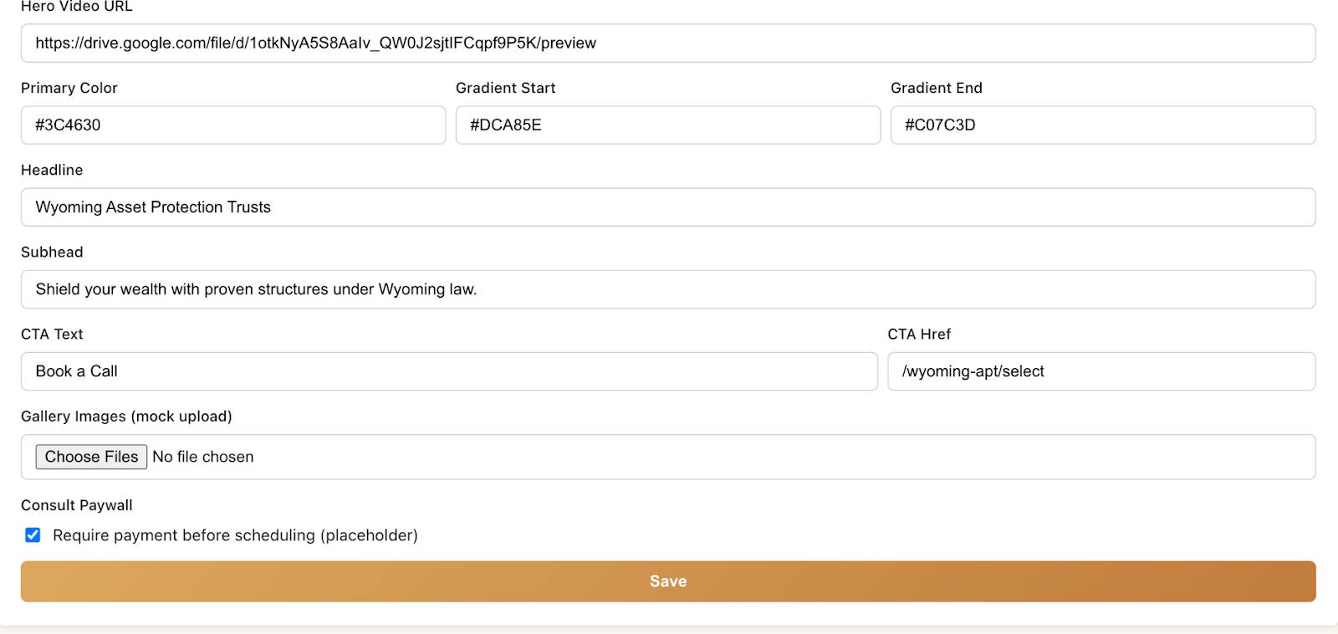

* Need to make this not static or Mock mode once Matt is logged on and that it is fully live and when you hover your cursor over each of these sections below it should have a “edit” button hover and be able to click and open to make changes and save so that it then populates the section of the public site with that new data.

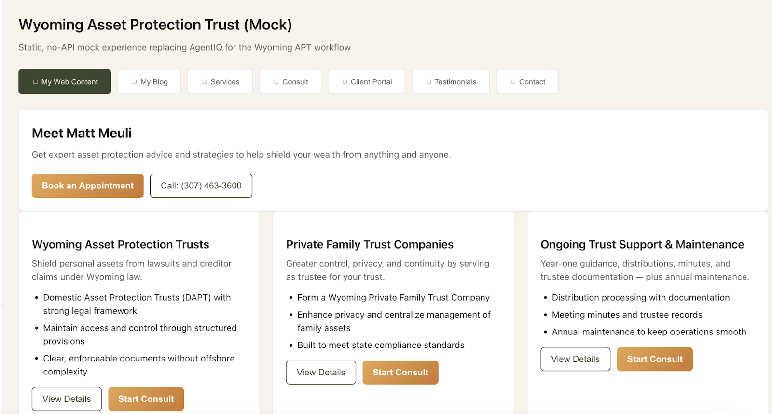

* Also the “Blog” widget needs to be fully functional and allow for posts to be added (ideally by incorporating the “seo optimized” content generation of a draft by copy and pasting raw content from an audio file or transcript into the chat box and then seeing an editable Title and body in the preview window before finalizing any manual edits and hitting “publish” and then having all of these blogs indexable on the public site under the sub page called “Blog” And once published each of these (mocks included) should be able to be edited, deleted, etc.

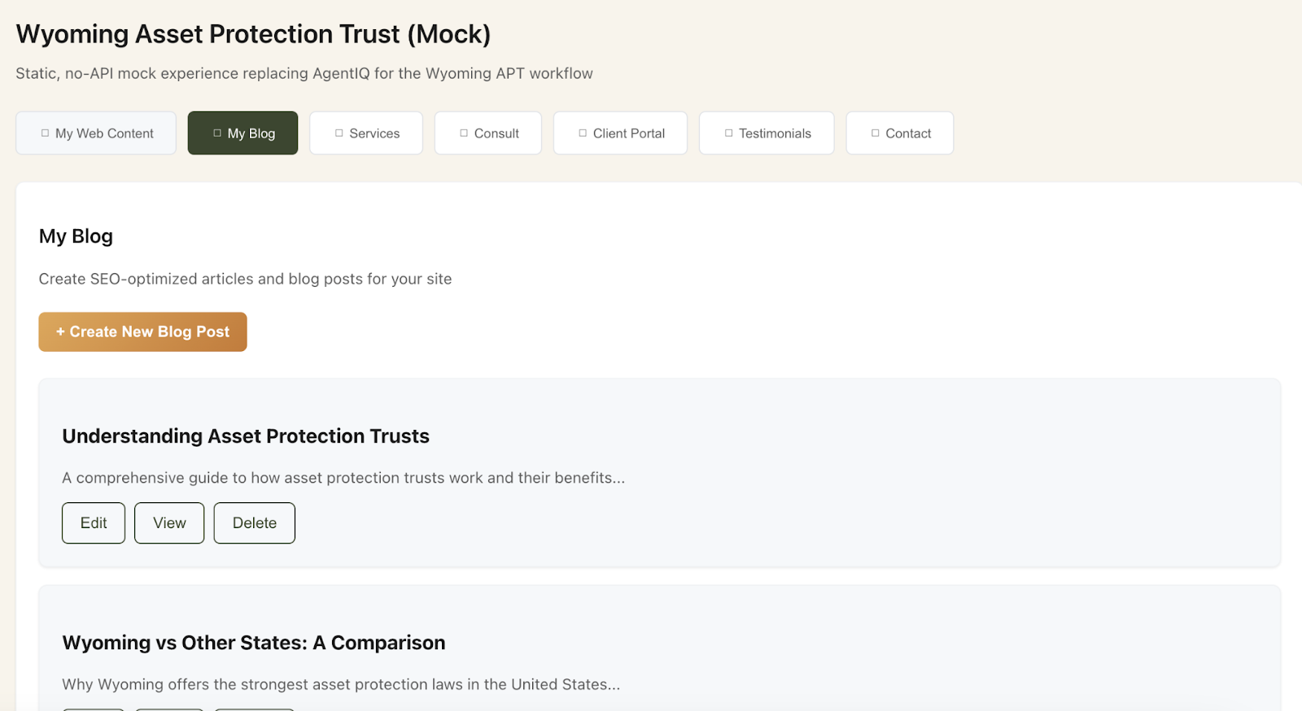

* Core Services section also needs to be editable and made live and map to the proper area of the public site

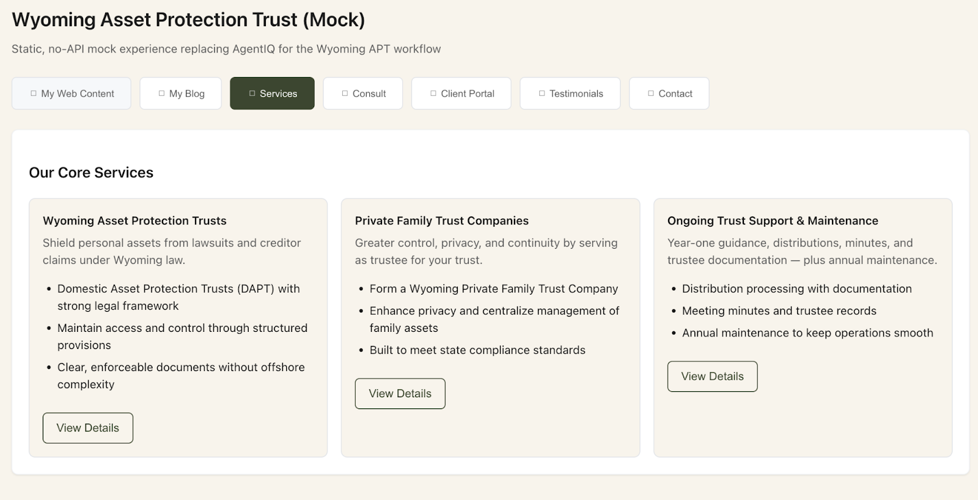

* The Consult section should be renamed “Consultations” and it should be sucking in the google calendar in the live version and be synced to the bookings page on the public site for available times. It should also allow for the cynamic creation of “appointment types” by meeting length, default google meet or zoom integration link, and also allow for the user to choose if this is a “paid” or “free” consult and when they select “paid” for that appointment type it should immediately allow for them to add the “price” in $ (i.e. $375 for 30min) and then trigger the Lawpay merchant account of the user to seamlessly check out with a credit card payment and confirmation of the appointment and have google then send the calendar invite to the client with join link and receipt. The area where it says Payment placeholder should be used for viewing and editing the integration to their lawpay account

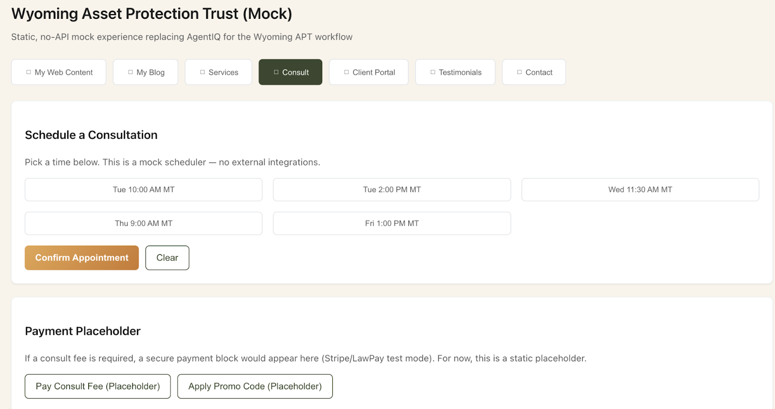

* The final three tabs in here (Client Portal) (Testimonials) and (Contact) also all just need to be able to be “edited” and “saved”and sync to update the saved information to the appropriate area in the public site

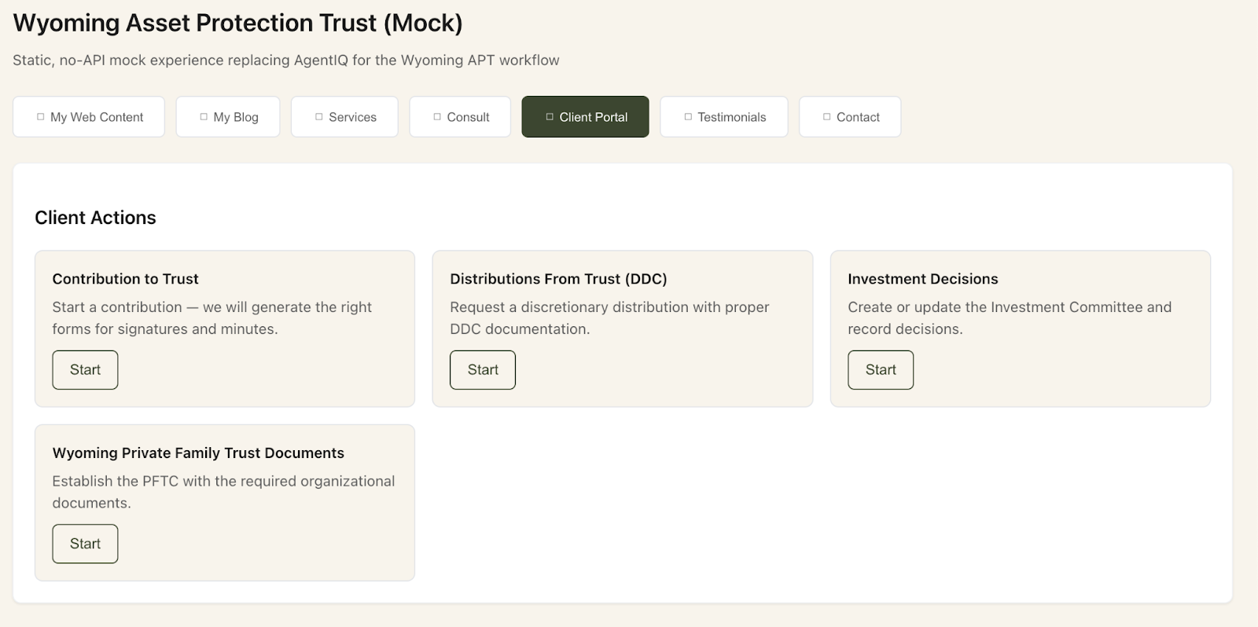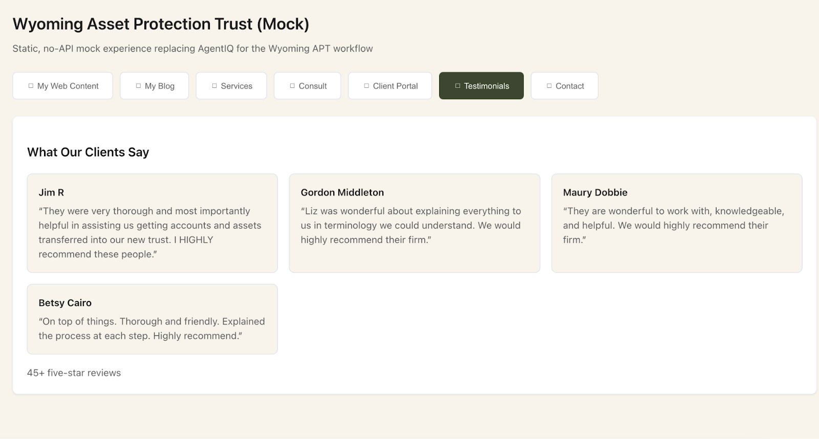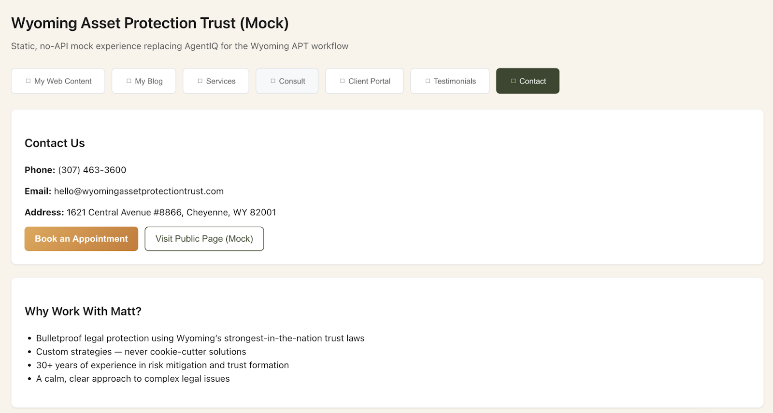

* Need this form from the current site booking of a paid 30 minute consult with all questions duplicated in the formbuilder for Matt and replace the current top left placeholder (mock) form and make sure that one is permanently deleted. The new form also needs to be mapped to the booking link on the public site and also we need a way to make multiple other landing pages in the tree that could have different consult book forms that map from this formbuilder to future subdomain landing pages, but for tomorrow at minimum we need the form to be replicated in here in this library and also mapped like it is right now and working with the google calendar sync for all open appointments that are actually available and with the lawypay $375 checkout for the consult.
* Need the Life&Legacy Planning Questionnaire and WealthCredit&Liquidity Assessment .txt files I texted yesterday uploaded to the custom forms as well and the associated Life&Legacy Planning Summary document .txt file should go in to the “my documents” library as something that can be populated by the associated assessment in a future workflow.
* 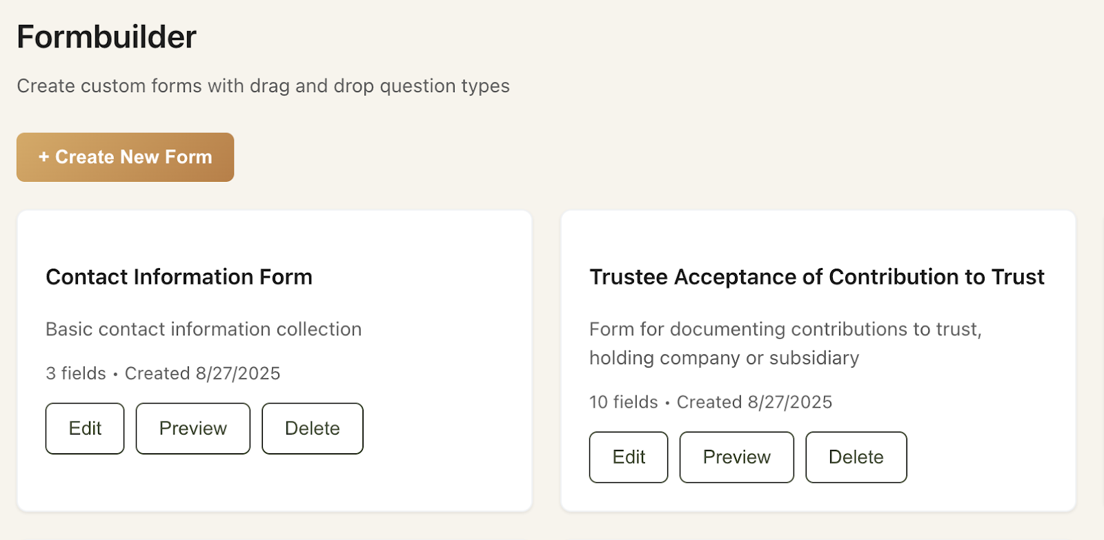
* The current form is viewable in his existing public site (but the calendar slots and openings need to map to his actuall google calendar openings and these form fills must also map and update the client details in the CRM and across all pipeline

This is the current live site, but needs to be updated and tied together

<https://agentiq-vfo-frontend.onrender.com/wyoming-apt>

* Need to make sure that each of these documents once uploaded is able to be vectorized (or whatever) as templates and then populated with the client details where relevant and that also if he wants to “edit” these document templates he can click on “edit” and have the template updated moving forward and still mapped to all the dynamic automations we build in the workflow sequences without issue. Not sure how we do this, but at a minimum if we have “edit” listed as an option here next to preview then it should work. If we cant make that work yet and need to edit them manually in google drive and revectorize for now then lets remove the “edit” button once they are uploaded and just focus on how we can preview them here in their template form, but also make them part of sequences in the workflow side that generate a preview when he visits a step, “selects the client” “selects the document” “selects the matter in process” “generates draft” (which customizes with their prefilled data from the associated forms that they completed in their details) and then has the “approve/send” or “edit” button option after reviewing it at that step.   
  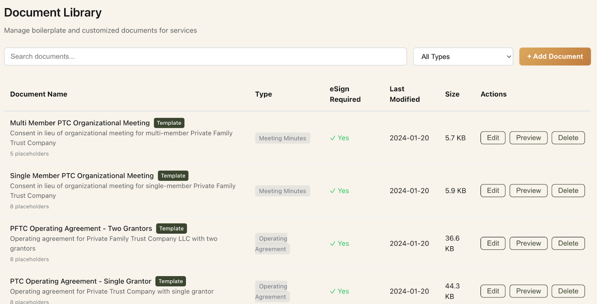
* The second part of the above should actually probably exist in the client “vault” section because it looks pretty good as bones the way it is laid out and we need to put the preview and select client, select document, select matter in process, and generate draft window here and then once it is approved and sent (it goes out for either e-sign when relevant or client copy that could be viewed or downloaded from their tiered access portal, when its a final document or disclosure) and simultaneously gets archived and stored in the advisors vaul

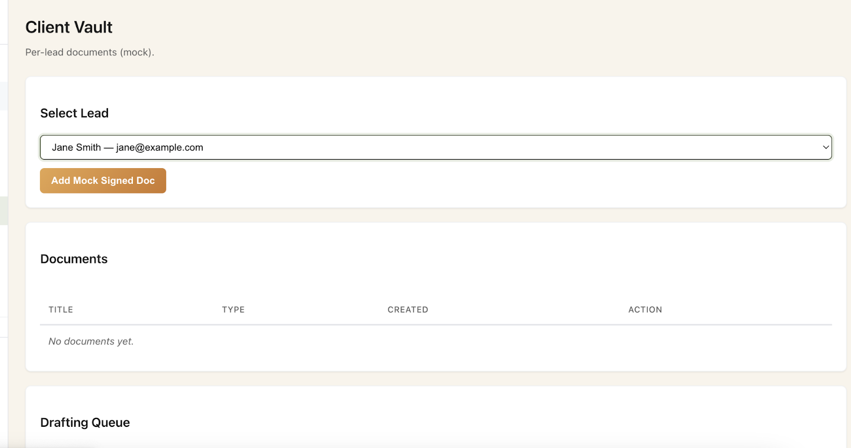

* The legalIQ tab and module on sidebar should also just be mapped live to the “ vault” for searching the documents that are completed for each client and also summarize simple analytics for now so that it is functional and live with the active users vault, and the Ai chat should be able to provide natural language questions they have to query their vault of documents and client records.

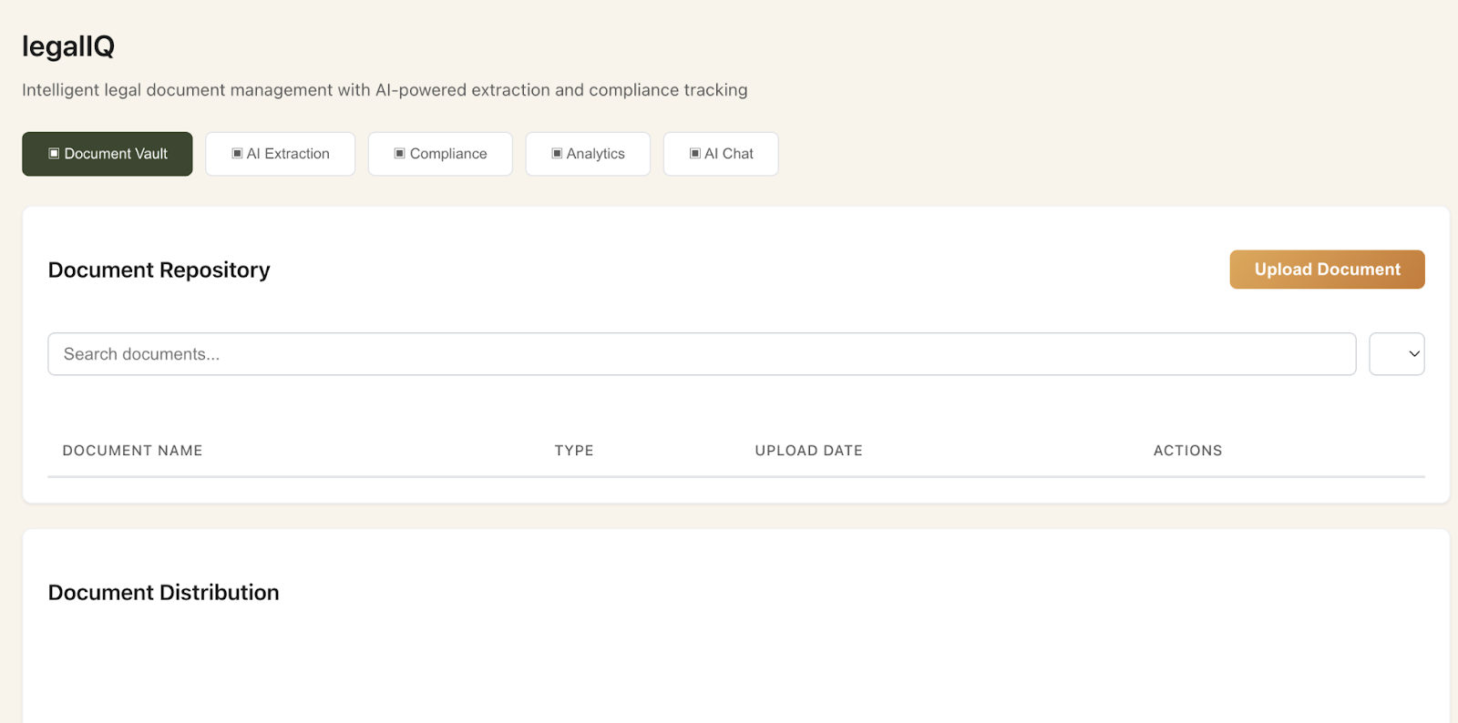

* On the “Audit” module this should just show a real time and historical archive of any and all archived actions within the system and be searchable by client name, matter type, and timestamp and serve as the single source of truth for all system triggers or updates from the sequences to client workflow automations and also be exportable to a .csv by search filter if audits are ever needed.

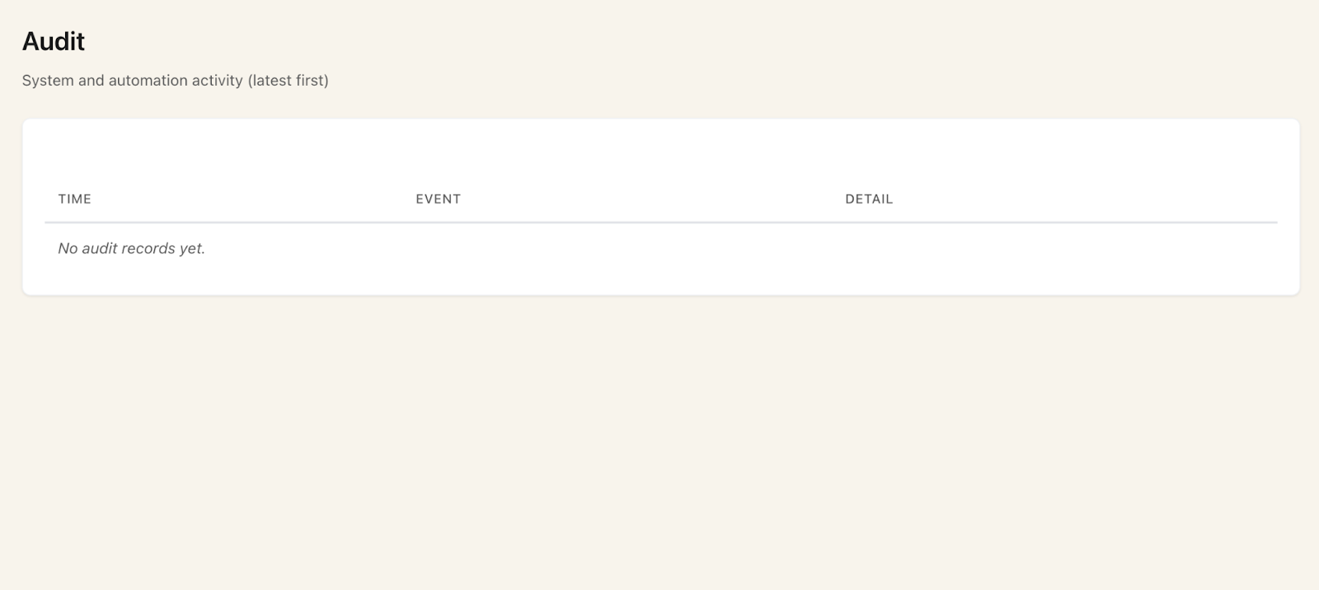

* On the CRM buttons on the top most of the top row don’t work yet and we need to talk through or map them to their other areas that do so you can use them from within this view if desired. Also let’s put that new pipeline widget from the home dashboard in here as well as a duplicate place to view it and drill deeper.

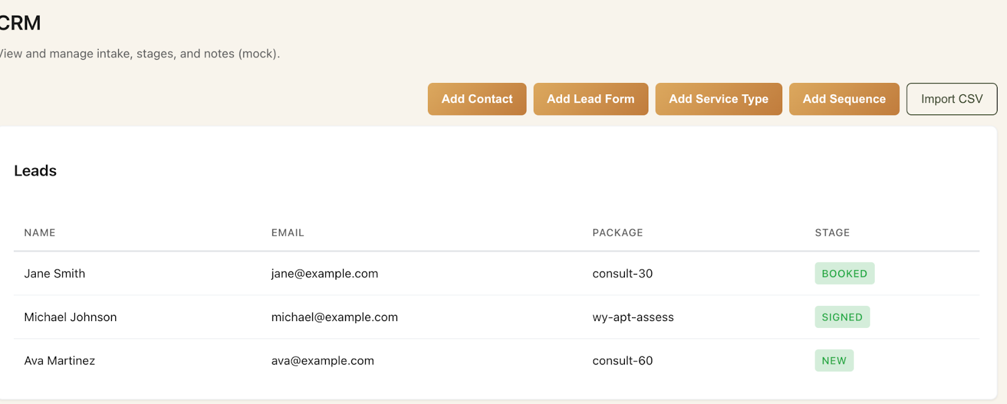

Also this kind of drag and drop (although we want the “add rules” and actions by bot and advisor to move people as well) functionality and layout is also a cool way to enhance the pipeline summary from home dashboard into something more manually usable like we do within nBrain CRM as a style

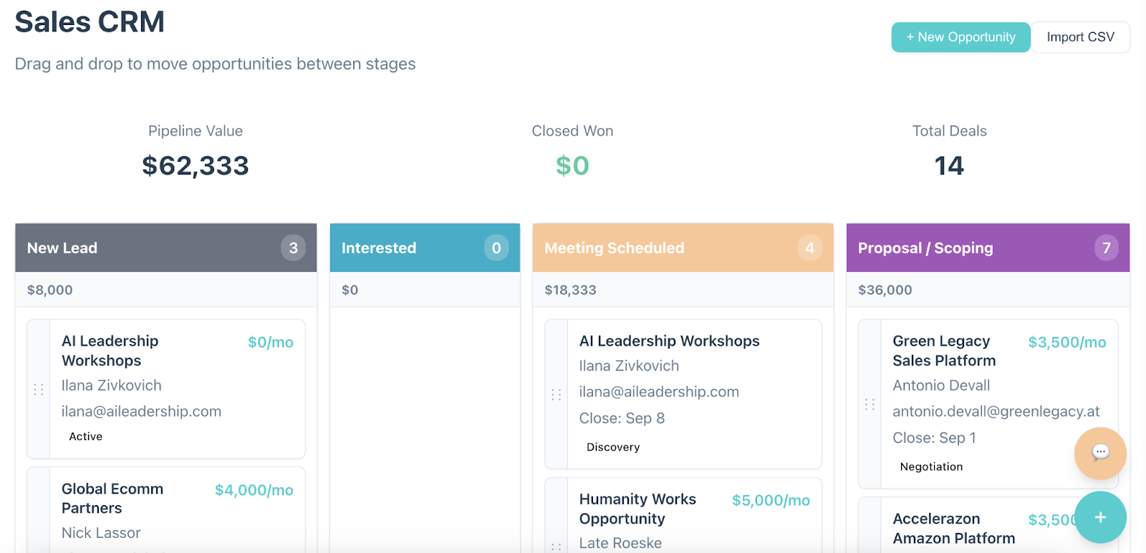

* Also I noticed a few small things in the sidebar tabs like the Documentation isn’t updated with the recent changes and it should be accurate and updating in real time as we make these tweaks so that it is accurate because she will be onboarding a CTO in the next week to work with me and you forward and we wanna groom them from the jump to help us :)
* Need Lawpay API integrated and working with both his checkout on the booking calendar as well as something we can build into the engagement letter e-sign docs and email with a live link out to the invoice that charges the amount in the engagement letter (standard for now in the WYDAPT Engagement letter is $18,500)
* The HEAVIEST lift and the most important overall once we get all these above done tonight is the Workflow and sequence adding and add rule functions. Let’s get through all the above before bed tonight and then hit the Workflow automations and build the first and main one end to end for the WYDAPT matter in the morning when fresh.

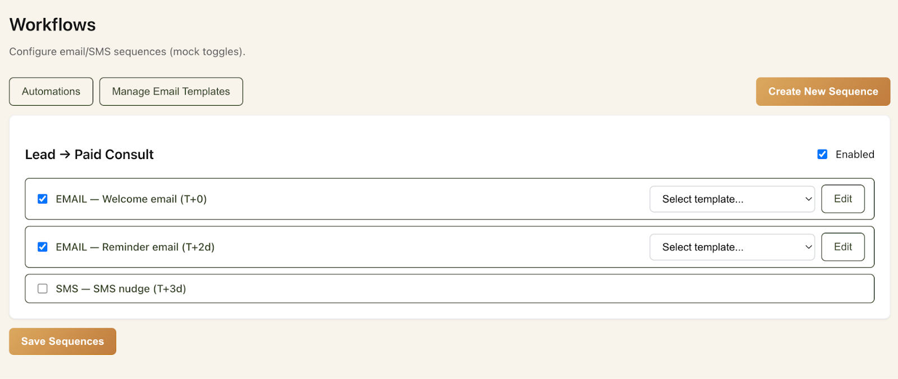

* **Need the “manage email templates” to work and save and be able to ingest the header banner from the public site on each template, and if possible to upload a bulk upload of email sequences for a nurture or workflow string of templates and steps with subject and body thats even better, but individual copy and paste is fine for now too.**

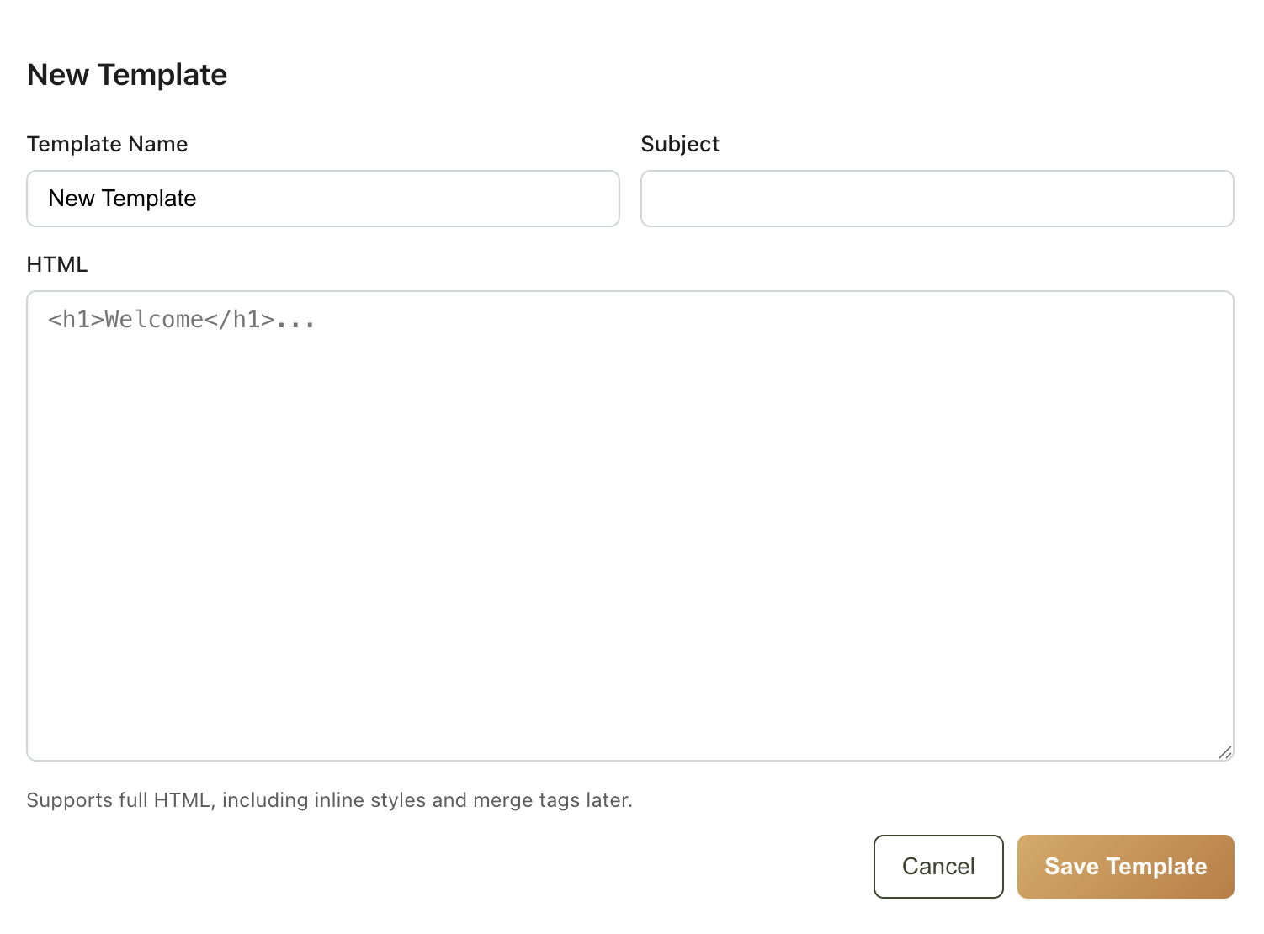

* **Done for 8/28 sprint.**
* **Signed by Ali Katz _________________________________**

**—-----------------------**

**backend technical doc context for any security architecture we need before going into “production” from beta.**

View here as needed for backend “vault security and vectorized data base design and technical documentation https://docs.google.com/document/d/1MW0ZWWSTMLEoKEtaUR2UFui2SCdRJDvHonHibPwK4zs/edit?tab=t.0