**Punchlist:**

* **Need to make sure that you can edit existing sequences and “add” or “delete” steps and or copy in each one without having to restart and recreate them from scratch> Right now once these are created you can’t go in and insert additional steps for alerts, or binary sequences that get triggered if actions are not take or when they are and that needs to be possible.   
  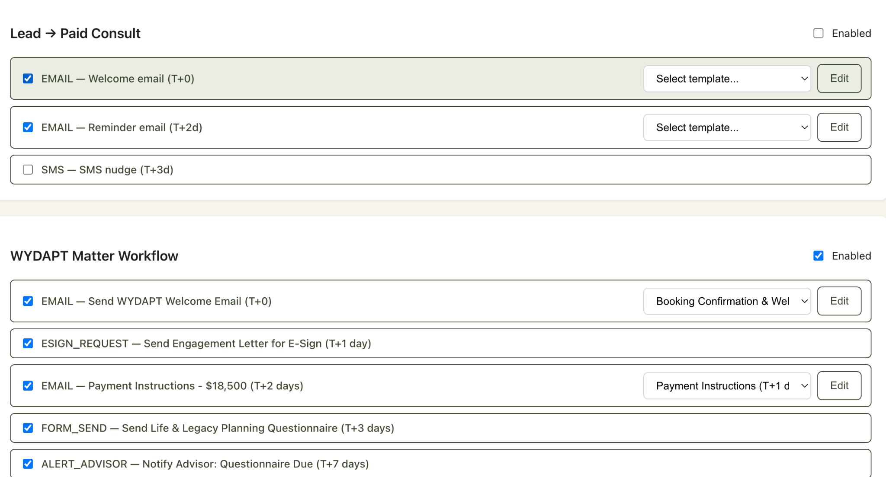  
    
  Also need to update the current WYDAPT sequence in here with full list of email templates below and changes available with all of these templates below   
  Perfect. Let’s build the full end-to-end WYDAPT nurture + fulfilment email sequence Hormozi-style:**
* **Conversion-driven copy (future pacing, authority, sunk-cost leverage).**
* **Compliance built-in (timelines, reminders, urgency).**
* **Voice of Matt Meuli (trusted attorney, firm yet approachable).**
* **CTAs that are clear, low-friction, and tied to outcomes (protecting legacy, securing wealth).**

**Got it. I’ll merge everything — the core workflow emails + the stalled client rescue sequences + SMS scripts into a single, copy-and-paste ready document.**

**The SMS messages are short, personal, and CTA-driven (no fluff, just urgency + clarity). They follow Hormozi’s philosophy: if email is the essay, SMS is the tweet.**

# **📩📱 WYDAPT End-to-End Workflow: Emails + SMS Scripts**

## **1. Booking Confirmation (T+0)**

**Email Subject: Your WYDAPT Consultation is Confirmed**

**Email Body:  
 Hi [First Name],**

**Thank you for booking your 30-minute Wyoming Domestic Asset Protection Trust (WYDAPT) consultation with me.**

**Here are the details:**

* **Date/Time: [Insert date/time]**
* **Location: [Zoom/Phone link]**

**This is your first step toward protecting your assets and ensuring your family’s legacy is safe for generations.**

**To make the most of our time together:**

* **Bring clarity on your goals and any questions you’d like answered.**
* **I’ll walk you through exactly how the WYDAPT structure works — and why it is the strongest available under U.S. law.**

**I look forward to speaking with you.**

**Warm regards,  
 Matt Meuli  
 Wyoming Asset Protection Trust Attorney, LLC**

**CTA: [Add to Calendar Link]**

**SMS (sent 5 min after booking):  
 “Hi [First Name], it’s Matt Meuli. Your WYDAPT consult is confirmed for [date/time]. Add this to your calendar — this step protects your legacy.”**

## **2a. No-Show Follow-Up**

**Email Subject: We Missed You — Let’s Reschedule**

**Email Body:  
 Hi [First Name],**

**I noticed we weren’t able to connect for your scheduled WYDAPT consultation. I understand — life happens.**

**Your consultation fee is non-refundable, but I want to make sure you get the full value you’ve already invested.**

**👉 Simply reply to this email with a time that works for you, and we’ll reschedule.**

**This conversation could be the difference between leaving your wealth exposed or securing it for future generations.**

**Best,  
 Matt**

**CTA: Reply to Reschedule**

**SMS (sent 30 min after missed appt):  
 “Hi [First Name], looks like we missed each other for your WYDAPT consult. Your fee is already applied — just reply here or email me to reschedule.”**

## **2b. Engagement Letter + Diagram (T+15 min post-appointment if they showed)**

**Email Subject: Your WYDAPT Engagement Letter & Next Steps**

**Email Body:  
 Hi [First Name],**

**Thank you for your time today. As discussed, I’ve prepared your Engagement Letter to officially begin building your Wyoming Domestic Asset Protection Trust.**

**Attached, you’ll also find a WYDAPT Diagram to visualize how the trust protects your assets.**

**👉 Please review and sign the Engagement Letter here: [E-Sign Link]**

**Once signed, we’ll proceed immediately with the next step: securing payment and beginning the setup of your complete WYDAPT.**

**Your legacy deserves nothing less.**

**Gratefully,  
 Matt**

**Attachments: Engagement Letter (E-Sign), WYDAPT Diagram**

**CTA: Sign the Engagement Letter**

**SMS (sent 1 hr after consult):  
 “Hi [First Name], thanks for today’s call. I’ve sent your WYDAPT Engagement Letter + diagram. Please review & sign here: [link].”**

## **3. Payment Instructions (T+1 day)**

**Email Subject: Begin Your WYDAPT Setup — Payment Instructions**

**Email Body:  
 Hi [First Name],**

**Now that your Engagement Letter is in place, the next step is to secure your trust by completing payment of $18,500.**

**This covers all legal drafting, customization, and compliance for your WYDAPT.**

**👉 Click here to pay securely via LawPay: [Custom Payment Link]**

**Please complete payment within the next 48 hours so we can begin setup immediately.**

**This is the moment your protection moves from “planned” to “real.”**

**To your legacy,  
 Matt**

**CTA: Make Payment Now**

**SMS (sent same morning):  
 “Hi [First Name], this is Matt. Your WYDAPT payment link is here: [link]. Once paid, we’ll start drafting your trust docs.”**

## **4. Questionnaire Send (Immediate after payment)**

**Email Subject: Complete Your Asset Protection Questionnaire**

**Email Body:  
 Hi [First Name],**

**Congratulations — your WYDAPT setup is officially underway.**

**The next step is to complete your Asset Protection Trust Questionnaire. This gives me the details I need to tailor your trust precisely to your assets, goals, and family needs.**

**👉 Complete your questionnaire here: [Link]**

**It should take 20–30 minutes. Please complete it right away so we can keep your project on schedule.**

**The sooner we have your answers, the sooner your assets are fully protected.**

**Warmly,  
 Matt**

**CTA: Start Questionnaire**

**SMS (sent 5 min after email):  
 “Hi [First Name], thanks for your payment. Next step: complete your WYDAPT Questionnaire here: [link]. Takes ~20 min.”**

## **5. Advisor Alert (internal)**

**System-only (advisor notified questionnaire received).**

## **6. Draft Trust Docs to Advisor (internal)**

**System-only.**

## **7. Advisor Manual Review (internal)**

**System-only.**

## **8. Matter Complete (T+21 days)**

**Email Subject: Congratulations — Your WYDAPT is Complete**

**Email Body:  
 Hi [First Name],**

**Congratulations — your Wyoming Domestic Asset Protection Trust is complete.**

**This means:**

* **Your assets are now shielded under one of the strongest legal frameworks available in the U.S.**
* **You’ve secured a personalized structure aligned with your family’s goals.**
* **You’ve joined a select group of individuals who have taken a serious step toward multi-generational protection.**

**Attached are your final trust documents. They are also securely stored in your Client Vault for safekeeping.**

**👉 Next Steps:**

1. **Save these documents in both physical and digital form.**
2. **Schedule a walkthrough with me if you’d like a guided review.**
3. **Share only with your most trusted advisors.**

**Thank you for trusting me with this critical part of your family’s future. It’s been an honor to serve you.**

**Warm regards,  
 Matt Meuli  
 Wyoming Asset Protection Trust Attorney, LLC**

**CTA: Schedule Walkthrough**

**Attachments: Final WYDAPT Docs, Client Vault Link**

**SMS (sent same day):  
 “Hi [First Name], congrats — your WYDAPT is complete 🎉. Docs are in your Client Vault & attached via email. Book walkthrough here: [link].”**

# **🚨 Stalled Client Rescue Sequences**

## **Rescue 1: Didn’t Sign Engagement Letter**

**Day 2 Email:  
 Subject: Still Need Your Signature to Begin Your WYDAPT  
 Body: [link above in my prior draft]  
 SMS: “Hi [First Name], your WYDAPT setup can’t start until your Engagement Letter is signed. Here’s your link: [link].”**

**Day 5 Email:  
 Subject: Your WYDAPT Is on Hold — Action Required  
 Body: [as above]  
 SMS: “Hi [First Name], your WYDAPT is paused. Sign your Engagement Letter now to protect your assets: [link].”**

**Day 7 Email:  
 Subject: Final Reminder: Sign Your WYDAPT Engagement Letter  
 Body: [as above]  
 SMS: “Final reminder: sign your WYDAPT Engagement Letter by [date] or your file closes. [link].”**

## **Rescue 2: Didn’t Pay Invoice**

**Day 2 Email:  
 Subject: Your WYDAPT Setup Can’t Start Until Payment Is Received  
 SMS: “Hi [First Name], payment of $18,500 is due to start your WYDAPT. Secure link: [link].”**

**Day 4 Email:  
 Subject: Your WYDAPT Is Stuck at Payment — Let’s Fix That  
 SMS: “Reminder: your WYDAPT is waiting on payment. Protect your legacy now: [link].”**

**Day 7 Email:  
 Subject: Final Notice: Secure Your WYDAPT Setup Today  
 SMS: “Final notice — pay by [date] to keep your WYDAPT active. Link: [link].”**

## **Rescue 3: Didn’t Submit Questionnaire**

**Day 3 Email:  
 Subject: WYDAPT Questionnaire — Please Complete Today  
 SMS: “Hi [First Name], complete your WYDAPT Questionnaire here: [link]. It only takes ~20 min.”**

**Day 5 Email:  
 Subject: Your WYDAPT Is on Hold — Questionnaire Needed  
 SMS: “Your WYDAPT is on hold. Please finish your Questionnaire so we can draft your trust docs: [link].”**

**Day 7 Email:  
 Subject: Final Reminder: Complete WYDAPT Questionnaire  
 SMS: “Final reminder: complete your WYDAPT Questionnaire by [date] or your file closes. [link].”**

* In the Formbuilder section when you create and edit forms and select options like “dropdown” it needs to provide a way to “add option” and type in the name of the option

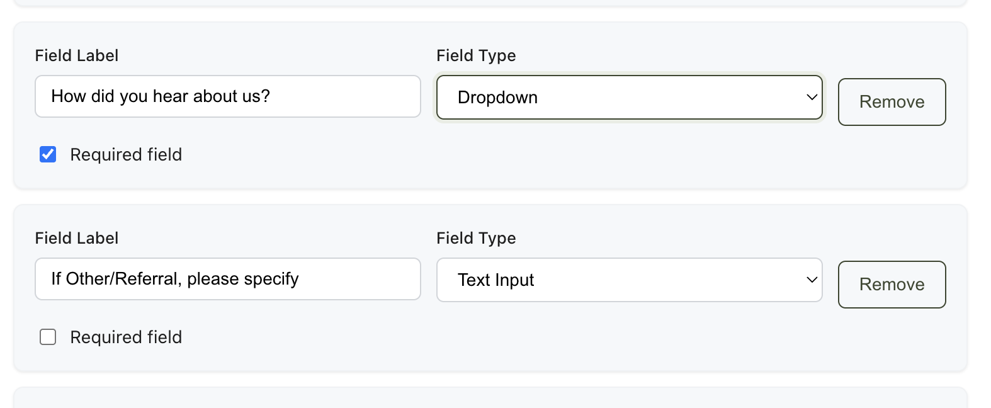

so that it can look like this questionnaire here with dropdown or multiple choice options laid out that can be edited and customized in the form and re-saved

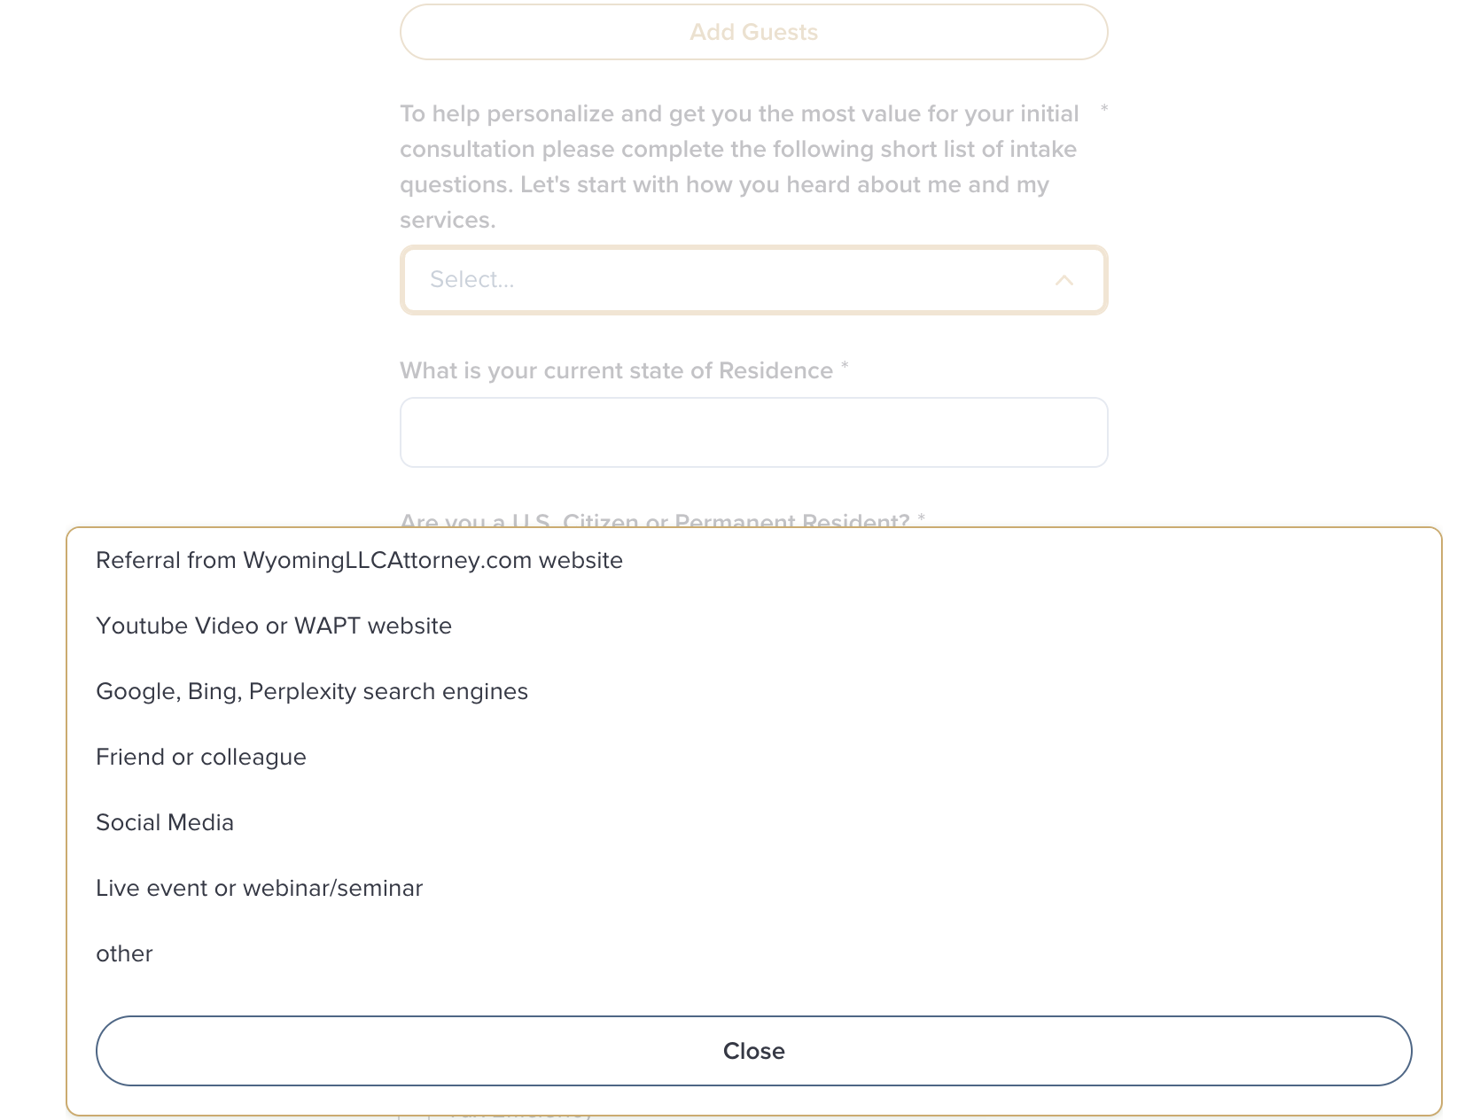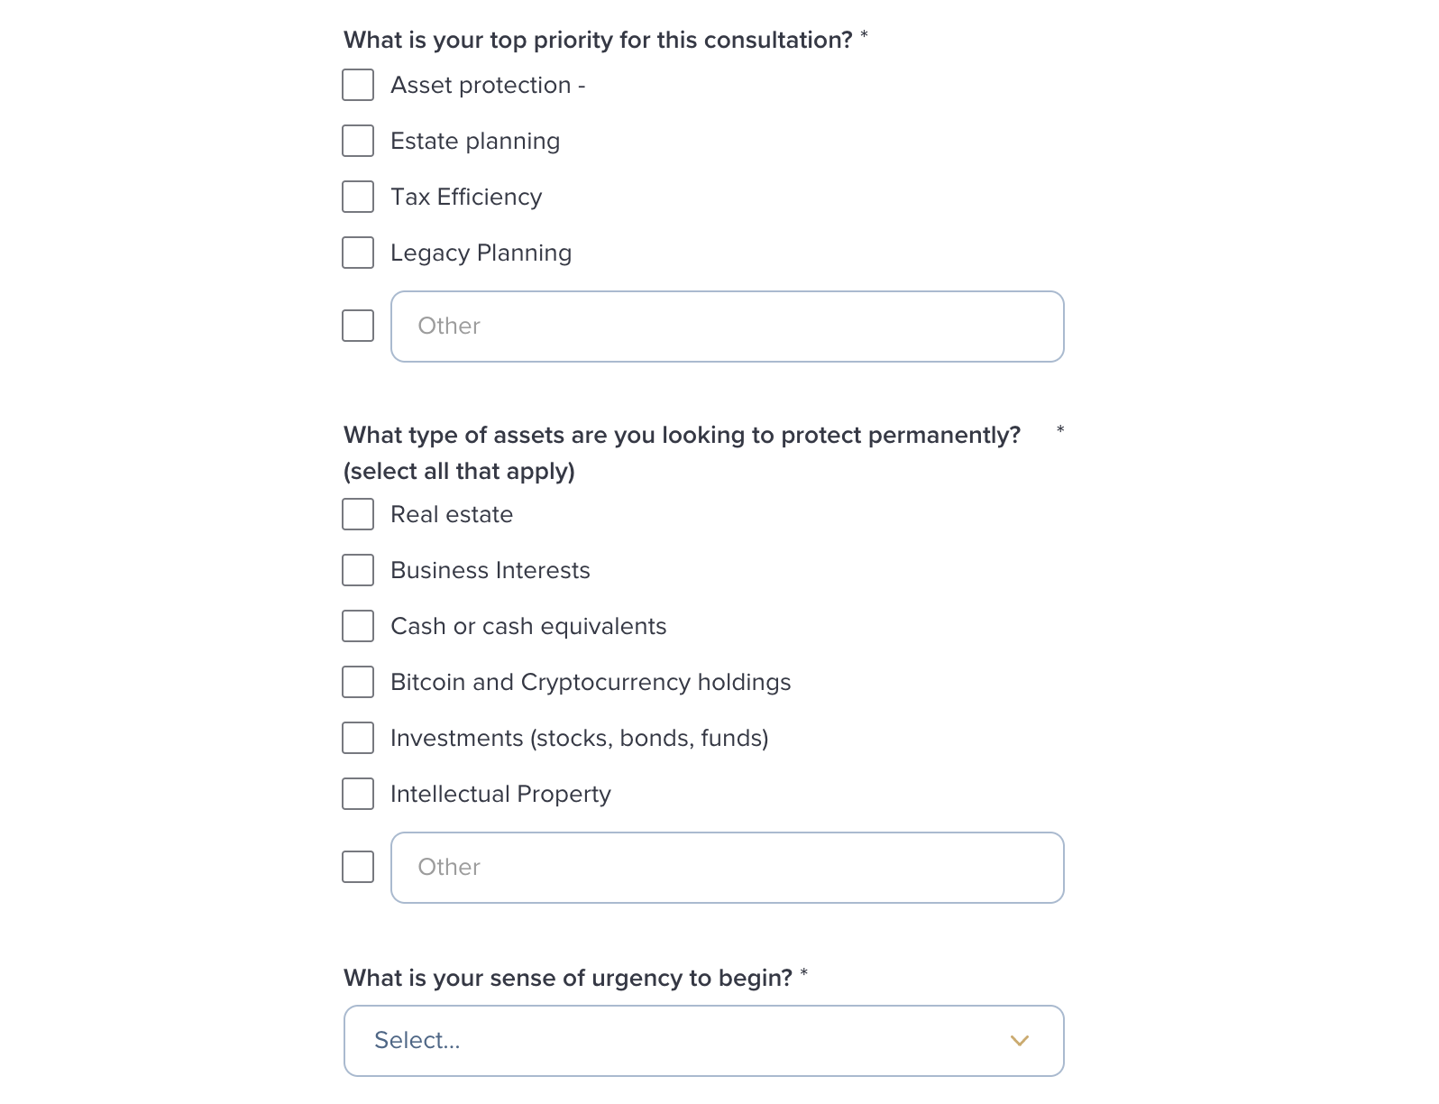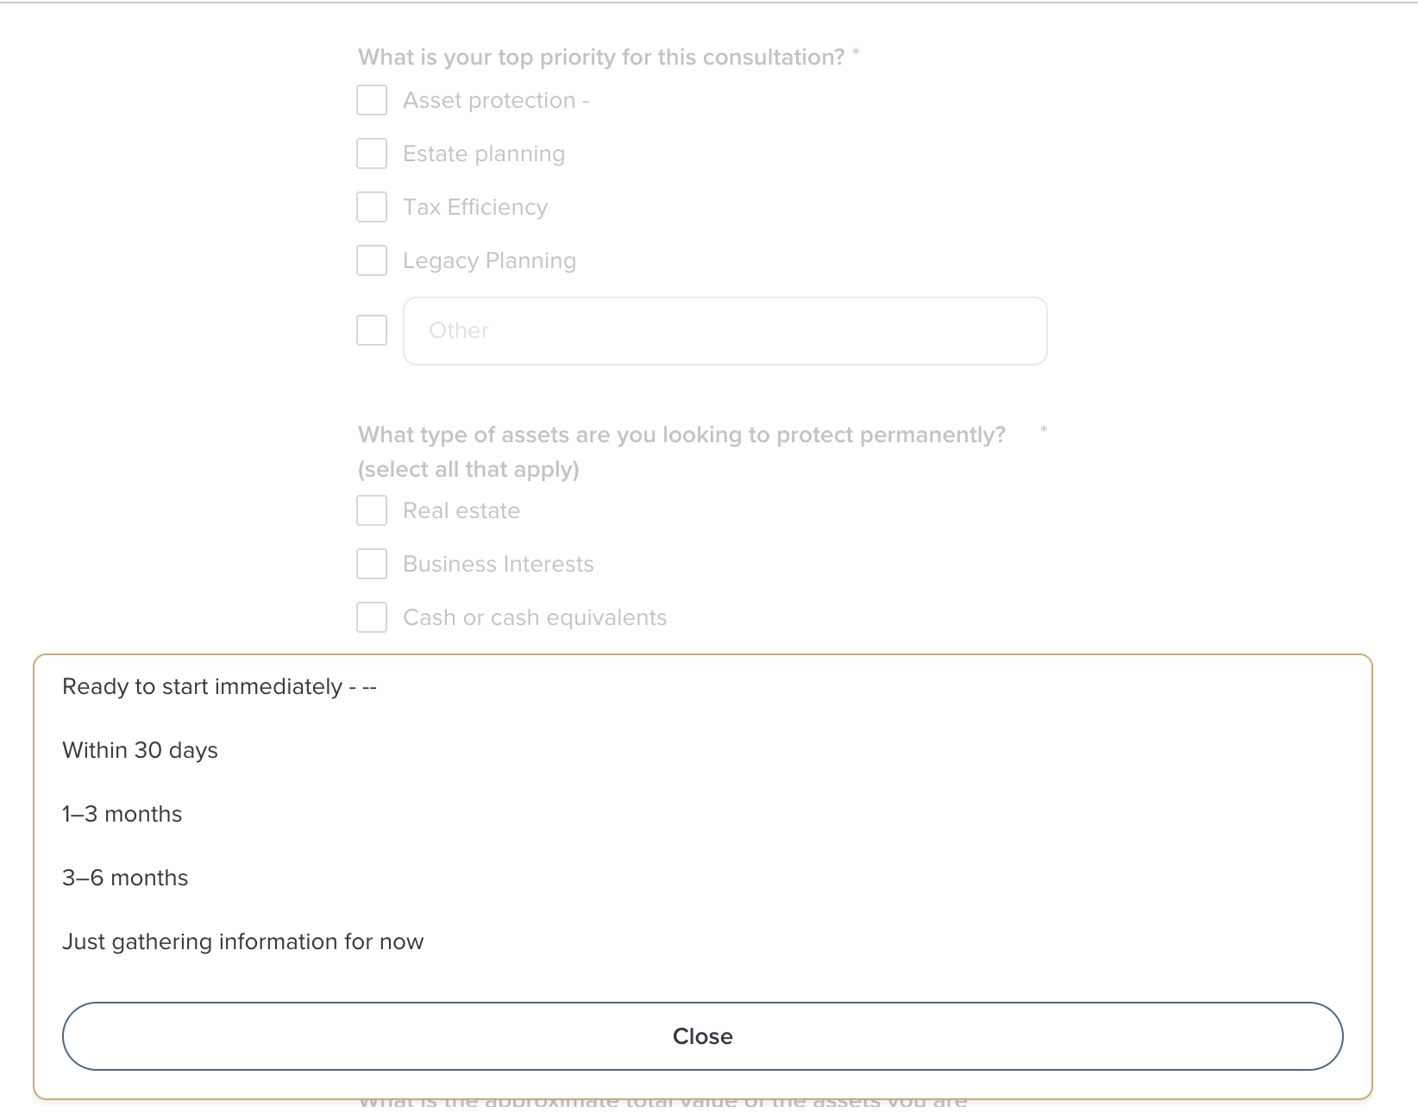

* Also when in the “edit” mode on the formbuilder there is no way to “X” out or close the popup and it freezes or forces me to click the back button on the browser so pllease make every pop up easy to inutitive click to close by clicking on the “x” or anywhere outside of the popup to return to the prior main screen you were on

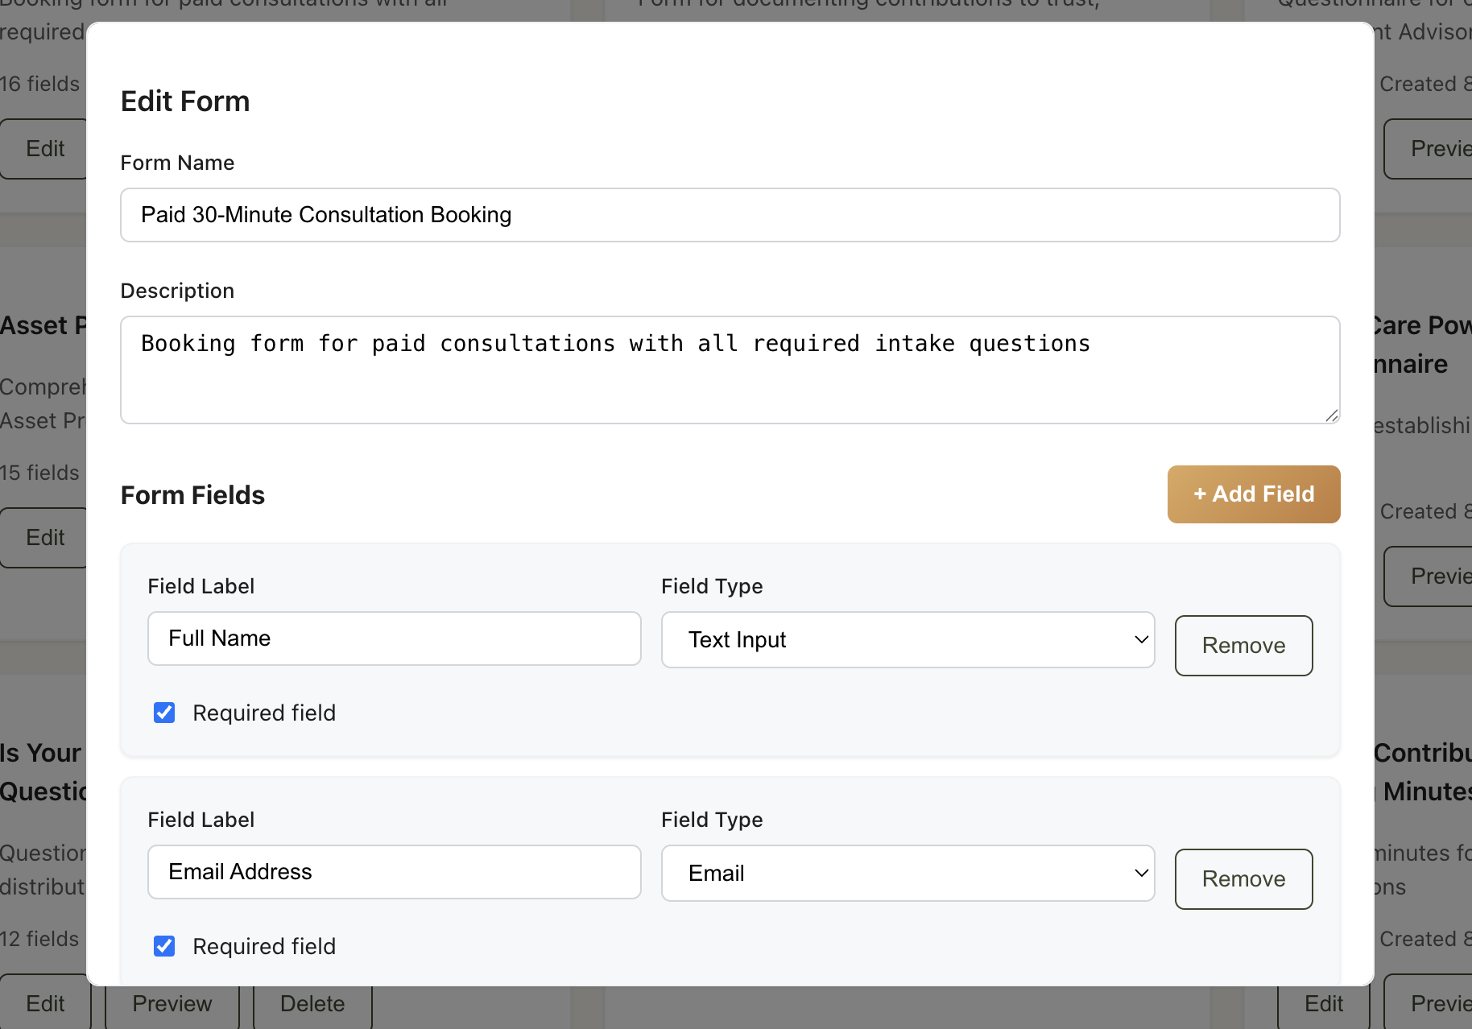

* **When you click on “edit” inside the My Documents library it goes to a blank white screen and so for now lets just make these documents able to be previewed and deleted and leave document editing something that occurs out of the system and have a button that allows the person to “upload new version” in the same spot again for version control and have that functionality replace the current “edit” button next to each document type that is stored.**

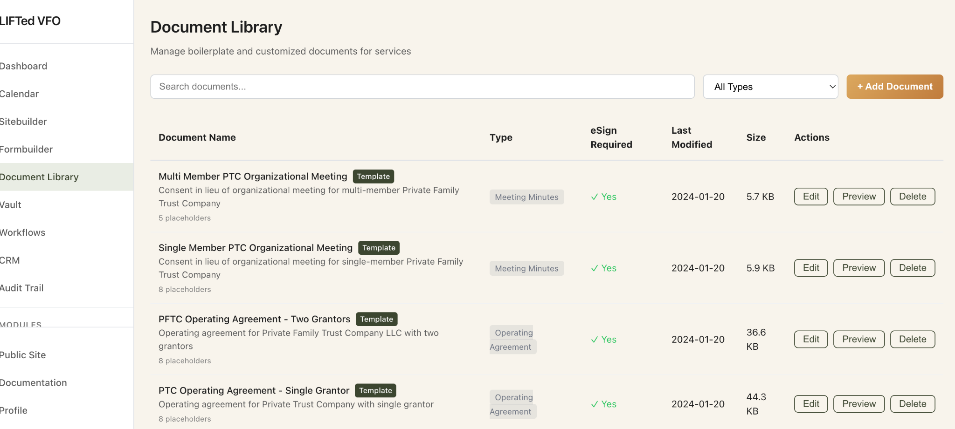

* **Make it easy to also “add Google Contacts” on this CRM module page please for those who have logged in from the Gsuite email as users and fix the connection to the formbuilder (for add lead form, add contact, add service type, and add sequence) since they aren’t mapping properly to the areas in the system where those tasks can be done. Also the import .CSV doesn’t actually save or import the csv into the Clients or lead list. It allows you to attach the .csv file but then doesn’t save them.**

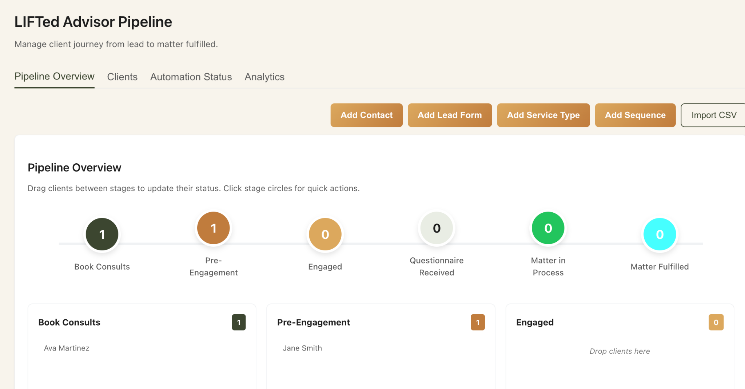

* **The advisorIQ section doesn’t let me edit the copy by clicking on the boxes on the first tab and the blog post section now allows be to add a post title and text but no inserted images and also doesn’t show up on the public site once published and just previews to a whiteout screen. And this needs to not save (MOCK) still in the header and be live.**

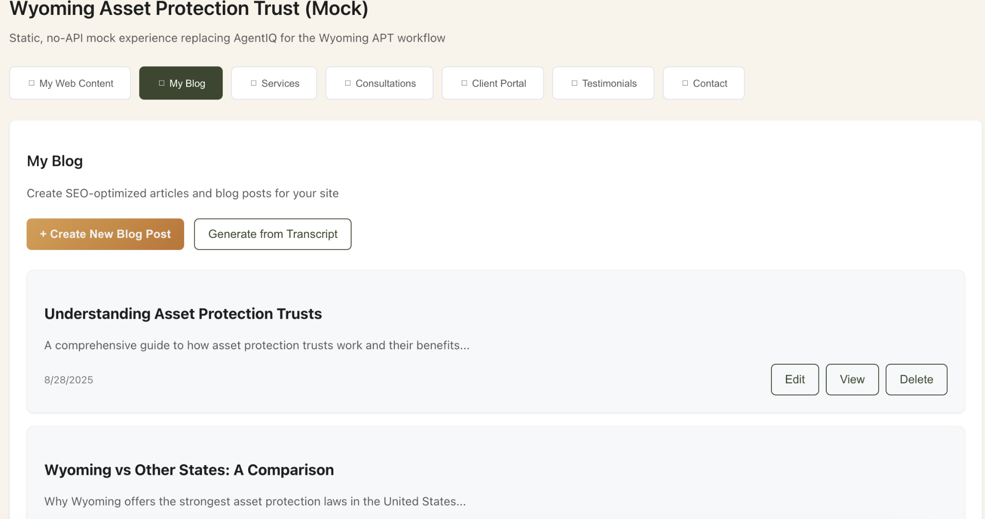

* **Each one of these tabs in the advisorIQ must be able to have its modules “editable” from within the system and saved and then properly sync to the area of the public site they connect to with that new information.**



* **Done for 8/28 sprint.**
* **Signed by Ali Katz _________________________________**

**—-----------------------**

**backend technical doc context for any security architecture we need before going into “production” from beta.**

View here as needed for backend “vault security and vectorized data base design and technical documentation https://docs.google.com/document/d/1MW0ZWWSTMLEoKEtaUR2UFui2SCdRJDvHonHibPwK4zs/edit?tab=t.0