**Punch**

* **Formbuilder Module- when you preview it and want to see what the options are to make sure they saved properly the preview doesn’t allow you to check.**

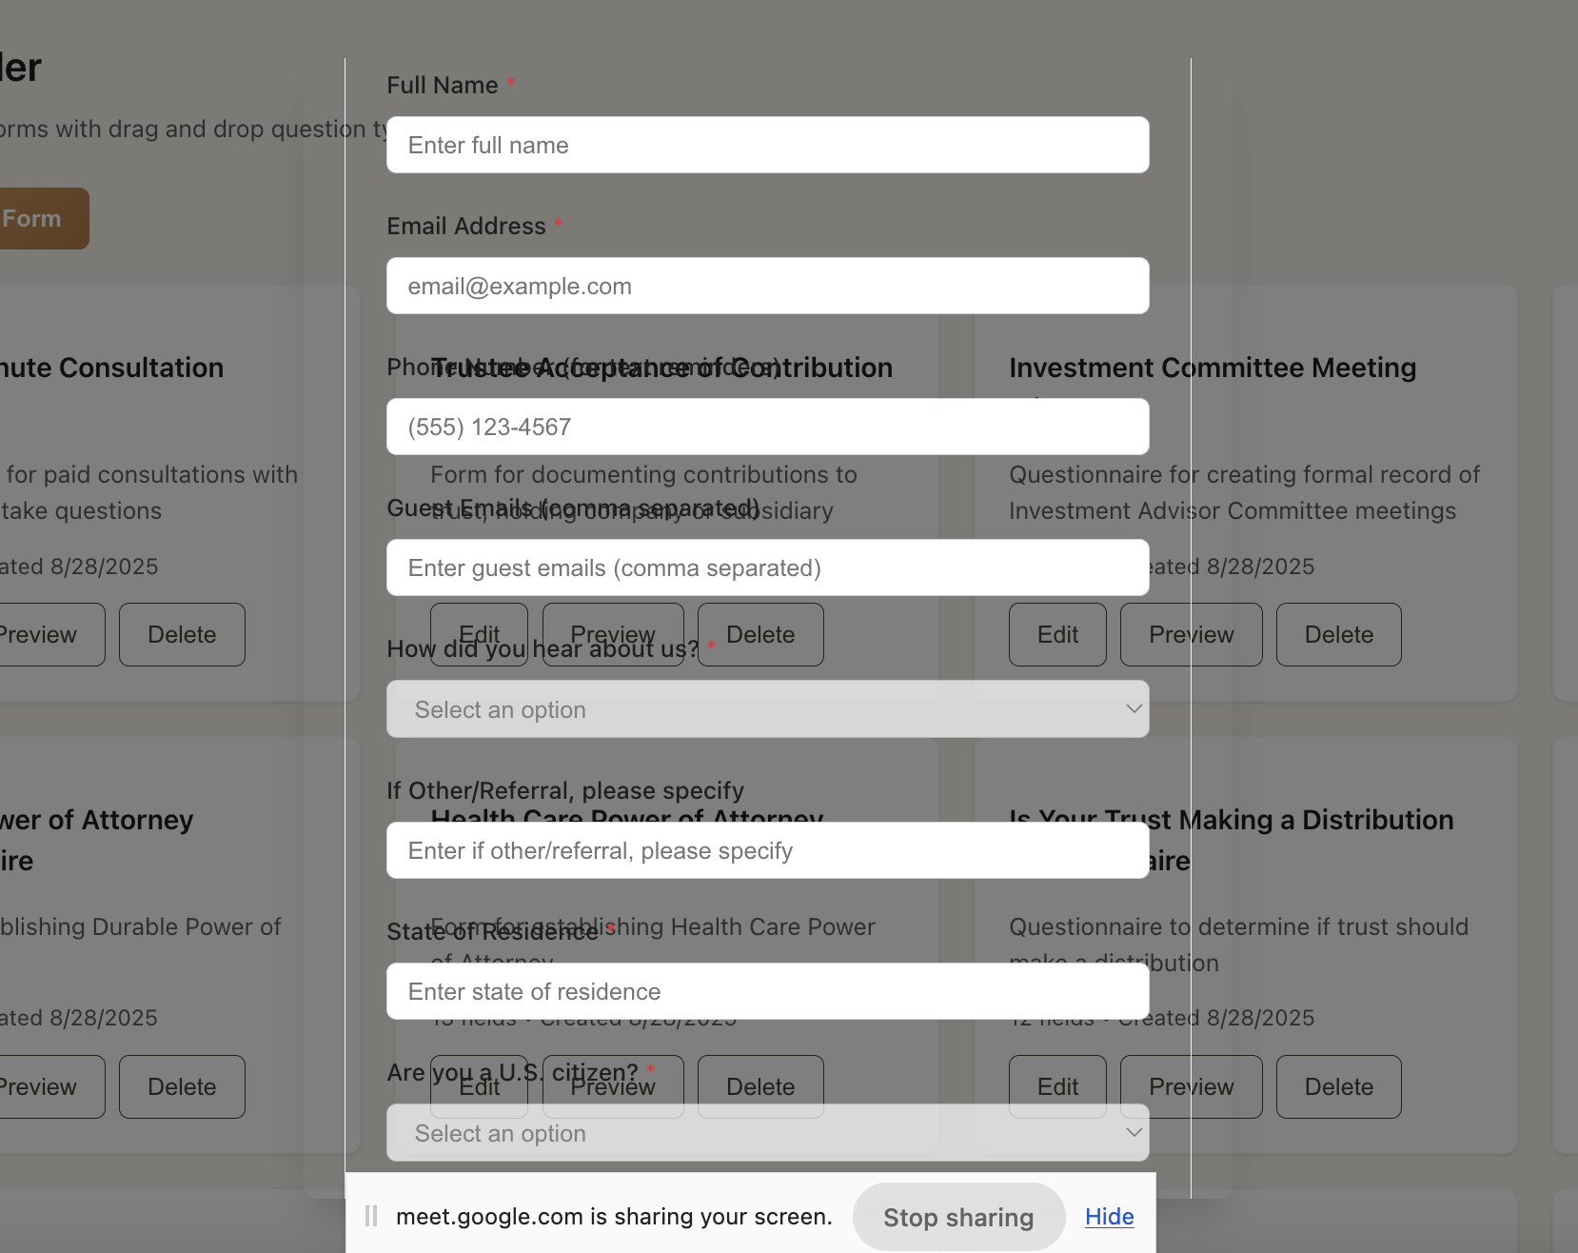

* **Workflow Module- Need to make sure that you can edit existing sequences and “add” or “delete” steps and or copy in each one without having to restart and recreate them from scratch> Right now once these are created you can’t go in and insert additional steps for alerts, or binary sequences that get triggered if actions are not take or when they are and that needs to be possible.   
  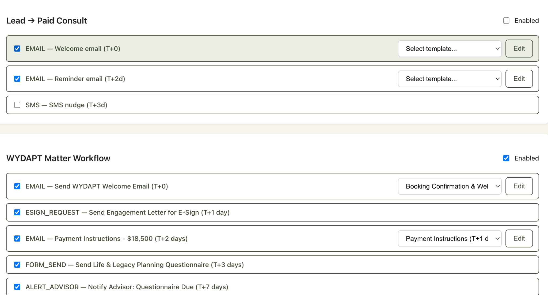**
* **Vault Module- When you are in this generate draft area and go to generate a draft it doesn’t provide a full preview that should be in a box and be able to “click into” to edit from the document it pulls in and personalized with the client details and or be able to save and approve/send.**

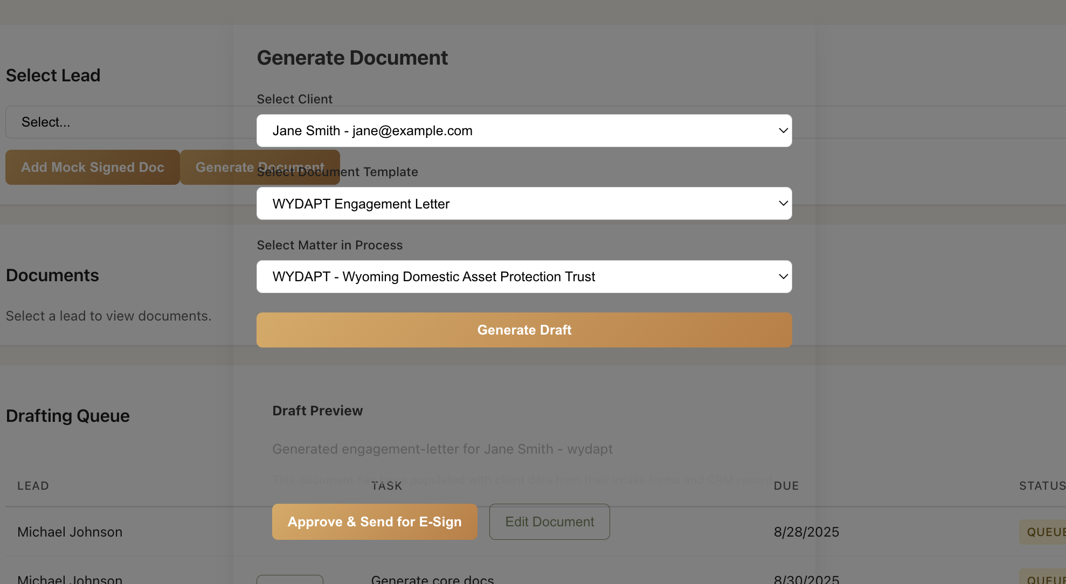

* **Workflows Module: tab popups when you click to view or edit an existing step doesn’t allow you to drill down and see or edit an existing step once at this phase**

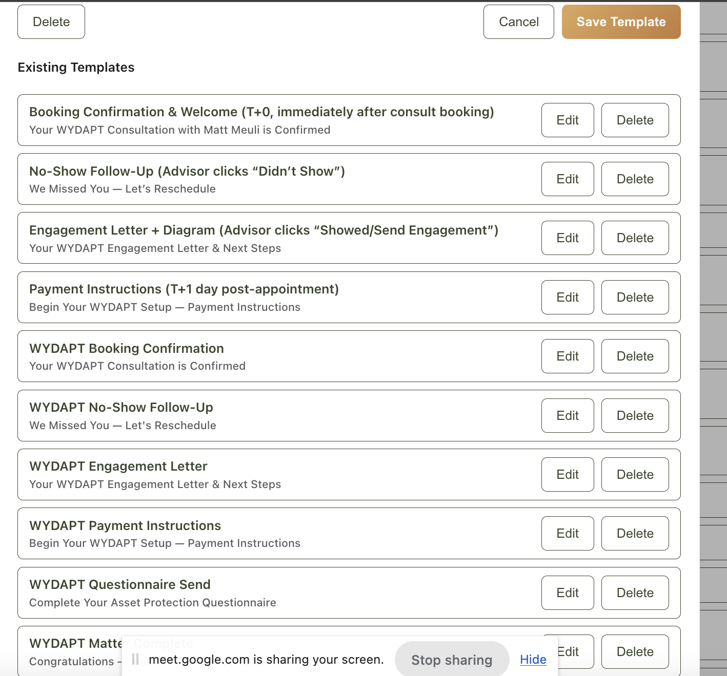

* **CRM Module: On this phase it needs to pull the advisors name from the “contact form” and user profile name. For instance this one should say Matt Meuli not Matt Johnston**

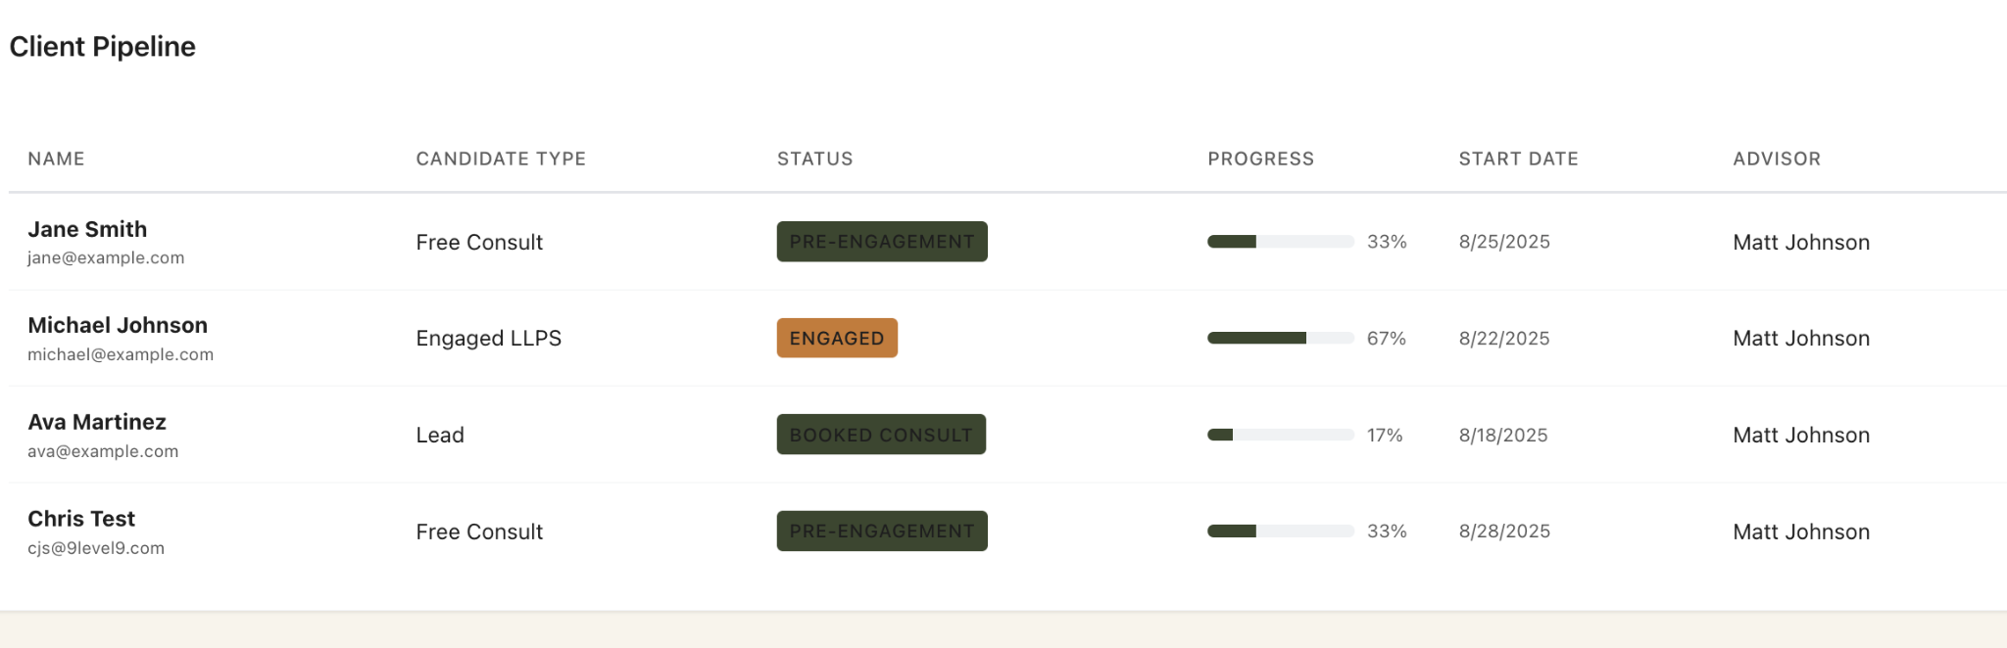

* **In the CRM module remove these buttons on the top except the “Add Contact” and “Import CSV” need to be removed. So please get rid of the “Add Lead Form”, “Add Sequence”, and “Add Service Type” buttons from this part of the module on CRM and just keep the “Add Contact” and “Import CSV” buttons and functionality.**

