**DASHBOARD MODULE:**

**All the sudden these KPIs aren’t making sense and should map to the actual CRM data by stage and show up ratio can never be higher than 100% and it currently says 400% for some reason. In addition this summary of the pipeline should be exactly fed in from the expanded Pipeline Overview inside the CRM module and update as it updates**

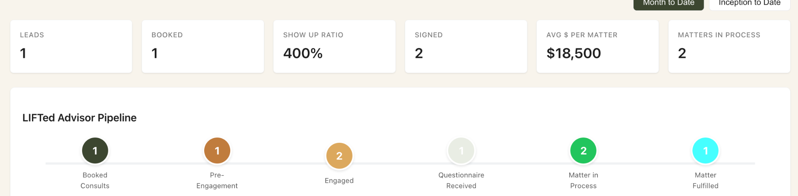

**Sitebuilder module:**

**The video link all the sudden is broken and the public site isn’t showing it and this needs to work for the demo and be seamless. The link is still active and viewable in google drive so this should be fixed in the code.**

