**__________________________________________________________________________**

**#LOGIN PAGE**

* Need to make sure that it allows for the selection of “Signing up/Creating an Account” for LIFTed Advisors and another option for “creating a client account” (for the clients of the advisors) On the latter it should provide a box that has a dropdown menu of active LIFTed Advisors to select by name or username-

I.e. Client UX should say “Connect with Google Account” or “email” and then on the next screen it should say for clients “Select your advisor” (search by username or dropdown of actives)” Matt Meuli”

**#DASHBOARD PAGE(Advisor Tier)**

Please make sure these metrics are actually accurate and tie in to the backend data that is in the #CRM and #Pipeline Modules so that as changes are made manually or automatically there via drag and drop or etc through the phases that the data accurately syncs to this dashboard summary of KPIs below:  
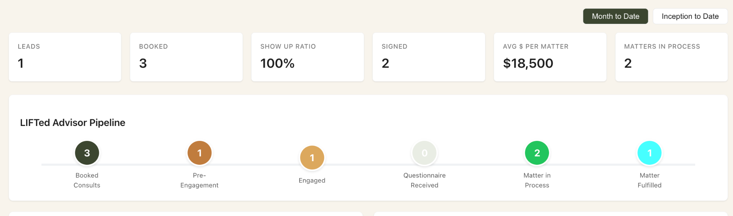

**#Calendar Module**

This needs to be synced in real time to the advisors and or the clients google calendar upon login so that all public site booking appointments are accurate in type, time and availability and this “connect my google” link needs to work properly

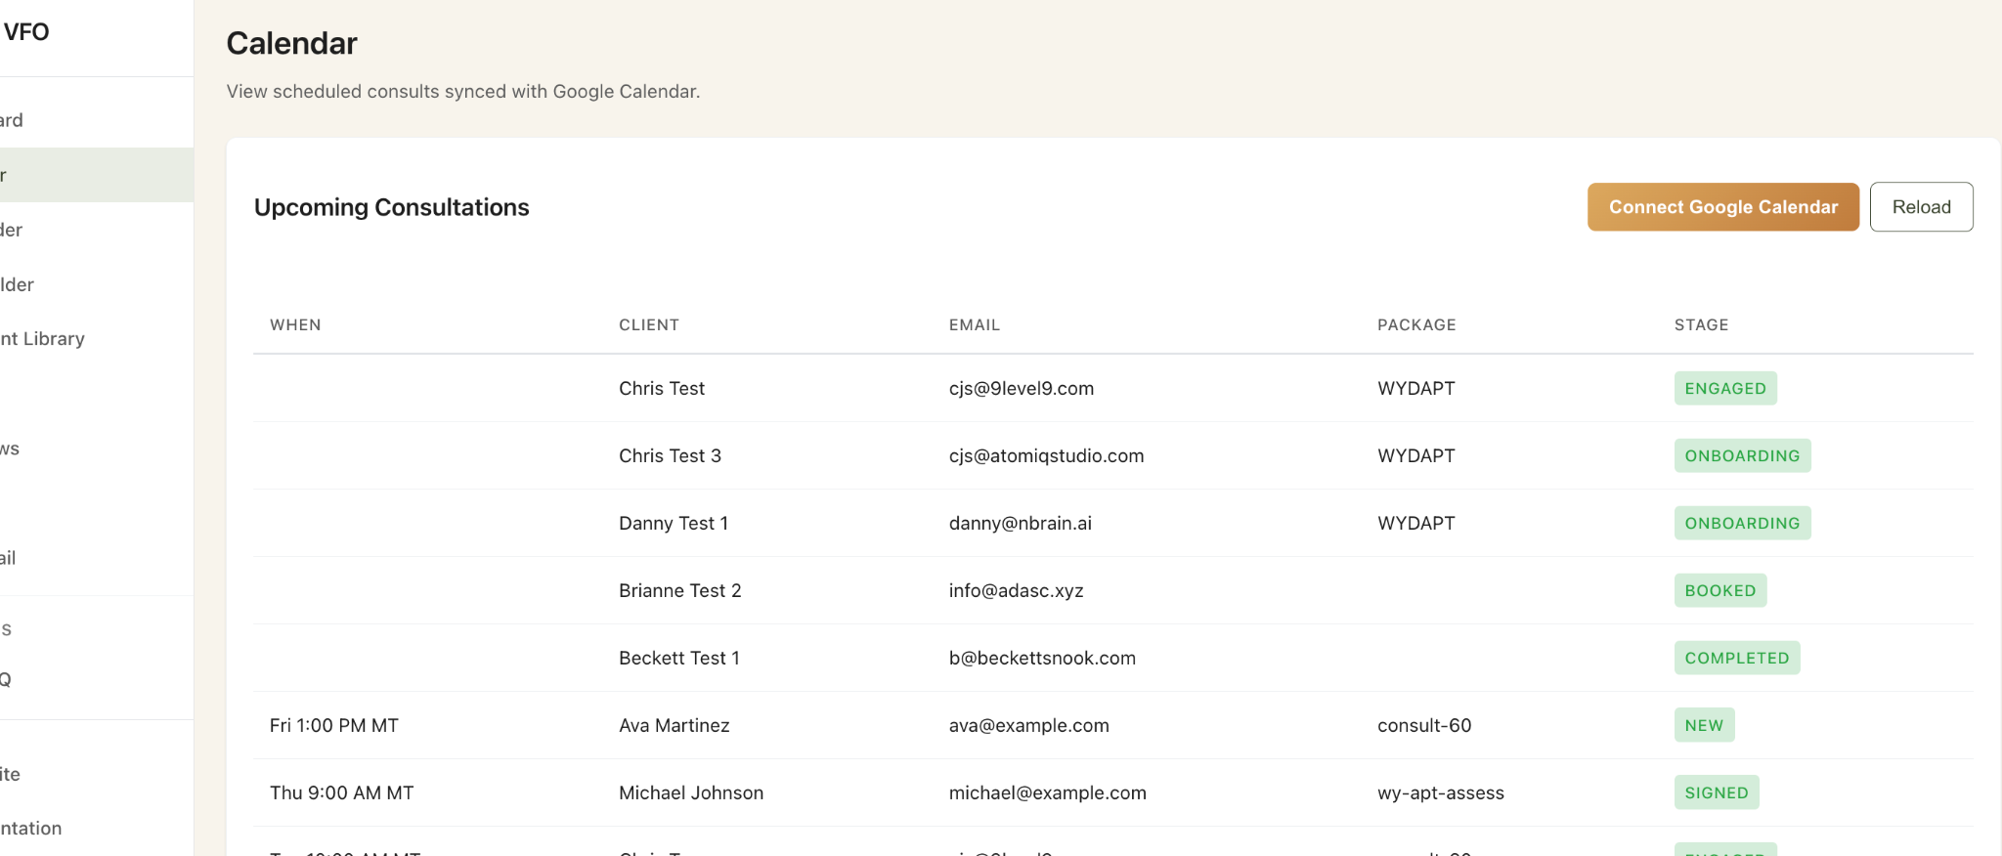

**#Sitebuilder module**

Needs to have the preview live site function working again and also needs to be able to have a section to “choose username” (scrubbing the god mode database for available handles before allowing them to “save” and this will then become their advisor public page if they don’t connect their custom URL (i.e. <https://liftedadvisors.com/username>) and they can choose to connect their own custom url to redirect to this system (ii.e <https://wyomingassetprotectiontrust.com> ) would replace and point to the same place and benefit from the SEO and GEO rankings instead as the TLD where their public site template was indexed.   
  
Example of what I want from another platform: This should be modeled after all other best practices like <https://wealthmatters.substack.com> or custom url version <https://wealthmatterstome.com> go to the same place hosted by Substack but owned by me.

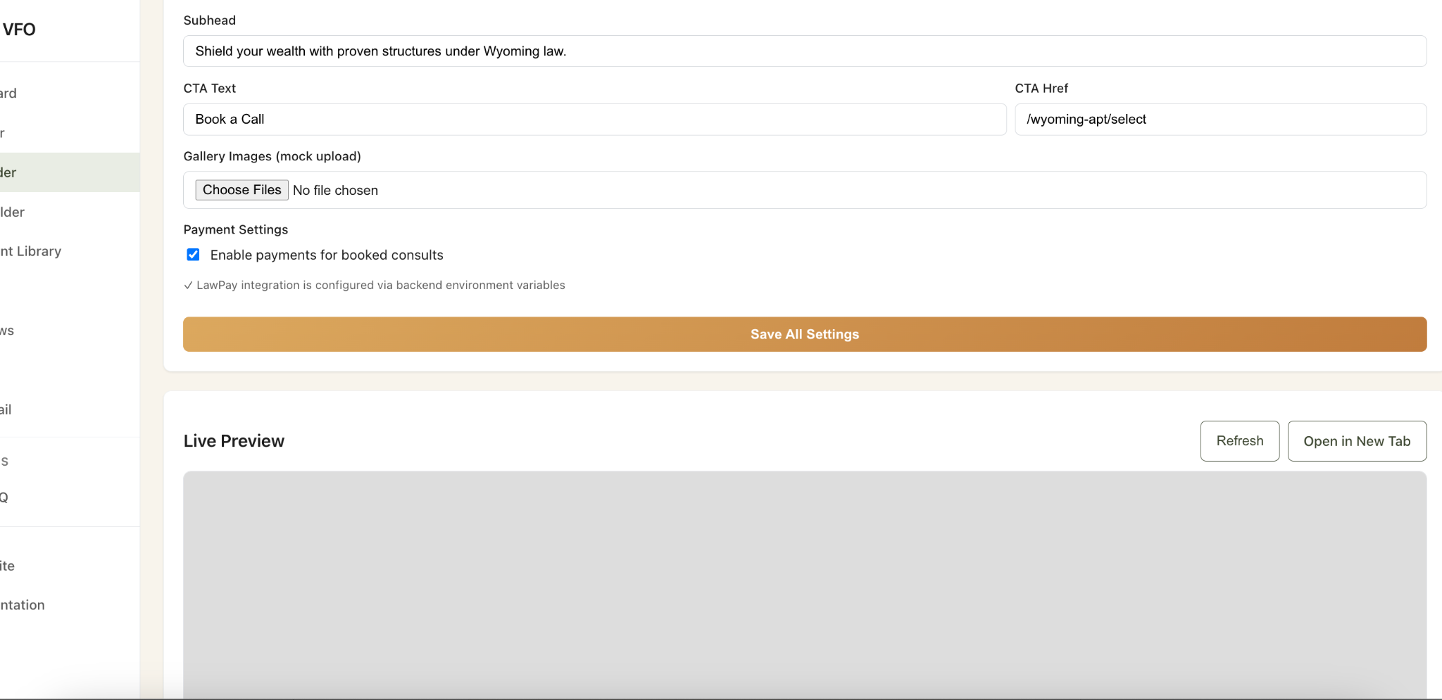

**#Formbuilder module**

* Need to make sure each form that is added or edited can be mapped on the backend to a front end process in the public site or client side when they click “Start” on a process or consult or engagement.
* Also every time a form from here is submitted by a user it must be tracked in their progress to completion section on their client side KPIs and dashboard as well as in the Advisors side on a user by user level and rolled up in the total pipeline view.
* ITs key that when these forms are completed and submitted that the audit trail reflects the activity of each login and step along the way in the client ID and in aggregate for the Advisors autit trail
* Its also key that each of these forms once submitted can be used in the creation of “rules” for the workflow automation tools that trigger future steps in the sequences of nurture and or project management to completion.

#Document Library Module

* The preview needs to be working and show the example of what the document looks like on the front end view experience to complete and submit in each of these documents that can be uploaded or previewed after being created in their GUI form. Example of the broken preview from one of the documents below:

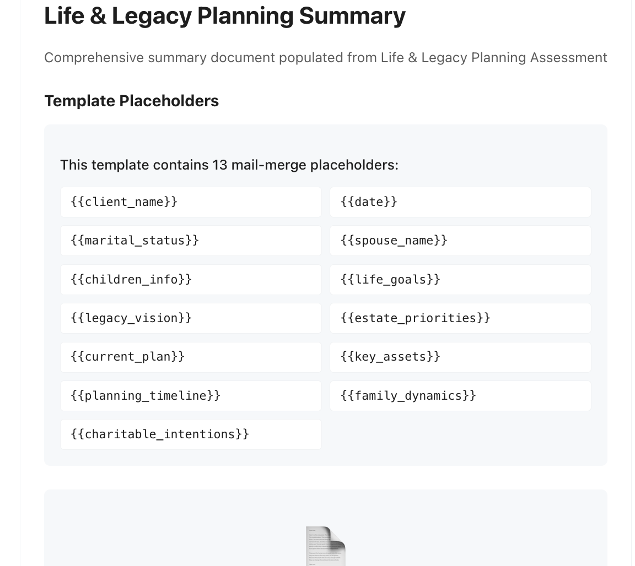

**#CRM Module**

This data in pipeline related to contact and client or prospect management must be properly connected across the entire backend to feed the related other visual displays in this system accurately from the Pipeline to the Pipeline Summary of KPIS on the Dashboard page and also in the Client record and details section so that we have a unified single source of truth here that feeds all the other modules accurately. This is not currently happening in the code. Examples of one of many disconnects or omissions is below from within the CRM module under the “Clients Tab” and the “Pipeline Tab”

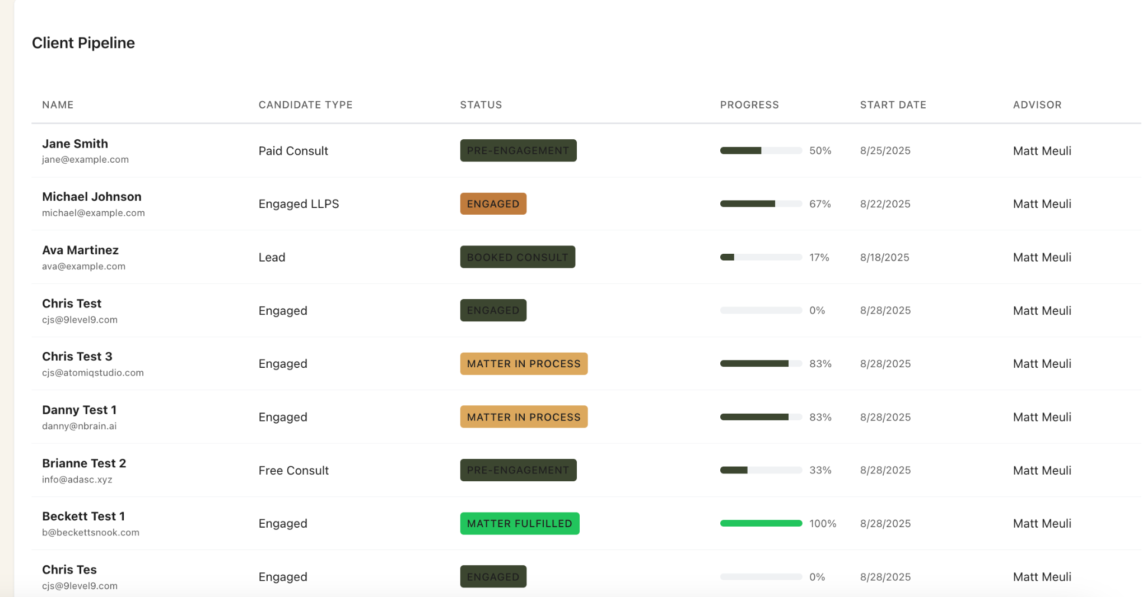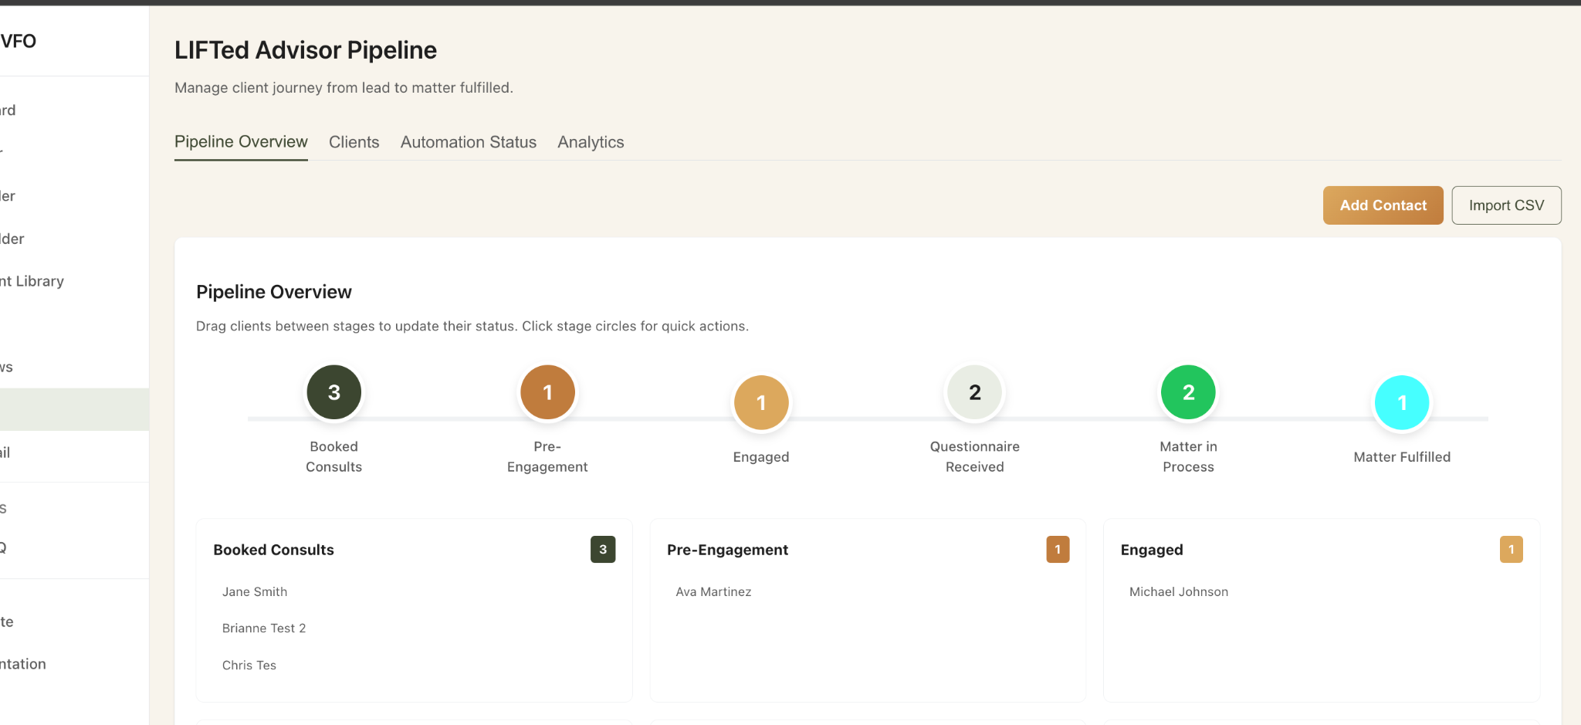

**#AdvisorIQ -Client Portal tab module:**

**The #formbuilder library must be able to link to an editable version of this page**

**And all of its tabs on “editing” so that if a call to action is in the front end facing output that a form or workflow can be selected to begin the ingestion or checkout, especially the “client portal” tab seen here since it is key to MVP functionality between the client tier interface and advisor automations or alerts**

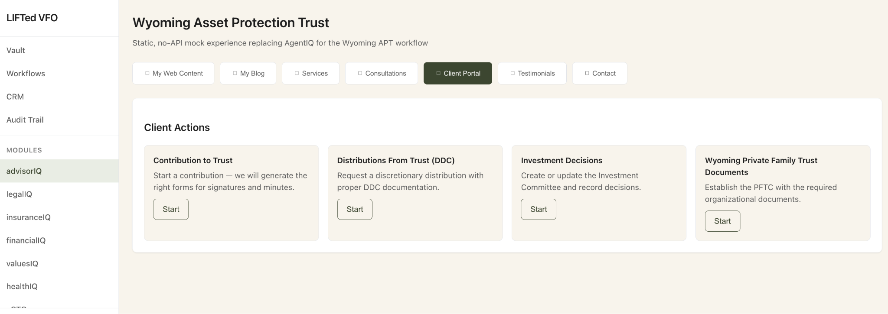

**#AdvisorIQ-Consultation Tab Module**

* On this page we need to be able to edit, delete, and add new types of consultations and have them sync with all lawpay merchant checkout procedures as well as the active google calendar of appointment types and real-time availability on the scheduling page when appropriate.

**#AdvisorIQ - Services Tab Module**

* On this page these sections need to be “editable and savable” so that this content can be modified and then repulbished to the appropriate front end section of the advisors landing page and sync. Also the “learn more” button should be editable so that it could be changed or redirected to either a “blog post” about the content or to the “book now” consultation page. For instance when the advisor is in editing mode they should be able to seledte “edit button” or “edit body” or “edit title” and do all three. When they edit the body it should have a character limit of 250 words. THe button should allow for text within the button and a link to an internal or external page for the hyperlink beginning with https://
* This tab should also allo the advisor to “Add Service Offering” as well as edit existing ones. Should the Advisor list more than 3 services the template will lay these out 3 across in desktop mode and as vertical squares in mobile mode for optimal readability.

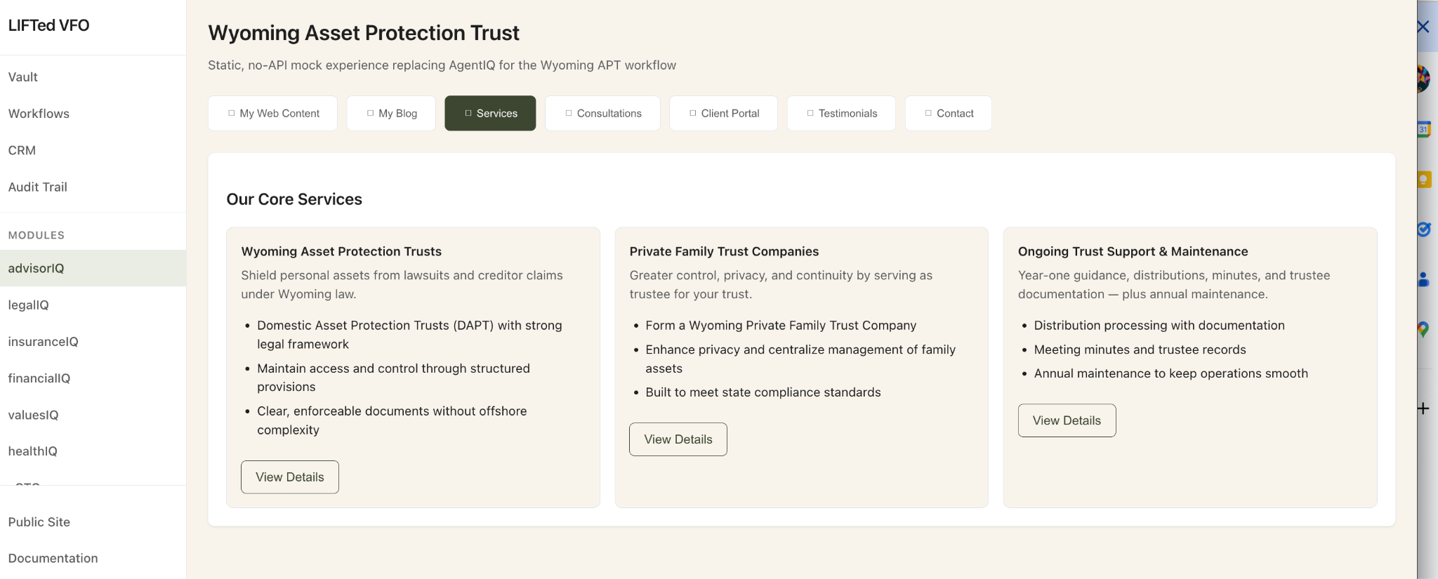

**#AdvisorIQ-My Blog Tab Module**

* This area must be live and also pushed to a navigation tab on the advisors public site template call “Blog” so that each post can be posted as a summary of posts with each one then being able to have its own full read indexable page for consumption.

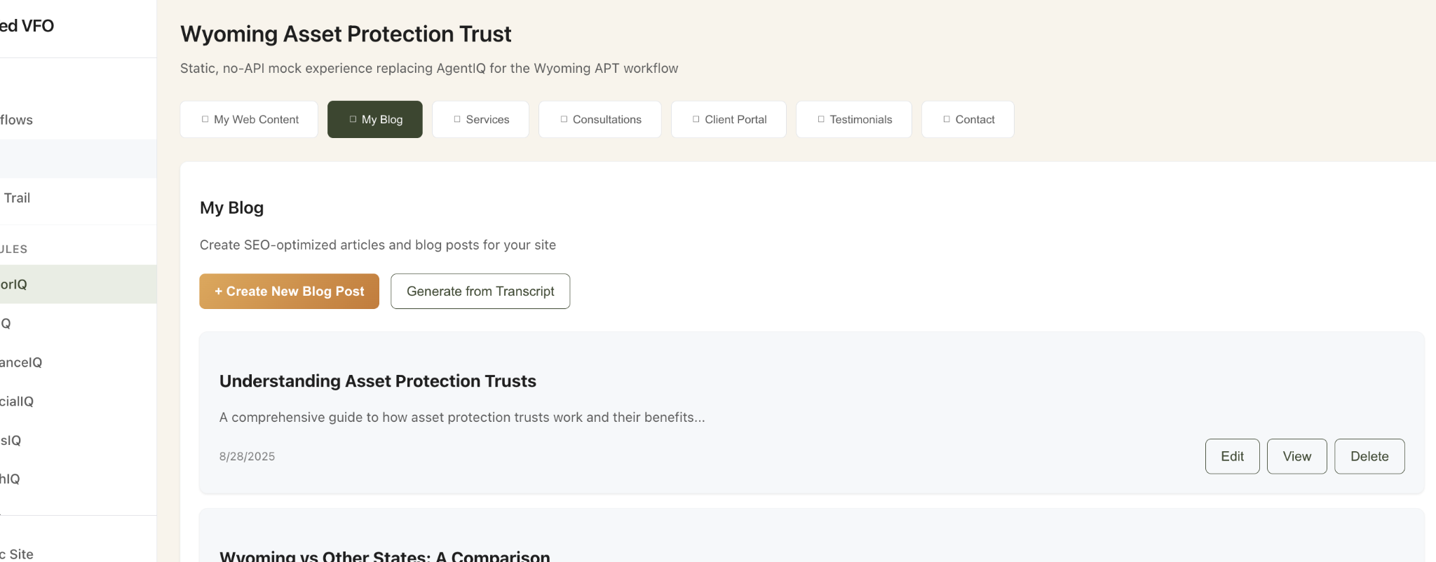

* There should be no limit to the number of blog post that can be created as indexed pages and there should be a “featured” selection on the post that would put up to three posts on a subsection of the home page called “Featured Posts” that is up to 6 at any time and three across in layout summary tiles with headline and the first 280 characters of the post

Add an option to “feature” this on the editing widget of each post so that it can then place these on the public site home page under a new section called “Featured Posts”

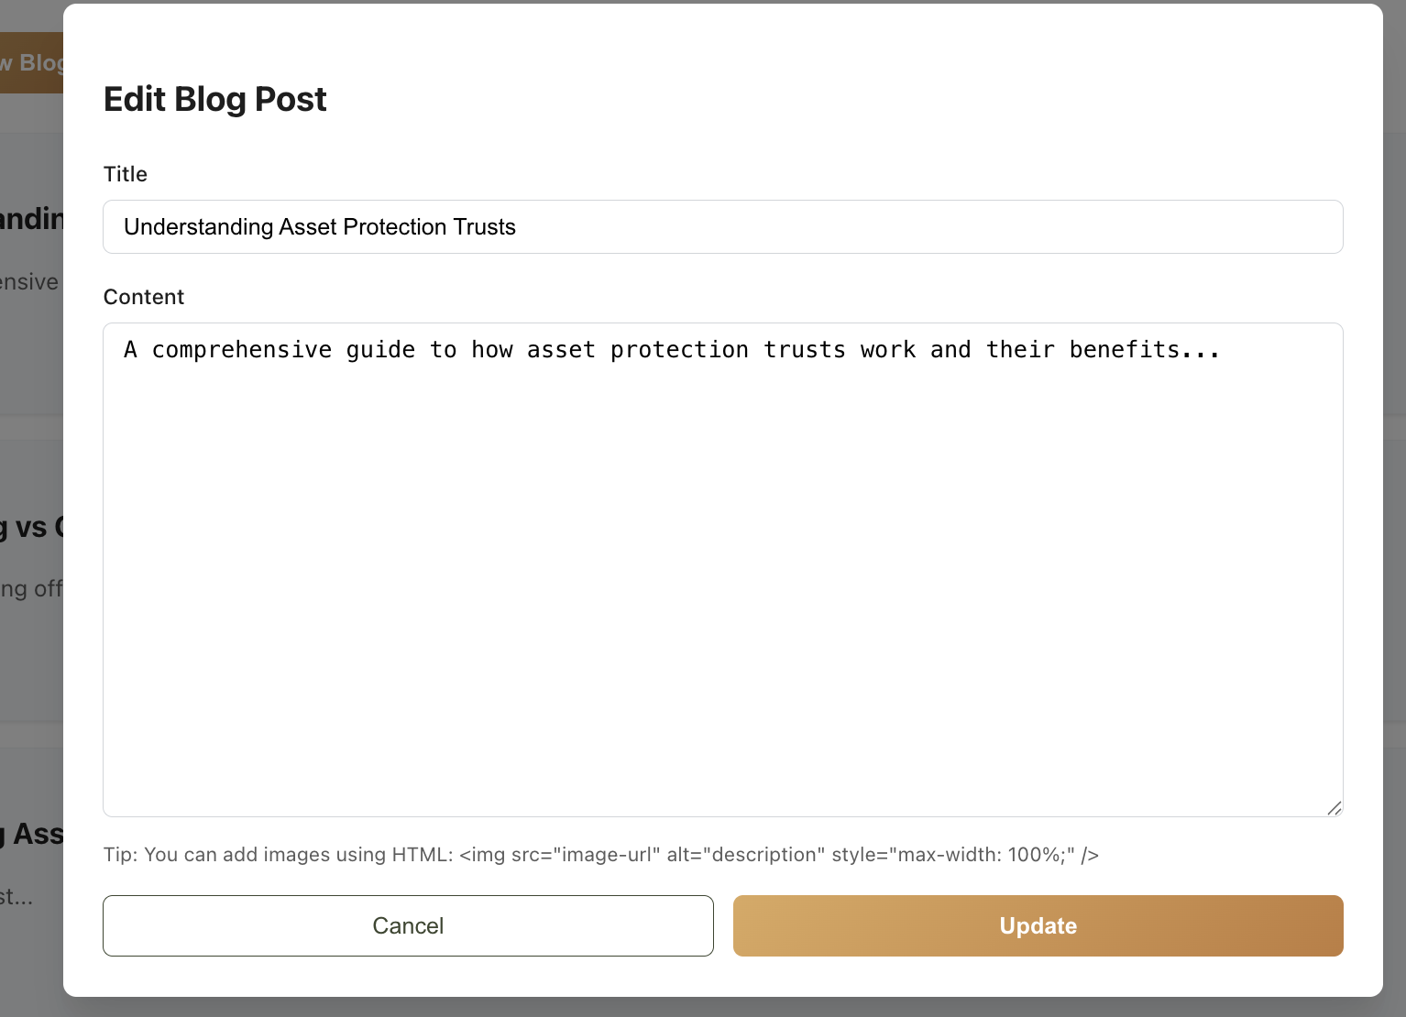

* Also the generate SEO enhanced blog from audio transcript feature should provide an editable “preview” post that can be modified and then published once it is started.

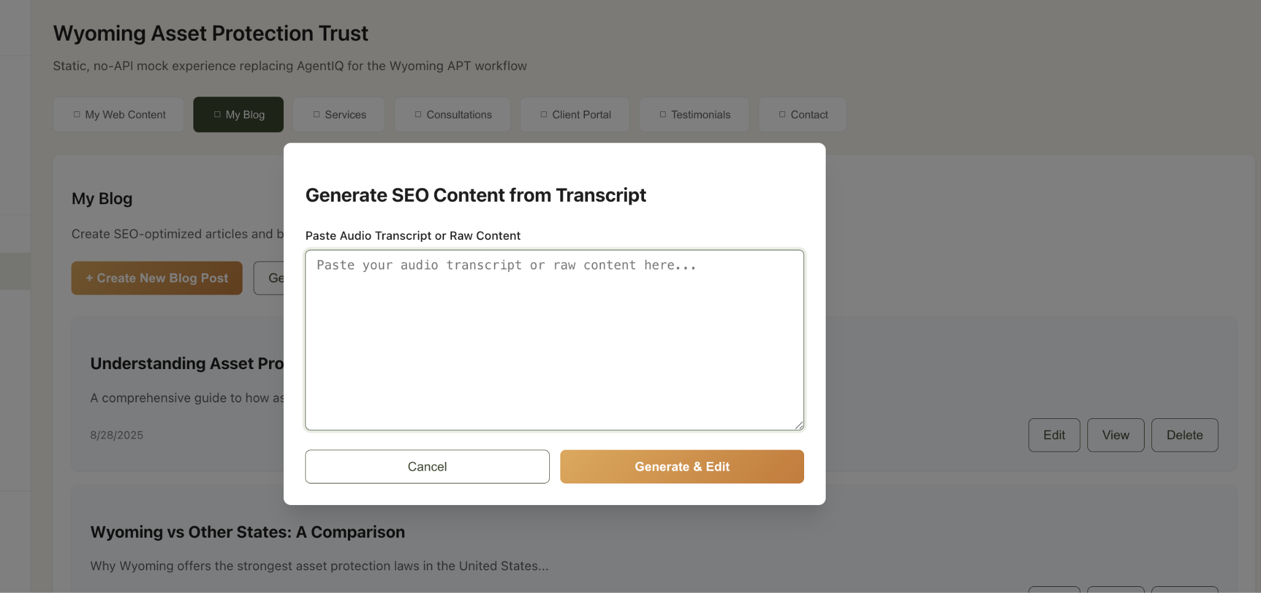

**#AdvisorIQ-My Web Content Tab**

This section needs to be editable in each box and sync all updates to the public site in its appropriate section. It also needs to have a section added that is for “Featured Posts” that ties to the Blog section above as the front end portal to the backend blog site of indexed pages

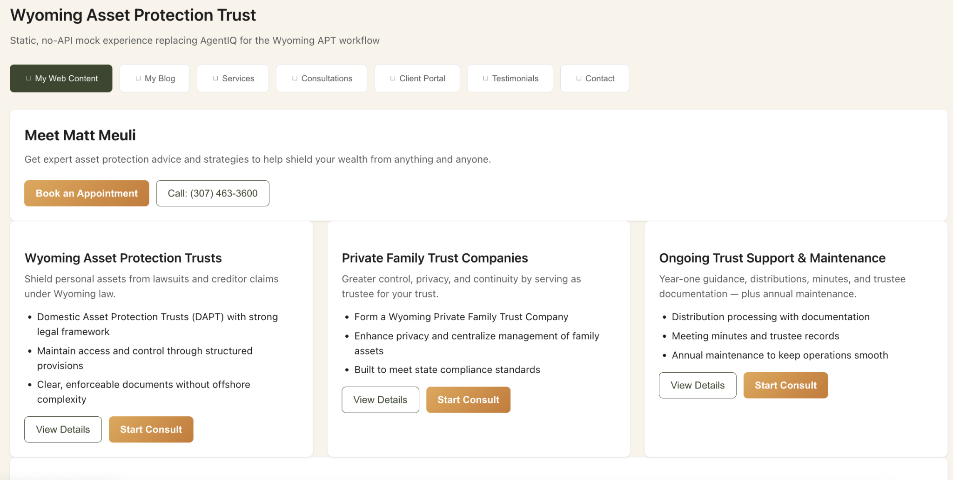

**#AdvisorIQ-My Testimonials Tab**

Needs to have all of these editable so that they can be changed or added to in number and synced to the public site home page section.

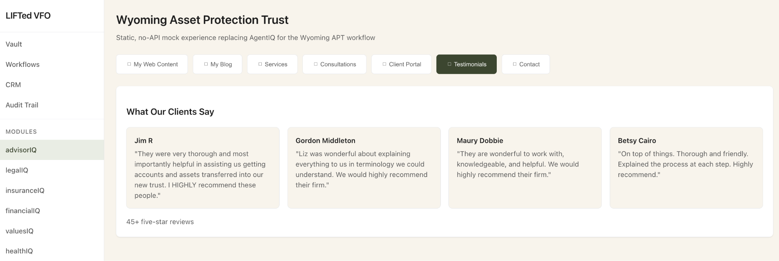

**#AdvisorIQ-Contact Tab**

This section also needs to be editable by each area so that it can be updated by the advisor as needed and have it synced in real time as it is republished to the public site.

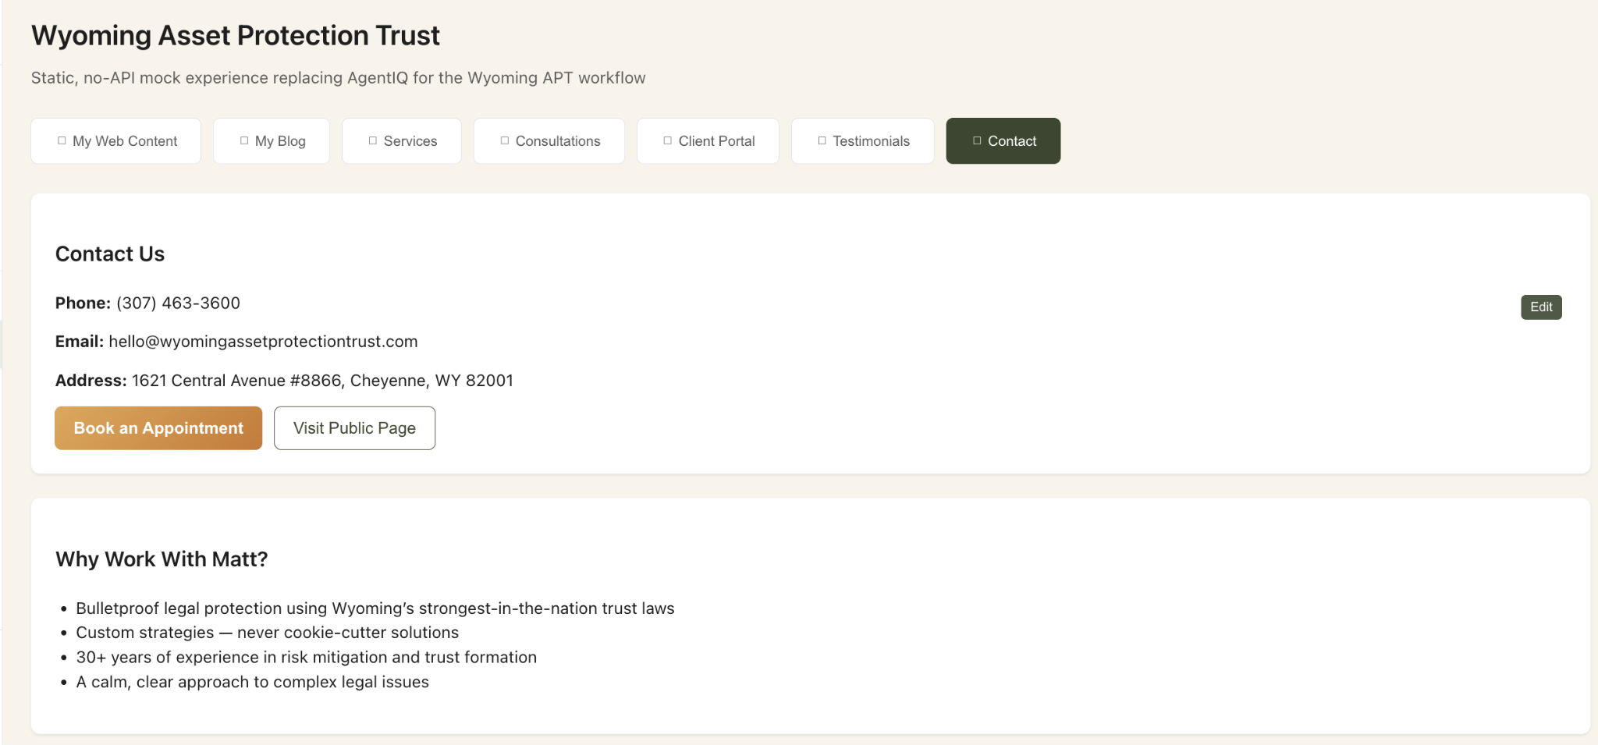

**—-----------------------------------------------**

**CLIENT LOGIN TIER CHANGES**

**#SIDEBAR (Client View)**

These are the only modules visible for launch on the Client side should be

-Dashboard Lists the KPIs and notes below when clicked and on login

-My Advisor (lists the contact info from advisorIQ side)

-Matters in Process

-My Vault (holds all of their secure and encrypted final copies of trusts, entity articles of incorporation, minutes, operating agreements,, wills etc for download or viewing.

-My Questionnaires (lists all the relevant questionnaires that can be started or in process and completed and ab le to be submitted directly to the advisors CRM and files when they do

-Book a Consult (takes them to their Advisors calendar booking page of appointment types.

-Audit Trail (links them to their client only audit trail from the advisors system)

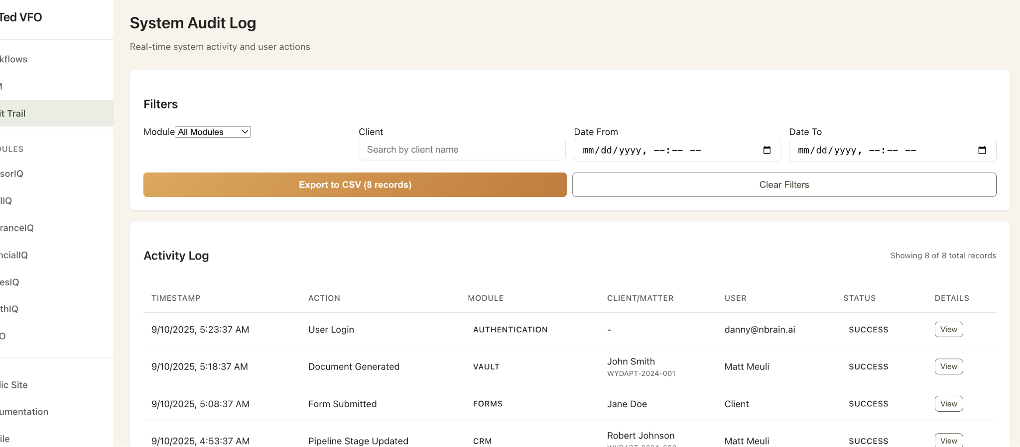

**#DASHBOARD PAGE (Client View)**

* **Need to see what this looks like in current state on that login tier since it should be different and show them their “Advisors name and contact info prominently and also the status of their matter in progress as the KPIS visually like this style in advisors dashboard but the phases are “Consultation Booked” “Consult Completed” “Engagement Letter Signed” “Questionnaires Completed” “Filings in Process” “Documents Received in Vault”**
* **This also should be the layout of action items in the DASHBOARD Client view for below the fold or the top KPIs section. And each of these should start the process of any necessary questionnaire from the advisor’s side form builder library and then map to the appropriate lawypay inventory of checkout items to pay for and begin if the matter is not related to an already existing and retained “maintenance item” This will be done client by client for now but the key for today is that when they hit “start” it takes them to a form that can be selected from the “library of formbuilder assets in the advisors side.**

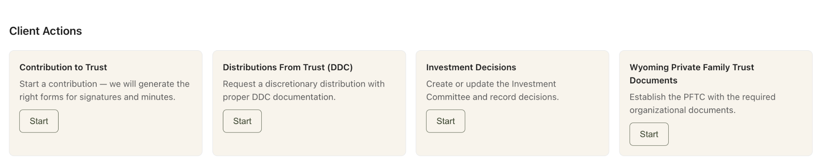

**—-------------------------------------------------------------------------------------------------------------------------**

**TECHNICAL DOCUMENTATION UPDATE NEEDED**

**#Documentation link on sidebar**

Must be updated with all the current code base and integrations and architecture as this is out of date and has wrong vernacular in it.

* Find replace AgentIQ VFO Platform- with “LIFTed VFO Platform”
* Find replace WealthIQ with FinancialIQ to match sidebar and current state,

See current errant version below:

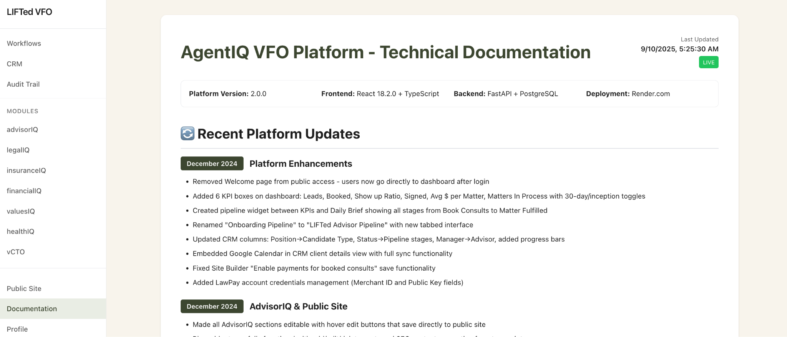

* but there is a lot more that needs to be accurate to the current code deployment after all of these tweaks and changes are made. Including the detailed way we must architect the VAULT and Vector database dynamic for stored data (default is to encrypted only Vault unless the document or form or data is selected and checked to be “vectorized” as well. The option to “vectorize” “vault only” or “Vectorize and Vault” is ideal

See the Vault and dual mode storage architecture notes and design here with the encrypted two-way secure chat powered by the [element.io](http://element.io) protocol for the roadmap section of technical docs update below and please merge all of the architectural technical documentation below with the actual code deployment of MVP and live integrations that exist already so we have one unified and accurate document of what is live and what is on the roadmap but also what the core architectural design of the entire vision is as of today’s handoff.

# 

# 

# 

# 

### 