EconIndicator

Noah Brannon

2023-07-16

library(knitr)

## Warning: package 'knitr' was built under R version 4.2.2

library(ggplot2)  
library(rmarkdown)

## Warning: package 'rmarkdown' was built under R version 4.2.2

library(GGally)

## Warning: package 'GGally' was built under R version 4.2.3

## Registered S3 method overwritten by 'GGally':  
## method from   
## +.gg ggplot2

data <- read.csv('c:\\Users\\nbwan\\Downloads\\fredgraph.csv')  
data2 <- data[,-1]

## Introduction:

Hello this is a project I did in R using the Federal Funds Rate, Unemployment Rate, and the Consumer Price Index of each month from 1960-2022 in the United States. The point of this project is to find out the relationship that CPI (inflation indicator) has on unemployment rates and federal funds rate. For my final project when I was in school I was able to find that the relationship between CPI and unemployment rates was pratically non existent, at least in the United Kingdom. That project also disproved the outdated ‘Phillips Curve’ theory which stated that inflation and unemployment rates had/ has a inverse relationship. The point of this project has three main statistical objectives : 1). To further reinforce that the Phillips Curve theory is non-existent. 2). To find the relationship between the Consumer Price Index and the Federal Funds Rate, which has lots of relevance at the time of writing this (7/16/23), as the Federal Reserve went on a streak of increasing Federal Funds rate in an attempt to cool the pace of inflation. This idea is known as Monetary policy tightening, as interest rates are increased the idea is that aggregate demand will be reduced, less investments, and a lower money supply because of the higher interest rates the Fed charges to banks. 3.) The relationship between CPI and Unemployment Rates and the FFR (at once). There is no real economic idea behind this, but I am doing this to make a multivariate linear regression model.

plot(data$CPI.US, type = "l", col = "blue", xlab = "Index", ylab = "Values", main = "Line Graph of CPI.US, Unemployment, and Federal Funds Rate", ylim = c(0, 20))  
lines(data$UNEMPLOYMENT, col = "red")  
lines(data$FEDFUNDS, col = "green")  
legend("topright", legend = c("CPI.US", "Unemployment", "Federal Funds Rate"), col = c("blue", "red", "green"), lty = 1)

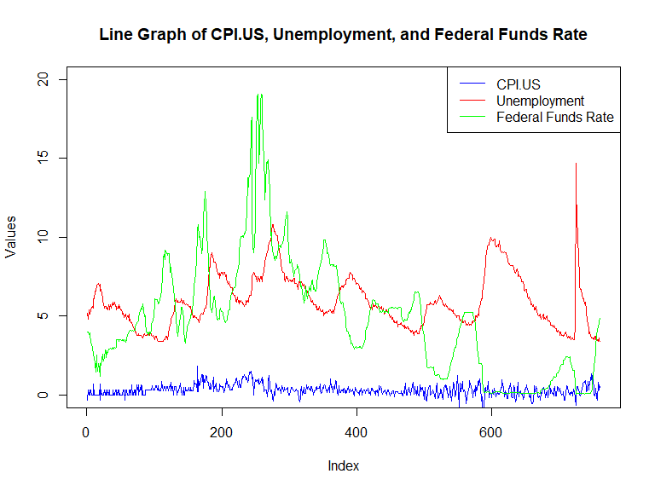

## Summary Statistics:

In this section will describe the summary statistics of each of the three variables and their histogram of the distribution of the data.

## CPI Summary:

In the summary statistics below, we can see that the mean and median are almost identical, however the mean does outstrip the median barely, so the data has a slight positive skew (or right), which you can see in the Histogram below, however the data looks to be a lot closer to a unimodal distribution, as that makes sense as CPI has generally stayed around 0 - 1 % since 1960 on a monthly basis. The standard deviation in this data set is .36, which indicates that on average the data points of the CPI variable are typically around .36 units away from the mean of .31, however as that number might look small, it really is not as the histogram shows almost all the data set in within -1.5 to 1.5 in values.

psych::describe(data2$CPI.US)

## vars n mean sd median trimmed mad min max range skew kurtosis se  
## X1 1 760 0.31 0.36 0.29 0.29 0.33 -1.92 1.81 3.73 0.07 2.77 0.01

hist(data$CPI.US, main = 'Histogram of CPI from 1960-2022', xlab = 'CPI', col = 'red')

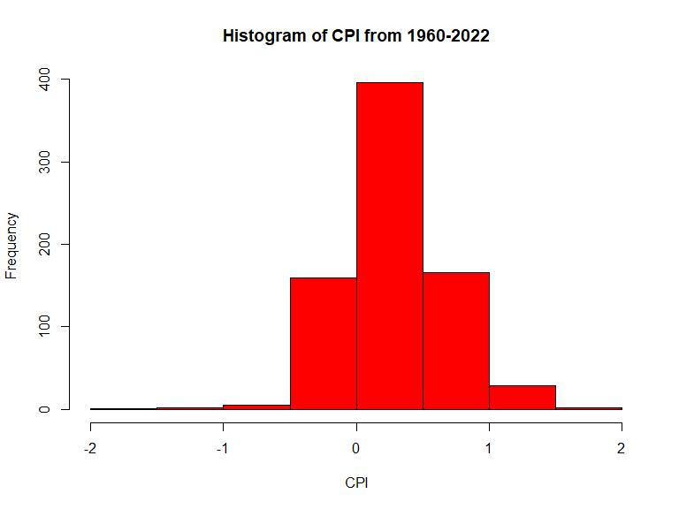

## Unemployment Summary:

Here we can see that the mean is outpacing the median which would indicate that the data is right-skewed, which can be confirmed by the histogram as there is a clear right skew near the beginning of the histogram for unemployment rates. This makes sense as unemployment has rarely ever shot passed 6% in the modern times but has during times of crisis such as the COVID-19 Pandemic Recession and Great Recession. The majority of the data happens between the intervals of values under 4% to around 10%. The standard deviation of 1.69 is relatively high respective to the dataset, this means on average the data points of the unemployment rate on average differntiate about 1.69 units away from the mean.

psych::describe(data2$UNEMPLOYMENT)

## vars n mean sd median trimmed mad min max range skew kurtosis se  
## X1 1 760 5.94 1.69 5.65 5.79 1.56 3.4 14.7 11.3 0.89 1.05 0.06

hist(data$UNEMPLOYMENT, main = 'Histogram of Unemployment from 1960-2022', xlab= 'Unemployment' ,col = 'blue')

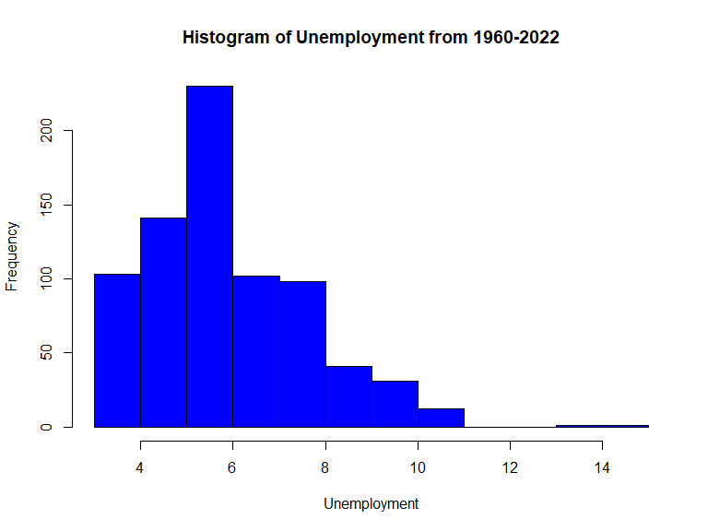

## Federal Funds Rate Summary:

Here we can see than the mean of 4.79 outpaced the median of 4.68. This would indicate that the data does have a right skew again, however if you look at the histogram there are two distinct peaks, one in the ‘0%’ bin and one peak at the ‘5%’ bin. This actually means the data is a bimodal distrubition with a right skew. Most of the data happens within the 0 to 10% range, however there is enough data pass the ‘10%’ to justify saying there is a right skew. The standard deviation of 3.69 is reltaviely high considering the values of the data set are inbetween the interval of 0 to 20.

psych::describe(data2$FEDFUNDS)

## vars n mean sd median trimmed mad min max range skew kurtosis se  
## X1 1 760 4.79 3.69 4.68 4.44 3.57 0.05 19.1 19.05 0.95 1.27 0.13

hist(data$FEDFUNDS, main = 'Histogram of Federal Funds Rate from 1960-2022', xlab = 'Federal Fund Rate', col = 'green')

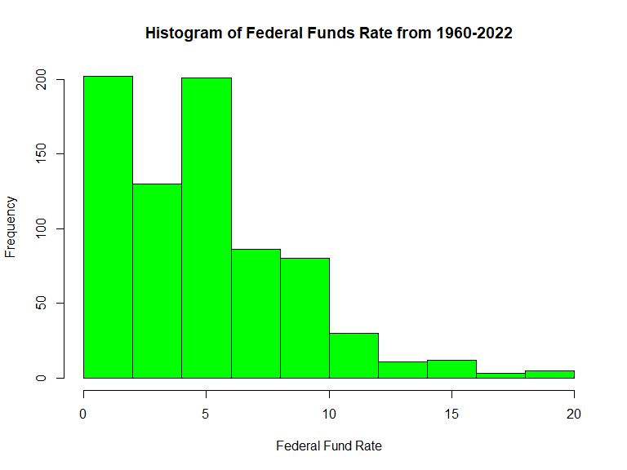

## Correlation Plots and Matrix:

Here is where we start to get into the real analysis. First is a correlation test between all three of the variables. The only correlation worth mentioning is the correlation between CPI and the Federal funds rate which a +.4306, which indicates a modertaly postive relationship between the the two variables, which can be seen below in the scattergraph plot between the two variables. The unemployment rate and CPI share pratically no relationship with a -.016 correlation, and the scattergraph between the two variables indicates there is no pattern present in the graph or relationship at all, which further inforces my previous paper (as mentioned before) that disproved the idea of the Phillips Curve. The last relationship should be basically thrown out as well is the Unemployment Rate and the federal funds rate, with a correlaion of .051, which is very weak correlation, the scattergraph also confirms this relationship, there is no real pattern to these variables in the graph. However, correlation does not equal casuation and more analysis will need to be done.

correlation_matrix <- cor(data2)  
print(correlation_matrix)

## UNEMPLOYMENT FEDFUNDS CPI.US  
## UNEMPLOYMENT 1.00000000 0.05118402 -0.01546201  
## FEDFUNDS 0.05118402 1.00000000 0.43061609  
## CPI.US -0.01546201 0.43061609 1.00000000

ggpairs(data2)

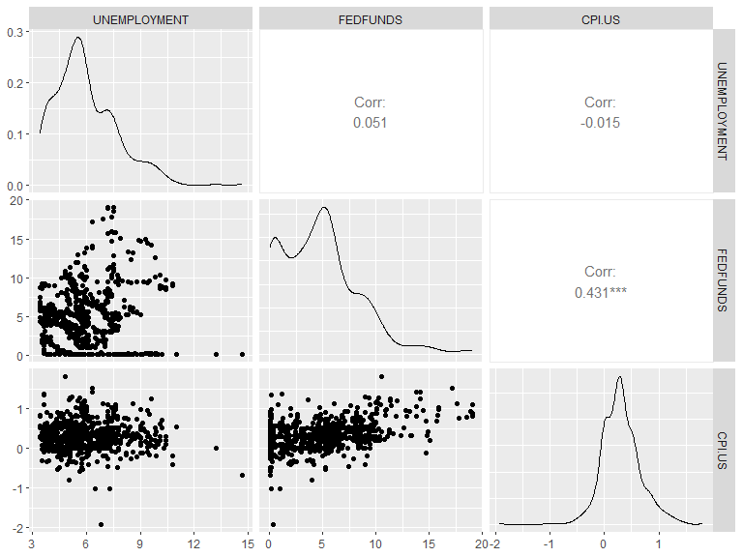

## Linear Regression Models:

Here we will get a better understanding of the relationships between the variables via Linear Regression models.

## CPI and Unemployment LR:

As expected, the relationship between CPI and Unemployment is practically non-existent. A R-Squared of .0002391 and a p-value of .6704 and an f-stat of .1813 means that there is almost literally no relationship via the R-Squared value, and the p-value is well above the common threshold of .05 and a low f-stat of .1813, means literally no effect was observed and there is a significant lack of a relationship. The scatter graph also visually shows the weak R / linear regression formula. If this doesn’t disprove the Phillips Curve theory, I don’t know what will. The Residual plots also show no relationship, however the normality plot is rather linear which does indicate the data is relatively normally distributed.

model <- lm(data$CPI.US ~ data$UNEMPLOYMENT, data = data)  
summary(model)

##   
## Call:  
## lm(formula = data$CPI.US ~ data$UNEMPLOYMENT, data = data)  
##   
## Residuals:  
## Min 1Q Median 3Q Max   
## -2.22550 -0.23573 -0.01541 0.20305 1.49789   
##   
## Coefficients:  
## Estimate Std. Error t value Pr(>|t|)   
## (Intercept) 0.327965 0.047910 6.845 1.57e-11 ***  
## data$UNEMPLOYMENT -0.003303 0.007759 -0.426 0.67   
## ---  
## Signif. codes: 0 '***' 0.001 '**' 0.01 '*' 0.05 '.' 0.1 ' ' 1  
##   
## Residual standard error: 0.3606 on 758 degrees of freedom  
## Multiple R-squared: 0.0002391, Adjusted R-squared: -0.00108   
## F-statistic: 0.1813 on 1 and 758 DF, p-value: 0.6704

ggplot(data, aes(x = UNEMPLOYMENT, y = CPI.US)) +  
 geom_point() +  
 geom_abline(intercept = coef(model)[1], slope = coef(model)[2], color = "red") +  
 xlab("Unemployment") +  
 ylab("CPI") +  
 theme_bw() +  
 theme(panel.grid = element_blank())

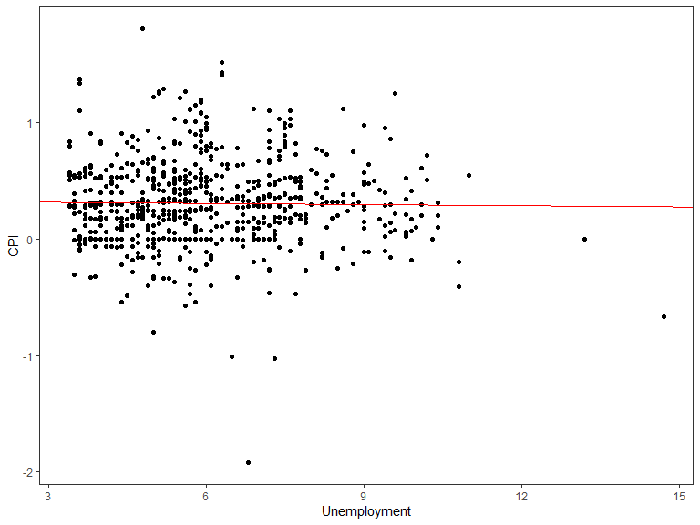

residuals <- resid(model)  
plot(fitted(model), residuals1, xlab = "Fitted Values", ylab = "Residuals", main = "Residual Plot")

## Error in xy.coords(x, y, xlabel, ylabel, log): object 'residuals1' not found

qqnorm(residuals)

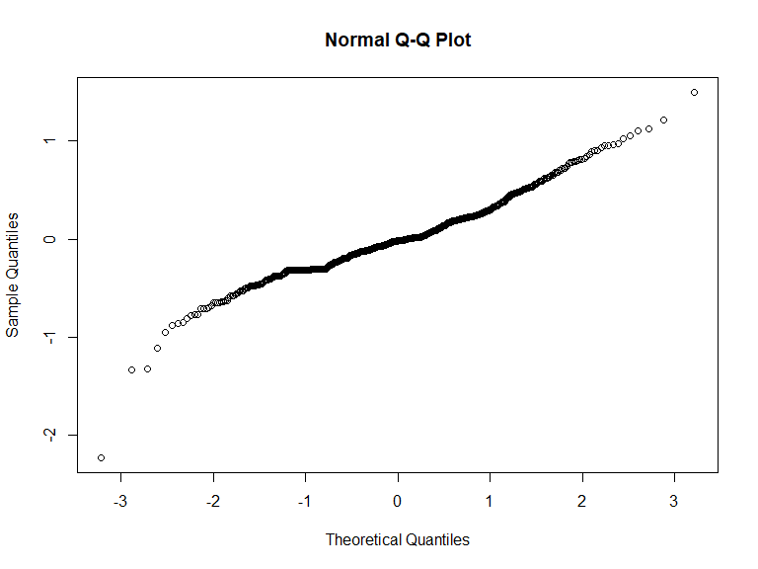

## CPI and Federal Funds Rate LR:

As noted above this relationship was really the only one worth diving into. As we can see below the R-Square of .1854 is relatively still low. I would classify the relationship between CPI and the FFR rate as a weak positive relationship. The R-Sqaure tells us that only about 18.54% of the variation in the data points in the CPI variable can be explained by the variation in the data points in the Federal Funds Rate. The p-value is very small, the value that returned was in notation, and the F-stat of 172.6 indicates there was a significant relationship was observed and we can conclude that these variables actually do share a significant relationship, albeit rather weak. The scatter graph plot below also visually represents the R-Squared regression line. The normality plot tells us that most of the data is normally distributed. This analysis does make sense as throughout recent history the Federal Reserve has turned to raising the FFR in times of high inflation growth, however, I think it is fair to say that this is probably not the greatest analysis to use as it takes time for inflation to cool after increasing the FFR, inflation does not change overnight, so maybe a different analysis such as a Time Series Analysis would be better for these variables.

model1 <- lm(data$CPI.US ~ data$FEDFUNDS, data = data)  
summary(model1)

##   
## Call:  
## lm(formula = data$CPI.US ~ data$FEDFUNDS, data = data)  
##   
## Residuals:  
## Min 1Q Median 3Q Max   
## -2.04334 -0.21560 -0.02047 0.19733 1.26151   
##   
## Coefficients:  
## Estimate Std. Error t value Pr(>|t|)   
## (Intercept) 0.106937 0.019351 5.526 4.51e-08 ***  
## data$FEDFUNDS 0.042053 0.003201 13.136 < 2e-16 ***  
## ---  
## Signif. codes: 0 '***' 0.001 '**' 0.01 '*' 0.05 '.' 0.1 ' ' 1  
##   
## Residual standard error: 0.3255 on 758 degrees of freedom  
## Multiple R-squared: 0.1854, Adjusted R-squared: 0.1844   
## F-statistic: 172.6 on 1 and 758 DF, p-value: < 2.2e-16

ggplot(data, aes(x = FEDFUNDS, y = CPI.US)) +  
 geom_point() +  
 geom_abline(intercept = coef(model1)[1], slope = coef(model1)[2], color = "red") +  
 xlab("FEDFUNDS") +  
 ylab("CPI") +  
 theme_bw() +  
 theme(panel.grid = element_blank())

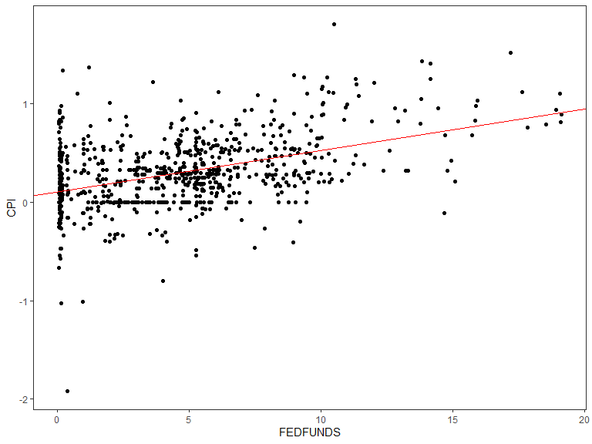

residuals1 <- resid(model1)  
  
plot(fitted(model1), residuals1, xlab = "Fitted Values", ylab = "Residuals", main = "Residual Plot")

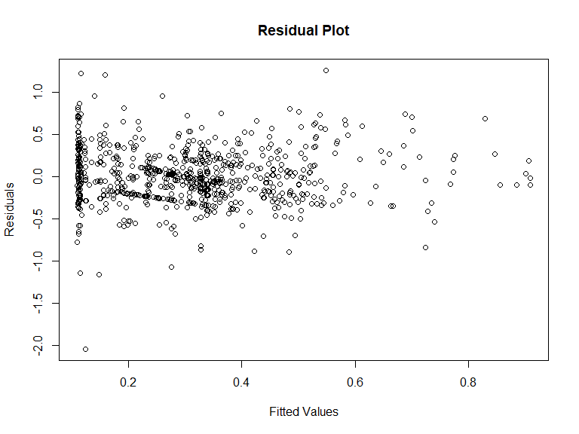

qqnorm(residuals1)

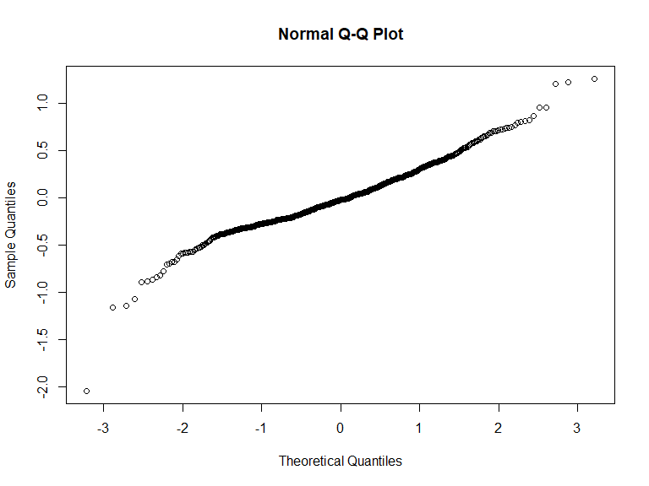

## CPI, Unemployment, and Federal Funds Rate LR:

This is a multivariate linear regression model, with CPI being the dependent variable and Unemployment and the FFR being the independents. Below we can an R-Squared of .1868, which is actually higher than the R-Squared values of the previous model. Which means that 18.68% of the variation in CPI can be explained by variation in unemployment and the federal funds rate at the same time. Albeit it weak and a p-value of something in the scientific notation, and a rather high f-stat of 86.97, we can conclude that the relationship between the three variables is statistically significant. This is suprising as this is indeed the highest R-Squared score out of all the three models, however obviously much more factors are driving all of these variables which makes sense when you look at the sheer size and complexity of today’s world economy.

model2 <- lm(data$CPI.US ~ data$FEDFUNDS + data$UNEMPLOYMENT, data = data)  
summary(model2)

##   
## Call:  
## lm(formula = data$CPI.US ~ data$FEDFUNDS + data$UNEMPLOYMENT,   
## data = data)  
##   
## Residuals:  
## Min 1Q Median 3Q Max   
## -2.03560 -0.21481 -0.02433 0.19905 1.25127   
##   
## Coefficients:  
## Estimate Std. Error t value Pr(>|t|)   
## (Intercept) 0.153756 0.045212 3.401 0.000707 ***  
## data$FEDFUNDS 0.042241 0.003205 13.180 < 2e-16 ***  
## data$UNEMPLOYMENT -0.008033 0.007011 -1.146 0.252258   
## ---  
## Signif. codes: 0 '***' 0.001 '**' 0.01 '*' 0.05 '.' 0.1 ' ' 1  
##   
## Residual standard error: 0.3254 on 757 degrees of freedom  
## Multiple R-squared: 0.1868, Adjusted R-squared: 0.1847   
## F-statistic: 86.97 on 2 and 757 DF, p-value: < 2.2e-16

residuals2 <- resid(model2)  
plot(fitted(model2), residuals2, xlab = "Fitted Values", ylab = "Residuals", main = "Residual Plot")

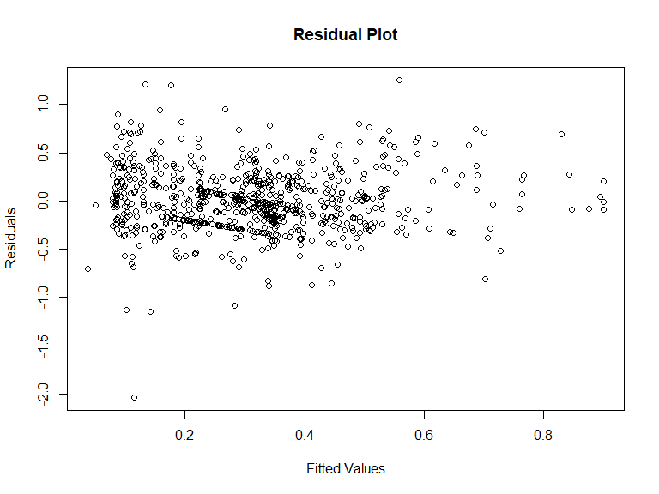

qqnorm(residuals2)

## 

## Conclusion:

To close out the point of this project was to find the statistical relationships between the variables of Consumer Price Index, the Unemployment Rate, and the Federal Funds Rate of the United States for every month of the years 1960-2022. This project further reinforces that the Phillips Curve theory is not longer a viable economic theory, or at least the original concept, as there has been numerous updates to the theory. The idea that CPI and the Federal Funds rate have a somewhat positive relationship makes sense to me, especially considering the current status of world affairs (July 2023), as the Federal Reserve increased the Federal funds rate in an attempt to quell the pace of inflation, as of writing this it appears their efforts have worked, but hopefully these interest rate hikes do not push the US into recession. However, one downside was that I used a Linear Regression Model for this analysis, which is obviously not the best method because inflation does not change overnight, its takes months, sometimes years for inflation %’s to move, so a better method would have been something like a Time Series Analysis. Lastly, the multivariate linear regression model actually had the highest R-Squared out of the three models albeit still very weak, which is suprising to me as there is another 760 data points in play with the additional variable. There is no real economic idea behind this, or at least one that I know of, but it was interesting to see the results.