Manual Testing for Tealiumdemo.com

**Environment:** https://ecommerce.tealiumdemo.com/women.html

**Title:** Unexpected Logout During Product Search

**Description:**

During active product searches on tealiumdemo.com, the system **logs the user out without warning**, even while the user is still interacting with the page. This behavior is misleading, as the interface continues to display a “Welcome” message, implying the user is still logged in. However, key functions like accessing the cart or account options become unavailable.

**Expected result:**

* The user should remain **logged in** during the browsing/searching process.
* The “**Welcome [username]**” message and **Account/Cart** state should persist throughout the session unless the user explicitly logs out or the session times out after an extended period of inactivity.

**Actual result:**

* The site **automatically logs out** the user **while actively browsing or searching**.
* The “Welcome” message remains, but the user is effectively **logged out**, losing access to cart or account features without notice.

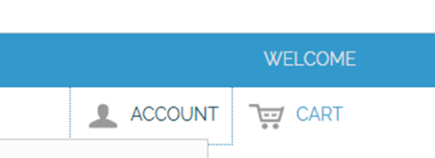

**Environment:** <https://ecommerce.tealiumdemo.com/wishlist/>

**Title:** Wishlist to Cart Behavior Issue

**Description:**

* The system does not prompt the user to choose their preferred size or color.
* As a result, the product is added to the cart with possibly incorrect or undesired variants.

**Expected result:**

After clicking **"Add to Cart"** from the Wishlist, the site should

* Prompt the user to select **size** and **color**, if they are configurable.
* Or redirect them to the **product detail page** to make a selection before adding to the cart.

**Actual result:**

When the user clicks “Add to Cart” from the Wishlist, the product is added directly to the cart with default size and color options, without giving the user an opportunity to select their preferences.

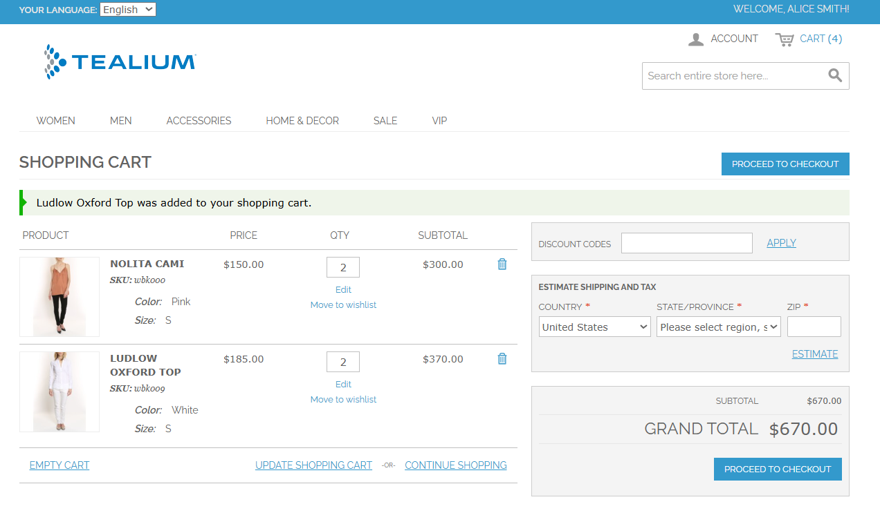

**Environment:** https://ecommerce.tealiumdemo.com/men.html?color=20

**Title:** Verify that the price filter provides multiple options via a dropdown

**Description:**

On the **MEN** category page of tealiumdemo.com, the **Price filter** located in the left sidebar is expected to offer users a dropdown or multiple selectable options to filter products based on different price ranges.

However, upon visiting the page, only **one static price option** is displayed — "**$70.00 and above**" — and there is **no dropdown menu or list of additional price options**.

**Expected result:**

The **Price** filter should provide a **dropdown menu** with **multiple price range options** (e.g.,

* $0 - $50
* $50 - $100
* $100 and above).

The user should be able to **select a range** to filter the products accordingly.

**Actual result:**

* The **Price** filter only shows a **single static option**: $70.00 and above.
* There is **no dropdown or list** of additional price range options.
* The filter is **non-interactive** beyond this single range.

