02 Descriptives

The ‘Immigration Issue’ Misnomer in Human Capital Research: Intersectional Inequalities in Adult Education and Literacy in Upper- and Middle-Income Countries

Author Omitted for Blind Peer Review
Data prepared for this stage in 01_Data_Setup.Rmd. Except for Table A1 (new data imported)
The first cycle of PIAAC is included to demonstrate change in literacy across countries.
Many functions are stored in the /Sub folder and called in this workflow.

Code knitted as HTML, due to HTML figures/tables, therefore, color-coding not reproduced (all red) unlike subsequent workflows.
Table of Contents
02 Descriptives 1
The ‘Immigration Issue’ Misnomer in Human Capital Research: Intersectional Inequalities in Adult Education and Literacy in Upper- and Middle-Income Countries 1
1 Setup 1
2 Data 1
3 Fig A1. Immigrant Literacy 2012 and 2022 3
3.1 Get rates for each country 3
3.2 Build 3
4 Tbl S1. Immigration Increases 1990-2024 4
5 Table A1. Descriptives 6
5.1 All 6
5.2 Women 8
5.3 Men 10
5.4 Foreign-born, non-native 12
5.5 Table S6. Omitted Intercategories 14
6 Fig 1. Intersectionality of Literacy 16
6.1 Define all groups 16
6.2 Plot 18
7 Tbl S2. Intersectional Descriptives (16 Groups) 35
8 Citations 37
9 Colophon 38

1 Setup
knitr::opts_chunk$set(warning = FALSE, message = FALSE)

packages <- c('tidyverse',
'readr',
'knitr',
'here',
'ggplot2',
'ggrepel',
'ragg',
'survey',
'kableExtra',
'scales',
'wbstats')

pacman::p_load(packages, character.only = T)

2 Data
df <- read_rds(here("Data", "df.RDS"))
df2 <- read_rds(here("Data", "df2.RDS"))

# basic or lower literacy, drop Denmark because FORLANG is missing
df2 <- df2 %>%
subset(iso3c != "DNK") %>%
mutate(reading_low = ifelse(literacy_level %in% c(0, 1), 1, 0),
ALL = 1)

df <- df %>%
mutate(reading_low = ifelse(literacy_level %in% c(0, 1), 1, 0),
ALL = 1)

europe <- c("AUT", "BEL", "CHE", "CZE", "DEU", "DNK", "ESP", "EST", "FIN", "FRA", "GBR", "HRV", "HUN", "IRL", "ITA", "LTU", "LVA", "NOR", "POL", "PRT", "SVK", "SWE")

rich <- c("AUT", "BEL", "CHE", "DEU", "DNK", "ESP", "FIN", "FRA", "GBR", "IRL", "ITA", "NOR", "PRT", "SWE", "JPN", "CAN", "USA", "AUS", "NZL")

dfeurope <- subset(df, iso3c %in% europe)
df2europe <- subset(df2, iso3c %in% europe)

dfrich <- subset(df, iso3c %in% rich)
df2rich <- subset(df2, iso3c %in% rich)

dfde <- subset(df, iso3c == "DEU")
df2de <- subset(df2, iso3c == "DEU")

# for repeated measures means
df1_rep <- svrepdesign(
weights = ~SPFWT0,
repweights = df[, paste0("SPFWT", 1:80)],
type = "Fay", rho = 0.5, mse = T, data = df)

df2_rep <- svrepdesign(
weights = ~SPFWT0,
repweights = df2[, paste0("SPFWT", 1:80)],
type = "Fay", rho = 0.5, mse = T, data = df2)

df1_rep_eur <- svrepdesign(
weights = ~SPFWT0,
repweights = dfeurope[, paste0("SPFWT", 1:80)],
type = "Fay", rho = 0.5, mse = T, data = dfeurope)

df2_rep_eur <- svrepdesign(
weights = ~SPFWT0,
repweights = df2europe[, paste0("SPFWT", 1:80)],
type = "Fay", rho = 0.5, mse = T, data = df2europe)

df1_rep_rich <- svrepdesign(
weights = ~SPFWT0,
repweights = dfrich[, paste0("SPFWT", 1:80)],
type = "Fay", rho = 0.5, mse = T, data = dfrich)

df2_rep_rich <- svrepdesign(
weights = ~SPFWT0,
repweights = df2rich[, paste0("SPFWT", 1:80)],
type = "Fay", rho = 0.5, mse = T, data = df2rich)

df1_rep_de <- svrepdesign(
weights = ~SPFWT0,
repweights = dfde[, paste0("SPFWT", 1:80)],
type = "Fay", rho = 0.5, mse = T, data = dfde)

df2_rep_de <- svrepdesign(
weights = ~SPFWT0,
repweights = df2de[, paste0("SPFWT", 1:80)],
type = "Fay", rho = 0.5, mse = T, data = df2de)

pvlit <- paste0("PVLIT", 1:10)
pvnum <- paste0("PVNUM", 1:10)

# helper function to identify rep means/SD for sub-groups

source(here("Sub", "IRT_helper_groups_se_pop.R"))

3 Fig A1. Immigrant Literacy 2012 and 2022

3.1 Get rates for each country
Run the routine country_loop.R once and then simply load the results thereafter as the saved object plot_df.RData
# Basic version

source(here("Sub", "IRT_helper_groups.R"))

# source(here("Sub", "country_loop.R"))

load(here("Data", "plot_df.RData"))

3.2 Build
agg_png(here("Results", "Fig1A.png"), res = 144, height = 600, width = 800)

ggplot(plot_df, aes(x = iso3c, y = change_lit, fill = group)) +
geom_col(position = position_dodge(width = 0.7), width = 0.6) +
coord_flip() +
labs(
x = NULL,
y = "Change in Literacy (Cycle 2, 2022/23 − Cycle 1, 2012/13)",
title = "Change in Mean Literacy between PIAAC Cycles",
caption = "NOTE: estimated with R survey package using repeated measures and population weights",
fill = NULL
) +
scale_fill_manual(values = c("Immigrants" = "steelblue", "All adults" = "gray70")) +
theme_minimal() +
theme(legend.position = "top",
plot.caption = element_text(hjust = 0, size = 6, face = "italic"))

dev.off()
## png
## 2
include_graphics(here("Results", "Fig1A.png"))
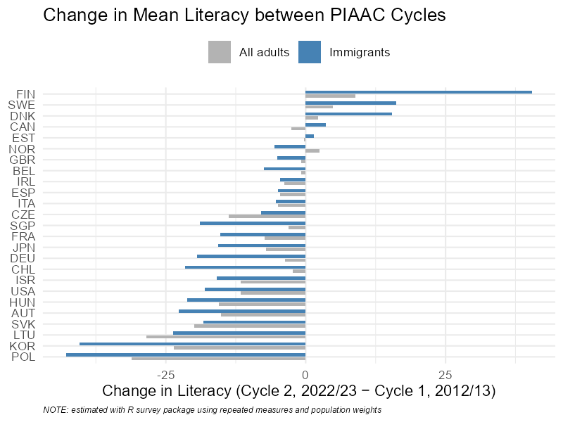

4 Tbl S1. Immigration Increases 1990-2024
UN. 2024. “Total Number of Emigrants: People That Were Born in a Country and Now Live in Another Country” [CSV]. Our World In Data: United Nations Department of Economic and Social Affairs. https://ourworldindata.org/migration.
UN. 2024. “Share of The Population That Were Born in Another Country” [CSV]. Our World In Data: United Nations Department of Economic and Social Affairs. https://ourworldindata.org/grapher/migrant-stock-share
Files downloaded 2025/12/05
df_un_mig <- read_csv(here("Data", "total-number-of-emigrants.filtered", "total-number-of-emigrants.csv"))

df_un_fb <- read_csv(here("Data", "migrant-stock-share.filtered", "migrant-stock-share.csv")) %>%
subset(Year %in% c(1990, 2024))

continents <- c("Africa","Asia","Europe","North America","Oceania","South America")

df_emig_out <- df_un_mig %>%
filter(Entity %in% continents, Year %in% c(1990, 2024)) %>%
select(Entity, Year, emigrants = `Total number of emigrants`) %>%
pivot_wider(names_from = Year, values_from = emigrants) %>%
transmute(
Entity,
emigrants_2024 = `2024`,
pct_change_1990_2024 = (`2024` - `1990`) / `1990` * 100
) %>%
bind_rows(
df_un_mig %>%
filter(Entity %in% continents, Year %in% c(1990, 2024)) %>%
group_by(Year) %>%
summarise(emigrants = sum(`Total number of emigrants`, na.rm = TRUE), .groups="drop") %>%
pivot_wider(names_from = Year, values_from = emigrants) %>%
transmute(
Entity = "World",
emigrants_2024 = `2024`,
pct_change_1990_2024 = (`2024` - `1990`) / `1990` * 100
)
)

source(here("Sub", "pop_2024.R"))

# this does not include Oceania, quick Google info 46 mil in 2024

df_pop_2024[7,1] <- "Oceania"
df_pop_2024[7,2] <- 46000000

df_2A <- df_emig_out %>%
left_join(df_pop_2024, by = "Entity")

df_2A <- df_2A %>%
mutate(pct_emig_2024 = round(100*(emigrants_2024/population_2024),1))

df_2A <- df_2A %>%
mutate(pct_fb_2024 = case_when(Entity == "Africa" ~ df_un_fb$`Share of the population that was born in another country`[df_un_fb$Entity == "Africa" & df_un_fb$Year == 2024],
Entity == "Asia" ~ df_un_fb$`Share of the population that was born in another country`[df_un_fb$Entity == "Asia" & df_un_fb$Year == 2024],
Entity == "Europe" ~ df_un_fb$`Share of the population that was born in another country`[df_un_fb$Entity == "Western Europe (UN)" & df_un_fb$Year == 2024],
Entity == "North America" ~ df_un_fb$`Share of the population that was born in another country`[df_un_fb$Entity == "North America" & df_un_fb$Year == 2024],
Entity == "Oceania" ~ df_un_fb$`Share of the population that was born in another country`[df_un_fb$Entity == "Oceania" & df_un_fb$Year == 2024],
Entity == "South America" ~ df_un_fb$`Share of the population that was born in another country`[df_un_fb$Entity == "South America" & df_un_fb$Year == 2024],
Entity == "World" ~ df_un_fb$`Share of the population that was born in another country`[df_un_fb$Entity == "World" & df_un_fb$Year == 2024]),
pct_fb_2024 = round(pct_fb_2024, 1),
pct_fb_1990 = case_when(Entity == "Africa" ~ df_un_fb$`Share of the population that was born in another country`[df_un_fb$Entity == "Africa" & df_un_fb$Year == 1990],
Entity == "Asia" ~ df_un_fb$`Share of the population that was born in another country`[df_un_fb$Entity == "Asia" & df_un_fb$Year == 1990],
Entity == "Europe" ~ df_un_fb$`Share of the population that was born in another country`[df_un_fb$Entity == "Western Europe (UN)" & df_un_fb$Year == 1990],
Entity == "North America" ~ df_un_fb$`Share of the population that was born in another country`[df_un_fb$Entity == "North America" & df_un_fb$Year == 1990],
Entity == "Oceania" ~ df_un_fb$`Share of the population that was born in another country`[df_un_fb$Entity == "Oceania" & df_un_fb$Year == 1990],
Entity == "South America" ~ df_un_fb$`Share of the population that was born in another country`[df_un_fb$Entity == "South America" & df_un_fb$Year == 1990],
Entity == "World" ~ df_un_fb$`Share of the population that was born in another country`[df_un_fb$Entity == "World" & df_un_fb$Year == 1990]),
pct_fb_1990 = round(pct_fb_1990, 1),
)

write.csv(df_2A, here("Results", "TS2.csv"), row.names = FALSE)

kable(df_2A)
rm(df_2A)
rm(df_un_mig, df_emig_out, df_pop_2024, df_un_fb)
Entity | emigrants_2024 | pct_change_1990_2024 | population_2024 | pct_emig_2024 | pct_fb_2024 | pct_fb_1990
Africa | 45750673 | 132.49810 | 1291044964 | 3.5 | 1.9 | 2.5
Asia | 120717155 | 122.91332 | 4042291127 | 3.0 | 1.9 | 1.5
Europe | 61061575 | 24.86158 | 928263208 | 6.6 | 18.4 | 9.6
North America | 31580108 | 139.35463 | 381464223 | 8.3 | 10.8 | 7.1
Oceania | 1602503 | 95.48417 | 46000000 | 3.5 | 21.5 | 17.8
South America | 21243834 | 418.78533 | 662186388 | 3.2 | 2.9 | 1.5
World | 281955848 | 100.19000 | 7305249910 | 3.9 | 3.7 | 2.9

5 Table A1. Descriptives

5.1 All
table_1_all <- df2 %>%
subset(ed_currently != 1) %>%
mutate(
ed_primary = ifelse(ed3 == 1, 1, 0),
ed_secondary = ifelse(ed3 == 2, 1, 0),
ed_tertiary = ifelse(ed3 == 3, 1, 0),
missing = case_when(is.na(skill_reading) | is.na(NFE12) | is.na(FORBORN) | is.na(children) | is.na(FORLANG) | is.na(ed3) | is.na(ed_currently) ~ 1,
.default = NA)
) %>%
select(-ed3) %>%
select(iso3c, skill_reading, NFE12, female, FORBORN, children, FORLANG, ed_primary, ed_secondary, ed_tertiary, missing, aweight)

# drop countries that do not have all variables
valid_countries <- table_1_all %>%
group_by(iso3c) %>%
summarise(across(everything(), ~ sum(!is.na(.)))) %>%
filter(across(-iso3c, ~ . > 0)) %>%
pull(iso3c)

table_1_all <- table_1_all %>%
filter(iso3c %in% valid_countries)

table_1outa <- table_1_all %>%
select(-iso3c) %>%
summarise(across(
everything(),
list(
mean = ~ mean(., na.rm = TRUE),
wmean = ~ weighted.mean(., aweight, na.rm = TRUE),
sd = ~ sd(., na.rm = TRUE),
min = ~ min(., na.rm = TRUE),
max = ~ max(., na.rm = TRUE),
n = ~ sum(!is.na(.))
),
.names = "{.col}__{.fn}"
)) %>%
pivot_longer(
everything(),
names_to = c("variable", ".value"),
names_sep = "__"
) %>%
mutate(variable = case_when(
variable == "skill_reading" ~ "Literacy Skills",
variable == "NFE12" ~ "ALE Participation",
variable == "FORBORN" ~ "Foreign-Born",
variable == "children" ~ "Has Children",
variable == "FORLANG" ~ "Non-Native Speaker",
variable == "ed_primary" ~ "Primary Education",
variable == "ed_secondary" ~ "Secondary Education",
variable == "ed_tertiary" ~ "Tertiary Education",
variable == "missing" ~ "Listwise Missing Cases",
TRUE ~ variable
))

# Save as HTML
table_1outa %>%
select(variable, mean, wmean, sd, min, max, n) %>%
kable("html", digits = 2, caption = "Descriptive Statistics with Weighted Means") %>%
kable_styling(full_width = FALSE, bootstrap_options = c("striped", "hover")) %>%
save_kable(here("Results", "table_S1.html"))

table_1outa %>% kable("html", digits = 2, caption = "Descriptive Statistics") %>%
kable_styling(full_width = FALSE, bootstrap_options = c("striped", "hover"))
write.csv(
table_1outa,
file = here("Results", "TA1.csv"),
row.names = FALSE
)

Descriptive Statistics
variable | mean | wmean | sd | min | max | n
Literacy Skills | 256.39 | 260.88 | 55.40 | 16.76 | 449.50 | 126621
ALE Participation | 0.41 | 0.46 | 0.49 | 0.00 | 1.00 | 124856
female | 0.54 | 0.50 | 0.50 | 0.00 | 1.00 | 126432
Foreign-Born | 0.13 | 0.25 | 0.34 | 0.00 | 1.00 | 123375
Has Children | 0.67 | 0.64 | 0.47 | 0.00 | 1.00 | 126621
Non-Native Speaker | 0.11 | 0.19 | 0.31 | 0.00 | 1.00 | 123375
Primary Education | 0.13 | 0.14 | 0.33 | 0.00 | 1.00 | 124323
Secondary Education | 0.44 | 0.40 | 0.50 | 0.00 | 1.00 | 124323
Tertiary Education | 0.44 | 0.45 | 0.50 | 0.00 | 1.00 | 124323
Listwise Missing Cases | 1.00 | 1.00 | 0.00 | 1.00 | 1.00 | 3805
aweight | 24.50 | 493.24 | 107.16 | 1.00 | 3988.08 | 126621
Drop cases of those still in formal education 20478 and do listwise deletion leaving 122816 cases for analysis. This is a 3.01 percent reduction.

5.2 Women
table_1 <- df2 %>%
subset(female == 1 & !is.na(female) & ed_currently != 1) %>%
mutate(
ed_primary = ifelse(ed3 == 1, 1, 0),
ed_secondary = ifelse(ed3 == 2, 1, 0),
ed_tertiary = ifelse(ed3 == 3, 1, 0),
missing = case_when(is.na(skill_reading) | is.na(NFE12) | is.na(FORBORN) | is.na(children) | is.na(FORLANG) | is.na(ed3) | is.na(ed_currently) ~ 1,
.default = NA)
) %>%
select(-ed3) %>%
select(iso3c, skill_reading, NFE12, FORBORN, children, FORLANG, ed_primary, ed_secondary, ed_tertiary, missing, aweight)

# drop countries that do not have all variables
valid_countries <- table_1 %>%
group_by(iso3c) %>%
summarise(across(everything(), ~ sum(!is.na(.)))) %>%
filter(across(-iso3c, ~ . > 0)) %>%
pull(iso3c)

table_1 <- table_1 %>%
filter(iso3c %in% valid_countries)

table_1out <- table_1 %>%
select(-iso3c) %>%
summarise(across(
everything(),
list(
mean = ~ mean(., na.rm = TRUE),
wmean = ~ weighted.mean(., aweight, na.rm = TRUE),
sd = ~ sd(., na.rm = TRUE),
min = ~ min(., na.rm = TRUE),
max = ~ max(., na.rm = TRUE),
n = ~ sum(!is.na(.))
),
.names = "{.col}__{.fn}"
)) %>%
pivot_longer(
everything(),
names_to = c("variable", ".value"),
names_sep = "__"
) %>%
mutate(variable = case_when(
variable == "skill_reading" ~ "Literacy Skills",
variable == "NFE12" ~ "ALE Participation",
variable == "FORBORN" ~ "Foreign-Born",
variable == "children" ~ "Has Children",
variable == "FORLANG" ~ "Non-Native Speaker",
variable == "ed_primary" ~ "Primary Education",
variable == "ed_secondary" ~ "Secondary Education",
variable == "ed_tertiary" ~ "Tertiary Education",
variable == "missing" ~ "Listwise Missing Cases",
TRUE ~ variable
))

# Save as HTML
table_1out %>%
select(variable, mean, wmean, sd, min, max, n) %>%
kable("html", digits = 2, caption = "Descriptive Statistics with Weighted Means") %>%
kable_styling(full_width = FALSE, bootstrap_options = c("striped", "hover")) %>%
save_kable(here("Results", "table_S1.html"))

table_1out %>% kable("html", digits = 2, caption = "Descriptive Statistics") %>%
kable_styling(full_width = FALSE, bootstrap_options = c("striped", "hover"))
write.csv(
table_1out,
file = here("Results", "TS1f.csv"),
row.names = FALSE
)

Descriptive Statistics
variable | mean | wmean | sd | min | max | n
Literacy Skills | 256.83 | 260.91 | 53.74 | 23.83 | 420.67 | 67669
ALE Participation | 0.42 | 0.47 | 0.49 | 0.00 | 1.00 | 66807
Foreign-Born | 0.13 | 0.25 | 0.34 | 0.00 | 1.00 | 66094
Has Children | 0.73 | 0.69 | 0.45 | 0.00 | 1.00 | 67669
Non-Native Speaker | 0.10 | 0.20 | 0.31 | 0.00 | 1.00 | 66094
Primary Education | 0.12 | 0.13 | 0.32 | 0.00 | 1.00 | 66542
Secondary Education | 0.41 | 0.39 | 0.49 | 0.00 | 1.00 | 66542
Tertiary Education | 0.47 | 0.49 | 0.50 | 0.00 | 1.00 | 66542
Listwise Missing Cases | 1.00 | 1.00 | 0.00 | 1.00 | 1.00 | 1864
aweight | 22.79 | 497.71 | 104.03 | 1.00 | 3988.08 | 67669

5.3 Men
table_1a <- df2 %>%
subset(female == 0 & !is.na(female) & ed_currently != 1) %>%
mutate(
ed_primary = ifelse(ed3 == 1, 1, 0),
ed_secondary = ifelse(ed3 == 2, 1, 0),
ed_tertiary = ifelse(ed3 == 3, 1, 0),
missing = case_when(is.na(skill_reading) | is.na(NFE12) | is.na(FORBORN) | is.na(children) | is.na(FORLANG) | is.na(ed3) | is.na(ed_currently) ~ 1,
.default = NA)
) %>%
select(-ed3) %>%
select(iso3c, skill_reading, NFE12, FORBORN, children, FORLANG, ed_primary, ed_secondary, ed_tertiary, missing, aweight)

# drop countries that do not have all variables
valid_countries <- table_1a %>%
group_by(iso3c) %>%
summarise(across(everything(), ~ sum(!is.na(.)))) %>%
filter(across(-iso3c, ~ . > 0)) %>%
pull(iso3c)

table_1a <- table_1a %>%
filter(iso3c %in% valid_countries)

table_1outa <- table_1a %>%
select(-iso3c) %>%
summarise(across(
everything(),
list(
mean = ~ mean(., na.rm = TRUE),
wmean = ~ weighted.mean(., aweight, na.rm = TRUE),
sd = ~ sd(., na.rm = TRUE),
min = ~ min(., na.rm = TRUE),
max = ~ max(., na.rm = TRUE),
n = ~ sum(!is.na(.))
),
.names = "{.col}__{.fn}"
)) %>%
pivot_longer(
everything(),
names_to = c("variable", ".value"),
names_sep = "__"
) %>%
mutate(variable = case_when(
variable == "skill_reading" ~ "Literacy Skills",
variable == "NFE12" ~ "ALE Participation",
variable == "FORBORN" ~ "Foreign-Born",
variable == "children" ~ "Has Children",
variable == "FORLANG" ~ "Non-Native Speaker",
variable == "ed_primary" ~ "Primary Education",
variable == "ed_secondary" ~ "Secondary Education",
variable == "ed_tertiary" ~ "Tertiary Education",
variable == "missing" ~ "Listwise Missing Cases",
TRUE ~ variable
))

# Save as HTML
table_1outa %>%
select(variable, mean, wmean, sd, min, max, n) %>%
kable("html", digits = 2, caption = "Descriptive Statistics with Weighted Means") %>%
kable_styling(full_width = FALSE, bootstrap_options = c("striped", "hover")) %>%
save_kable(here("Results", "table_S1.html"))

table_1outa %>% kable("html", digits = 2, caption = "Descriptive Statistics") %>%
kable_styling(full_width = FALSE, bootstrap_options = c("striped", "hover"))

write.csv(
table_1outa,
file = here("Results", "TS1m.csv"),
row.names = FALSE
)

Descriptive Statistics
variable | mean | wmean | sd | min | max | n
Literacy Skills | 255.86 | 260.87 | 57.22 | 16.76 | 449.50 | 58763
ALE Participation | 0.39 | 0.46 | 0.49 | 0.00 | 1.00 | 57862
Foreign-Born | 0.13 | 0.24 | 0.33 | 0.00 | 1.00 | 57098
Has Children | 0.61 | 0.59 | 0.49 | 0.00 | 1.00 | 58763
Non-Native Speaker | 0.10 | 0.18 | 0.31 | 0.00 | 1.00 | 57098
Primary Education | 0.14 | 0.15 | 0.34 | 0.00 | 1.00 | 57599
Secondary Education | 0.47 | 0.42 | 0.50 | 0.00 | 1.00 | 57599
Tertiary Education | 0.40 | 0.42 | 0.49 | 0.00 | 1.00 | 57599
Listwise Missing Cases | 1.00 | 1.00 | 0.00 | 1.00 | 1.00 | 1927
aweight | 26.54 | 489.01 | 110.79 | 1.00 | 3174.53 | 58763

5.4 Foreign-born, non-native
# Helper function to summarize a group
summarize_group <- function(data) {
data %>%
mutate(
ed_primary = ifelse(ed3 == 1, 1, 0),
ed_secondary = ifelse(ed3 == 2, 1, 0),
ed_tertiary = ifelse(ed3 == 3, 1, 0)
) %>%
summarise(across(
c(skill_reading, NFE12, FORBORN, children, FORLANG,
ed_primary, ed_secondary, ed_tertiary, ed_currently),
list(
mean = ~ mean(.x, na.rm = TRUE),
wmean = ~ weighted.mean(.x, aweight, na.rm = TRUE)
),
.names = "{.col}__{.fn}"
)) %>%
pivot_longer(
everything(),
names_to = c("variable", ".value"),
names_sep = "__"
)
}

# Summarize females
female_sum <- df2 %>%
filter(female == 1, FORLANG == 1, FORBORN == 1) %>%
summarize_group()

# Summarize males
male_sum <- df2 %>%
filter(female == 0, FORLANG == 1, FORBORN == 1) %>%
summarize_group()

# Combine both into one table
table_summary <- female_sum %>%
rename(female_mean = mean, female_wmean = wmean) %>%
full_join(
male_sum %>%
rename(male_mean = mean, male_wmean = wmean),
by = "variable"
) %>%
mutate(variable = case_when(
variable == "skill_reading" ~ "Literacy Skills",
variable == "NFE12" ~ "ALE Participation",
variable == "FORBORN" ~ "Foreign-Born",
variable == "children" ~ "Has Children",
variable == "FORLANG" ~ "Non-Native Speaker",
variable == "ed_currently" ~ "Currently in Education",
variable == "ed_primary" ~ "Primary Education",
variable == "ed_secondary" ~ "Secondary Education",
variable == "ed_tertiary" ~ "Tertiary Education",
TRUE ~ variable
))

# Create formatted table
table_output <- table_summary %>%
kable("html", digits = 2, caption = "Means and Weighted Means by Gender") %>%
kable_styling(full_width = FALSE, bootstrap_options = c("striped", "hover"))

# Save to HTML file
save_kable(table_output, file = here::here("Results", "Table_S1ag.html"))

# Print table to viewer
table_output

Means and Weighted Means by Gender
variable | female_mean | female_wmean | male_mean | male_wmean
Literacy Skills | 236.16 | 247.32 | 234.02 | 249.38
ALE Participation | 0.42 | 0.52 | 0.42 | 0.53
Foreign-Born | 1.00 | 1.00 | 1.00 | 1.00
Has Children | 0.68 | 0.66 | 0.59 | 0.57
Non-Native Speaker | 1.00 | 1.00 | 1.00 | 1.00
Primary Education | 0.18 | 0.12 | 0.22 | 0.15
Secondary Education | 0.32 | 0.29 | 0.33 | 0.26
Tertiary Education | 0.50 | 0.59 | 0.45 | 0.59
Currently in Education | 0.13 | 0.18 | 0.13 | 0.18

5.5 Table S6. Omitted Intercategories
summary_table <- df2 %>%
mutate(
g1 = ifelse(FORBORN == 0 & FORLANG == 1, 1, 0),
g1_ale = ifelse(g1 == 1 & NFE12 == 1, 1, 0),

g2 = ifelse(FORBORN == 1 & FORLANG == 0, 1, 0),
g2_ale = ifelse(g2 == 1 & NFE12 == 1, 1, 0)
) %>%
group_by(iso3c) %>%

summarise(
# Native-born, non-native speaker
pct_g1 = weighted.mean(g1, SPFWT0, na.rm = TRUE) * 100,
pct_g1_ale = weighted.mean(g1_ale, SPFWT0, na.rm = TRUE) * 100,
ratio_g1 = pct_g1 / pct_g1_ale,

# Foreign-born, native speaker
pct_g2 = weighted.mean(g2, SPFWT0, na.rm = TRUE) * 100,
pct_g2_ale = weighted.mean(g2_ale, SPFWT0, na.rm = TRUE) * 100,
ratio_g2 = pct_g2 / pct_g2_ale,

.groups = "drop"
) %>%
# Country population
left_join(
wb_data("SP.POP.TOTL", start_date = 2023, end_date = 2023) %>%
select(iso3c, pop_2023 = SP.POP.TOTL),
by = "iso3c"
) %>%

select(iso3c, pop_2023, pct_g1, pct_g1_ale, ratio_g1, pct_g2, pct_g2_ale, ratio_g2
)

summary_table <- summary_table %>%
mutate(across(c(starts_with("pct_"), starts_with("ratio_")), ~ round(.x, 2)))

kable(
summary_table,
col.names = c("ISO3", "Pop 2023",
"Nat-born/Non-nat (%)", "ALE Nat-born/Non-nat (%)", "Ratio",
"FB/Nat-speaker (%)", "ALE FB/Nat-speaker (%)", "Ratio")
)

write.csv(
summary_table,
file = here("Results", "TS2.csv"),
row.names = FALSE
)

ISO3 | Pop 2023 | Nat-born/Non-nat (%) | ALE Nat-born/Non-nat (%) | Ratio | FB/Nat-speaker (%) | ALE FB/Nat-speaker (%) | Ratio
AUT | 9131761 | 2.54 | 0.85 | 3.01 | 5.17 | 2.14 | 2.42
BEL | 11779946 | 2.82 | 1.02 | 2.75 | 3.84 | 1.53 | 2.51
CAN | 40083484 | 4.26 | 1.93 | 2.21 | 11.33 | 6.40 | 1.77
CHE | 8888822 | 4.83 | 1.96 | 2.46 | 15.36 | 7.19 | 2.14
CHL | 19658835 | 0.22 | 0.07 | 3.15 | 8.10 | 2.59 | 3.13
CZE | 10864042 | 0.36 | 0.13 | 2.72 | 1.31 | 0.52 | 2.51
DEU | 83287273 | 2.32 | 0.80 | 2.90 | 3.08 | 1.08 | 2.84
ESP | 48352528 | 3.17 | 1.23 | 2.57 | 13.61 | 5.41 | 2.52
EST | 1370286 | 1.69 | 0.84 | 2.02 | 8.63 | 3.76 | 2.30
FIN | 5583911 | 0.98 | 0.61 | 1.60 | 1.58 | 0.69 | 2.29
FRA | 68372286 | 1.50 | 0.51 | 2.96 | 5.99 | 1.78 | 3.36
GBR | 68492000 | 1.76 | 0.83 | 2.13 | 7.56 | 4.22 | 1.79
HRV | 3859686 | 0.68 | 0.05 | 13.53 | 6.91 | 1.49 | 4.63
HUN | 9592186 | 0.64 | 0.13 | 5.12 | 3.67 | 1.25 | 2.94
IRL | 5311538 | 0.55 | 0.17 | 3.14 | 14.55 | 8.20 | 1.78
ISR | 9849000 | 4.42 | 1.52 | 2.91 | 3.61 | 1.10 | 3.29
ITA | 58984216 | 2.42 | 0.80 | 3.01 | 3.47 | 0.73 | 4.75
JPN | 124516650 | 0.01 | 0.00 | Inf | 0.42 | 0.18 | 2.30
KOR | 51712619 | 0.13 | 0.01 | 12.44 | 1.41 | 0.10 | 13.58
LTU | 2871585 | 4.73 | 1.32 | 3.57 | 1.71 | 0.61 | 2.80
LVA | 1883710 | 6.31 | 2.92 | 2.16 | 6.86 | 2.77 | 2.47
NOR | 5519601 | 0.51 | 0.32 | 1.58 | 0.39 | 0.34 | 1.15
POL | 36687353 | 0.33 | 0.10 | 3.12 | 0.19 | 0.00 | Inf
PRT | 10578174 | 0.69 | 0.26 | 2.63 | 19.65 | 6.32 | 3.11
SGP | 5917648 | 36.57 | 14.90 | 2.45 | 7.18 | 3.92 | 1.83
SVK | 5426740 | 2.57 | 0.69 | 3.71 | 0.75 | 0.20 | 3.72
SWE | 10536632 | 1.26 | 0.68 | 1.87 | 1.69 | 0.89 | 1.89
USA | 336806231 | 4.56 | 2.28 | 2.00 | 5.46 | 3.37 | 1.62

6 Fig 1. Intersectionality of Literacy

6.1 Define all groups

6.1.1 All countries
# helper defined in IRT_helper_groups.R
calc_groups_pv(
df1_rep = df1_rep,
df2_rep = df2_rep,
pvlit = pvlit,
pvnum = NA,
group_vars = c("ALL", "male", "female", "male_not", "male_fb", "female_not", "female_fb", "male_not_natlang", "male_not_notnatlang", "male_fb_natlang", "male_fb_notnatlang", "female_not_natlang", "female_not_notnatlang", "female_fb_natlang", "female_fb_notnatlang", "male_not_natlang_child", "male_not_notnatlang_child", "male_fb_natlang_child", "male_fb_notnatlang_child", "male_not_natlang_nochild", "male_not_notnatlang_nochild", "male_fb_natlang_nochild", "male_fb_notnatlang_nochild", "female_not_natlang_child", "female_not_notnatlang_child", "female_fb_natlang_child", "female_fb_notnatlang_child", "female_not_natlang_nochild", "female_not_notnatlang_nochild", "female_fb_natlang_nochild", "female_fb_notnatlang_nochild")
)

# combine all mean and se objects into a df
source(here("Sub", "combine_g_objects.R"))

# combine all pct of groups with PIAAC level at 1 or below
source(here("Sub", "combine_g_objects_pct.R"))

# remove raw objects
rm(list = ls(pattern = "^g[0-9]+_(mean|se)_(lit|num)_df[12]$"))
rm(list = ls(pattern = "^g[0-9]+_(mean|se)_(lit|num)_diff$"))
rm(list = ls(pattern = "^g[0-9]+_(pct)_lit01_df[12]$"))
rm(list = ls(pattern = "^g[0-9]+_pct_ale_df[12]$"))
rm(list = ls(pattern = "^g[0-9]+_pct_sec_df[12]$"))

# pct is literacy-only so far (num can be calculated the same way)

# give unique naming (note that ALE is already included here so we don't need a new df for it)
df_lit_all <- df_lit
df_num_all <- df_num
df_pct_level_1_or_less_all <- df_pct_level_1_or_less

6.1.2 Rich countries only
These are destination countries
calc_groups_pv(
df1_rep = df1_rep_rich,
df2_rep = df2_rep_rich,
pvlit = pvlit,
pvnum = NA,
group_vars = c("ALL", "male", "female", "male_not", "male_fb", "female_not", "female_fb", "male_not_natlang", "male_not_notnatlang", "male_fb_natlang", "male_fb_notnatlang", "female_not_natlang", "female_not_notnatlang", "female_fb_natlang", "female_fb_notnatlang", "male_not_natlang_child", "male_not_notnatlang_child", "male_fb_natlang_child", "male_fb_notnatlang_child", "male_not_natlang_nochild", "male_not_notnatlang_nochild", "male_fb_natlang_nochild", "male_fb_notnatlang_nochild", "female_not_natlang_child", "female_not_notnatlang_child", "female_fb_natlang_child", "female_fb_notnatlang_child", "female_not_natlang_nochild", "female_not_notnatlang_nochild", "female_fb_natlang_nochild", "female_fb_notnatlang_nochild")
)

source(here("Sub", "combine_g_objects.R"))

# PIAAC level at 1 or below
source(here("Sub", "combine_g_objects_pct.R"))

# remove raw objects
rm(list = ls(pattern = "^g[0-9]+_(mean|se)_lit_df[12]$"))
rm(list = ls(pattern = "^g[0-9]+_(pct|se)_lit01_df[12]$"))
rm(list = ls(pattern = "^g[0-9]+_pct_ale_df[12]$"))
rm(list = ls(pattern = "^g[0-9]+_pct_sec_df[12]$"))

# unique names
df_lit_rich <- df_lit
df_pct_level_1_or_less_rich <- df_pct_level_1_or_less

6.1.3 Europe only
calc_groups_pv(
df1_rep = df1_rep_eur,
df2_rep = df2_rep_eur,
pvlit = pvlit,
pvnum = NA,
group_vars = c("ALL", "male", "female", "male_not", "male_fb", "female_not", "female_fb", "male_not_natlang", "male_not_notnatlang", "male_fb_natlang", "male_fb_notnatlang", "female_not_natlang", "female_not_notnatlang", "female_fb_natlang", "female_fb_notnatlang", "male_not_natlang_child", "male_not_notnatlang_child", "male_fb_natlang_child", "male_fb_notnatlang_child", "male_not_natlang_nochild", "male_not_notnatlang_nochild", "male_fb_natlang_nochild", "male_fb_notnatlang_nochild", "female_not_natlang_child", "female_not_notnatlang_child", "female_fb_natlang_child", "female_fb_notnatlang_child", "female_not_natlang_nochild", "female_not_notnatlang_nochild", "female_fb_natlang_nochild", "female_fb_notnatlang_nochild")
)

source(here("Sub", "combine_g_objects.R"))
source(here("Sub", "combine_g_objects_pct.R"))

rm(list = ls(pattern = "^g[0-9]+_(mean|se)_lit_df[12]$"))
rm(list = ls(pattern = "^g[0-9]+_(pct|se)_lit01_df[12]$"))
rm(list = ls(pattern = "^g[0-9]+_pct_ale_df[12]$"))
rm(list = ls(pattern = "^g[0-9]+_pct_sec_df[12]$"))

df_lit_eur <- df_lit
df_pct_level_1_or_less_eur <- df_pct_level_1_or_less

6.1.4 Germany only
This is for a blog post related to the paper
group_vars = c("ALL", "male", "female", "male_not", "male_fb", "female_not", "female_fb", "male_not_natlang", "male_not_notnatlang", "male_fb_natlang", "male_fb_notnatlang", "female_not_natlang", "female_not_notnatlang", "female_fb_natlang", "female_fb_notnatlang", "male_not_natlang_child", "male_not_notnatlang_child", "male_fb_natlang_child", "male_fb_notnatlang_child", "male_not_natlang_nochild", "male_not_notnatlang_nochild", "male_fb_natlang_nochild", "male_fb_notnatlang_nochild", "female_not_natlang_child", "female_not_notnatlang_child", "female_fb_natlang_child", "female_fb_notnatlang_child", "female_not_natlang_nochild", "female_not_notnatlang_nochild", "female_fb_natlang_nochild", "female_fb_notnatlang_nochild")

calc_groups_pv(
df1_rep = df1_rep_de,
df2_rep = df2_rep_de,
pvlit = pvlit,
pvnum = pvnum,
group_vars = group_vars)

source(here("Sub", "combine_g_objects.R"))
source(here("Sub", "combine_g_objects_pct.R"))

rm(list = ls(pattern = "^g[0-9]+_(mean|se)_(lit|num)_df[12]$"))
rm(list = ls(pattern = "^g[0-9]+_(mean|se)_(lit|num)_diff$"))
rm(list = ls(pattern = "^g[0-9]+_(pct|se)_lit01_df[12]$"))
rm(list = ls(pattern = "^g[0-9]+_pct_ale_df[12]$"))

df_lit_de <- df_lit
df_num_de <- df_num
df_pct_level_1_or_less_de <- df_pct_level_1_or_less

rm(df_lit, df_num, df_pct_level_1_or_less)

6.2 Plot

6.2.1 Prep dfs
# function for mapping viridis onto different scalings, e.g., literacy versus percedntages
map_viridis <- function(x) {
pal <- viridis_pal()(100) # Get 100 viridis colors
# Cut the numeric vector into 100 bins and map to palette
idx <- as.numeric(cut(x, breaks = 100))

res <- rep(NA_character_, length(x))
res[!is.na(idx)] <- pal[idx[!is.na(idx)]]
return(res)
}

# All
df_a2 <- df_lit_all %>%
filter(cycle %in% c("df2", "Cycle 2", "Cycle 2 (2022)", "2022")) %>%
select(group_label, mean, pct_ale, pct_sec) %>%
drop_na(mean)

# Rich
df_a2_rich <- df_lit_rich %>%
filter(cycle %in% c("df2", "Cycle 2", "Cycle 2 (2022)", "2022")) %>%
select(group_label, mean, pct_ale, pct_sec) %>%
drop_na(mean)

# Europe
df_a2_eur <- df_lit_eur %>%
filter(cycle %in% c("df2", "Cycle 2", "Cycle 2 (2022)", "2022")) %>%
select(group_label, mean, pct_ale, pct_sec) %>%
drop_na(mean)

# DE
df_a2_de <- df_lit_de %>%
filter(cycle %in% c("df2", "Cycle 2", "Cycle 2 (2022)", "2022")) %>%
select(group_label, mean, pct_ale, pct_sec) %>%
drop_na(mean)

df_a2num_de <- df_num_de %>%
filter(cycle %in% c("df2", "Cycle 2", "Cycle 2 (2022)", "2022")) %>%
select(group_label, mean, pct_ale, pct_sec) %>%
drop_na(mean)

# ChatGPT made this cool hierarchy routine
parent_of <- function(label) {
if (label == "ALL") return(NA_character_)
if (!str_detect(label, "_")) return("ALL")
sub("_[^_]+$", "", label)
}

depth_of <- function(label) {
if (label == "ALL") return(0L)
str_count(label, "_") + 1L
}

df_a2 <- df_a2 %>%
mutate(
depth = vapply(group_label, depth_of, integer(1)),
parent = vapply(group_label, parent_of, character(1))
)

df_a2_rich <- df_a2_rich %>%
mutate(
depth = vapply(group_label, depth_of, integer(1)),
parent = vapply(group_label, parent_of, character(1))
)

df_a2_eur <- df_a2_eur %>%
mutate(
depth = vapply(group_label, depth_of, integer(1)),
parent = vapply(group_label, parent_of, character(1))
)

df_a2_de <- df_a2_de %>%
mutate(
depth = vapply(group_label, depth_of, integer(1)),
parent = vapply(group_label, parent_of, character(1))
)

df_a2num_de <- df_a2num_de %>%
mutate(
depth = vapply(group_label, depth_of, integer(1)),
parent = vapply(group_label, parent_of, character(1))
)

# make a label map vector instead of case_match each time

plot_label_map <- c(
"ALL" = "Entire Population",
"male" = "Male",
"female" = "Female",
"male_not" = "Native-born",
"female_not" = "Native-born",
"male_fb" = "Foreign-born",
"female_fb" = "Foreign-born",
"male_not_natlang" = "Native",
"male_fb_natlang" = "Native",
"female_not_natlang" = "Native",
"female_fb_natlang" = "Native",
"male_not_notnatlang" = "Non-native",
"male_fb_notnatlang" = "Non-native",
"female_not_notnatlang" = "Non-native",
"female_fb_notnatlang" = "Non-native",
"male_not_natlang_child" = "Parent",
"male_fb_natlang_child" = "Parent",
"female_not_natlang_child" = "Parent",
"female_fb_natlang_child" = "Parent",
"male_not_notnatlang_child" = "Parent",
"male_fb_notnatlang_child" = "Parent",
"female_not_notnatlang_child" = "Parent",
"female_fb_notnatlang_child" = "Parent",
"male_not_natlang_nochild" = "Childless",
"male_fb_natlang_nochild" = "Childless",
"female_not_natlang_nochild" = "Childless",
"female_fb_natlang_nochild" = "Childless",
"male_not_notnatlang_nochild" = "Childless",
"male_fb_notnatlang_nochild" = "Childless",
"female_not_notnatlang_nochild" = "Childless",
"female_fb_notnatlang_nochild" = "Childless"
)

# Add group labels for plotting
df_a2 <- df_a2 %>%
mutate(plot_label = plot_label_map[group_label])

df_a2_rich <- df_a2_rich %>%
mutate(plot_label = plot_label_map[group_label])

df_a2_eur <- df_a2_eur %>%
mutate(plot_label = plot_label_map[group_label])

df_a2_de <- df_a2_de %>%
mutate(plot_label = plot_label_map[group_label])

df_a2num_de <- df_a2num_de %>%
mutate(plot_label = plot_label_map[group_label])

# organize data for plotting
labels <- df_a2$group_label
#labels <- df_a2_de$group_label

children_map <- df_a2 %>%
select(group_label, parent) %>%
filter(!is.na(parent), parent %in% labels) %>%
arrange(parent, group_label) %>%
group_by(parent) %>%
summarise(children = list(group_label), .groups = "drop") %>%
deframe()

children_map_rich <- df_a2_rich %>%
select(group_label, parent) %>%
filter(!is.na(parent), parent %in% labels) %>%
arrange(parent, group_label) %>%
group_by(parent) %>%
summarise(children = list(group_label), .groups = "drop") %>%
deframe()

children_map_eur <- df_a2_eur %>%
select(group_label, parent) %>%
filter(!is.na(parent), parent %in% labels) %>%
arrange(parent, group_label) %>%
group_by(parent) %>%
summarise(children = list(group_label), .groups = "drop") %>%
deframe()

children_map_de <- df_a2_de %>%
select(group_label, parent) %>%
filter(!is.na(parent), parent %in% labels) %>%
arrange(parent, group_label) %>%
group_by(parent) %>%
summarise(children = list(group_label), .groups = "drop") %>%
deframe()

children_map_de_num <- df_a2num_de %>%
select(group_label, parent) %>%
filter(!is.na(parent), parent %in% labels) %>%
arrange(parent, group_label) %>%
group_by(parent) %>%
summarise(children = list(group_label), .groups = "drop") %>%
deframe()

# Ensure every label is a key (even if it has no children)
for (lab in labels) if (is.null(children_map[[lab]])) children_map[[lab]] <- character(0)

for (lab in labels) if (is.null(children_map_rich[[lab]])) children_map_rich[[lab]] <- character(0)

for (lab in labels) if (is.null(children_map_eur[[lab]])) children_map_eur[[lab]] <- character(0)

for (lab in labels) if (is.null(children_map_de[[lab]])) children_map_de[[lab]] <- character(0)

for (lab in labels) if (is.null(children_map_de_num[[lab]])) children_map_de_num[[lab]] <- character(0)

max_depth <- max(df_a2$depth, na.rm = TRUE)
max_depth_rich <- max(df_a2_rich$depth, na.rm = TRUE)
max_depth_eur <- max(df_a2_eur$depth, na.rm = TRUE)
max_depth_de <- max(df_a2_de$depth, na.rm = TRUE)
max_depth_de_num <- max(df_a2num_de$depth, na.rm = TRUE)

# Assign x recursively
x_pos <- setNames(rep(NA_real_, length(labels)), labels)

assign_positions <- function(node, depth, x) {
x_pos[[node]] <<- x
ch <- children_map[[node]]
if (length(ch) == 2) {
# symmetric left/right offset that shrinks with depth
offset <- 2^(max_depth - depth - 1)
assign_positions(ch[1], depth + 1, x - offset)
assign_positions(ch[2], depth + 1, x + offset)
} else if (length(ch) == 1) {
# single child straight below (although this case doesn't exist in these groupings)
assign_positions(ch[1], depth + 1, x)
}
}

assign_positions_rich <- function(node, depth, x) {
x_pos[[node]] <<- x
ch <- children_map_rich[[node]]
if (length(ch) == 2) {
# symmetric left/right offset that shrinks with depth
offset <- 2^(max_depth_rich - depth - 1)
assign_positions_rich(ch[1], depth + 1, x - offset)
assign_positions_rich(ch[2], depth + 1, x + offset)
} else if (length(ch) == 1) {
# single child straight below (although this case doesn't exist in these groupings)
assign_positions_rich(ch[1], depth + 1, x)
}
}

assign_positions_eur <- function(node, depth, x) {
x_pos[[node]] <<- x
ch <- children_map_eur[[node]]
if (length(ch) == 2) {
# symmetric left/right offset that shrinks with depth
offset <- 2^(max_depth_eur - depth - 1)
assign_positions_eur(ch[1], depth + 1, x - offset)
assign_positions_eur(ch[2], depth + 1, x + offset)
} else if (length(ch) == 1) {
# single child straight below (although this case doesn't exist in these groupings)
assign_positions_eur(ch[1], depth + 1, x)
}
}

# DE
assign_positions_de <- function(node, depth, x) {
x_pos[[node]] <<- x
ch <- children_map_de[[node]]
if (length(ch) == 2) {
offset <- 2^(max_depth_de - depth - 1)
assign_positions_de(ch[1], depth + 1, x - offset)
assign_positions_de(ch[2], depth + 1, x + offset)
} else if (length(ch) == 1) {
assign_positions_de(ch[1], depth + 1, x)
}
}

assign_positions_de_num <- function(node, depth, x) {
x_pos[[node]] <<- x
ch <- children_map_de_num[[node]]
if (length(ch) == 2) {
offset <- 2^(max_depth_de_num - depth - 1)
assign_positions_de_num(ch[1], depth + 1, x - offset)
assign_positions_de_num(ch[2], depth + 1, x + offset)
} else if (length(ch) == 1) {
assign_positions_de_num(ch[1], depth + 1, x)
}
}

root <- if ("ALL" %in% labels) "ALL" else df_a2 %>% arrange(depth) %>% slice(1) %>% pull(group_label)
assign_positions(root, 0L, 0)

root_rich <- if ("ALL" %in% labels) "ALL" else df_a2_rich %>% arrange(depth) %>% slice(1) %>% pull(group_label)
assign_positions_rich(root_rich, 0L, 0)

root_eur <- if ("ALL" %in% labels) "ALL" else df_a2_eur %>% arrange(depth) %>% slice(1) %>% pull(group_label)
assign_positions_eur(root_eur, 0L, 0)

root_de <- if ("ALL" %in% labels) "ALL" else df_a2_de %>% arrange(depth) %>% slice(1) %>% pull(group_label)
assign_positions_de(root_de, 0L, 0)

root_de_num <- if ("ALL" %in% labels) "ALL" else df_a2num_de %>% arrange(depth) %>% slice(1) %>% pull(group_label)
assign_positions_de_num(root_de_num, 0L, 0)

# Top is y=0, then working down (by going up in count)
df_a2 <- df_a2 %>%
mutate(
x = unname(x_pos[group_label]),
y = depth
)

df_a2_rich <- df_a2_rich %>%
mutate(
x = unname(x_pos[group_label]),
y = depth
)

df_a2_eur <- df_a2_eur %>%
mutate(
x = unname(x_pos[group_label]),
y = depth
)

df_a2_de <- df_a2_de %>%
mutate(
x = unname(x_pos[group_label]),
y = depth
)

df_a2num_de <- df_a2num_de %>%
mutate(
x = unname(x_pos[group_label]),
y = depth
)

# map colors using new viridis scale function

df_a2 <- df_a2 %>%
mutate(color_lit = map_viridis(mean), color_ale = map_viridis(pct_ale), color_sec = map_viridis(pct_sec))

df_a2_rich <- df_a2_rich %>%
mutate(color_lit = map_viridis(mean), color_ale = map_viridis(pct_ale), color_sec = map_viridis(pct_sec))

df_a2_eur <- df_a2_eur %>%
mutate(color_lit = map_viridis(mean), color_ale = map_viridis(pct_ale), color_sec = map_viridis(pct_sec))

df_a2_de <- df_a2_de %>%
mutate(color_lit = map_viridis(mean), color_ale = map_viridis(pct_ale), color_sec = map_viridis(pct_sec))

df_a2num_de <- df_a2num_de %>%
mutate(color_lit = map_viridis(mean), color_ale = map_viridis(pct_ale), color_sec = map_viridis(pct_sec))

#conmecting lines
edges <- df_a2 %>%
#mutate(y = y + 1) %>%
select(child = group_label, xend = x, yend = y, parent) %>%
left_join(df_a2 %>% select(parent = group_label, x, y),
by = "parent", relationship = "many-to-one") %>%
filter(!is.na(parent))

edges_rich <- df_a2_rich %>%
#mutate(y = y + 1) %>%
select(child = group_label, xend = x, yend = y, parent) %>%
left_join(df_a2_rich %>% select(parent = group_label, x, y),
by = "parent", relationship = "many-to-one") %>%
filter(!is.na(parent))

edges_eur <- df_a2_eur %>%
#mutate(y = y + 1) %>%
select(child = group_label, xend = x, yend = y, parent) %>%
left_join(df_a2_eur %>% select(parent = group_label, x, y),
by = "parent", relationship = "many-to-one") %>%
filter(!is.na(parent))

# DE
edges_de <- df_a2_de %>%
#mutate(y = y + 1) %>%
select(child = group_label, xend = x, yend = y, parent) %>%
left_join(df_a2_de %>% select(parent = group_label, x, y),
by = "parent", relationship = "many-to-one") %>%
filter(!is.na(parent))

edges_de_num <- df_a2num_de %>%
#mutate(y = y + 1) %>%
select(child = group_label, xend = x, yend = y, parent) %>%
left_join(df_a2num_de %>% select(parent = group_label, x, y),
by = "parent", relationship = "many-to-one") %>%
filter(!is.na(parent))

6.2.2 Scale adjustment
x_sclr <- 3

df_a2 <- df_a2 %>%
mutate(x = x * x_sclr)

edges <- edges %>%
mutate(xend = xend * x_sclr,
x = x * x_sclr)

df_a2_rich <- df_a2_rich %>%
mutate(x = x * x_sclr)

edges_rich <- edges_rich %>%
mutate(xend = xend * x_sclr,
x = x * x_sclr)

df_a2_eur <- df_a2_eur %>%
mutate(x = x * x_sclr)

edges_eur <- edges_eur %>%
mutate(xend = xend * x_sclr,
x = x * x_sclr)

df_a2_de <- df_a2_de %>%
mutate(x = x * x_sclr)

edges_de <- edges_de %>%
mutate(xend = xend * x_sclr,
x = x * x_sclr)

6.2.3 A. All
agg_png(here("Results", "Fig2A_A.png"), res = 200, width = 2000, height = 1000)

# Petal size parameters
rx <- 0.8 # Horizontal radius
ry <- 0.15 # Vertical radius

# Dynamic Legend Coordinates
# Find far-left and far-right
min_x <- min(df_a2$x, na.rm = TRUE) + 8
max_x <- max(df_a2$x, na.rm = TRUE) - 8

leg_x <- min_x + 1 # Top-left anchor for the flower legend
leg_y <- 0 # Aligned vertically with the root "ALL" node

bar_w <- (max_x - min_x) * 0.15 # Width of the color bar (15% of total plot width)
bar_x <- max_x - bar_w # Top-right anchor for the color bar
bar_y <- 0

p <- ggplot(df_a2, aes(x = x, y = y)) +
# Connecting Lines
geom_segment(
data = edges,
aes(x = x, y = y, xend = xend, yend = yend),
color = "grey75",
linetype = "dotted"
) +

# FLOWER PETALS (DATA)
# 4 o'clock Petal (ALE)
geom_segment(
aes(xend = x + rx * 0.866, yend = y + ry * 0.7, color = color_ale),
linewidth = 3.5, lineend = "round"
) +
# 8 o'clock Petal (Secondary Ed)
geom_segment(
aes(xend = x - rx * 0.866, yend = y + ry * 0.7, color = color_sec),
linewidth = 3.5, lineend = "round"
) +
# 12 o'clock Petal (Literacy)
geom_segment(
aes(xend = x, yend = y - ry, color = color_lit),
linewidth = 3.5, lineend = "round"
) +

# PETAL LABELS
geom_text(aes(x = x, y = y - ry - 0.1, label = round(mean, 0)), vjust = 0, hjust = 0.5, size = 2.2, color = "black") +
geom_text(aes(x = x + rx * 0.866 + 0.3, y = y + ry * 0.5 + 0.05, label = paste0(" ", round(pct_ale, 0), c("%", rep("", 30)))), hjust = 0, vjust = 0.5, size = 2.2, color = "black") +
geom_text(aes(x = x - rx * 0.866 - 0.3, y = y + ry * 0.5 + 0.05, label = paste0(round(pct_sec, 0), c("% ", rep(" ", 30)))), hjust = 1, vjust = 0.5, size = 2.2, color = "black") +

# GROUP SPLIT LABELS
geom_text(aes(label = plot_label), vjust = 5.0, size = 1.9, color = "black") +

# Top-Left FLOWER LEGEND
# Grey Petals for the Key
annotate("segment", x = leg_x, xend = leg_x, y = leg_y, yend = leg_y - ry, linewidth = 3.5, color = "grey60", lineend = "round") +
annotate("segment", x = leg_x, xend = leg_x + rx * 0.866, y = leg_y, yend = leg_y + ry * 0.7, linewidth = 3.5, color = "grey60", lineend = "round") +
annotate("segment", x = leg_x, xend = leg_x - rx * 0.866, y = leg_y, yend = leg_y + ry * 0.7, linewidth = 3.5, color = "grey60", lineend = "round") +
# Line-break Text Labels
annotate("text", x = leg_x, y = leg_y - ry - 0.15, label = "Literacy\n(Avg.)", vjust = 0, hjust = 0.5, size = 2.2, color = "black") +
annotate("text", x = leg_x + rx * 0.866 + 4.5, y = leg_y + ry * 0.5 + 0.05, label = "ALE partici-\npation (%)", hjust = 0.5, vjust = 0.5, size = 2.2, color = "black") +
annotate("text", x = leg_x - rx * 0.866 - 4.5, y = leg_y + ry * 0.5 + 0.05, label = "Tertiary\ncompletion (%)", hjust = 0.5, vjust = 0.5, size = 2.2, color = "black") +

# Top right legend
# connected rectangles gradient bar
annotate("rect",
xmin = bar_x + (0:8) * (bar_w/9),
xmax = bar_x + (1:9) * (bar_w/9),
ymin = bar_y + 0.09,
ymax = bar_y + 0.15,
fill = viridis_pal()(9)) +
annotate("text", x = bar_x - 0.3, y = bar_y + 0.12, label = "Lowest values", hjust = 1, vjust = 0.5, size = 2.2, color = "black") +
annotate("text", x = bar_x + bar_w + 0.3, y = bar_y + 0.12, label = "Highest values", hjust = 0, vjust = 0.5, size = 2.2, color = "black") +

# Interpret pre-calculated hex literal
scale_color_identity() +

# Expand ylimits
scale_y_reverse(
breaks = 0:4,
labels = c("All", "Gender", "Migration", "Language", "Parenthood"),
limits = c(4.5, -0.6) # Slightly expanded to ensure the top legend labels don't get cut off
) +
labs(
x = NULL, y = NULL,
title = NULL
) +
annotate("text", x = 40, y = -0.3,
label = "A. All Countries", size = 4) +
theme_classic() +
theme(
legend.position = "none",
panel.grid.minor = element_blank(),
axis.text.x = element_blank(),
axis.ticks.x = element_blank()
)

p

dev.off()
## png
## 2
include_graphics(here("Results", "Fig2A_A.png"))
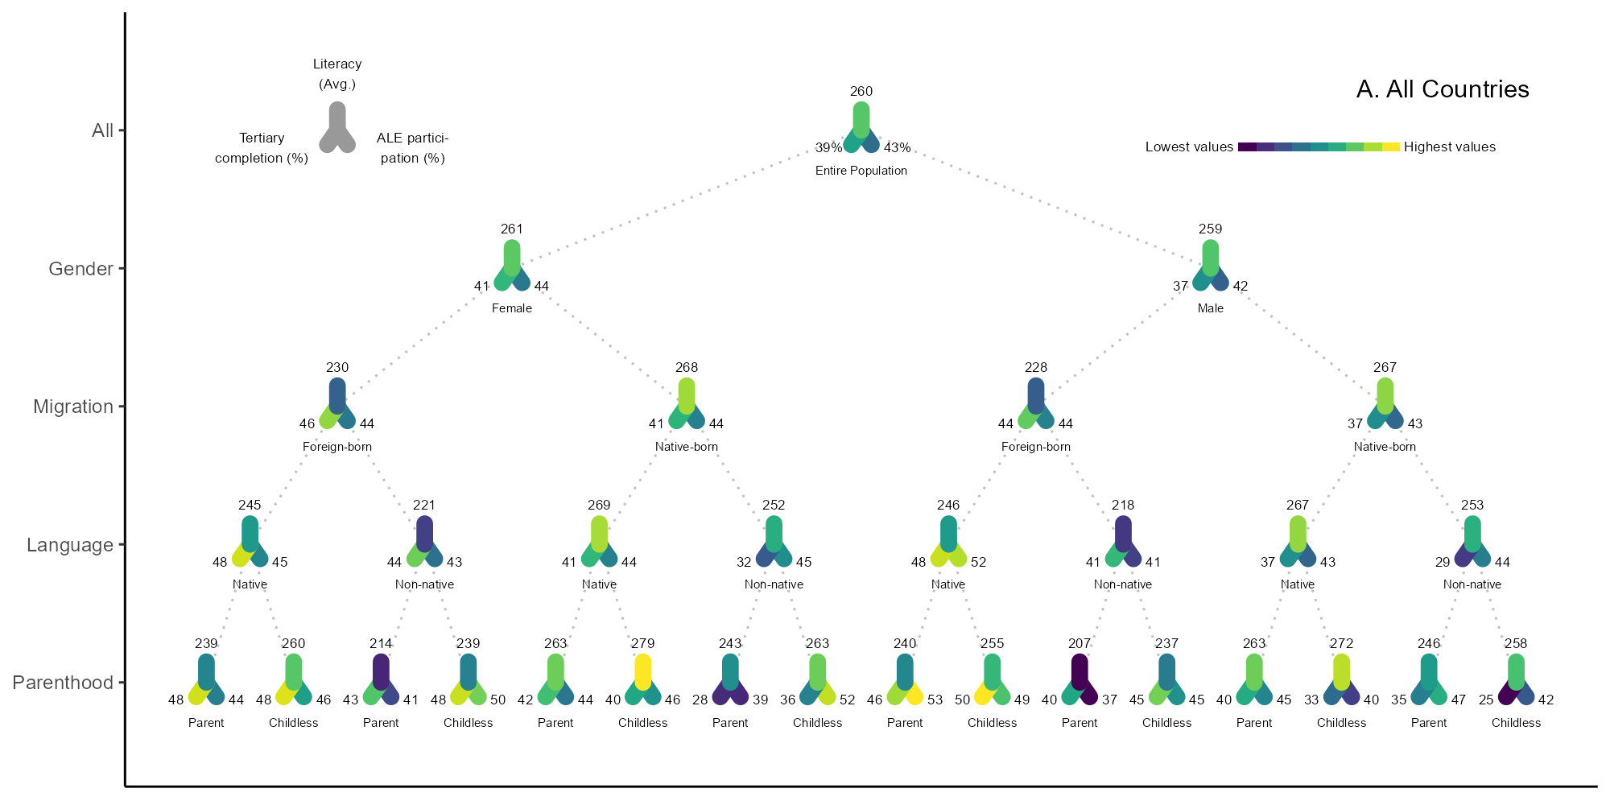

6.2.4 B. Rich
agg_png(here("Results", "Fig2A_B.png"), res = 200, width = 1850, height = 1000)

rx <- 0.8
ry <- 0.15
bar_w <- (max_x - min_x) * 0.15
bar_x <- max_x - bar_w
bar_y <- 0

p <- ggplot(df_a2_rich, aes(x = x, y = y)) +
geom_segment(
data = edges_rich,
aes(x = x, y = y, xend = xend, yend = yend),
color = "grey75",
linetype = "dotted"
) +
geom_segment(
aes(xend = x + rx * 0.866, yend = y + ry * 0.7, color = color_ale),
linewidth = 3.5, lineend = "round"
) +
geom_segment(
aes(xend = x - rx * 0.866, yend = y + ry * 0.7, color = color_sec),
linewidth = 3.5, lineend = "round"
) +
geom_segment(
aes(xend = x, yend = y - ry, color = color_lit),
linewidth = 3.5, lineend = "round"
) +

geom_text(aes(x = x, y = y - ry - 0.1, label = round(mean, 0)), vjust = 0, hjust = 0.5, size = 2.2, color = "black") +
geom_text(aes(x = x + rx * 0.866 + 0.3, y = y + ry * 0.5 + 0.05, label = paste0(" ", round(pct_ale, 0), c("%", rep("", 30)))), hjust = 0, vjust = 0.5, size = 2.2, color = "black") +
geom_text(aes(x = x - rx * 0.866 - 0.3, y = y + ry * 0.5 + 0.05, label = paste0(round(pct_sec, 0), c("% ", rep(" ", 30)))), hjust = 1, vjust = 0.5, size = 2.2, color = "black") +
geom_text(aes(label = plot_label), vjust = 5.0, size = 1.9, color = "black") +

scale_color_identity() +
scale_y_reverse(
breaks = 0:4,
labels = c("", "", "", "", ""),
limits = c(4.5, -0.6)
) +
labs(
x = NULL, y = NULL,
title = NULL
) +
annotate("text", x = 40, y = -0.3,
label = "B. Rich", size = 4) +
theme_classic() +
theme(
legend.position = "none",
panel.grid.minor = element_blank(),
axis.text.x = element_blank(),
axis.ticks.x = element_blank()
)

p

dev.off()
## png
## 2
include_graphics(here("Results", "Fig2A_B.png"))
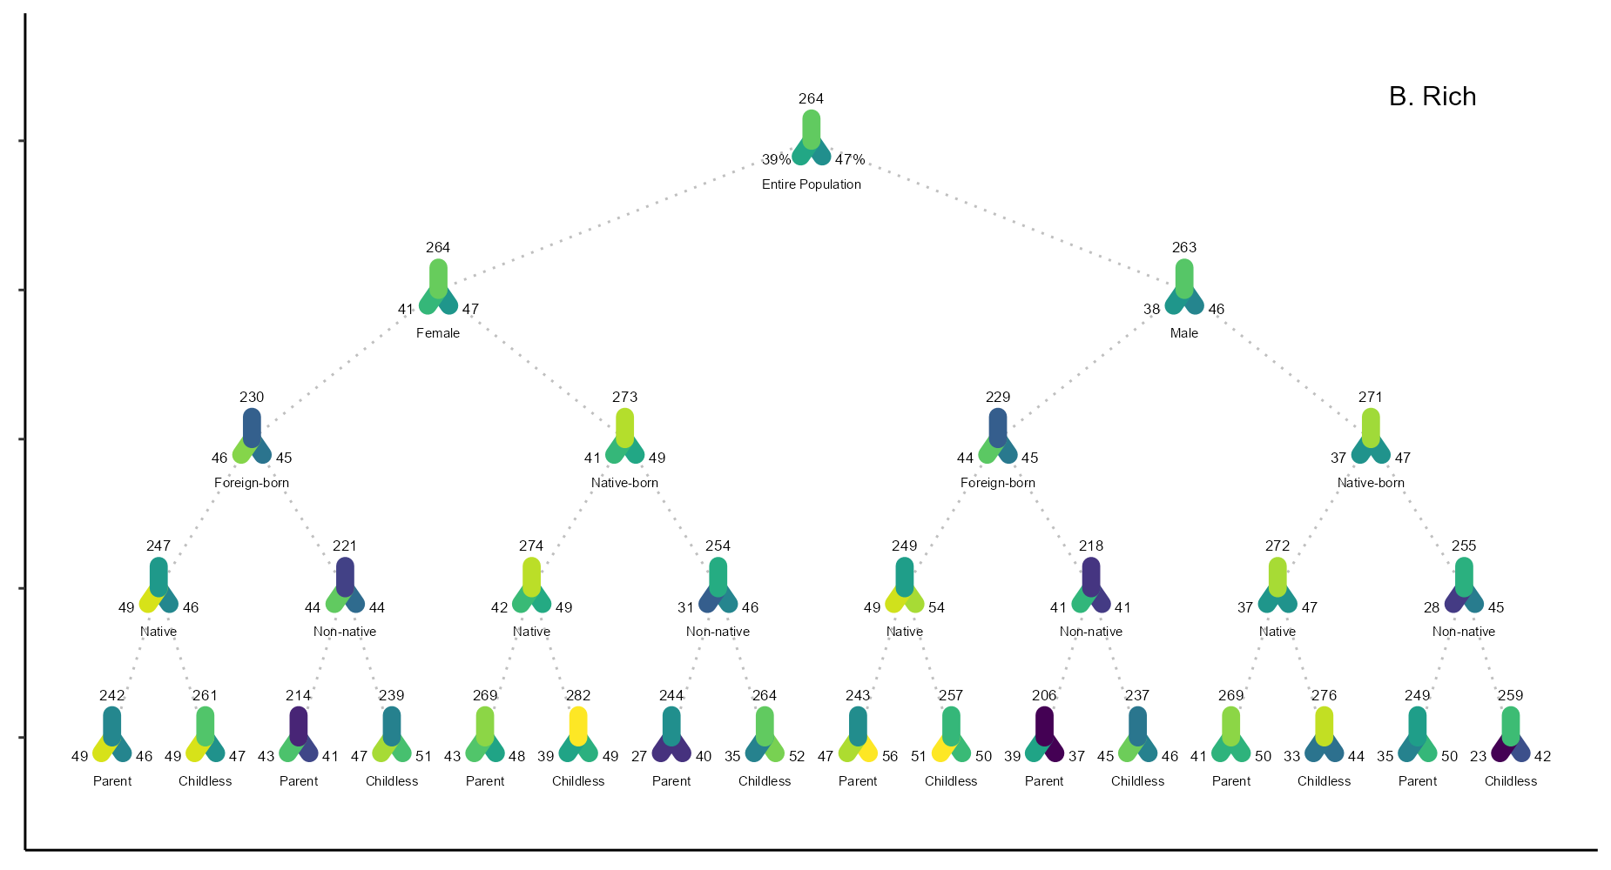

6.2.5 C. Europe
agg_png(here("Results", "Fig2A_C.png"), res = 200, width = 2000, height = 1000)

rx <- 0.8
ry <- 0.15
bar_w <- (max_x - min_x) * 0.15
bar_x <- max_x - bar_w
bar_y <- 0

p <- ggplot(df_a2_eur, aes(x = x, y = y)) +
geom_segment(
data = edges_eur,
aes(x = x, y = y, xend = xend, yend = yend),
color = "grey75",
linetype = "dotted"
) +
geom_segment(
aes(xend = x + rx * 0.866, yend = y + ry * 0.7, color = color_ale),
linewidth = 3.5, lineend = "round"
) +
geom_segment(
aes(xend = x - rx * 0.866, yend = y + ry * 0.7, color = color_sec),
linewidth = 3.5, lineend = "round"
) +
geom_segment(
aes(xend = x, yend = y - ry, color = color_lit),
linewidth = 3.5, lineend = "round"
) +

geom_text(aes(x = x, y = y - ry - 0.1, label = round(mean, 0)), vjust = 0, hjust = 0.5, size = 2.2, color = "black") +
geom_text(aes(x = x + rx * 0.866 + 0.3, y = y + ry * 0.5 + 0.05, label = paste0(" ", round(pct_ale, 0), c("%", rep("", 30)))), hjust = 0, vjust = 0.5, size = 2.2, color = "black") +
geom_text(aes(x = x - rx * 0.866 - 0.3, y = y + ry * 0.5 + 0.05, label = paste0(round(pct_sec, 0), c("% ", rep(" ", 30)))), hjust = 1, vjust = 0.5, size = 2.2, color = "black") +
geom_text(aes(label = plot_label), vjust = 5.0, size = 1.9, color = "black") +

scale_color_identity() +
scale_y_reverse(
breaks = 0:4,
labels = c("All", "Gender", "Migration", "Language", "Parenthood"),
limits = c(4.5, -0.6)
) +
labs(
x = NULL, y = NULL,
title = NULL
) +
annotate("text", x = 40, y = -0.3,
label = "C. Europe", size = 4) +
theme_classic() +
theme(
legend.position = "none",
panel.grid.minor = element_blank(),
axis.text.x = element_blank(),
axis.ticks.x = element_blank()
)

p

dev.off()
## png
## 2
include_graphics(here("Results", "Fig2A_C.png"))
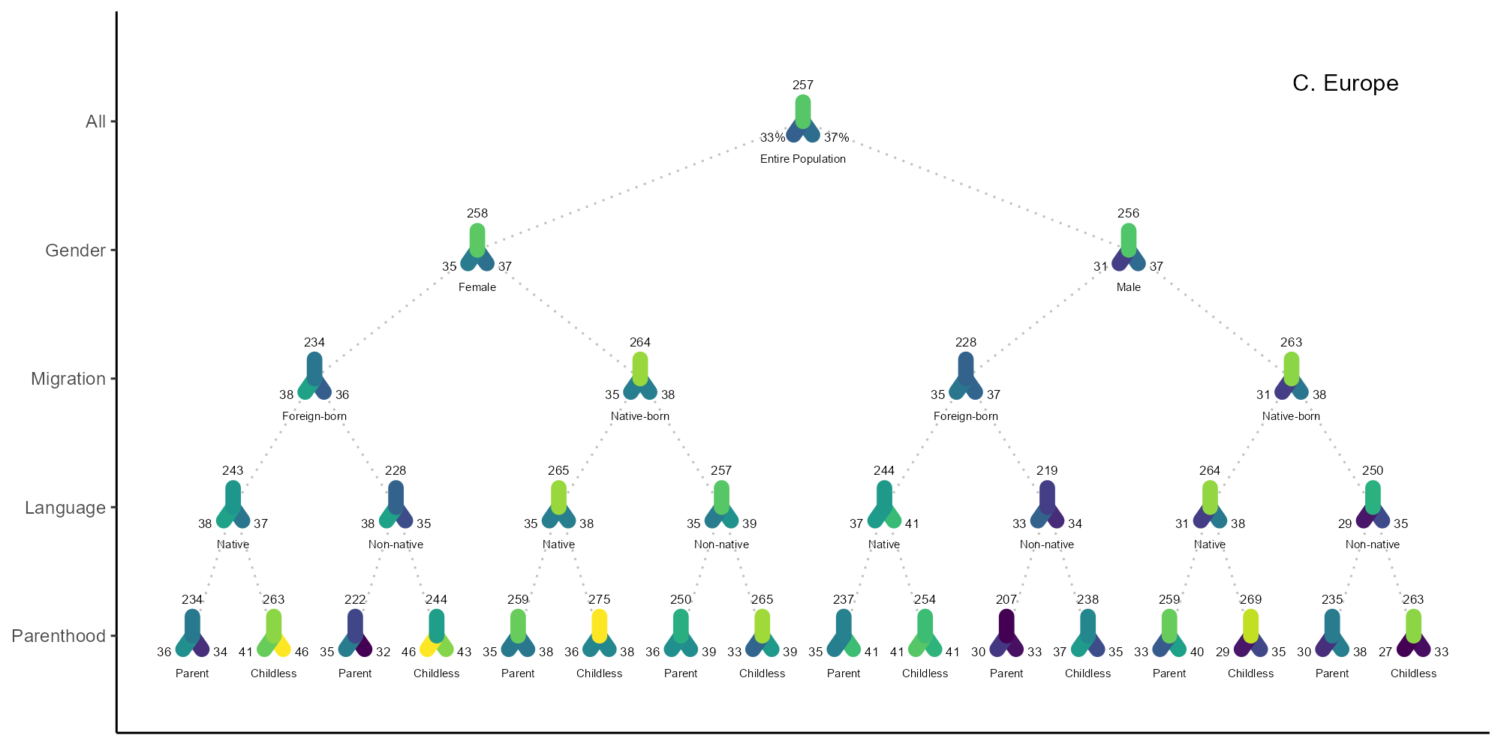

6.2.6 D. DEU

6.2.6.1 Lit English Labels
agg_png(here("Results", "Fig2A_D.png"), res = 200, width = 1850, height = 1000)

rx <- 0.8
ry <- 0.15
bar_w <- (max_x - min_x) * 0.15
bar_x <- max_x - bar_w
bar_y <- 0

p <- ggplot(df_a2_de, aes(x = x, y = y)) +
geom_segment(
data = edges_de,
aes(x = x, y = y, xend = xend, yend = yend),
color = "grey75",
linetype = "dotted"
) +
geom_segment(
aes(xend = x + rx * 0.866, yend = y + ry * 0.7, color = color_ale),
linewidth = 3.5, lineend = "round"
) +
geom_segment(
aes(xend = x - rx * 0.866, yend = y + ry * 0.7, color = color_sec),
linewidth = 3.5, lineend = "round"
) +
geom_segment(
aes(xend = x, yend = y - ry, color = color_lit),
linewidth = 3.5, lineend = "round"
) +

geom_text(aes(x = x, y = y - ry - 0.1, label = round(mean, 0)), vjust = 0, hjust = 0.5, size = 2.2, color = "black") +
geom_text(aes(x = x + rx * 0.866 + 0.3, y = y + ry * 0.5 + 0.05, label = paste0(" ", round(pct_ale, 0), c("%", rep("", 30)))), hjust = 0, vjust = 0.5, size = 2.2, color = "black") +
geom_text(aes(x = x - rx * 0.866 - 0.3, y = y + ry * 0.5 + 0.05, label = paste0(round(pct_sec, 0), c("% ", rep(" ", 30)))), hjust = 1, vjust = 0.5, size = 2.2, color = "black") +
geom_text(aes(label = plot_label), vjust = 5.0, size = 1.9, color = "black") +

scale_color_identity() +
scale_y_reverse(
breaks = 0:4,
labels = c("", "", "", "", ""),
limits = c(4.5, -0.6)
) +
labs(
x = NULL, y = NULL,
title = NULL
) +
annotate("text", x = 40, y = -0.3,
label = "D. DEU", size = 4) +
theme_classic() +
theme(
legend.position = "none",
panel.grid.minor = element_blank(),
axis.text.x = element_blank(),
axis.ticks.x = element_blank()
)

p

dev.off()
## png
## 2
include_graphics(here("Results", "Fig2A_D.png"))
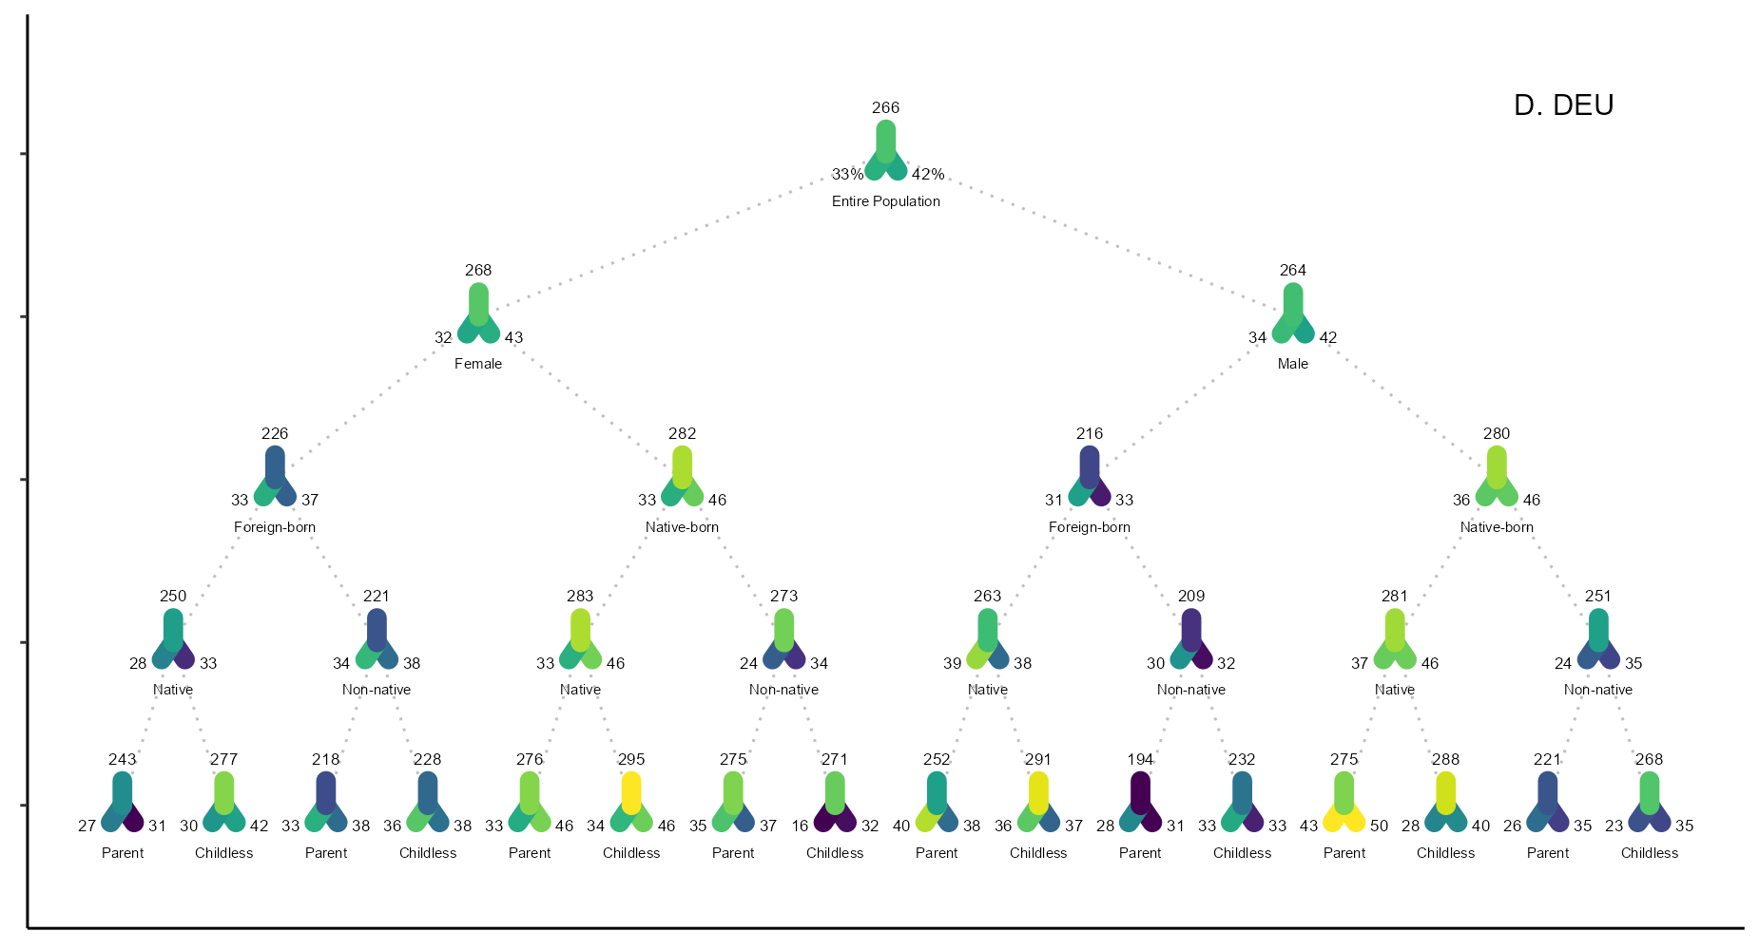

6.2.6.2 Lit DE Labels
agg_png(here("Results", "Fig2A_D_Deutsch.png"), res = 576, width = 3200, height = 2250)

df_a2_de_X <- df_a2_de %>%
mutate(plot_label = case_match(plot_label,
"Male" ~ "Männer",
"Female" ~ "Frauen",
"Native-born" ~ "DE geboren",
"Foreign-born" ~ "Ausl. geboren",
"Native" ~ "Erstsprache",
"Non-native" ~ "nicht Erstsprache",
"Parent" ~ "Mit",
"Childless" ~ "Ohne")
)

pdex <- ggplot(df_a2_de_X, aes(x = x, y = y, color = mean)) +
geom_segment(
data = edges_de,
aes(x = x, y = y, xend = xend, yend = yend),
color = "grey75",
linetype = "dotted"
) +
geom_point(size = 5) +
geom_text(
aes(label = round(mean, 0)),
vjust = -2.2,
size = 2.2,
color = "black"
) +
geom_text(
aes(label = plot_label),
vjust = 3,
size = 1.7,
color = "black"
) +
scale_color_viridis_c(name = "Literalität") +
scale_y_reverse(
breaks = 0:4,
labels = c("Gesamt", "Geschlecht", "Migration", "Deutsch", "Elternschaft"),
limits = c(4.1,-0.1)
) +
labs(
x = NULL, y = "Gruppen",
title = NULL
) +
theme_classic() +
theme(
legend.position = "bottom",
panel.grid.minor = element_blank(),
axis.text.x = element_blank(),
axis.ticks.x = element_blank()
)

pdex

dev.off()
## png
## 2
include_graphics(here("Results", "Fig2A_D_Deutsch.png"))
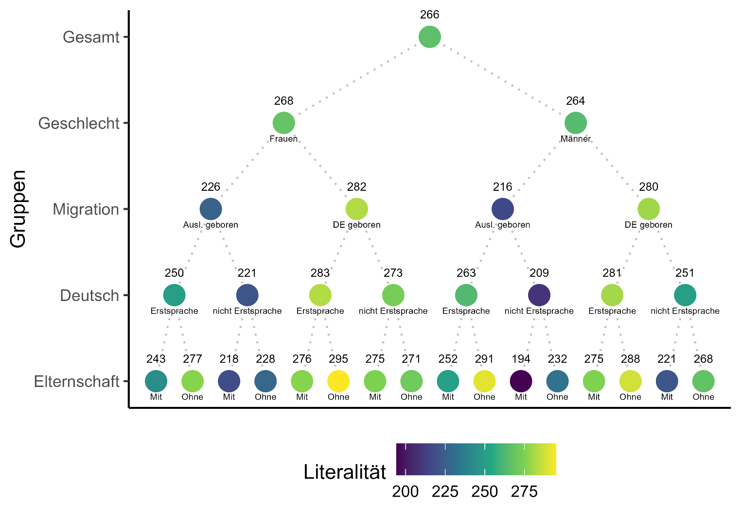

6.2.6.3 Num DE Labels
agg_png(here("Results", "Fig2A_D_Num_Deutsch.png"), res = 576, width = 3200, height = 2250)

df_a2num_de_X <- df_a2num_de %>%
mutate(plot_label = case_match(plot_label,
"Male" ~ "Männer",
"Female" ~ "Frauen",
"Native-born" ~ "DE geboren",
"Foreign-born" ~ "Ausl. geboren",
"Native" ~ "Erstsprache",
"Non-native" ~ "nicht Erstsprache",
"Parent" ~ "Mit",
"Childless" ~ "Ohne")
)

pdex <- ggplot(df_a2num_de_X, aes(x = x, y = y, color = mean)) +
geom_segment(
data = edges_de_num,
aes(x = x, y = y, xend = xend, yend = yend),
color = "grey75",
linetype = "dotted"
) +
geom_point(size = 5) +
geom_text(
aes(label = round(mean, 0)),
vjust = -2.2,
size = 2.2,
color = "black"
) +
geom_text(
aes(label = plot_label),
vjust = 3,
size = 1.7,
color = "black"
) +
scale_color_viridis_c(name = "Numeralität") +
scale_y_reverse(
breaks = 0:4,
labels = c("Gesamt", "Geschlecht", "Migration", "Deutsch", "Elternschaft"),
limits = c(4.1,-0.1)
) +
labs(
x = NULL, y = "Gruppen",
title = NULL
) +
theme_classic() +
theme(
legend.position = "bottom",
panel.grid.minor = element_blank(),
axis.text.x = element_blank(),
axis.ticks.x = element_blank()
)

pdex

dev.off()
## png
## 2
include_graphics(here("Results", "Fig2A_D_Num_Deutsch.png"))
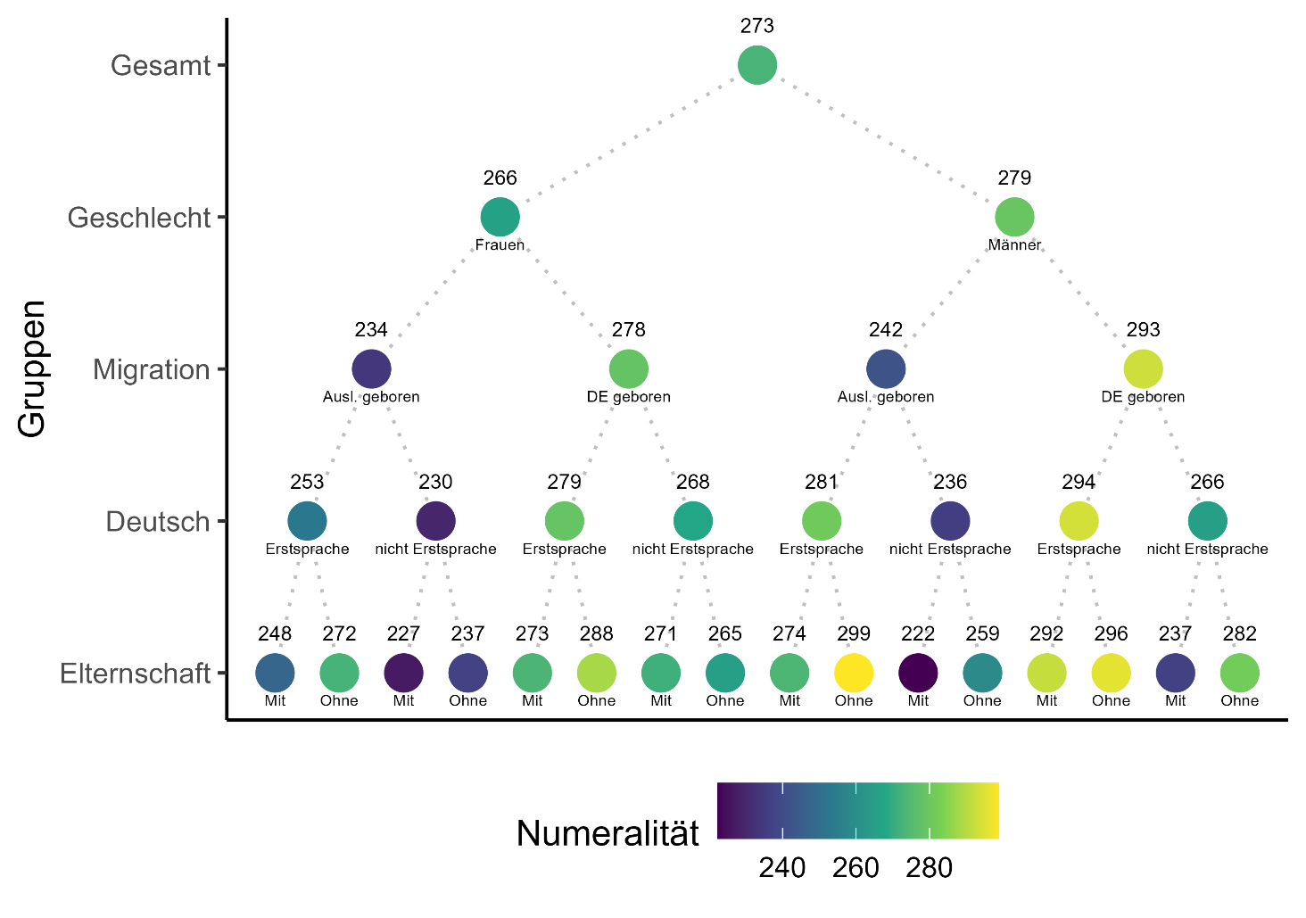

7 Tbl S2. Intersectional Descriptives (16 Groups)
The unweighted N and sec education % were moved to Fig A2 construction
# Fig A2 group labels
group_labels_16 <- c(
"male_not_natlang_child", "male_not_notnatlang_child",
"male_fb_natlang_child", "male_fb_notnatlang_child",
"male_not_natlang_nochild", "male_not_notnatlang_nochild",
"male_fb_natlang_nochild", "male_fb_notnatlang_nochild",
"female_not_natlang_child", "female_not_notnatlang_child",
"female_fb_natlang_child", "female_fb_notnatlang_child",
"female_not_natlang_nochild", "female_not_notnatlang_nochild",
"female_fb_natlang_nochild", "female_fb_notnatlang_nochild"
)

# Extract Literacy from Fig A2 data
df_figA2_values <- df_lit_all %>%
filter(cycle %in% c("df2", "Cycle 2", "Cycle 2 (2022)", "2022")) %>%
filter(group_label %in% group_labels_16) %>%
select(group_label, Literacy_wmean = mean, ALE_pct_wmean = pct_ale)

# Calculate Unweighted N and Sec Education from df2
df2_calc <- df2 %>%
filter(ed_currently != 1) %>%
filter(!is.na(female) & !is.na(FORBORN) & !is.na(FORLANG) &
!is.na(children) & !is.na(ed3)) %>%
mutate(
ed_sec_or_higher = ifelse(ed3 %in% c(2, 3), 1, 0),
# labwel for joining
group_label = paste0(
ifelse(female == 1, "female", "male"), "_",
ifelse(FORBORN == 1, "fb", "not"), "_",
ifelse(FORLANG == 1, "notnatlang", "natlang"), "_",
ifelse(children == 1, "child", "nochild")
)
) %>%
group_by(group_label, female, FORBORN, FORLANG, children) %>%
summarise(
N_unweighted = n(),
SecEd_pct_wmean = weighted.mean(ed_sec_or_higher, SPFWT0, na.rm = TRUE) * 100,
.groups = "drop"
)

table_16_groups <- df_figA2_values %>%
left_join(df2_calc, by = "group_label") %>%
mutate(
Gender = ifelse(female == 1, "Female", "Male"),
Origin = ifelse(FORBORN == 1, "Foreign-born", "Native-born"),
Language = ifelse(FORLANG == 1, "Non-native speaker", "Native speaker"),
Parenthood = ifelse(children == 1, "Parent", "Childless")
) %>%
select(Gender, Origin, Language, Parenthood, N_unweighted, Literacy_wmean, ALE_pct_wmean, SecEd_pct_wmean) %>%
arrange(desc(Gender), desc(Origin), Language, desc(Parenthood))

table_16_out <- table_16_groups %>%
kable("html",
digits = 1,
caption = "Descriptive Statistics for 16 Intersectional Groups (Cycle 2)",
col.names = c("Gender", "Origin", "Language", "Parenthood", "N (Cases)", "Mean Literacy", "ALE Participation (%)", "Sec. Ed or Higher (%)")) %>%
kable_styling(full_width = FALSE, bootstrap_options = c("striped", "hover"))

save_kable(table_16_out, file = here::here("Results", "TS3.html"))

table_16_out

Descriptive Statistics for 16 Intersectional Groups (Cycle 2)
Gender | Origin | Language | Parenthood | N (Cases) | Mean Literacy | ALE Participation (%) | Sec. Ed or Higher (%)
Male | Native-born | Native speaker | Parent | 29373 | 262.8 | 44.7 | 86.3
Male | Native-born | Native speaker | Childless | 18353 | 271.8 | 40.4 | 87.2
Male | Native-born | Non-native speaker | Parent | 1209 | 245.9 | 47.4 | 77.1
Male | Native-born | Non-native speaker | Childless | 730 | 257.9 | 41.9 | 77.6
Male | Foreign-born | Native speaker | Parent | 2074 | 240.5 | 53.4 | 75.9
Male | Foreign-born | Native speaker | Childless | 1130 | 255.0 | 48.9 | 87.6
Male | Foreign-born | Non-native speaker | Parent | 2595 | 206.9 | 37.4 | 69.3
Male | Foreign-born | Non-native speaker | Childless | 1387 | 236.6 | 45.5 | 84.9
Female | Native-born | Native speaker | Parent | 40523 | 263.1 | 43.8 | 87.8
Female | Native-born | Native speaker | Childless | 14459 | 279.1 | 45.6 | 91.0
Female | Native-born | Non-native speaker | Parent | 1459 | 242.6 | 39.2 | 74.9
Female | Native-born | Non-native speaker | Childless | 652 | 262.8 | 51.9 | 85.4
Female | Foreign-born | Native speaker | Parent | 2973 | 239.4 | 44.2 | 82.4
Female | Foreign-born | Native speaker | Childless | 1011 | 259.8 | 46.3 | 87.9
Female | Foreign-born | Non-native speaker | Parent | 3507 | 214.5 | 41.0 | 71.7
Female | Foreign-born | Non-native speaker | Childless | 1244 | 238.9 | 50.0 | 88.9

8 Citations
packages %>%
map(citation) %>%
print(style = "text")
## [[1]]
## Wickham H, Averick M, Bryan J, Chang W, McGowan LD, François R,
## Grolemund G, Hayes A, Henry L, Hester J, Kuhn M, Pedersen TL, Miller E,
## Bache SM, Müller K, Ooms J, Robinson D, Seidel DP, Spinu V, Takahashi
## K, Vaughan D, Wilke C, Woo K, Yutani H (2019). "Welcome to the
## tidyverse." _Journal of Open Source Software_, *4*(43), 1686.
## doi:10.21105/joss.01686 <https://doi.org/10.21105/joss.01686>.
##
## [[2]]
## Wickham H, Hester J, Bryan J (2024). _readr: Read Rectangular Text
## Data_. R package version 2.1.5,
## <https://CRAN.R-project.org/package=readr>.
##
## [[3]]
## Xie Y (2025). _knitr: A General-Purpose Package for Dynamic Report
## Generation in R_. R package version 1.50, <https://yihui.org/knitr/>.
##
## Xie Y (2015). _Dynamic Documents with R and knitr_, 2nd edition.
## Chapman and Hall/CRC, Boca Raton, Florida. ISBN 978-1498716963,
## <https://yihui.org/knitr/>.
##
## Xie Y (2014). "knitr: A Comprehensive Tool for Reproducible Research in
## R." In Stodden V, Leisch F, Peng RD (eds.), _Implementing Reproducible
## Computational Research_. Chapman and Hall/CRC. ISBN 978-1466561595.
##
## [[4]]
## Müller K (2020). _here: A Simpler Way to Find Your Files_. R package
## version 1.0.1, <https://CRAN.R-project.org/package=here>.
##
## [[5]]
## Wickham H (2016). _ggplot2: Elegant Graphics for Data Analysis_.
## Springer-Verlag New York. ISBN 978-3-319-24277-4,
## <https://ggplot2.tidyverse.org>.
##
## [[6]]
## Slowikowski K (2024). _ggrepel: Automatically Position Non-Overlapping
## Text Labels with 'ggplot2'_. R package version 0.9.6,
## <https://CRAN.R-project.org/package=ggrepel>.
##
## [[7]]
## Pedersen T, Shemanarev M (2024). _ragg: Graphic Devices Based on AGG_.
## R package version 1.3.3, <https://CRAN.R-project.org/package=ragg>.
##
## [[8]]
## Lumley T (2024). "survey: analysis of complex survey samples." R
## package version 4.4.
##
## Lumley T (2004). "Analysis of Complex Survey Samples." _Journal of
## Statistical Software_, *9*(1), 1-19. R package verson 2.2.
##
## Lumley T (2010). _Complex Surveys: A Guide to Analysis Using R: A Guide
## to Analysis Using R_. John Wiley and Sons.
##
## [[9]]
## Zhu H (2024). _kableExtra: Construct Complex Table with 'kable' and
## Pipe Syntax_. R package version 1.4.0,
## <https://CRAN.R-project.org/package=kableExtra>.
##
## [[10]]
## Wickham H, Pedersen T, Seidel D (2023). _scales: Scale Functions for
## Visualization_. R package version 1.3.0,
## <https://CRAN.R-project.org/package=scales>.
##
## [[11]]
## Vargas Sepulveda M (2025). _wbstats: Programmatic Access to the World
## Bank API_. Oak Ridge National Laboratory, Oak Ridge, Tennessee. Vargas
## Sepulveda, Mauricio (2025). wbstats: Programmatic Access to the World
## Bank API. Oak Ridge National Laboratory. Oak Ridge, Tennessee. URL
## https://doi.org/10.11578/dc.20171025.1827,
## <https://doi.org/10.11578/dc.20171025.1827>.

9 Colophon
sessionInfo()
## R version 4.4.1 (2024-06-14 ucrt)
## Platform: x86_64-w64-mingw32/x64
## Running under: Windows 11 x64 (build 26200)
##
## Matrix products: default
##
##
## locale:
## [1] LC_COLLATE=English_United States.utf8
## [2] LC_CTYPE=English_United States.utf8
## [3] LC_MONETARY=English_United States.utf8
## [4] LC_NUMERIC=C
## [5] LC_TIME=English_United States.utf8
##
## time zone: America/New_York
## tzcode source: internal
##
## attached base packages:
## [1] grid stats graphics grDevices utils datasets methods
## [8] base
##
## other attached packages:
## [1] wbstats_1.1 scales_1.3.0 kableExtra_1.4.0 survey_4.4-2
## [5] survival_3.6-4 Matrix_1.7-0 ragg_1.3.3 ggrepel_0.9.6
## [9] here_1.0.1 knitr_1.50 lubridate_1.9.4 forcats_1.0.0
## [13] stringr_1.5.1 dplyr_1.1.4 purrr_1.0.4 readr_2.1.5
## [17] tidyr_1.3.1 tibble_3.2.1 ggplot2_3.5.1 tidyverse_2.0.0
##
## loaded via a namespace (and not attached):
## [1] gtable_0.3.6 xfun_0.51 bslib_0.9.0 lattice_0.22-6
## [5] tzdb_0.5.0 vctrs_0.6.5 tools_4.4.1 generics_0.1.3
## [9] curl_6.2.2 parallel_4.4.1 pacman_0.5.1 pkgconfig_2.0.3
## [13] lifecycle_1.0.4 compiler_4.4.1 farver_2.1.2 textshaping_1.0.0
## [17] munsell_0.5.1 mitools_2.4 htmltools_0.5.8.1 sass_0.4.9
## [21] yaml_2.3.10 crayon_1.5.3 pillar_1.10.1 jquerylib_0.1.4
## [25] cachem_1.1.0 tidyselect_1.2.1 digest_0.6.37 stringi_1.8.4
## [29] labeling_0.4.3 splines_4.4.1 rprojroot_2.0.4 fastmap_1.2.0
## [33] colorspace_2.1-1 cli_3.6.4 magrittr_2.0.3 withr_3.0.2
## [37] bit64_4.6.0-1 timechange_0.3.0 httr_1.4.7 rmarkdown_2.29
## [41] bit_4.6.0 png_0.1-8 hms_1.1.3 evaluate_1.0.3
## [45] viridisLite_0.4.2 rlang_1.1.5 Rcpp_1.0.14 glue_1.8.0
## [49] DBI_1.2.3 xml2_1.3.8 svglite_2.1.3 rstudioapi_0.17.1
## [53] vroom_1.6.5 jsonlite_2.0.0 R6_2.6.1 systemfonts_1.2.1

