Bulk Quantity Promotion Plugin

# Introduction

This document explains how to install and integrate the Bulk Quantity promotion plugin for NBSv3.

# Installation

Install the plugin Install zip like you would any normal DNN module. Then go into the NBSv3 Back Office and goto the Admin>Plugin menu. This should install the required plugin data into the Back Office menu. You should then find a BO>Promotions>Bulk-Buy option on the menu.

NOTE: If you using a NBS version prior to v3.5.2.2 then the plugin it injected at the top of the list, this pushes the dashboard option down and therefore you need to move the dashboard plugin back to the top of the list.

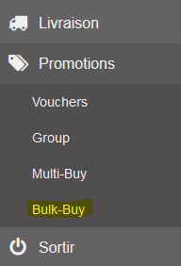

# Adding a Promotion

Go into the Bulk-Buy option and you can create a new promotion by click the “Add” button above the list. This will open a new promotion detail page for you.

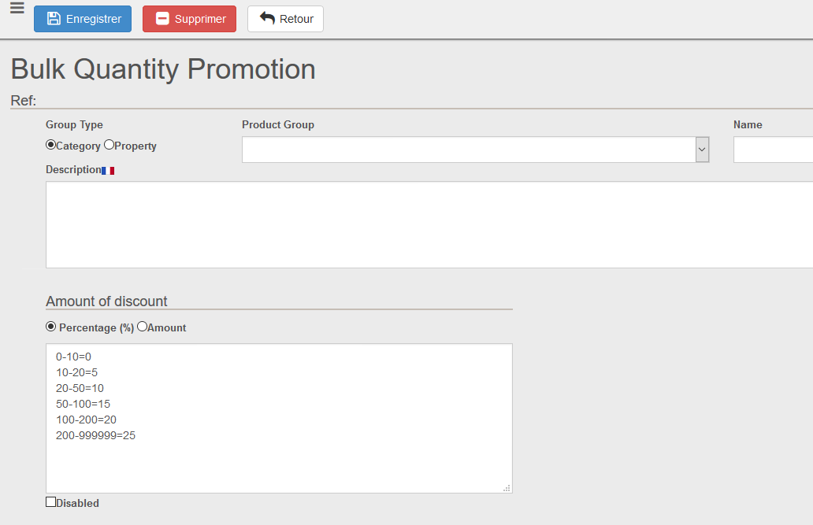

### Assign to Property or Category

Bulk Promotions work by assigning the promotion to a category or property. All products that are in the category or have the property will have the promotion activate.

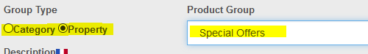

### Description Information

The description field allows you to enter a description which can be displayed on the product when the promotion is activate. This is localized to the language being displayed. HTML code can be entered, to make the display appear as formatted on the product detail.

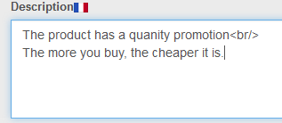

### Promotion Qty Range

The range of quantity promotion is entered into the “Amount of discount” textbox and can be a percentage to an amount. Each row represents a new quantity range.

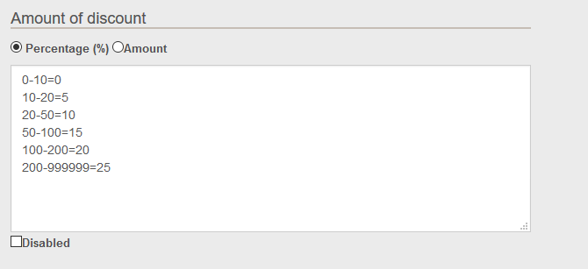

### Displaying the Promotion detail on the product display

The description of the promotion or any other data you wish can be displayed on the product display by altering the display template being used. (By default “NBS_ProductDisplayDetail.cshtml” or NBS_ProductDisplayList.cshtml)

This works by editing the template and adding a token to display a template. The token to be entered into the display template is the “@RenderTemplate”

In the example below we’ve linked the token to an example template which is delivered with QtyPromo install.

@RenderTemplate("/DesktopModules/NBright/NBrightQtyPromo/Themes/config/default/productdisplay.cshtml", Model)

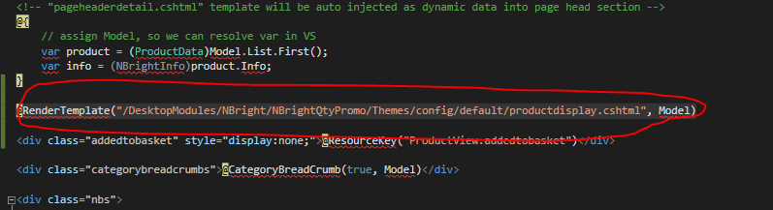

This token is rendering the example template which renders the data using special 2 tokens.

@HasQtyPromo

@QtyPromoDescription.

Look at the example template in the plugin as an example how it can be edited to match your needs.

