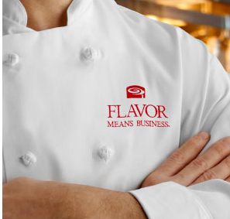

Minor’s Ingredients were presented to me from Chef Richard Reilly as a solution to taking an everyday veggie dip to the next level. In my experience with food manufacturing, it’s not always easy to create exciting flavor profiles consistently and cost effectively. But that is just what Minor’s allows. Their concentrates have bold flavor profiles that incorporate well into many traditional dips and completely take them to the next level.
Their long standing tradition of quality and manufacturing excellence also provides peace of mind when putting this ingredient into a finished product that will be distributed across the masses. I know from a manufacturing standpoint that this ingredient has been tested over and over and is back by a company that has deep roots in Food Safety.
My personal favorite concentrate, Minor’s Ancho, is especially good in traditional baked beans. It takes a non-protein added baked bean and gives the smoky notes that many companies use BBQ’d meat for. It keeps the cost low, but provides a flavor and a finished product you won’t’ hesitate spending money on.
I want to point out that I thought the Ancho Concentrate was a fantastic addition to our company’s current baked bean flavor profile, however it was reviewed by our customer panel and found to be at “parody” with our current offering. It was at that time that we decided not to go with the Minor’s concentrate. I only bring this up because even though many of us thought it was the “next best thing” for baked beans, the fact that the project got killed and Minor’s lost the sale did not stop their team from asking, “What else can we do to help”? This kind of loyalty and customer support is hard to find in the market these days. I was really impressed, because I have had many companies drop off the face of the earth after breaking the news that their ingredient wasn’t chosen in a finished product.
I am currently developing some Greek yogurt based dips that will be featuring Minor’s concentrates. I wish I could expand more on them, but until they are on the market, it’s going to be my secret..
As far as “Flavor means Business” – Minors has repeatedly shown that they can execute providing quality ingredients that meet the needs of Food Service, Food Manufactures, and just plain Foodies everywhere. In addition to meeting needs, the Minor’s team has a unique group of Chefs that provide insight and resources to their customers that other companies only wish they could offer. You’re not only buying the brand, you’re buying excellent customer service. And that’s why 60 years have come and gone, but Minor’s has not.

