# IST359 – Fall 2017 Mid-term Exam Instructions & Questions

## Effort: Individual Effort, you may use course materials to assist you with the Exam. You may NOT use the aid of another person directly or indirectly. Failure to comply will result in a grade of 0. Maximum Points: 100 pts. Partial credit will be given for code that executes properly. Use template file provided in BB. Due Date: Timed exam, 1 hour 15 minutes maximum. Submission: Use the exam template file and upload it to blackboard when you are finished. Late exam submissions will not be accepted. Be sure to place your name as the first line in the script as a --COMMENT.

**Description:** I’m starting a small transportation business and need to track my drivers and vehicles. Your exam relates to creating the database for me. Your script should execute without error multiple times. You must use the template file provided in BlackBoard so be sure to download it before you begin. Be mindful of time. Allocate 5 minutes per question to complete the entire exam in the time allowed. SAVE OFTEN and know where you have saved your code. In the end, simply upload it to BB. DO NOT COMPRESS it just upload the SQL file. Partial credit is awarded.

You will use the following draft database diagram and sample data for your work. Please review it carefully before you begin.

In your script you will perform the following activities:

1. Delete any existing tables and procedures
2. Use DDL Commands to Add New Tables, Physical and Logical Constraints to your internal model
3. Use DML to add data to your tables.
4. Create a procedure to implement the external model.
5. Execute a procedure that manipulates existing data.
6. Run validation queries to check your work.

Good luck.

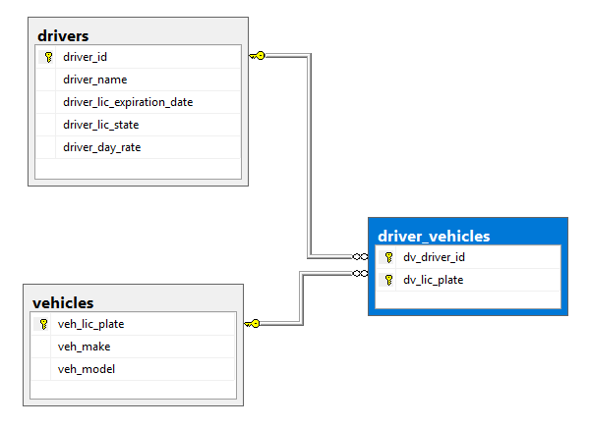

|  |  |  |  |  |  |  |  |
| --- | --- | --- | --- | --- | --- | --- | --- |
| **Drv ID** | **Drv Name** | **Drv Chg Per Day** | **Driver Lic State** | **Veh Lic Pl** | **Veh Make** | **Veh Mod** | **License Exp** |
| 10 | Smith,Ted | $100.00 | NY | SYR555 | BMW | S3 | 12/31/2020 |
| 10 | Smith,Ted | $100.00 | NY | NY123 | Audi | Q5 | 12/31/2020 |
| 15 | Nosky, Deb | $200.00 | PA | NY123 | Audi | Q5 | 7/7/2018 |
| 20 | Tang, Max | $300.00 | NY | NY123 | Audi | Q5 | 9/1/2019 |
| 20 | Tang, Max | $300.00 | NY | SYR555 | BMW | S3 | 9/1/2019 |
| 25 | Lee, Pedro | $400.00 | FL | SU44 | Toyota | Rav4 | 5/15/2020 |

## Questions

1. Based on the above diagram add the necessary code to drop each of the tables. Later you should come back to this step and code the drop for the procedure you will create in step X. Your code must execute without error no matter how many times it is run for full points. **(10 pts)**
2. Write an SQL statement to create the table **vehicles. Do not add constraints yet.** Refer to the sample data to help you determine appropriate data types and sizes. **(5 pts)**

|  |  |  |  |
| --- | --- | --- | --- |
| **Column Name** | **Data Type** | **Allow Null** | **Default Value** |
| **veh_lic_plate** | **This is a field that will allow up to 8 characters. It will serve to enforce entity integrity.** | **No** |  |
| **veh_make** | **This field will allow up to 25 characters. Most will be far shorter though. Think of Make as the Manufacturer or Company.** | **No** |  |
| **veh_model** | **This field will allow up to 25 characters. Most will be far shorter though. It is the model of the car.** | **No** |  |

1. Write an SQL statement to create the table **driver_vehicles. Do not add constraints yet.** Drivers are allowed to drive more than one vehicle. This table shows us exactly who can drive which car. **(5 pts)**

|  |  |  |  |
| --- | --- | --- | --- |
| **Column Name** | **Data Type** | **Allow Null** | **Default Value** |
| **dv_drive_id** | **This will contain valid driver ids.** | **No** |  |
| **dv_lic_plate** | **This will contain valid license plates.** | **No** |  |

1. Write an SQL statement to create the table **drivers. Do not add constraints yet. (10 pts)**

|  |  |  |  |
| --- | --- | --- | --- |
| **Column Name** | **Data Type** | **Allow Null** | **Default Value** |
| **driver_id** | **Surrogate key that starts with 10 and increments by 5 each time we insert a new driver.** | **No** |  |
| **driver_name** | **The name of a driver. It is stored as last,first.** | **No** |  |
| **driver_lic_expiration_date** | **This is the date that the driver’s license expires. It must contain the year, month and day but a driver’s license doesn’t expire on the hour so DO NOT INCLUDE time.** | **No** |  |
| **driver_lic_state** | **This holds the abbreviation for each state. It is the state where the driver is licensed. For example, NY is New York, PA is Pennsylvania** | **No** |  |
| **driver_day_rate** | **This is how much the driver earns per day.** | **No** |  |

1. Write the SQL statements to add the following logical constraints to **drivers** . **(5 pts)**

|  |  |
| --- | --- |
| **Constraint Name** | **Constraint Type** |
| **pk_driver** | **Primary key** |

1. Write the SQL statements to add the following logical constraints to **vehicles** . **(5 pts)**

|  |  |
| --- | --- |
| **Constraint Name** | **Constraint Type** |
| **pk_vehicles** | **Primary key** |

1. Write the SQL statements to add the following logical constraints to **driver_vehicles**. **(5 pts)**

|  |  |
| --- | --- |
| **Constraint Name** | **Constraint Type** |
| **pk_driver_vehicle** | **Primary key** |
|  |  |
| **fk_..... (as per convention)**  **Implement the foreign keys as identified in the original database diagram** | **Foreign Keys** |

1. Write the SQLstatement to get all of our cars into the **vehicles** table. I started this but I’m not a good coder. It has several errors but once you fix the errors it will execute successfully and add our 3 cars. Fix and run the code provided in your script. (**5 pts**)
2. Write the SQL statement to get our 4 drivers into the **drivers** table. **(10 pts)**

1. Write the SQL needed to add the info into the **driver_vehicles** table. Hey, that good is the script is perfect but incomplete. Finish it up and execute! **(5 pts)**
2. Write a Procedure called **p_ny_driver_raise**. We would like to give drivers who are licensed to drive in NY a raise. The raise can vary each time so we want you to write a procedure to do this. This procedure assumes it is sent the amount you should add to their existing current day rate. Simply write the procedure in this step. **(10 pts)**
3. Execute the previous procedure to give all good drivers a $50 raise. **(5 pts)**
4. Write a query to show all the rows in our tables. Your results must look like this. **(10 pts)**

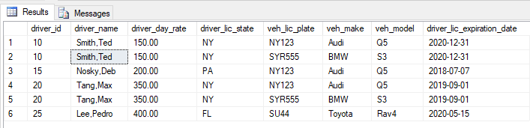

1. Write a query to show the lowest and highest driver daily rates. Your results must look like this. **(10 pts)**

