## 2f: Lab Questions (place answers in Word Document and Upload to BlackBoard)

1. Activity: Just like we did in our Pre-Lab, open your explorer on the left, open your database folder, open the tables folder and include a screen shot that shows your database folder name and both tables.

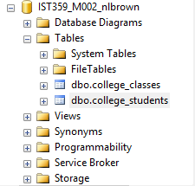

1. Activity: Open a new query window and execute the following command   
   SELECT * FROM college_students JOIN college_classes on student_class = class_name  
   Click Execute!  
   Copy the **result set** into a your answer sheet.

1 Terry Cloth 3.120 Freshman 1988-12-01 00:00:00.000 1 Freshman

8 Ima Testing 4.000 Freshman 1990-12-12 00:00:00.000 0 Freshman

1. Is a table data or metadata? Explain.

A table is metadata, it provides information about the data contained within.

1. “Persistent” is often used to mean permanent or continuing. What does it mean to say that data persists in a database table?

Persistence in our database means that the data is “saved” and can be queried / read.

1. What is the difference, if any, between a primary key constraint and a unique constraint?

The primary key constraint is useful as a unique identifier for a row of data, the unique constraint forces each value entered to be different, similar to a primary key however it is enforced on data that is not normally used as a primary key such as email addresses.

1. What is a convention?

A convention is a style or standard that provides a framework for which to build something off.

1. Can you control the number used by a surrogate key? Does it matter? Should you do some research before answering this question? Explain being sure to reference Seeds and Increments as shown in the following document…

Yes you can, they can be in order / increments (1,2,3) or they can be a pseudo-random number generated by and algorithm which usually requires a seed number entered by the user.

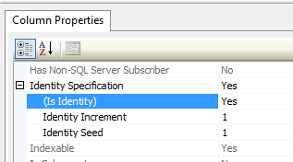

1. How does physical domain differ from logical domain?

The physical domain is our type of data in our table (eg INT, CHAR, STRING). In our logical domain the concern is primarily with what problem our database is solving and how it is done vs the actual datatypes and data contained.

1. What are your options for creating a table column that only accepts exactly 3 characters?

Char(3) will accept no less and no more than 3 non-Unicode characters

1. What are your options for creating a column that only accepts dates from last year? I don’t need the code you just have to explain how you would do this based on what you have learned thus far.

One would create a column that accepts date() values and then place a check constraint on the date year from the previous year up until whenever you wanted to stop it.

1. Explain how we used a lookup table in this lab.

We used a lookup table to create a foreign key check on a column of our table known as student_class. Now any data entered into student_class must match one of the primary key entries (Freshman, Sophomore, Junior, Senior) found in our lookup table (college_classes)

Upload your Word document into the lab result space for Unit 2 - Part 1.