### 1.D: Portion You Turn in for Part 1

Answer and upload a Word document to Blackboard.

Questions:

1. Open a blank WORD document where you can paste your answers
2. Open your object explorer and click on the folder called Tables? Please **take a screen shot that includes your database folder and shows the contents of your tables folder.** That should show a systems tables folder and one that starts with DBO.college_students. This should be similar to my shot in 1.c.1

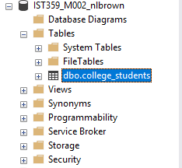

1. Activity: In SSMS - open a new query window and execute the following command   
   SELECT * FROM college_students   
   Place a screenshot of the **result set** in your answer sheet

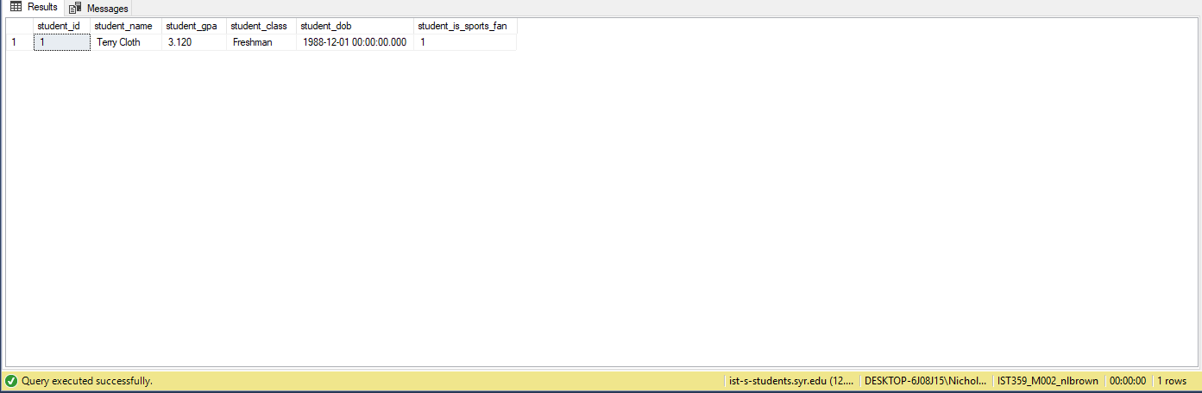

1. What is the difference between a primary key and a surrogate key?

A primary key is a unique value used from one column of a given table. A surrogate key is the same however we have made up a unique value for each row using a random or otherwise created number.

1. What is a schema? Do not cut/copy/paste a definition. USE YOUR OWN WORDS.

A schema relates to the plan and design of the database. It gives us consistency across tables and naming conventions.

1. What should you take into account when deciding which table column should be the primary key?

A primary key value should be one that does not change and is not going to be reproduced by another row. Therefor one should not use a something like a name as a value because people will sometimes change their name and many people even have the same name.

1. Write one question that you have about what you have seen in the videos or one thing you are confused about so far.

I’m curious about how to use a lookup table to validate our data, what is the syntax for this?

Upload your Word document into the lab result space for Unit 2 - Prelab.