## Section 4: Lab Questions: This is the Portion you will upload to Blackboard.

* 1. Write an SQL SELECT to show ALL of the rows in the table **fudgemart_timesheets.** Copy the **results** here.

1 2007-09-10 00:00:00.000 1 45.0

2 2007-09-10 00:00:00.000 2 45.0

3 2007-09-10 00:00:00.000 3 45.0

4 2007-09-10 00:00:00.000 4 45.0

5 2007-09-10 00:00:00.000 5 50.0

6 2007-09-10 00:00:00.000 6 50.0

* 1. Execute the following SQL. Explain in your own words why this command will not insert a row into the table.  
     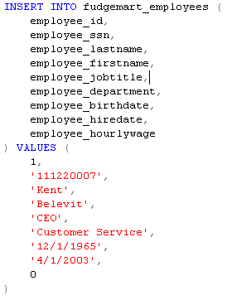

We can see that we get an error upon execution of this command:

Msg 2627, Level 14, State 1, Line 329

Violation of PRIMARY KEY constraint 'pk_employee_id'. Cannot insert duplicate key in object 'dbo.fudgemart_employees'. The duplicate key value is (1).

This means that our primary key constraint has been violated by setting our CEO’s employee ID to that of an existing employee in the table (1). To fix this we could use a number not taken by an employee.

Execute the following SQL. Explain in your own words why this command will not insert a row into the table.  
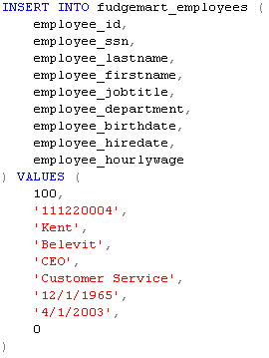   
Again we can see that we get an error upon execution of this command:

Msg 2627, Level 14, State 1, Line 354

Violation of UNIQUE KEY constraint 'u_employee_ssn'. Cannot insert duplicate key in object 'dbo.fudgemart_employees'. The duplicate key value is (111220004).

This time we have violated a unique constraint places on our employees SSN, it looks like the CEO has the same SSN as a current employee. The boss will need to give a different number to be entered into our employees table.

* 1. Create a database diagram of the 4 tables created in this lab. Be sure we can see the physical constraints placed upon each column – just the column name won’t cut it.

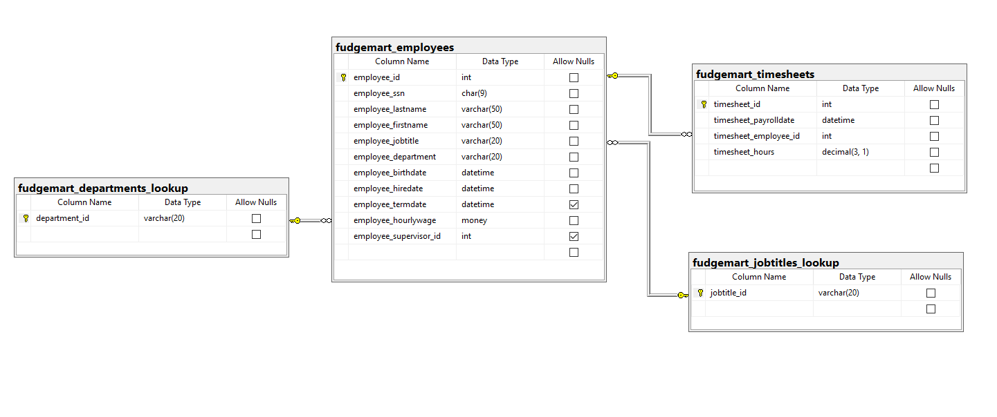

* 1. Explain in your own words why in  **fudgemart_timesheets**, 61 hours would not be accepted if executed within the SQL code?

We have a constraint on our timesheets _hours columns that only allows for number to be between 0 and 60 hours, therefor an employee cannot work more than 60 hours per week.

* 1. Can you DROP a table if its primary key is used in a foreign key constraint? Why or why not? What error message will you get if you try to do so?

No you cannot, the DBMS will give you an error in order to preserve referential integrity.

* 1. Give one important advantage SQL DML has over building tables interactively via the GUI (graphical user interface). Give one disadvantage, too.

The disadvantage would be less abstraction from the actual database system, we can visualize less and have to conceptualize more. The major advantage is that we can reuse code over and over, this boosts our productivity and the end quality of our product.