# Lab: SQL SELECT Statement Part 1 Answer Sheet Place Your Name Here: Nicholas Brown

## Place your Answers to Each Section in the Corresponding Area Below. Add as much additional space as you need so your answers are easy to read. Only Upload these Pages, not the Entire LaB.

**Answer 1.B Your Database Diagram Should Be Placed Below. DO Not COPY the one provided in your lab! Create your own!**

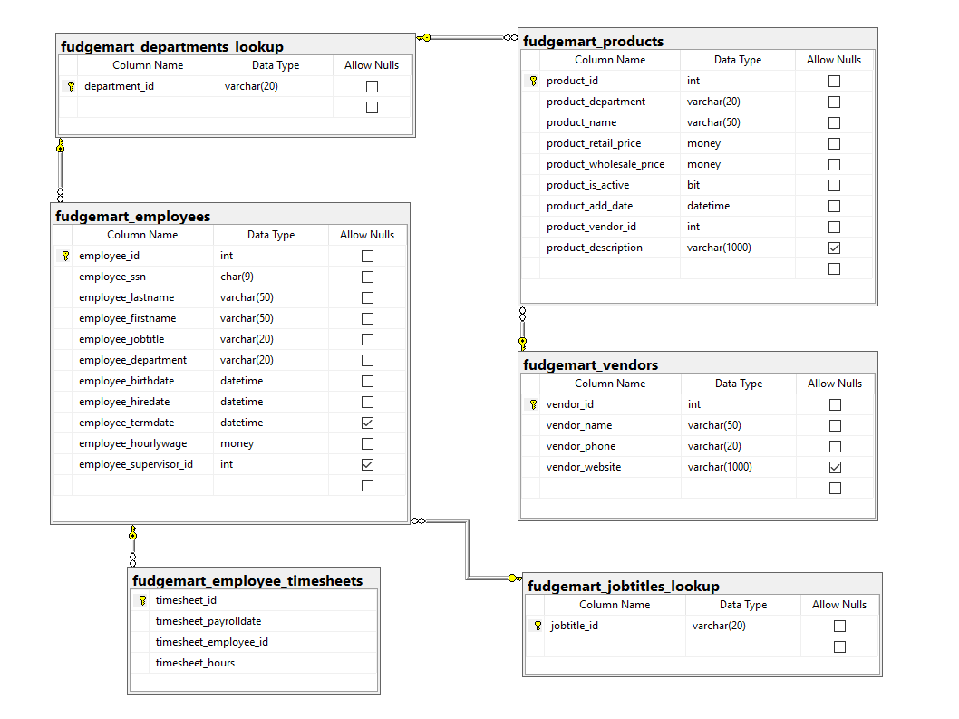

**Answer 2.a-J For each SQL statement, Describe what the statement does**

2.a

This statement selects all sales associate’s first and last names from the employees table sorting them by their last name then first name in ascending alphabetical order.

2.b

Returns all employees that work in a department that begin with an H sorted by lastname and firstname in ascending alphabetical order.

2.c

This query will return all employees first and last name together in a new column called employee_name and will then take the employee hire date and calculate their years of service to the company from the current date and time. The results will be ordered with those with the most service at the top.

2.d

Compared to the previous query we can see that the “top 10” command gives us only the top 10 rows of our choice which in this case are years_of_service, so only the top 10 highest years of service employees will be in our results

2.e

This command selects the single top most expensive item from the products table

2.f

This query returns all products sorted in descending order by their vendors name using a left join to compare the product vendor id and get the name of the vendor instead. It also finds the product markup using subtraction and adds the result as a column called product_markup

2.g

This query will join two tables to get the names of the employees from their employee id number. Then it will return all the employees names and payroll hours where the timesheet payroll date is January of the year 2006

2.h

Returns all payroll slips for 1/6/2006 including employee_name hourly wage timesheet_hours and calculated columns like employee_gross_pay. The returned data is ordered by lowest to highest gross pay for the pay period

2.i

This select statement uses the distinct keyword to force the query to only return distinct values for each column returned. Furthermore we join a few tables in this command to get some other interesting output appended to our query return. Things like the employee department, vendor, and vendor phone are all now available after completing a join on the product department and vendor tables. Finally the only employees to be shown are those with the job title “Department Manager”

2.j

This query returns two columns, vendor_name and vendor_phone, we obtain these through a left join where our vendor_id matches the product_vendor_id in our fudgemart_products table. Finally we narrow these results even further by only listing the vendors who have products with null values for their names. If we query our