# Lab: ADVANCED SQL SELECT Statement Part 1 Answer Sheet Place Your Name Here: Nicholas Brown

## Place your Answers to Each Section in the Corresponding Area Below. Add as much additional space as you need so your answers are easy to read. Only Upload these Pages, not the Entire Lab.

**Answer 1.B Your Database Diagram Should Be Placed Below. DO Not COPY the one provided in your lab! Create your own!**

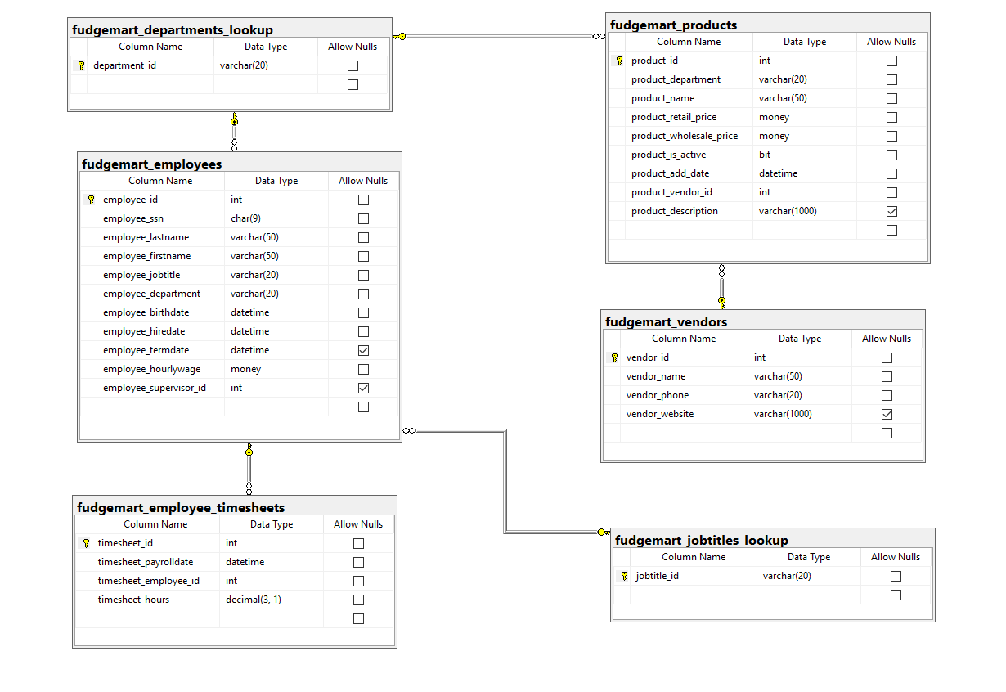

**Answer 2.a-J For each SQL statement, Describe what the statement does**

2.a

This query uses the average (avg) function to calculate the average employee hourly wage from the fudgemart_employees table. It returns a single value column we named average_hourly_wage with the average of all employees hourly wage

2.b

This query returns two columns: employee_department and number_of_employees. We used count with the wildcard (*) in conjunction with a group by statement to count all the employees of each department. We then return the number of employees in a new column with the name number_of_employees .

2.c

Again the group by statement is critical to understanding whats happening here. We can see the returned information from the query includes three columns: product_department, average_wholesale_price, average_retail_price. The average prices are calculated for all the products in a given department group such as Sporting Goods.

2.d

This query uses some clever logic to count and return the number of employees whose hourly wage is less than the average hourly wage for all the fudgemart employees (26). To execute the comparison a where statement is necessary comparing a new select statement calculating the average of all employee_hourlywage

2.e

This query returns three columns, employee_jobtitle, employee_count, and employee_avg_wage. The data contained in the returned columns are grouped by job titles providing the number of employees with that title and the average wage employees with that title are paid. The results are ordered by the average highest paid to lowest paid

2.f

This query returns two columns timesheet_month and total_hours. For the year 2006 the results returned are months 1-12 (January-December) with the total sum of all employee hours worked for each month that year in the adjacent column (total_hours)

2.g

This query returns four columns: employee_fullname, which is the employees first and last name, employee_hourlywage which is the employees pay rate, total_hours_ytd which is the total hours worked in the year 2006, and total_pay_ytd which is calculated from the total_hours_ytd and hourly wage columns. A join is necessary to return employee name information and employee pay information in the same query. The results are returned from total year pay highest to lowest.

2.h

This query returns each departments name as department_id and a count of all the products with that department_id under product_count. The results are ordered from lowest product count (Customer Service) to highest product count (Clothing). A left join is necessary to reference the products table while still getting all the departments in fudgemart.