# Lab: SQL Programming Part 1 Answer Sheet Place Your Name Here: Nicholas Brown

## Place your Answers to Each Section in the Corresponding Area Below. Add as much additional space as you need so your answers are easy to read. Only Upload these Pages, not the Entire Lab.

**Answer 2.a-J For each SQL statement, Describe what the statement does**

2.a

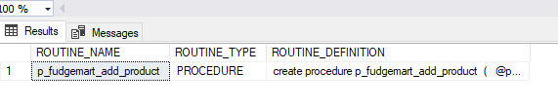

2.b



2.c

select * from fudgemart_products where product_department='Hardware'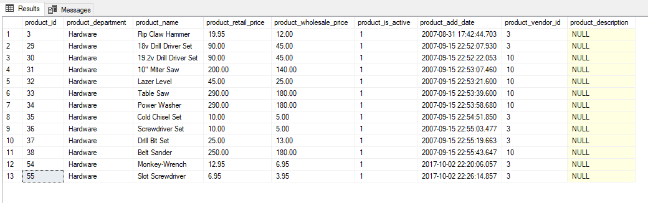

2.d

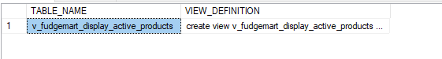

2.e

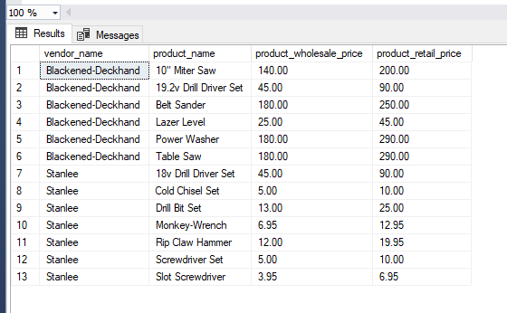

2.f



