# Lab For U9 – Data Analysis and Data Modeling in Visio

## Overview

In this lab, we will learn to map and then draw the Logical models with Microsoft Visio using the ERD’s we created in the previous lab.

### Learning Objectives

Upon completion of this learning unit you should be able to:

* Understand the concept of logical data modeling
* Construct Relational Model Diagrams
* Demonstrate how to map ideas from the conceptual model into the logical model.
* Develop entity relationships and define various types of attributes

### Lab Goals

Our lab goals are to:

1. Learn to build Logical models in Microsoft Visio.
2. Create the 4 Logical models from the Conceptual Models you drew in the previous lab.

You will accomplish this by drawing the 4 diagrams from the previous lab as logical models. Draw each logical model in its own Visio Tab inside the same file and hand in the file containing 4 diagrams by uploading to Blackboard.

### What you will need to begin

1. A copy of Microsoft Visio 2016
2. Conceptual model lab answers from last week
3. You might need this week’s reading, the PowerPoint, and/or the mapping cheat sheet (all the mapping rules on one page) also found in the same place you got this lab.

## Part 1: Using Microsoft Visio for Logical Modeling

### Overview

This section will explain how to use Microsoft Visio to create Logical Models. The following is a Demo of how to create a logical model:

### Step 1: Create New Document

The first step is to create a new document.

Use the procedure you learned in the last lab to open a new document with the crow's foot template.

### Step 2: Create First Table

We are going to alter our Crow's Foot Database Notation to accommodate the logical model.

1. First Drag an entity into the page.
2. Turn on the datatypes column by right clicking in the entity and choosing "Show Attribute Types"  
   Note: The right click menus are contextual, so make sure nothing is selected before you click or you will get a different menu.



### Step 3: Add Columns, Datatypes and Keys

1. Type in your column names. Add extra columns using the procedure from the last lab.
2. To change the data types, select int, right click and choose edit text. Note, you may have to click more than one time to select the data type.



1. If you need to add a PK or FK to the column, click the column name twice to get a special selection box around that column and right click to choose primary or foreign key.



You want your table to look like this:

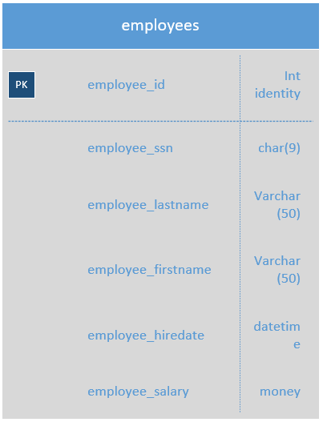

Now try to add another entity, and set it up like this:



You’re ready to try a FK relationship.

### Step 4: Relationships

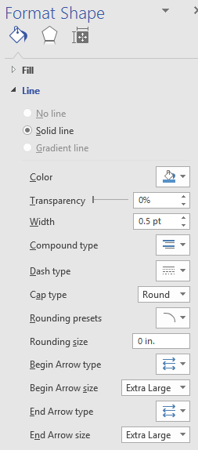Use the relationship connector from the last lab to connect the two tables. You are going to need to change the ends of the lines to be an arrow and tail. The easiest way to do this is right click on the connector and choose format shape. This will open the Format Shape dialog box on the right. You will see the Begin and end arrow type options at the bottom.

In logical modeling we attach an arrow head 🡨 to the primary key side (i.e. the one side of the relationship) and the tail to the foreign key side (i.e. the many side of the relationship). For example, since a department employs many employees, the arrow should point towards the departments table like this:

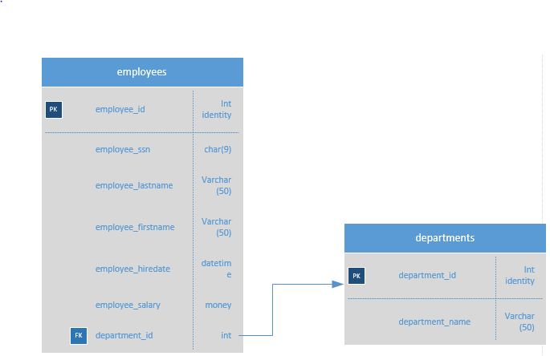

### Summary

This concludes how to implement a logical model in visio.

## Part 2: Creating the 4 diagrams from class exercise & handing it in.

Take the 4 diagrams from class you drew last week (these are now the ***Lab Exercises*** for this week) and map and draw them as logical models.

* Create one MS Visio document
* Add a document Tab for each logical model diagram (4 in total).
* Once you’re done, save and upload to Blackboard.