CWB205 Project 7 - Objects
(5 pts)

Extract the files for Project 7 (prj7_objects.zip).
The project is composed of:
- An images folder - containing the graphics for the project.
- bmass.css (the .css file for the page)
- generic_bmass.html (the web page you will use for the project).
Revise the Bmi Object, created in Project 6 so it will work in any instance on any page. And apply it to generic_bmass.html. Name your revised .js file: generic_bmass.js.
The revised application details are as follows:
- Encode this application as a separate part of a web page concerning bike tour training so that clicking a button, “Get BMI”, will trigger the application (Figure 1). Project 6 triggered the application when the page loaded.
- The application should run completely and result in output to the page with the visitor’s BMI (Figure 2) after the height and weight are entered.
- The basic structure of the Bmi Object should not change:
  - Bmi properties for weight and height.
  - Two Bmi methods
    - The first will retrieve the height of the user in inches and the weight in pounds.
    - The second will convert the inputs to the proper measurement units (kilograms and meters), perform the calculation to obtain the BMI, and produce formatted output for the page.

Figure 1.
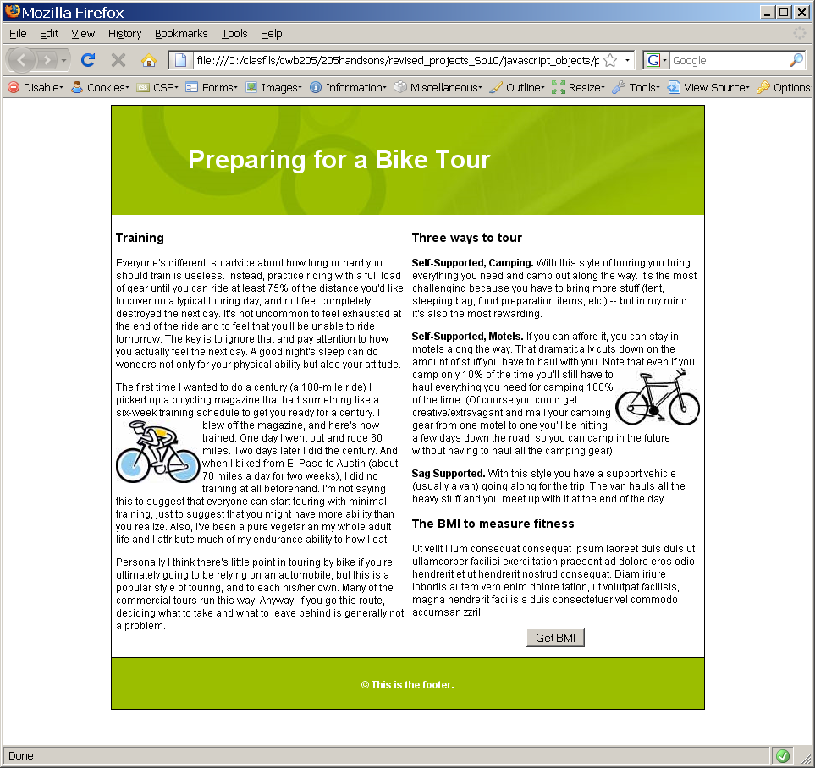
Page does not display any script output when loaded.
Add a button where indicated.

Figure 2.
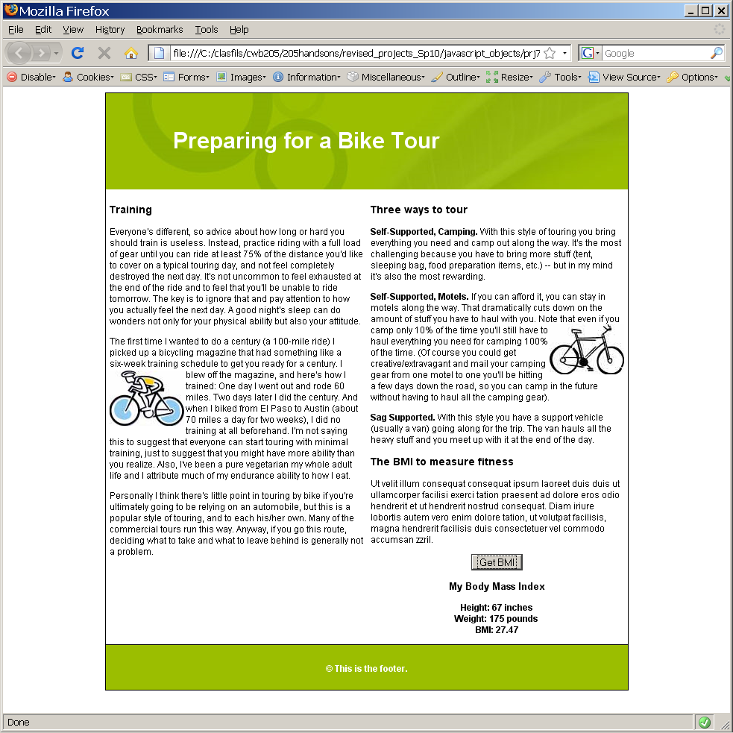
Format the script output area appropriately. The styles should be added to bmass.css.

Note:
- Be sure your page contains all code necessary to make it W3C compliant. Include only the absolutely essential script code in generic_bmass.html. The script file, generic_bmass.js, should contain nearly all scripts for this project.
- Validate your completed page with the W3C validation service.

Publish all necessary Project 7 files to your web server account…be sure to test the project and include a link to it from your navigation page.
Submit itsup.txt to the appropriate Dropbox on the Aims Online location for CWB205 to insure you receive full credit for this project.

