**CWB205 Final Project**

(68 points)

The final project for CWB205 involves creating the scripts and CSS to achieve the necessary functionality on the eight pages of **The Big Bike Tour** website using the **jQuery Libraries**. Download the project files from Aims Online.

Notes:

* Students rename files without the _st - for example index_st.html - rename to index.html.
* Include all .js files in a single js folder for the project (include all plug-in files **you actually need**).
* Include all .css files in a single css directory for the project.
* All individual scripts you write for individual pages should be included as separate files in the js directory as well. Multiple instances of the document.ready() function are ok …this will not cause a problem.
* The file, **final_default_st.css** is the base CSS file for the project template and includes most of the default CSS formatting for the pages.
* Obviously, you must include the ***jquery-1.11.0.min.js*** library on all pages along with additional plug in libraries that are needed for the individual pages. Only include the libraries necessary for that page.
* Document your script entries as some of these will occur on every page i.e. the plug in files necessary to animate the menus on every page.
* Work smart, some of the projects we have already done may give you clues about which files to include on the various pages…just remember, you may have to tweak them to fit the pages on this project.
* **All hyperlinks must work** when you submit your project. **Clean up your pages** - check font sizes to see that they are reasonable, remove borders from linked images etc.
* When you have submitted your final project to the web server, double check all pages to be sure links are working, images are displaying etc.
* See the screen shots below to see examples of the completed pages.

**Animated Menus -** Apply animated menu functionality on all pages.

Include the CSS for the menus in a separate file, ***menus.css.***

* Include a separate .js file for the specific menu characteristics, ***menus.js.***
  + Set the width of the menus so that the longest title does not wrap.
  + Set an appropriate height for the menus
  + Control the navigation transition effects including the speed. Set the speed to an appropriate millisecond value for ease of use.
  + Be sure the graphics (arrows) indicating hidden content display (see the ***index.html*** screenshot below).

**index.html -** Apply the plug in files necessary for the animated menus on the page…if you document this carefully, you should be able to simply copy and paste the script link code to other pages since they all have the animated menu functionally.

**register.html -** See figure below. Use form validation on all fields and test for valid email address

* + The “First Name” field should have the focus when the page loads.
  + Any entry in the card number and card holder fields are ok…checking for a valid credit card number sequence is not required on this project.
  + Modify the error message for the email address indicating a valid address must be entered.
  + Include the menu system functionality
  + Add the Datepicker widget in jquery-ui to the Date field of the form. Modify the date format so it uses the “yyyy-mm-dd” (2016-06-22) format.

**get_ready.html -** see figure below

* + Create a tabbed panel layout for this page using jQuery-ui. See figure below. ***Note: this feature is covered in Chapter 9 in the text.***
  + Include the BMI calculator script on this page in the “training” tab (this was created in Objects Project 7 - generic BMI). Include your script in a separate .js file, ***bmi.js***.
  + ***Note: you should include a style on this page that insures the dropdown menus will load over the top of the tabs on the page when they are active (go back to your CSS text book to investigate how to do this. You may need to change the z-index.)***

**lodging_meals.html -**

* Just add the menu system functionality and your CSS links.

**photos.html** - see figure below

* Use jQuery FancyBox2 plug-in to display large versions of the thumbnail images on the page.
* Include the menu system functionality.
* Be sure you include directional arrows and titles for each image.

**tour.html** -

* Include the menu system functionality.

**tour_miles.html -**

* Stripe rows in the table.
  + Use #ccc for the striping alternating rows of the table. ***Note this is a different functionality than the table on train_schd.html which uses a hover effect like the hilite project***. Here is the code you need to stripe the table:
* <script>$(document).ready(function(){
* $('tbody tr:even').addClass('stripem');
* }); </script>
* Include the menu system functionality.
* You will need to create a class called stripem which will add the #ccc background color.

**train_schd.html -**

* Apply highlighting functionality to this table so that a row is highlighted on mouse over and highlighting is removed on mouse out.
  + Use #ccc background for the striping.
  + Do not include the heading row in the highlighting (this is the same as the hilite project).
* Include the menu system functionality.

**Calories Burned Estimator - links to external file.**

**Page Screen Shots-**

**index.html -**

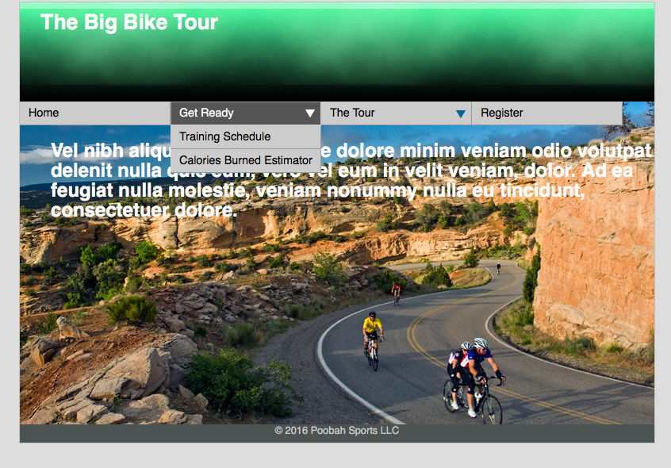

Completed page showing one menu expanded

**train-sched.html** Training Schedule: Use hilite rows code to achieve hover effect:

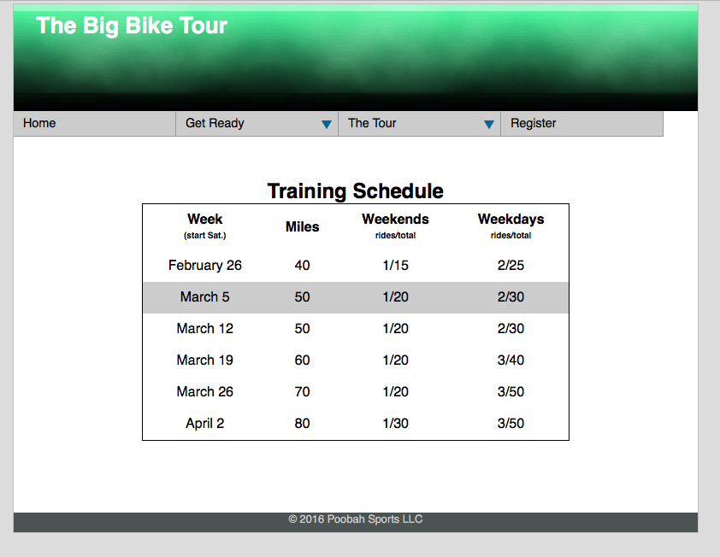

**tour_miles.html**

Note that this table is striped on its even rows with javascript as explained in these instructions previously.

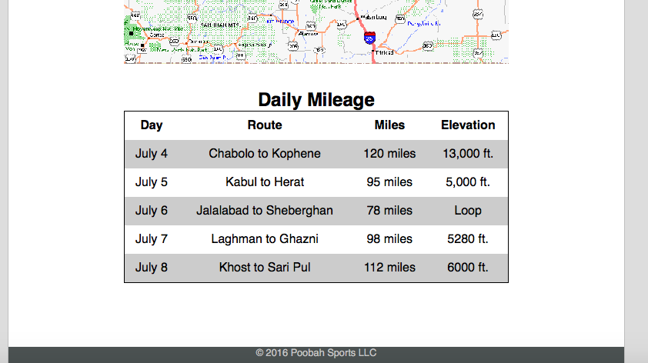

**photos.html - User fancybox2 code for photo gallery**

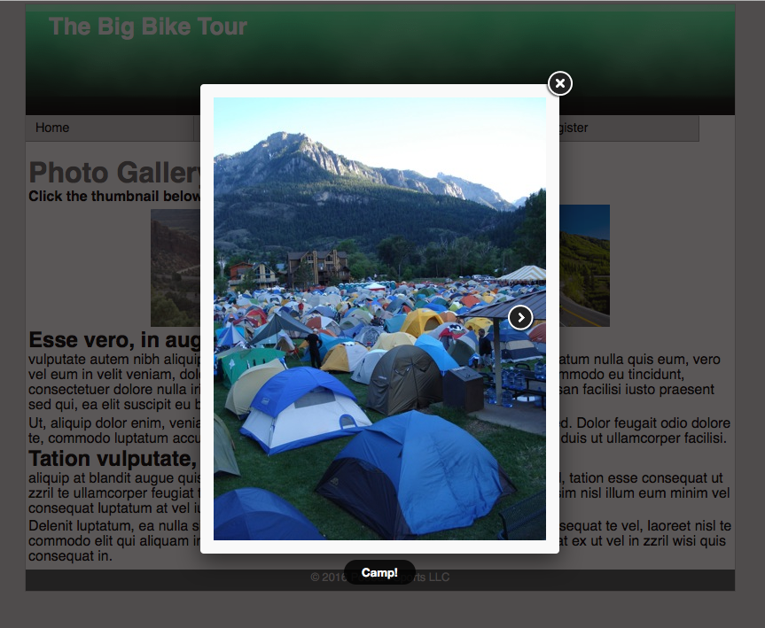

Include titles on images and include the directional images necessary for navigation as well (close, prev, next)

**get_ready.html – Tabbed tables code is based on tutorial in the textbook in chapter 9**

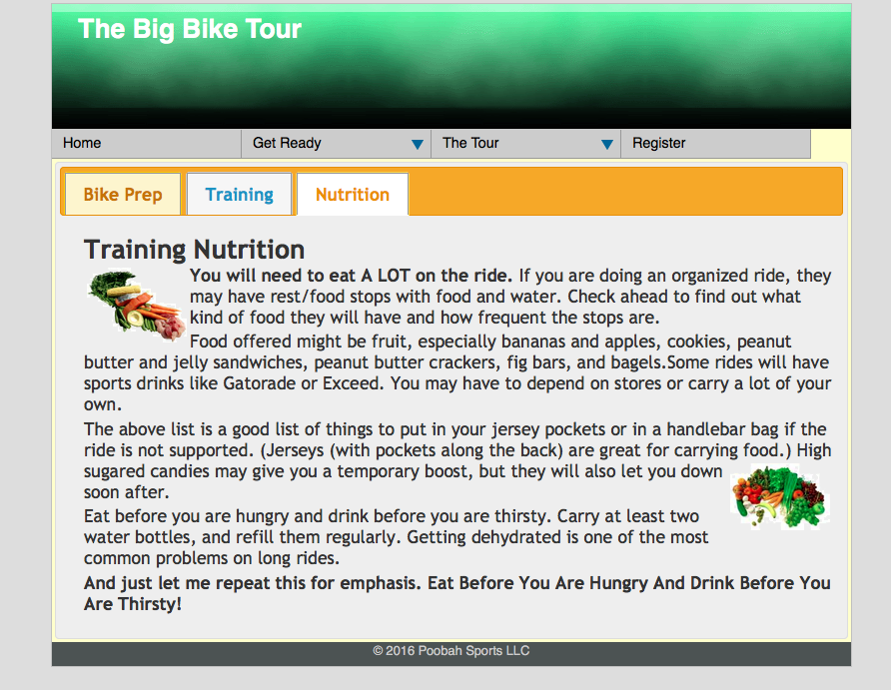

**Note: the BMI calculator needs to be added into the training tab section as shown below. After you click "Get BMI", it should calculate and display the Height, Weight, and BMI as shown:**

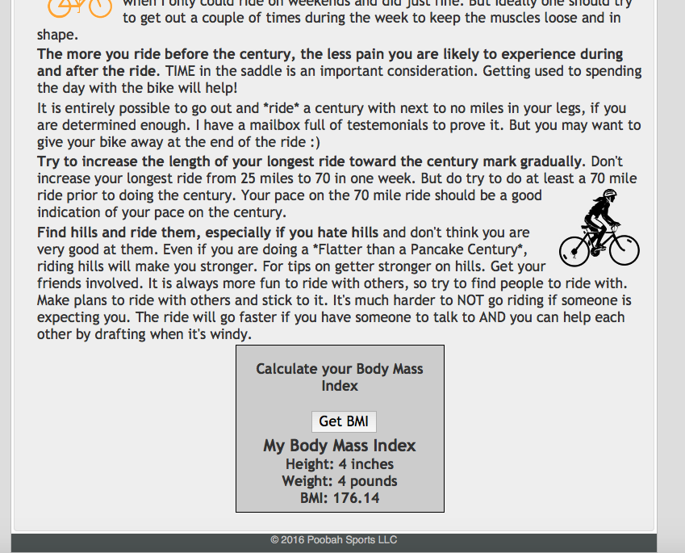

**register.html**

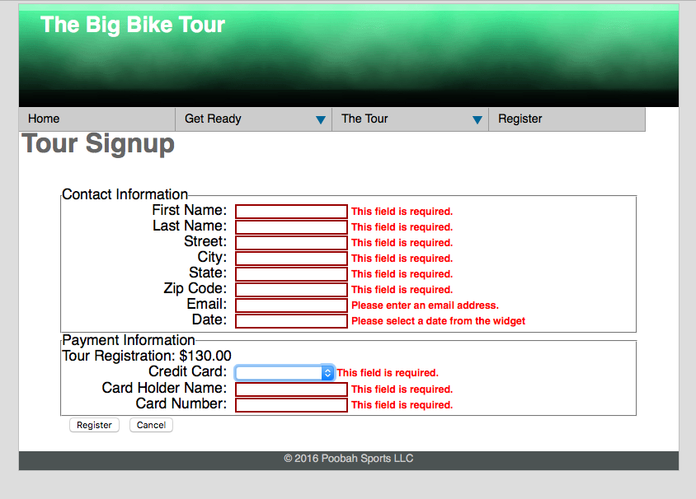

Pressing register results in the indicated validation messages. Format the text box border and error message color as shown. Note the email field requires a properly formatted email address.

**register.html - showing Date widget.**

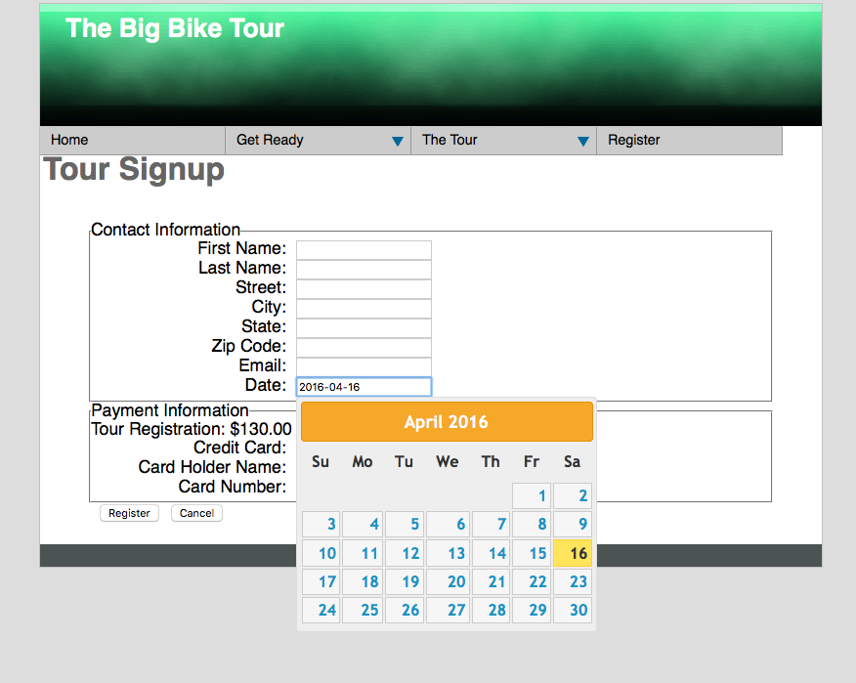

Upload the completed Final Project to your server account and double check all pages thoroughly. Submit ***itsup.txt*** to the Dropbox on Aims Online.