**CWB205 jQuery Hilite rows**

(10 pts)

Download and extract the files for the Hilite rows project (hilite_rows.zip). The files included are:

* **images** directory - contains images needed for project
  + **bgteal.jpg** - background for the page
  + **header_mod.jpg** - header image
* **resources** directory - contains the
  + **d_pg.css** - style sheet for the page. You will need to link to this style sheet.
  + **images** - cis_sm.gif and bgblue_sm.jpg - included in d_pg.css already.
* **hilite_rows.html** - the web page you will use for the project.

Additionally, you will need to copy the **js/jquery-1.11.0.min.js** folder to your working directory. ***Note: This will have to be uploaded to the server along with your completed project when you submit it. This file is included in your tutorial files for the class.***

Create a script that will highlight each table row as you roll your mouse over it and remove the highlight when your mouse leaves the row.

***Note:*** *Only content rows should be highlighted.*

The highlight color should be #CCC. You may embed any styles, you add, in the head area of the page.

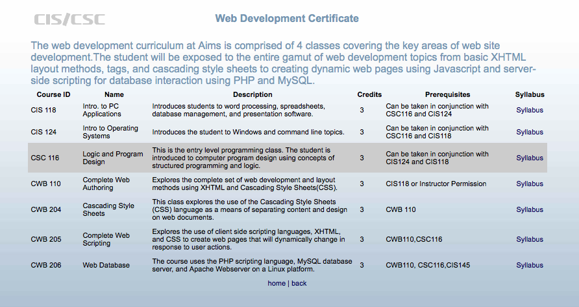

Row highlighted when the mouse rolls over it. Highlight color is #CCC.

* You will need to link to the **js/jquery-1.11.0.min.js** folder to make sure you have access to the jQuery structures you will need to complete the project.
* You must use **jQuery** structures to complete the project.
* Upload this project to your web server account on the **cislinux** web server.
* Test your submission on the server and correct any errors.
* Modify your navigation page with a linkthat will open **hilite_rows.html**.
* Submit the “**itsup.txt**” file to the Aims Online Drop box area for this assignment.