1. Landing screen -> User can customize inputs
   1. Select source csv file
   2. Database server, Database name, username & Password
   3. Based on left menu, script file will be selected. Currently only one script file is added(Model1)

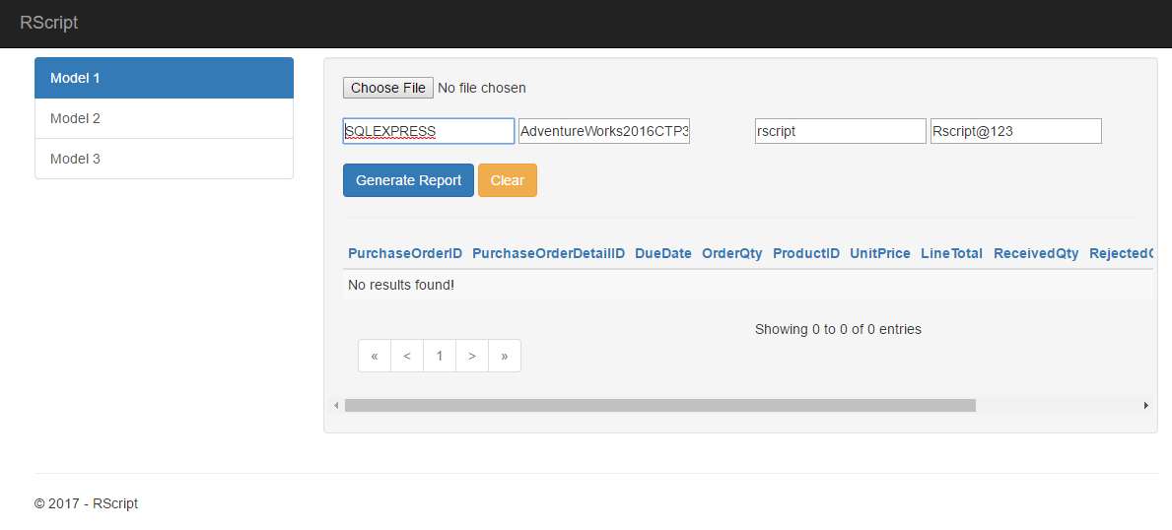

1. Generated output

