**Step by Step Guide to Categorizing your Bank Statements using 22Seven.com**

22Seven is a free app that helps you to categorize your spend without having to manually capture and group everything from your bank statement.

**Step 1**

Download your bank statement and save it as a PDF.

**Step 2:**

Go to [www.22seven.com](http://www.22seven.com) and click sign up.

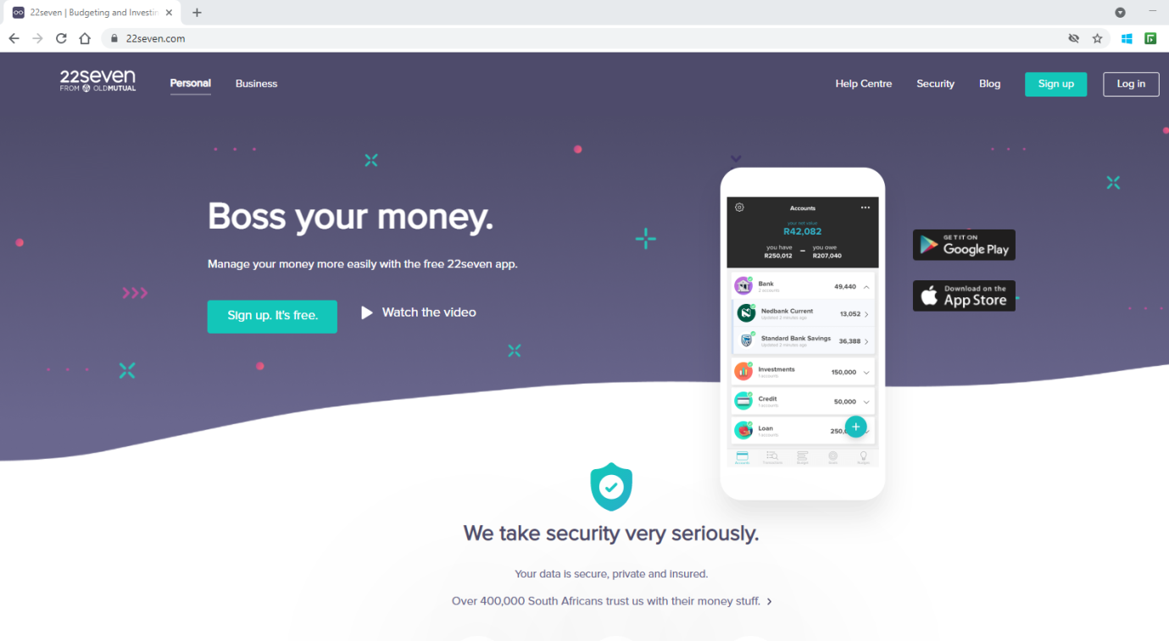

**Step 3:**

Enter your details and create a password, then hit Get Started.

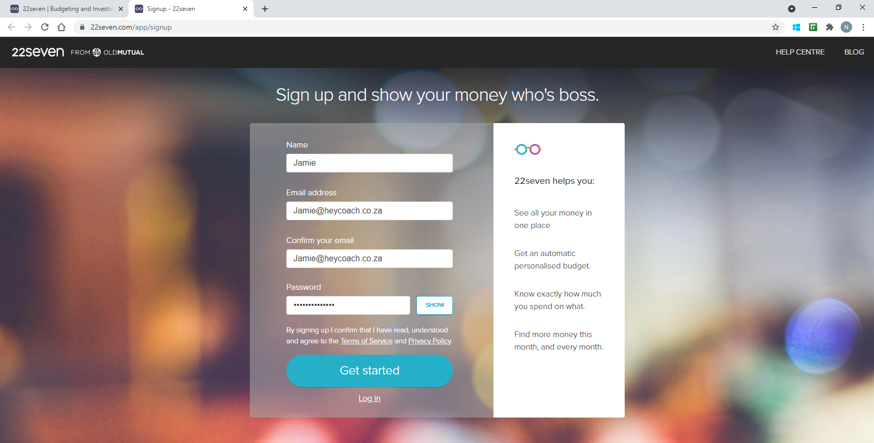

**Step 4**

It will ask you to link an account – you can if you would like too. We would suggest clicking on the grey area and then on “IMPORT A BANK STATEMENT”.

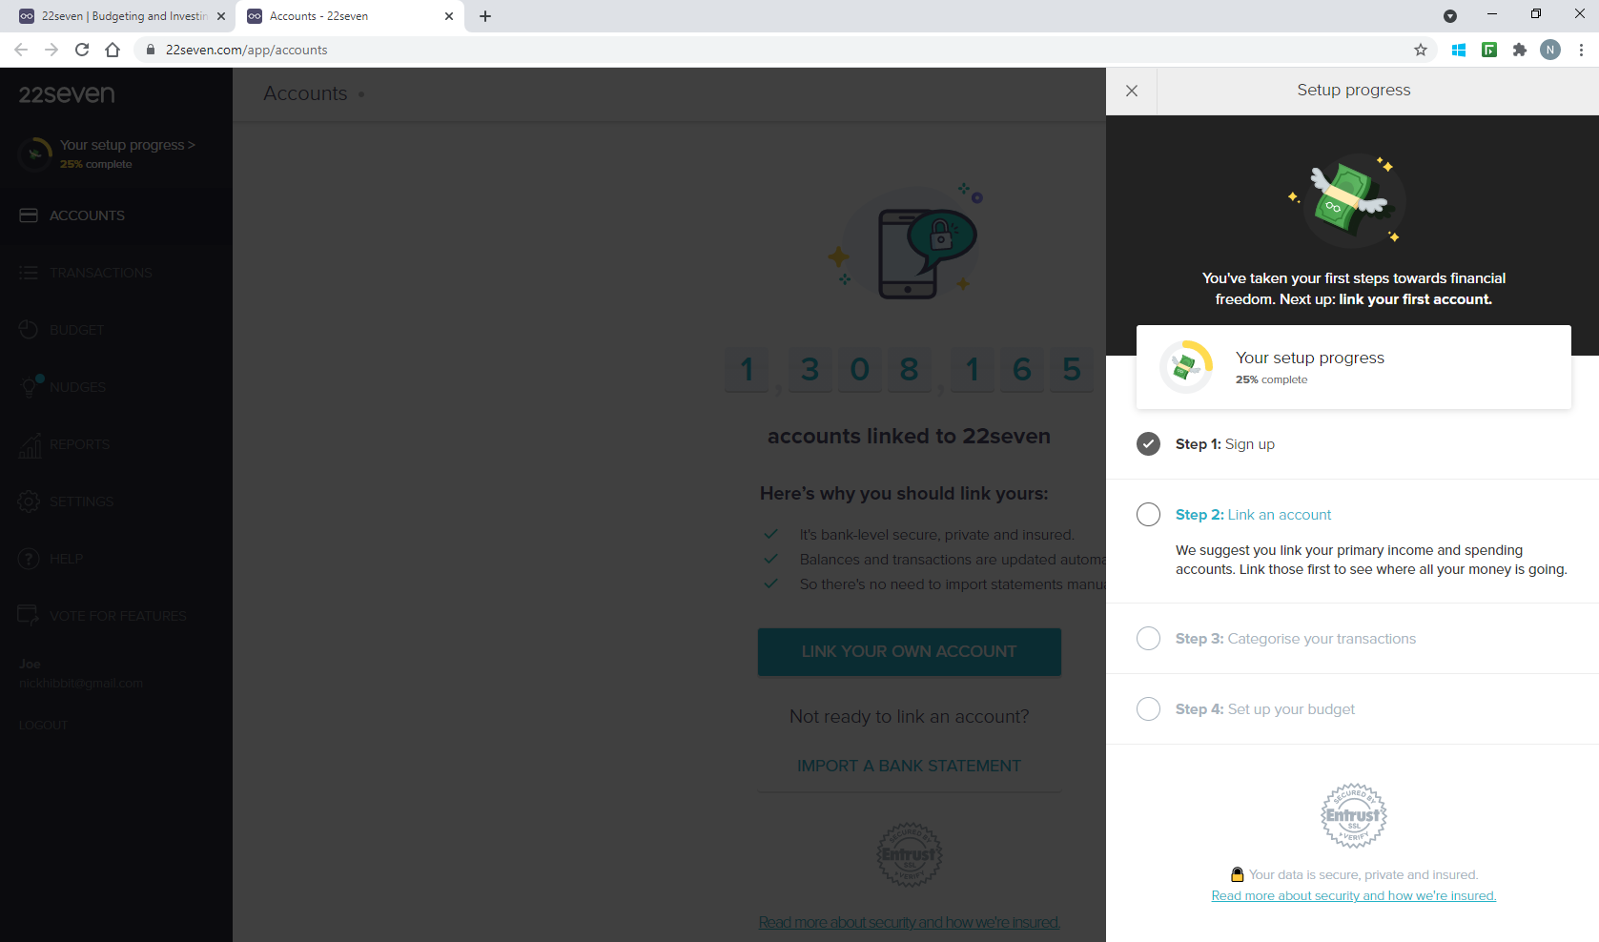

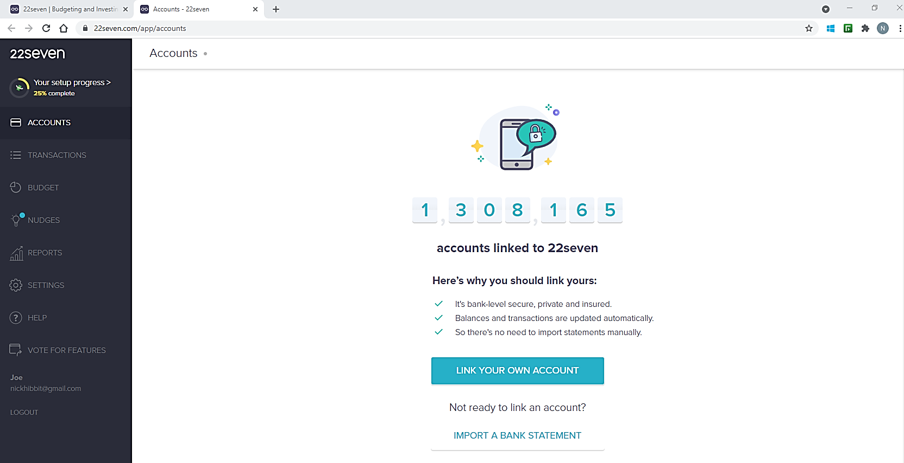

**Step 5**

Select the bank your bank statement comes from.

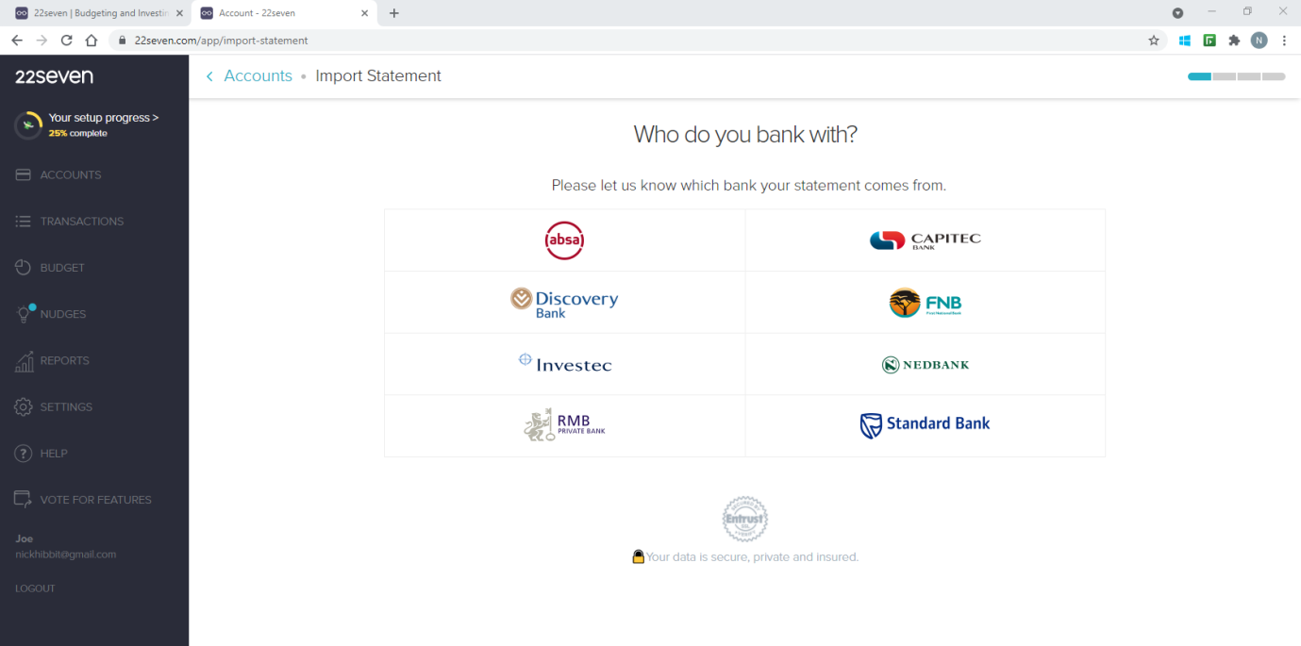

**Step 6**

Upload your bank statement by dragging the file or click Browse Files.

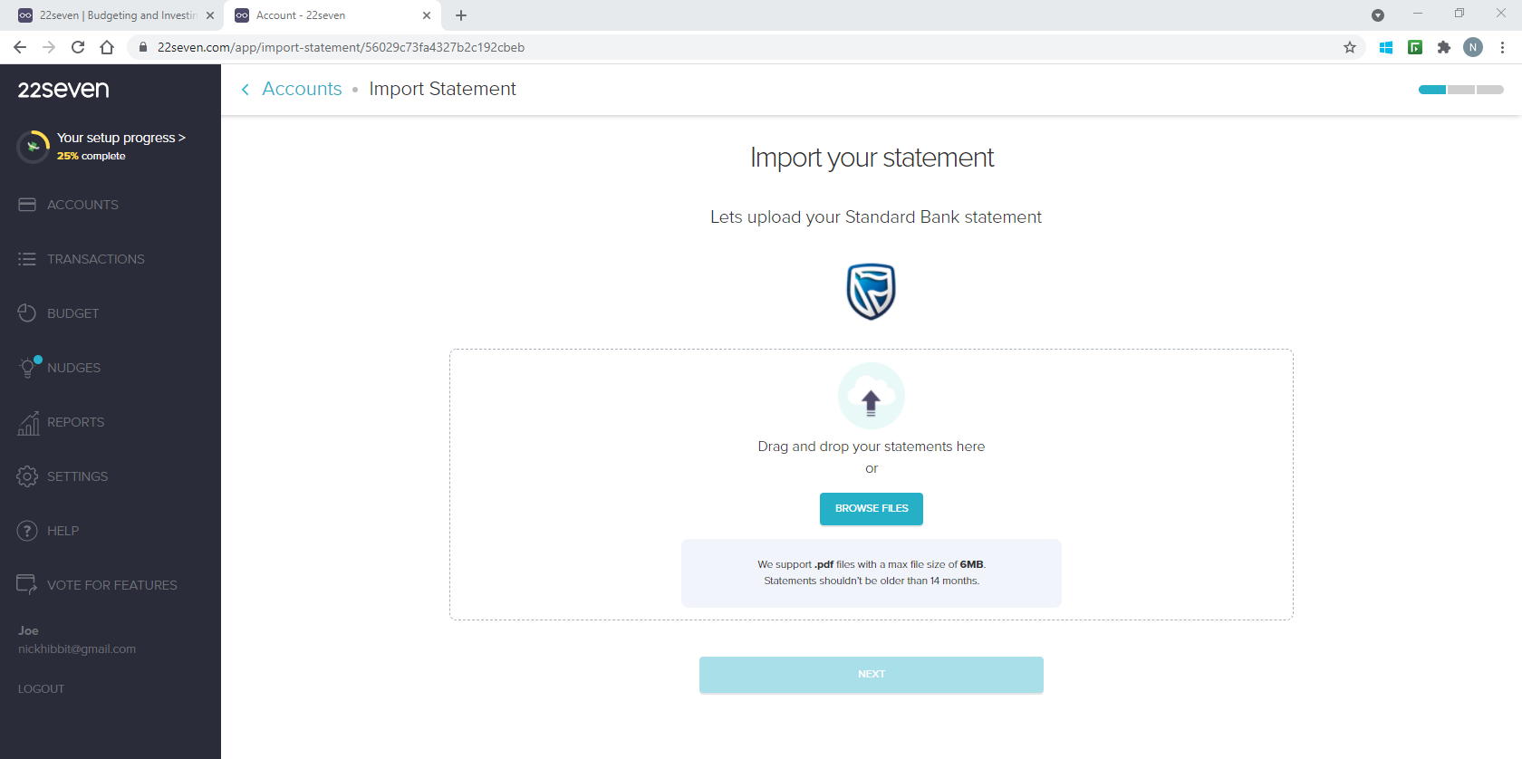

**Step 7**

Once you get the Upload Complete verification, click NEXT.

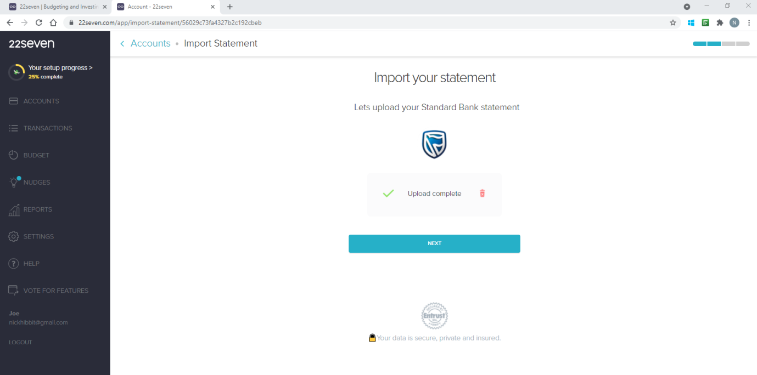

**Step 8**

Enter the document password if there is one. If not just hit SUBMIT.

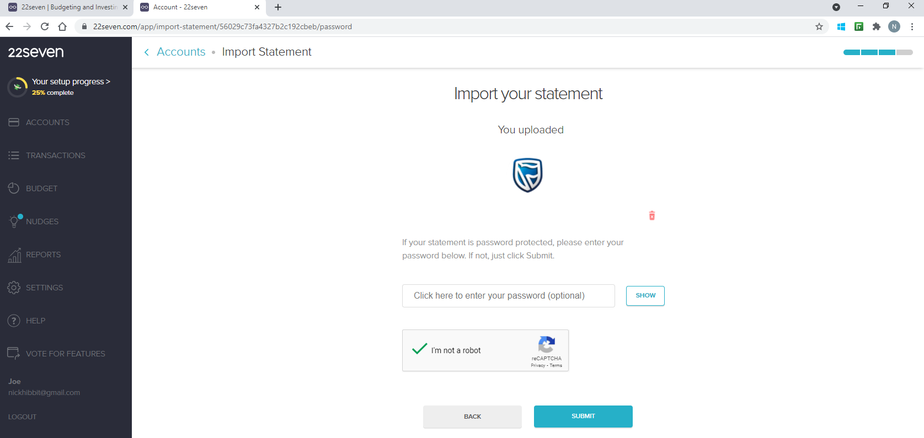

Then wait while your statement is imported. It may take a few minutes, so sit back and enjoy a coffee.

**Step 9**

Now you are ready to go, you can see all your transactions in the transaction tab. Note that 22Seven allocates your spending into their categories, you are able to change these if you would like.

**Enjoy the journey!**

**Team HeyCoach**