TNRDC-TMP-SDD

First-Year Design Project SW 설계서 (SW Design Document)

Project Name | LINE FOLLOWER ROBOT
Student | - Phan Thi Kim Cuong  - Ha Thanh Duc  - Tran Van Hien  - Truong Cao Nam Khanh  - Phạm Thanh Liem  - Phan Tan Loi  - Ngo Duc Long  - Vu Xuan Phu  - Nguyen Bao Tinh  - Pham Ngoc Van  - Nguyen Thanh Vinh | ID | 20161074  20161306  20161314  20161095  20161331  20161337  20161333  20161083  20161383  20161395  20161397
Major | Electronics and Communication Engineering | Supervisor | Assoc. Prof. Phan Van Ca

Contents

1 Introduction 5
2 Technical objectives 6
3 Concept/Technology 7
4 System Architecture 8
5 Final Product 9
6 Appendix 10
6.1 Division of Labor 10
6.2 Bill of Material 10
6.3 Gantt Chart 11
6.4 User manual 12

- Revision History
Version | Date | Content of revision | Author | Supervisor
1.0 | 10-01-2021 | Damaged arduino | Team | Assoc. Prof. Phan Van Ca
1.1 | 20-01-2021 | More complete aesthetically | Team | Assoc. Prof. Phan Van Ca

- Terms and abbreviations

- References

- Cộng đồng arduino Việt nam: http://arduino.vn/.

- https://www.youtube.com/watch?v=t7k9D1jDEtk.

- List of Tables & Figures

Introduction

Robots were born very early to replace humans to do heavy and toxic things, bringing a great benefit to humans.
In the industrial age today, robots are increasingly widely used in production as well as in life. Due to the increasing and complex love of dogs, robots need flexible and responsive changes, especially mobile robots.
Mobile robot is a self-teleporting, autonomous robot capable of completing assigned jobs. In which line detection robot is a robot that can determine its relative position and move following a predetermined trajectory (magnetic line, color line).
Currently, line detection robots have seen widely and increasingly used in the field of ocean exploration, self-propelled in the air, in warehouse environments, factories to transport goods instead of humans or used to study techniques in competitions of different sizes.

Technical objectives
Propose a structural solution for the product and main components;
- Make necessary calculations, confirm the economic and technical criteria specified in the technical tasks;
- Make necessary principle diagrams, mounting diagrams…;
- Propose and demonstrate technical solutions, ensuring the reliability criteria, which have been specified in previous technical tasks and research stages.
- Design, manufacture and test models;
- Product evaluation of the ability to transport, store and install at use;
- Evaluation of operational criteria (miscibility, convenience in maintenance and repair, failures, product quality checks, assurance of technical status checks by means of testing) investigation has;
- Describe the final requirements for product research, design and manufacture, new materials to be used in the design product;

Concept/Technology
Line detector robot is a combination of the line detector modules and arduino. Each attachment has a certain role with the general purpose of controlling the robot to run on a given line.
Line detector robot is a device capable of operating by itself:
- Robot automatically when power on.
- Robot stops when the power is turned off or out.
- Move according to the predefined line.
- Redirect when the line changes direction.
The system is capable of receiving signal to acknowledge the route
- The power supply works stably for a period of time.
- The power supply is easily swappable or rechargeable.
- Sensors work well for the robot to move the correct path to the user.

System Architecture
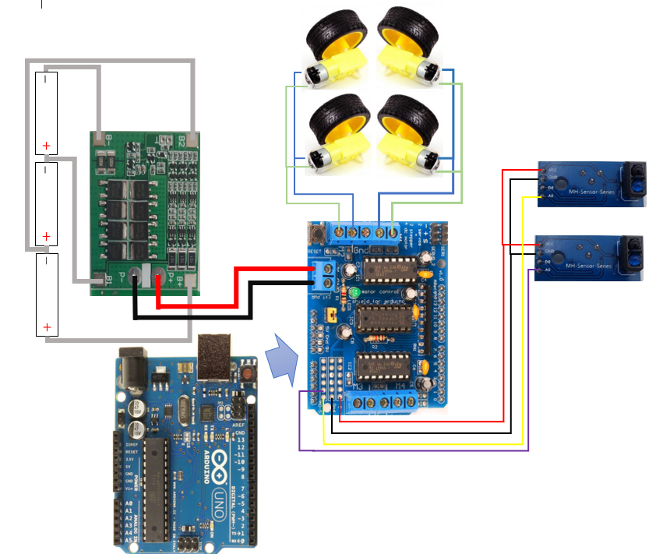

Shield L298D | Left Infrared Sensor Module | Right Infrared Sensor Module | Power Source | DC Motor
GND | GND
5+ | VCC
A4 | A0
GND |  | GND
5+ |  | VCC
A5 |  | A0
GND |  |  | P-
M+ |  |  | P+
M1 |  |  |  | DC 1
M2 |  |  |  | DC 2

Final Product
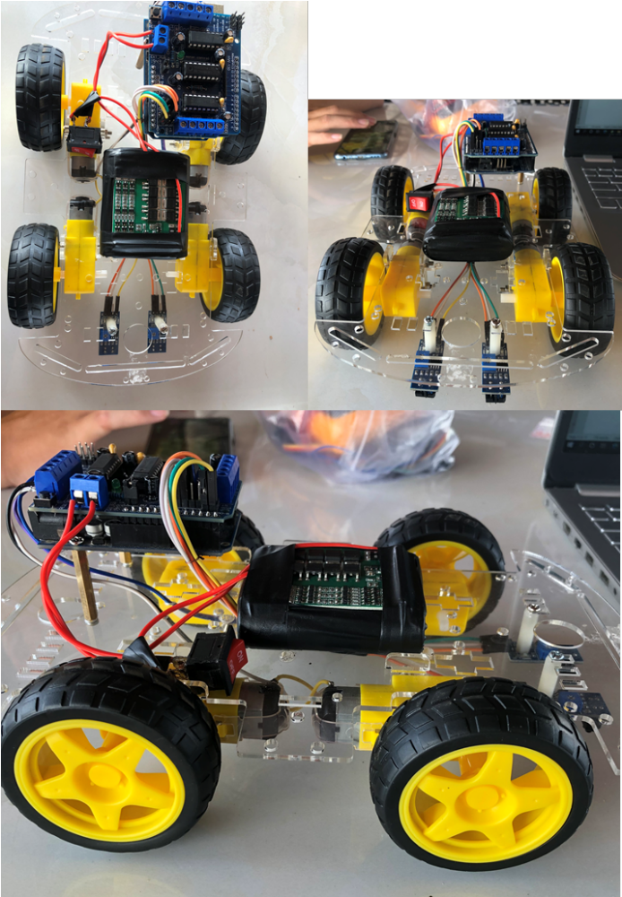

Appendix

Division of Labor
ID | Task | Team Member
1 | Buy materials- components | Pham Ngoc Van  Phan Thi Kim Cuong
2 | Design car | Tran Van Hien  Pham Tan Loi  Truong Cao Nam Khanh
3 | Vehicle assembly | Ha Thanh Duc  Vu Xuan Phu  Ngo Duc Long
4 | Installation of car-load trial run code | Nguyen Bao Tinh  Pham Thanh Liem  Nguyen Thanh Vinh
5 | Fix errors | Team
6 | Report | Nguyen Bao Tinh

Bill of Material
ID | Parts/Components | Amount | Price per Unit | Total
1 | Arduino UNO R3 | 1 | 82.000 | 82.000
2 | Motor Driver Shield | 1 | 45.000 | 45.000
3 | Infrared Sensor | 2 | 12.000 | 24.000
4 | DC Motor | 4 | 29.000 | 116.000
5 | Wheels | 4 | 14.000 | 56.000
6 | Rechargeable battery protection circuit and 3s | 1 | 52.000 | 52.000
7 | Battery 18650 | 3 | 47.000 | 141.000
8 | Chassis + screws | 1 | 55,000 | 55.000
9 | wire | 10 | 300 | 3000
Total |  | 28 |  | 574.000

Gantt Charthart

ID | Task | Time
ID | Task | January 2021
ID | Task | 9 | 10 | 11 | 12 | 13 | 14 | 15 | 16 | 17 | 18 | 19 | 20 | 21
1 | Buy equipment
2 | Design car
3 | Assembly
4 | Write code
5 | Fix error
6 | Write report

User manual
- Create a roadway for vehicles with black glue or objects in black.
- Check for plugs, welds, other vehicle parts.
- Turn on the switch to drive the car. Observe and evaluate.

