BÁO CÁO BÀI TẬP TT DSP

Nguyễn Bảo Tính 20161383 Lớp sáng thứ hai

Test 1:

1. A linear and time-invariant system is described by the difference equation:

System 1: y1(n) − 0.5y1(n − 1)+ 0.25y1(n − 2) = x(n) + 2x(n − 1) + x(n − 3)

System 2: $y_{2}(n)=x(n)-3x(n-2)+\frac{15}{4}y_{2}(n-1) +\frac{3}{4}y_{2}(n-3)$

a. Write the matlab program P1a.m: Compute and plot the impulse response of the system 1 and the cascade system over 0 ≤ n ≤ 50 and determine the stability of the system from this impulse response.

b. Write the matlab program P1b.m: If the input to this system is

x(n) = [5 cos(0.2πn) +4 sin(0.6πn)] u(n), determine the response y(n) over

0 ≤ n ≤ 200.

Answer:

a.Code:

|  |
| --- |
| clf;  % Define the coefficients  num1 = [1 2 0 1]; num2 = [1 0 -3];  den1 = [1 -0.5 0.25]; den2 = [1 -15/4 0 3/4];    n = 0:50;  impulse = [1, zeros(1, length(n)-1)];  h1 = filter(num1, den1, impulse);  h2 = filter(num2, den2, impulse);  h_cascade = conv(h1, h2);    % Plot the impulse responses  subplot(2, 1, 1);  stem(n, h1);  xlabel('n');  ylabel('h_1(n)');  title('Impulse Response of System 1');    subplot(2, 1, 2);  stem(n, h_cascade(1:length(n)));  xlabel('n');  ylabel('h_{cascade}(n)');  title('Impulse Response of Cascade System');    % Check stability  if all(abs(roots(den1)) < 1)  disp('System 1 is stable.');  else  disp('System 1 is unstable.');  end    if all(abs(roots(conv(den1, den2))) < 1)  disp('Cascade System is stable.');  else  disp('Cascade System is unstable.');  end |

Result:



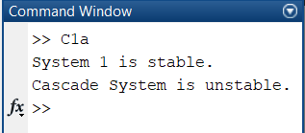

b.Code:

|  |
| --- |
| clf;  % Define the coefficients  num1 = [1 2 0 1]; num2 = [1 0 -3];  den1 = [1 -0.5 0.25]; den2 = [1 -15/4 0 -3/4];    n = 0:200;  x = 5*cos(0.2*pi*n) + 4*sin(0.6*pi*n);  y1 = filter(num1, den1, x);  y = filter(num2, den2, y1);  % Plot the response  stem(n, y);  xlabel('n');  ylabel('y');  title('Response of Cascade System'); |

Result:



2. The transfer function of discrete time systems is given below:

$$H_{3}\left(z\right)=\frac{1-2z^{-1}-3z^{-2}+2z^{-4}}{1+0.2z^{-2}+0.7z^{-3}-{0.8z}^{-4}}$$

a. Write the matlab program P2a.m : compute the pole-zero, plot the pole-zero pattern of system 3 and investigate the stability.

b. Write the matlab program P2b.m : Compute and plot the magnitude and phase spectra of system 3.

Answer:

a.Code:

|  |
| --- |
| clf;  num = [1 -2 -3 0 2];  den = [1 0 0.2 0.7 -0.8];  % compute poles and zeros and display  [z p k] = tf2zpk(num,den);  disp('Zeros:');  disp(z);  disp('Poles:');  disp(p);  % generate pole-zero plot  zplane(z,p);  % Check the stability  if all(abs(p) < 1)  disp('The system is stable.');  else  disp('The system is unstable.');  end |

Result:



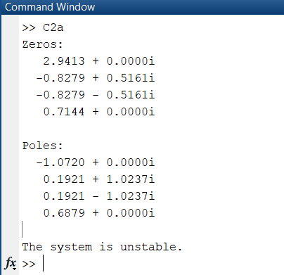

b. Code:

|  |
| --- |
| clf;  num = [1 -2 -3 0 2];  den = [1 0 0.2 0.7 -0.8];  w = -2*pi:8*pi/511:2*pi;  H = freqz(num, den, w);  subplot(2,1,1)  plot(w/pi,abs(H));grid  title('Magnitude Spectrum |H(e^{j\omega})|')  xlabel('\omega /\pi');  ylabel('Amplitude');  subplot(2,1,2)  plot(w/pi,angle(H));grid  title('Phase Spectrum arg[H(e^{j\omega})]')  xlabel('\omega /\pi');  ylabel('Phase, radians'); |

Result:



3. Write the matlab program P3.m : Plot the pole-zero and Find the transfer function with zero, pole of discrete time systems is given below:

Zero: Z1= -1+0.3j; Z2= -1-0.3j;

Pole: P1=1/5, P2=3/4.

Gain: K=10

Answer:

Code:

|  |
| --- |
| clf;  % Define the zeros, poles, and gain  z = [-1+0.3j -1-0.3j]';  p = [1/5 3/4]';  k = 10;  % find numerator and denominator polynomial coefficients  zplane(z,p);  [num den] = zp2tf(z,p,k);  h= tf(num,den) |

Result:

 