Name: Nguyễn Bảo Tính
Section: 20161383
Laboratory Exercise 1
DISCRETE-TIME SIGNALS: TIME-DOMAIN REPRESENTATION
1.1 GENERATION OF SEQUENCES
Project 1.1 Unit sample and unit step sequences
A copy of Program P1_1 is given below.
% Program P1_1
% Generation of a Unit Sample Sequence
clf;
% Generate a vector from -10 to 20
n = -10:20;
% Generate the unit sample sequence
u = [zeros(1,10) 1 zeros(1,20)];
% Plot the unit sample sequence
stem(n,u);
xlabel('Time index n');ylabel('Amplitude');
title('Unit Sample Sequence');
axis([-10 20 0 1.2]);
Answers:
Q1.1 The unit sample sequence u[n] generated by running Program P1_1 is shown below:
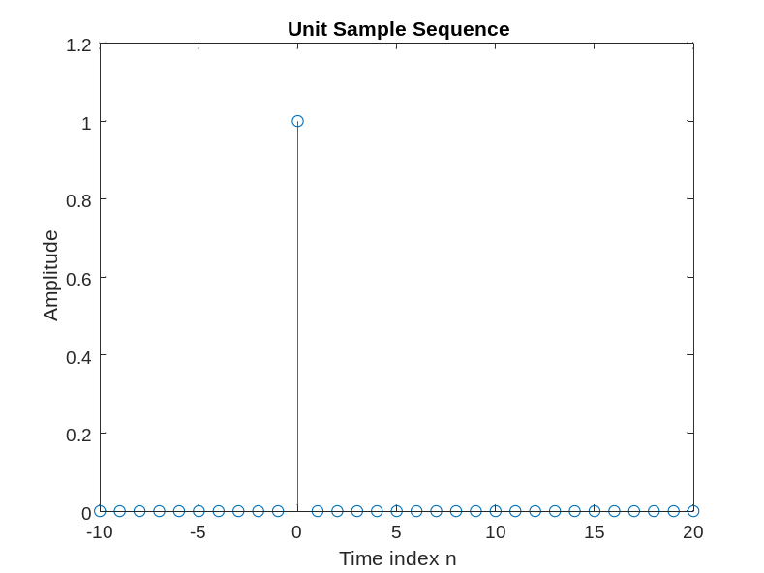
Q1.2 The purpose of clf command is - Clear current figure.
The purpose of axis command is - Control axis scaling and appearance.help
The purpose of title command is - Graph title.
The purpose of xlabel command is - X-axis label.
The purpose of ylabel command is - Y-axis label.
Q1.3 The modified Program P1_1 to generate a delayed unit sample sequence ud[n] with a delay of 11 samples is given below along with the sequence generated by running this program.
% Program P1_1
% Generation of a Unit Sample Sequence
clf;
% Generate a vector from -10 to 20
n = -10:20;
% Generate the unit sample sequence
ud = [zeros(1,21) 1 zeros(1,9)];
% Plot the unit sample sequence
stem(n,ud);
xlabel('Time index n');ylabel('Amplitude');
title('Unit Sample Sequence');
axis([-10 20 0 1.2]);
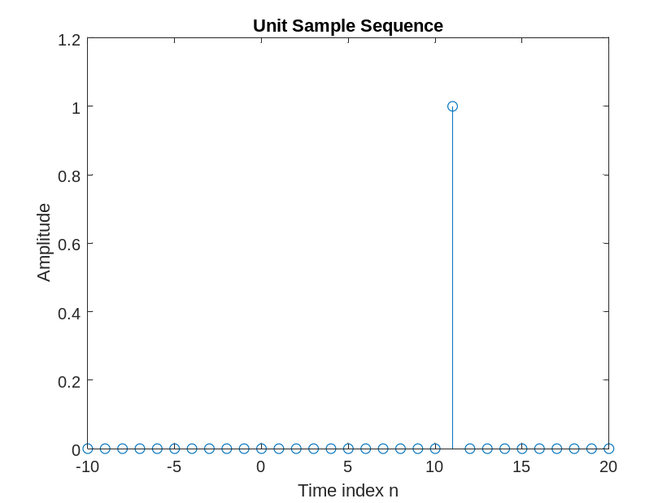
Q1.4 The modified Program P1_1 to generate a unit step sequence s[n] is given below along with the sequence generated by running this program.
% Program P1_1
% Generation of a Unit Sample Sequence
clf;
% Generate a vector from -10 to 20
n = -10:20;
% Generate the unit sample sequence
s = [zeros(1,10) 1 ones(1,20)];
% Plot the unit sample sequence
stem(n,s);
xlabel('Time index n');ylabel('Amplitude');
title('Unit Sample Sequence');
axis([-10 20 0 1.2]);
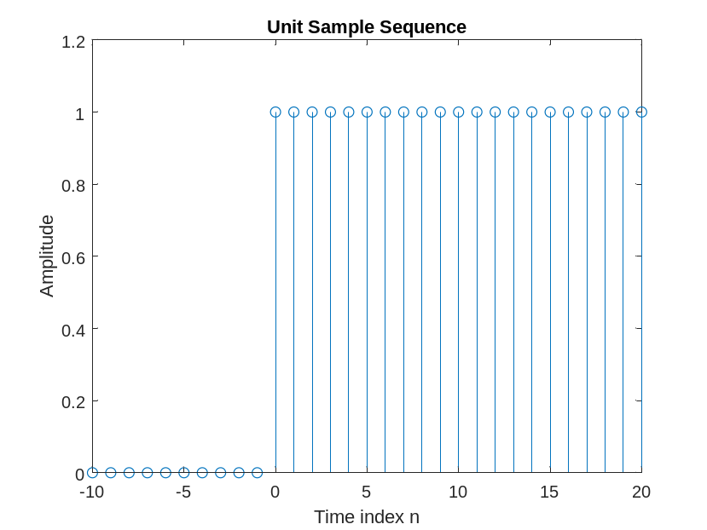
Q1.5 The modified Program P1_1 to generate a unit step sequence sd[n] with an advance of 7 samples is given below along with the sequence generated by running this program.
% Program P1_1
% Generation of a Unit Sample Sequence
clf;
% Generate a vector from -10 to 20
n = -10:20;
% Generate the unit sample sequence
sd = [zeros(1,17) 1 ones(1,13)];
% Plot the unit sample sequence
stem(n,sd);
xlabel('Time index n');ylabel('Amplitude');
title('Unit Sample Sequence');
axis([-10 20 0 1.2]);
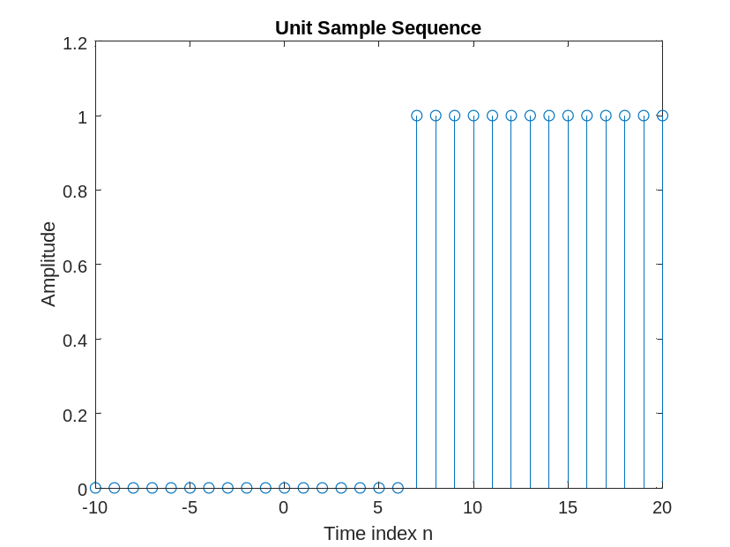
Project 1.2 Exponential signals
A copy of Programs P1_2 and P1_3 are given below.
% Program P1_2
% Generation of a complex exponential sequence
clf;
c = -(1/12)+(pi/6)*i;
K = 2;
n = 0:40;
x = K*exp(c*n);
subplot(2,1,1);
stem(n,real(x));
xlabel('Time index n');ylabel('Amplitude');
title('Real part');
subplot(2,1,2);
stem(n,imag(x));
xlabel('Time index n');ylabel('Amplitude');
title('Imaginary part');
% Program P1_3
% Generation of a real exponential sequence
clf;
n = 0:35; a = 1.2; K = 0.2;
x = K*a.^n;
stem(n,x);
xlabel('Time index n');ylabel('Amplitude');

Answers:
Q1.6 The complex-valued exponential sequence generated by running Program P1_2 is shown below:
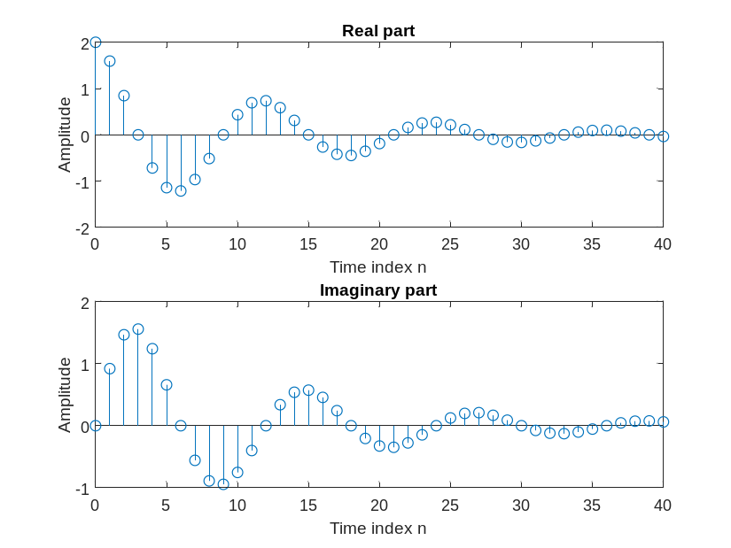
Q1.7 The parameter controlling the rate of growth or decay of this sequence is – Complex numbers C The parameter controlling the amplitude of this sequence is – Constant K
Q1.8 The result of changing the parameter c to (1/12)+(pi/6)*i is – biên độ tăng theo n thay vì giảm theo n.
Q1.9 The purpose of the operator real is – Complex real part.
The purpose of the operator imag is - Complex imaginary part.
Q1.10 The purpose of the command subplot is - Create axes in tiled positions.
Q1.11 The real-valued exponential sequence generated by running Program P1_3 is shown below:
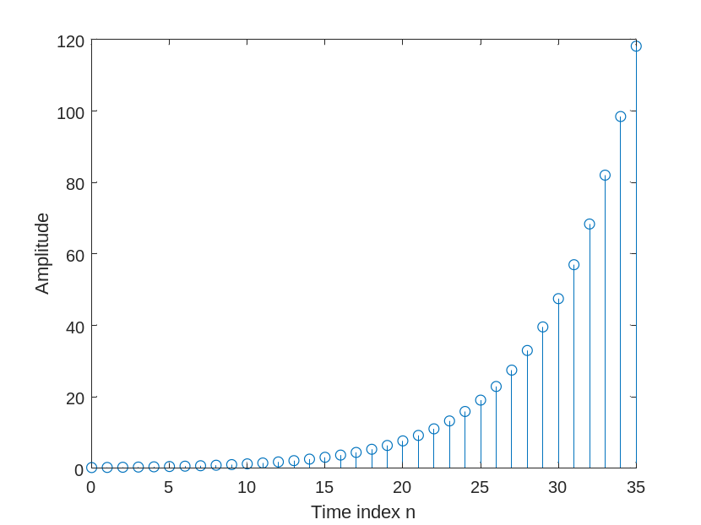
Q1.12 The parameter controlling the rate of growth or decay of this sequence is – Constant a
The parameter controlling the amplitude of this sequence is - Constant K
Q1.13 The difference between the arithmetic operators ^ and .^ is - ^ is multiplied by the matrix x, and .^ is the corresponding multiplication of each element of x
Q1.14 The sequence generated by running Program P1_3 with the parameter a changed to 0.9 and the parameter K changed to 20 is shown below:
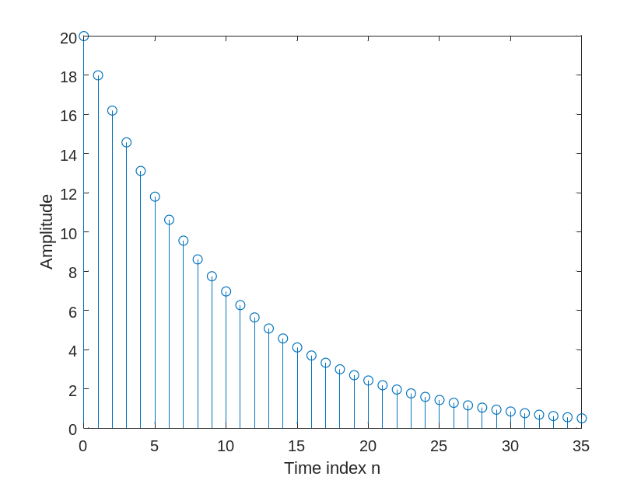
Q1.15The length of this sequence is - 36
It is controlled by the following MATLAB command line: n = 0:35;
It can be changed to generate sequences with different lengths as follows (give an example command line and the corresponding length): vector a X elements, n=0:X-1
Q1.16 The energies of the real-valued exponential sequences x[n]generated in Q1.11 and Q1.14 and computed using the command sum are - E = sum(x.^2);
(E= 2104.19467623988)
Project 1.3 Sinusoidal sequences
A copy of Program P1_4 is given below.
% Program P1_4
% Generation of a sinusoidal sequence
n = 0:40;
f = 0.1;
phase = 0;
A = 1.5;
arg = 2*pi*f*n - phase;
x = A*cos(arg);
clf; % Clear old graph
stem(n,x); % Plot the generated sequence
axis([0 40 -2 2]);
grid;
title('Sinusoidal Sequence');
xlabel('Time index n');
ylabel('Amplitude');
axis;
Answers:
Q1.17 The sinusoidal sequence generated by running Program P1_4 is displayed below
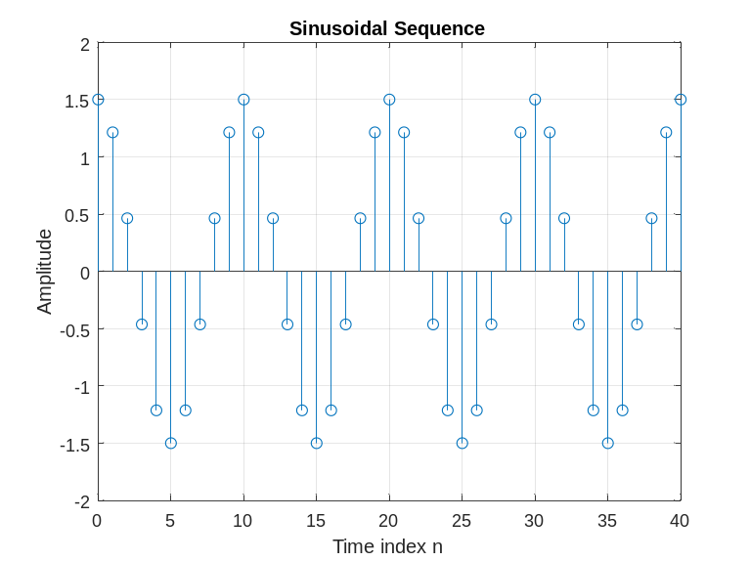.
Q1.18 The frequency of this sequence is – f = 0.1;
It is controlled by the following MATLAB command line: f = 0.1;
A sequence with new frequency fnew can be generated by the following command line: f=fnew;
The parameter controlling the phase of this sequence is - phase
The parameter controlling the amplitude of this sequence is - A
The period of this sequence is - 1/f = 10

Q1.19 The length of this sequence is - 41
It is controlled by the following MATLAB command line: n = 0:40;
A sequence with new length X can be generated by the following command line: lengthnew = 0:X-1;
Q1.20 The average power of the generated sinusoidal sequence is - P_avg=(A^2)/2);
(P_avg =1.125)

Q1.21 The purpose of axis command is - Control axis scaling and appearance.
The purpose of grid command is - Grid lines.
Q1.22 The modified Program P1_4 to generate a sinusoidal sequence of frequency 0.9 is given below along with the sequence generated by running it.
% Program P1_4
% Generation of a sinusoidal sequence
n = 0:40;
%f = 0.1;
f = 0.9;
phase = 0;
A = 1.5;
arg = 2*pi*f*n - phase;
x = A*cos(arg);
clf; % Clear old graph
stem(n,x); % Plot the generated sequence
axis([0 40 -2 2]);
grid;
title('Sinusoidal Sequence');
xlabel('Time index n');
ylabel('Amplitude');
axis;
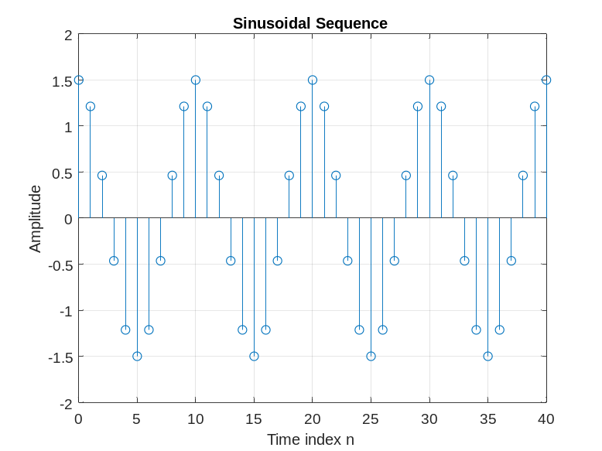
A comparison of this new sequence with the one generated in Question Q1.17 shows – The graph is the same, the difference is that in the old program the frequency f is set to 0.1, while in the new program the frequency f is set to 0.9.
A sinusoidal sequence of frequency 1.1 generated by modifying Program P1_4 is shown below. 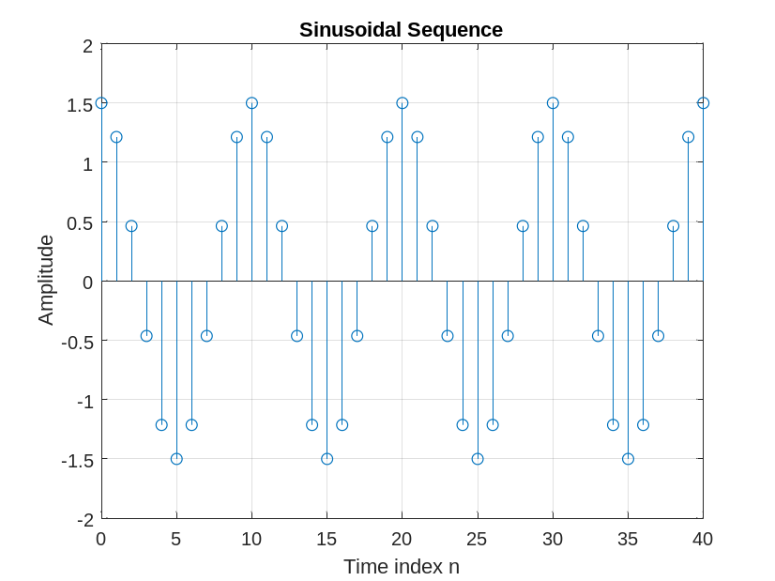
A comparison of this new sequence with the one generated in Question Q1.17 shows - The graph is the same, the difference is that in the old program the frequency f is set to 0.9, while in the new program the frequency f is set to 1.1
Q1.23 The sinusoidal sequence of length 50, frequency 0.08, amplitude 2.5, and phase shift of 90 degrees generated by modifying Program P1_4 is displayed below.
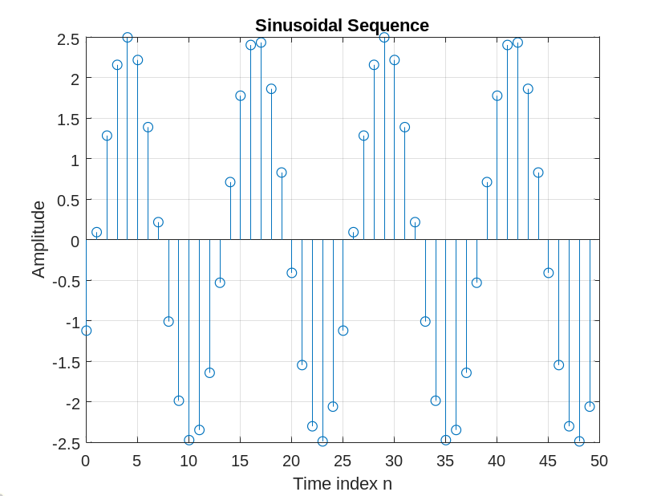
The period of this sequence is – T =1/f = 1/0.08=12.5(s)
Q1.24 By replacing the stem command in Program P1_4 with the plot command, the plot obtained is as shown below:
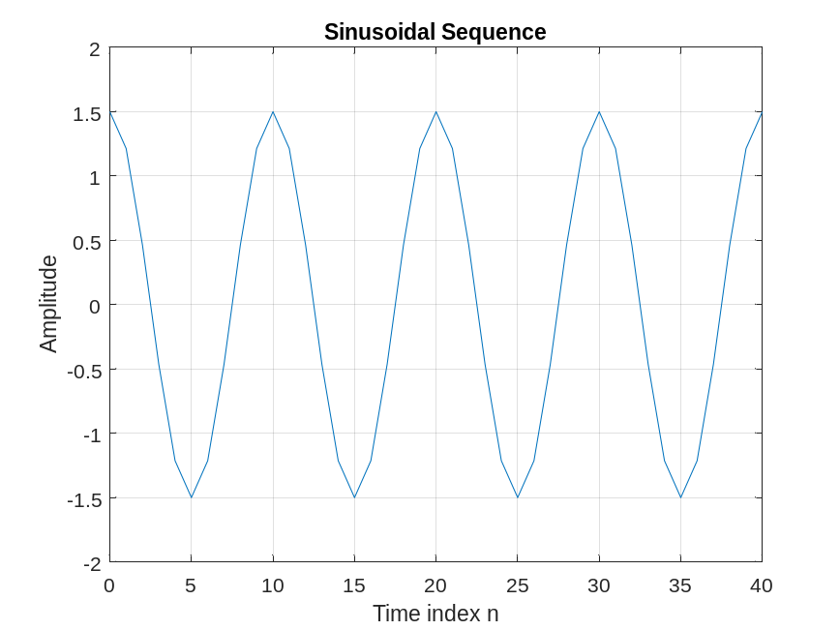
The difference between the new plot and the one generated in Question Q1.17 is - The graph of the new program connects the points, and the old graph only shows the points that are not connected. The plot function will draw a solid line, connecting the data points together to form a continuous curve. plot function is often used to represent continuous data series, while stem function is often used to represent discrete data series
Q1.25 By replacing the stem command in Program P1_4 with the stairs command the plot obtained is as shown below:
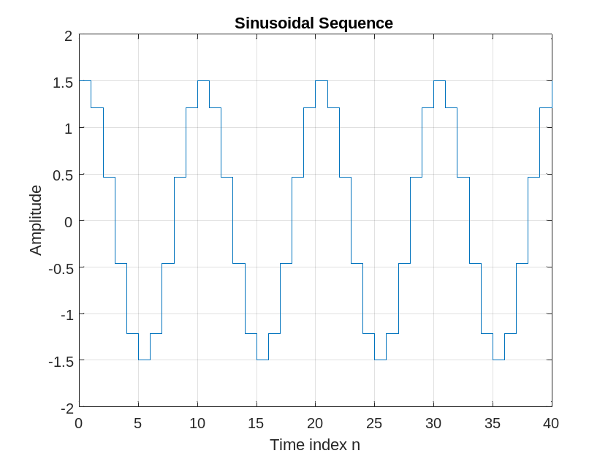
The difference between the new plot and those generated in Questions Q1.17 and Q1.24 is – Graph of Q1.17 with data points marked with vertical lines. In the graph of Q1.24 the vertical lines will be connected by horizontal segments. The values of the data series will be preserved on these horizontal segments. The stem function is often used to represent discrete data strings, while the stairs function is often used to represent discrete data strings. has the characteristic of a jump.
Project 1.4 Random signals
Answers:
Q1.26 The MATLAB program to generate and display a random signal of length 100 with elements uniformly distributed in the interval [–2, 2] is given below along with the plot of the random sequence generated by running the program:
%Q1_26
clf;
n=0:99;
x = -2 +4*rand(1,100);
stem(n,x);
axis([0,100,-2,2]);
title('Random signal');
xlabel('time index n');
ylabel('Amplitude');
grid;

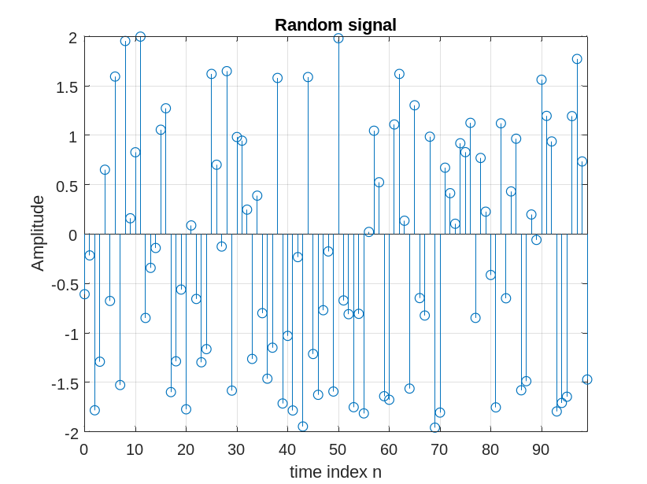
Q1.27 The MATLAB program to generate and display a Gaussian random signal of length 75 with elements normally distributed with zero mean and a variance of 3 is given below along with the plot of the random sequence generated by running the program:
%Q1.27
clf;
n=0:74;
x = sqrt(3) +4*randn(1,75);
stem(n,x);
title('Random signal');
xlabel('time index n');
ylabel('Amplitude');
grid;
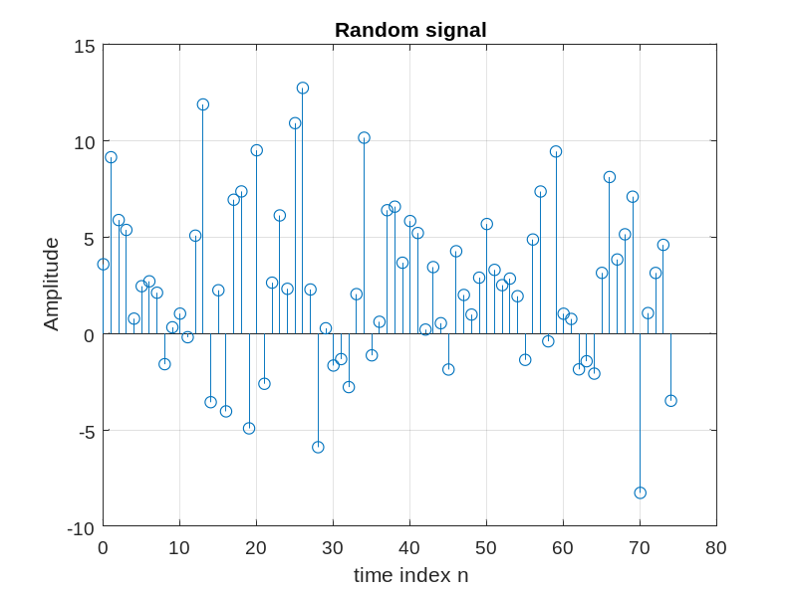
Q1.28 The MATLAB program to generate and display five sample sequences of a random sinusoidal signal of length 31
{X[n]} = {A.cos(ωon + φ)}
where the amplitude A and the phase φ are statistically independent random variables with uniform probability distribution in the range for the amplitude and in the range 0 ≤ φ ≤ 2π for the phase is given below. Also shown are five sample sequences generated by running this program five different times.
% Program Q1.28
clf;% Clear old graph
% Generation of a random sinusoidal sequence
n = 0:30;
A = 4*rand(1);
phase = 2*pi*rand(1);
w = 2*pi*0.9;
x = A*cos(w*n + phase);
% Plot the generated sequence
stem(n,x);
axis([0 30 -A-0.5 A+0.5]);
grid;
title('Random Sequence');
xlabel('Time index n');
ylabel('Amplitude');
axis;
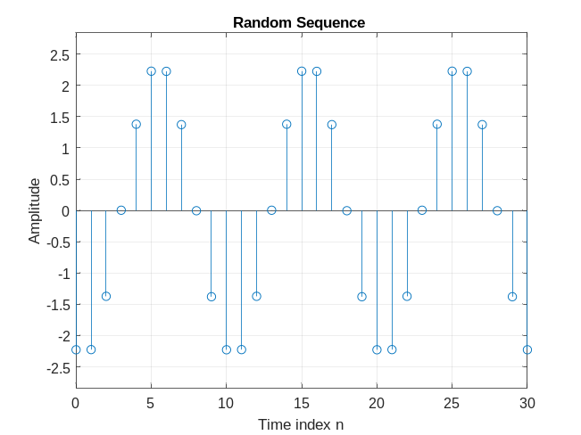
1.2 SIMPLE OPERATIONS ON SEQUENCES
Project 1.5 Signal Smoothing
A copy of Program P1_5 is given below.
% Program P1_5
% Signal Smoothing by Averaging
clf;
R = 51;
d = 0.8*(rand(R,1) - 0.5); % Generate random noise
m = 0:R-1;
s = 2*m.*(0.9.^m); % Generate uncorrupted signal
x = s + d'; % Generate noise corrupted signal
subplot(2,1,1);
plot(m,d','r-',m,s,'g--',m,x,'b-.');
xlabel('Time index n');ylabel('Amplitude');
legend('d[n] ','s[n] ','x[n] ');
x1 = [0 0 x];x2 = [0 x 0];x3 = [x 0 0];%x(n-1),x(n),x(n+1)
y = (x1 + x2 + x3)/3;
subplot(2,1,2);
plot(m,y(2:R+1),'r-',m,s,'g--');
legend( 'y[n] ','s[n] ');
xlabel('Time index n');ylabel('Amplitude');
Answers:
Q1.29 The signals generated by running Program P1_5 are displayed below:
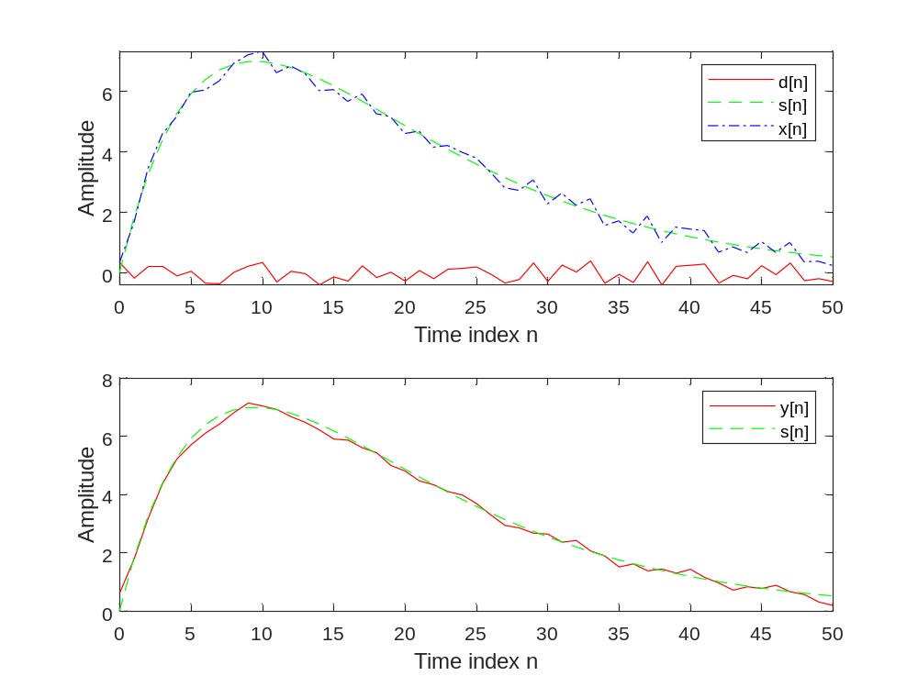
Q1.30 The uncorrupted signal s[n]is - s = 2*m.*(0.9.^m)
The additive noise d[n]is - d = 0.8*(rand(R,1) - 0.5);
Q1.31 The statement x = s + d CAN / CANNOT be used to generate the noise corrupted signal because – d is a 51x1 matrix, and s is a 1x51 matrix, the two matrices are not the same size, so they cannot be added together.
Q1.32 The relations between the signals x1, x2, and x3, and the signal x are – x1 is x2 shift right 1 time unit, x3 is x2 shift left 1 time unit
Q1.33 The purpose of the legend command is – Create legend.
Project 1.6 Generation of Complex Signals
A copy of Program P1_6 is given below.
% Program P1_6
% Generation of amplitude modulated sequence
clf;
n = 0:100;
m = 0.4;fH = 0.1; fL = 0.01;
xH = sin(2*pi*fH*n);
xL = sin(2*pi*fL*n);
y = (1+m*xL).*xH;
stem(n,y);grid;
xlabel('Time index n');ylabel('Amplitude');
Answers:
Q1.34 The amplitude modulated signals y[n] generated by running Program P1_6 for various values of the frequencies of the carrier signal xH[n] and the modulating signal xL[n], and various values of the modulation index m are shown below:
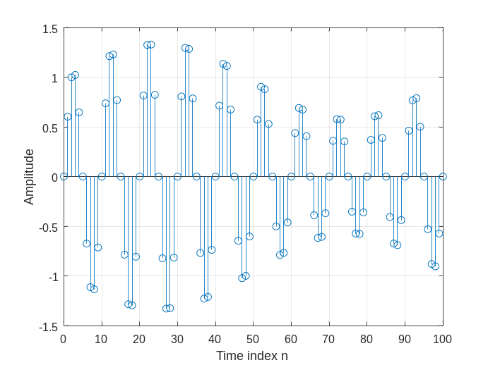
Q1.35 The difference between the arithmetic operators * and .* is - operator * denotes matrix multiplication, while .* represents element multiplication
A copy of Program P1_7 is given below.
% Program P1_7
% Generation of a swept frequency sinusoidal sequence
n = 0:100;
a = pi/2/100;
b = 0;
arg = a*n.*n + b*n;
x = cos(arg);
clf;
plot(n, x);
axis([0,100,-1.5,1.5]);
title('Swept-Frequency Sinusoidal Signal');
xlabel('Time index n');
ylabel('Amplitude');
grid; axis;
Answers:
Q1.36 The swept-frequency sinusoidal sequence x[n] generated by running Program P1_7 is displayed below.
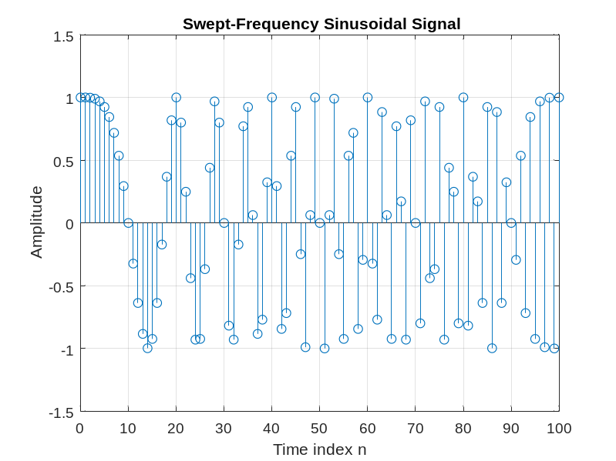
Q1.37 The minimum and maximum frequencies of this signal are – fmin = b = 0, fmax = a*n^2 = 157,08Hz
Q1.38 The Program 1_7 modified to generate a swept sinusoidal signal with a minimum frequency of 0.1 and a maximum frequency of 0.3 is given below:
% Program P1_7
% Generation of a swept frequency sinusoidal sequence
n = 0:100;
a = 0.004/2/100;
b = 0.1;
arg = a*n.*n + b;
x = cos(arg);
clf;
plot(n, x);
axis([0,100,-1.5,1.5]);
title('Swept-Frequency Sinusoidal Signal');
xlabel('Time index n');
ylabel('Amplitude');
grid; axis;
1.3 WORKSPACE INFORMATION
Q1.39 The information displayed in the command window as a result of the who command is - List current variables.
Q1.40 The information displayed in the command window as a result of the whos command is - List current variables, long form.
1.4 OTHER TYPES OF SIGNALS (Optional)
Project 1.7 Squarewave and Sawtooth Signals
Answer:
Q1.41 MATLAB programs to generate the square-wave and the sawtooth wave sequences of the type shown in Figures 1.1 and 1.2 are given below along with the sequences generated by running these programs:
% Q.41
clf
n = 0:30;
f = 0.1;
phase = 0;
A = 2.5;
arg = 2*pi*f*n - phase;
x1 = A*square(arg,60);
x2 = A*square(arg,30);
subplot(2,1,1);
stem(n,x1); % Plot the generated sequence
axis([0 30 -3 3]);
grid;
subplot(2,1,2);
stem(n,x2); % Plot the generated sequence
axis([0 30 -3 3]);
grid;

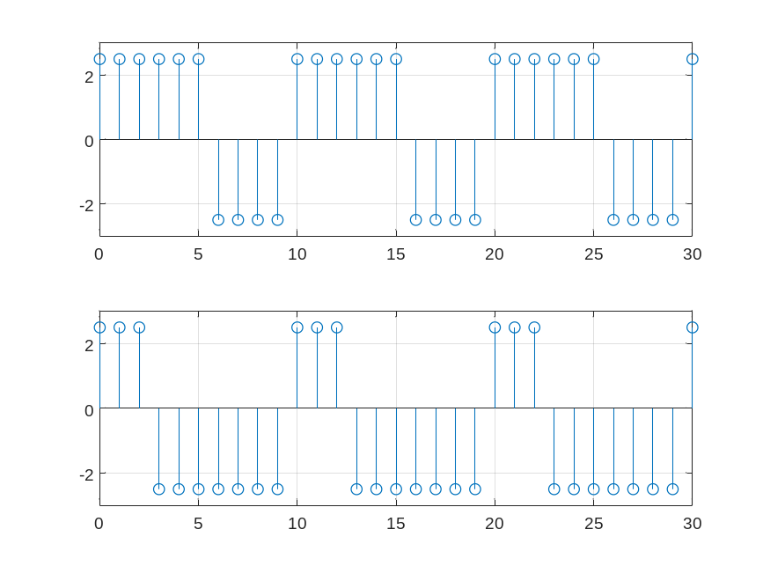
% Q.41
clf; % Clear old graph
n = 0:50;
f = 0.05;
phase = 0;
A = 2.5;
arg = 2*pi*f*n - phase;
x1 = A*sawtooth(arg);
x2 = A*sawtooth(arg,1/2);
subplot(2,1,1);
stem(n,x1); % Plot the generated sequence
axis([0 50 -3 3]);
grid;
title('Sinusoidal Sequence');
xlabel('Time index n');
ylabel('Amplitude');
axis;
subplot(2,1,2);
stem(n,x2); % Plot the generated sequence
axis([0 50 -3 3]);
grid;
title('Sinusoidal Sequence');
xlabel('Time index n');
ylabel('Amplitude');
axis;
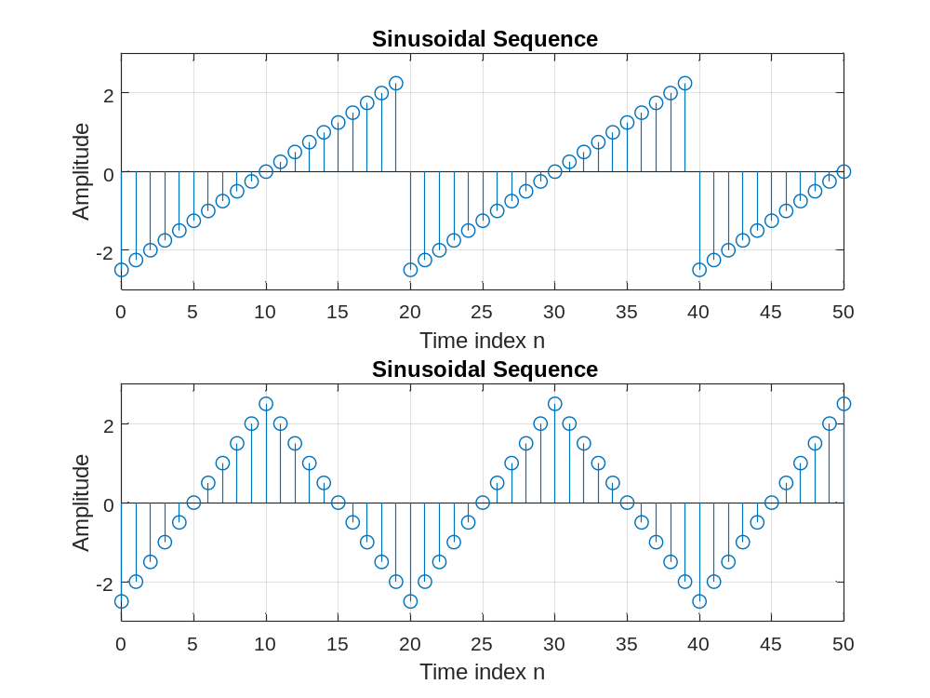
Date: Signature:

