Name:Nguyễn Bảo Tính
Section: 20161383
Laboratory Exercise 3
DISCRETE-TIME SIGNALS: FREQUENCY-DOMAIN REPRESENTATIONS
3.1 DISCRETE-TIME FOURIER TRANSFORM
Project 3.1 DTFT Computation
A copy of Program P3_1 is given below:
% Program P3_1
% Evaluation of the DTFT
clf;
% Compute the frequency samples of the DTFT
w = -4*pi:8*pi/511:4*pi;
num = [2 1];den = [1 -0.6];
h = freqz(num, den, w);
% Plot the DTFT
subplot(2,1,1)
plot(w/pi,real(h));grid
title('Real part of H(e^{j\omega})')
xlabel('\omega /\pi');
ylabel('Amplitude');
subplot(2,1,2)
plot(w/pi,imag(h));grid
title('Imaginary part of H(e^{j\omega})')
xlabel('\omega /\pi');
ylabel('Amplitude');
pause
subplot(2,1,1)
plot(w/pi,abs(h));grid
title('Magnitude Spectrum |H(e^{j\omega})|')
xlabel('\omega /\pi');
ylabel('Amplitude');
subplot(2,1,2)
plot(w/pi,angle(h));grid
title('Phase Spectrum arg[H(e^{j\omega})]')
xlabel('\omega /\pi');
ylabel('Phase in radians');

Answers:
Q3.1 The expression of the DTFT being evaluated in Program P3_1 is - 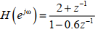
The function of the pause command is - Wait for user response
Q3.2 The plots generated by running Program P3_1 are shown below:
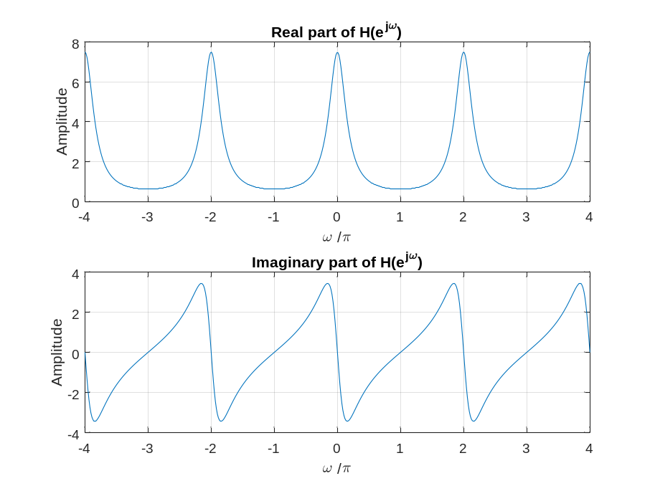
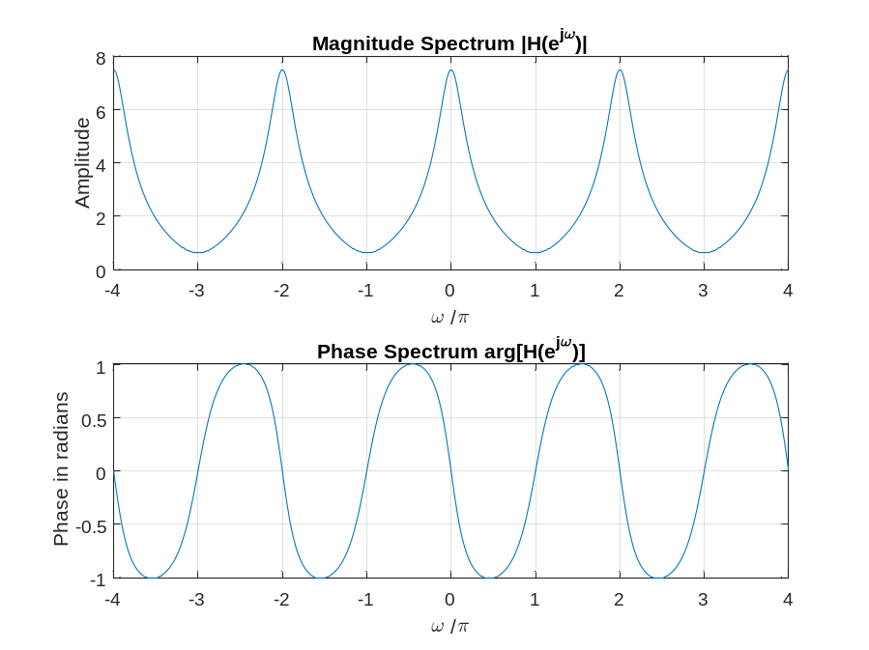
The DTFT is a __periodic__ function of ω.
Its period is - 2π
The types of symmetries exhibited by the four plots are as follows:
• The real part is 2 periodic and EVEN SYMMETRIC.
• The imaginary part is 2 periodic and ODD SYMMETRIC.
• The magnitude is 2 periodic and EVEN SYMMETRIC.
• The phase is 2 periodic and ODD SYMMETRIC.
Q3.3 The required modifications to Program P3_1 to evaluate the given DTFT of Q3.3 are given below:
%Q3.3
% Program P3_1
% Evaluation of the DTFT
clf;
% Compute the frequency samples of the DTFT
w = 0:8*pi/511:pi;
num = [0.7 -0.5 0.3 1];
den = [1 0.3 -0.5 0.7];
h = freqz(num, den, w);
% Plot the DTFT
subplot(2,1,1)
plot(w/pi,real(h));grid
title('Real part of H(e^{j\omega})')
xlabel('\omega /\pi');
ylabel('Amplitude');
subplot(2,1,2)
plot(w/pi,imag(h));grid
title('Imaginary part of H(e^{j\omega})')
xlabel('\omega /\pi');
ylabel('Amplitude');
pause
subplot(2,1,1)
plot(w/pi,abs(h));grid
title('Magnitude Spectrum |H(e^{j\omega})|')
xlabel('\omega /\pi');
ylabel('Amplitude');
subplot(2,1,2)
plot(w/pi,angle(h));grid
title('Phase Spectrum arg[H(e^{j\omega})]')
xlabel('\omega /\pi');
ylabel('Phase in radians');
The plots generated by running the modified Program P3_1 are shown below:
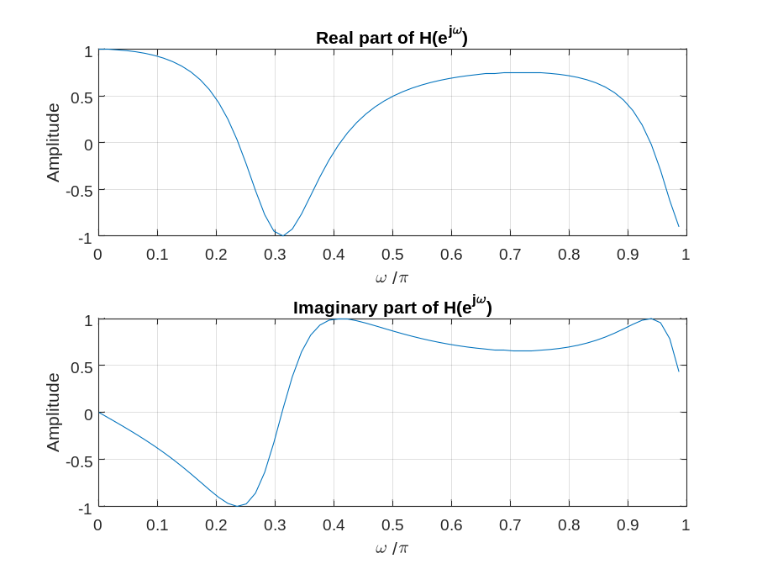
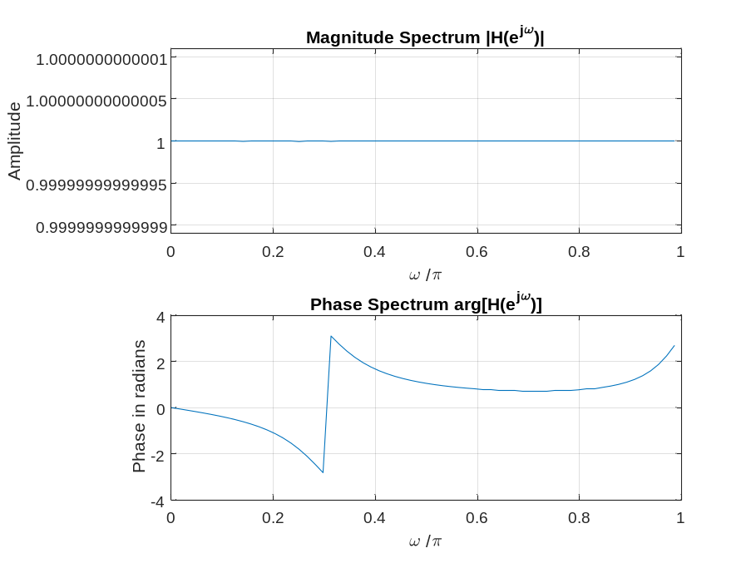
The DTFT is a ___periodic___ function of ω.
Its period is - 2π
The jump in the phase spectrum is caused by - abrupt change of the phase value of the transfer function (transfer function) H(e^(jω)) when the input frequency changes
The phase spectrum evaluated with the jump removed by the command unwrap is as given below:
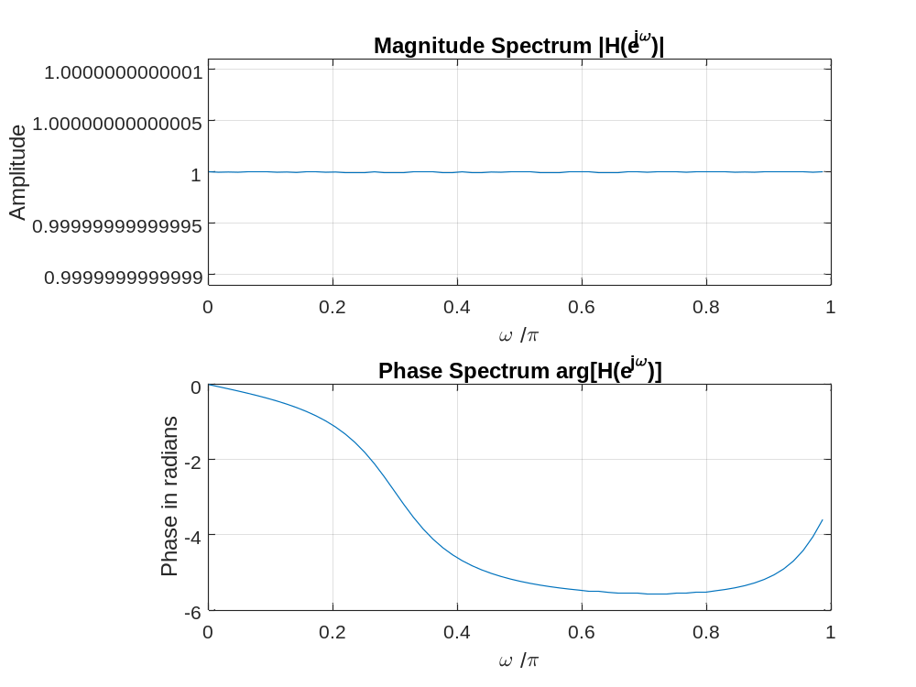

Q3.4 The required modifications to Program P3_1 to evaluate the given DTFT of Q3.4 are given below:
% Program P3_1
% Evaluation of the DTFT
clf;
% Compute the frequency samples of the DTFT
w = -4*pi:8*pi/511:4*pi;
num = [1 3 5 7 9 11 13 15 17];den = 1;
h = freqz(num, den, w);
% Plot the DTFT
subplot(2,1,1)
plot(w/pi,real(h));grid
title('Real part of H(e^{j\omega})')
xlabel('\omega /\pi');
ylabel('Amplitude');
subplot(2,1,2)
plot(w/pi,imag(h));grid
title('Imaginary part of H(e^{j\omega})')
xlabel('\omega /\pi');
ylabel('Amplitude');
pause
subplot(2,1,1)
plot(w/pi,abs(h));grid
title('Magnitude Spectrum |H(e^{j\omega})|')
xlabel('\omega /\pi');
ylabel('Amplitude');
subplot(2,1,2)
plot(w/pi,angle(h));grid
title('Phase Spectrum arg[H(e^{j\omega})]')
xlabel('\omega /\pi');
ylabel('Phase in radians');
The plots generated by running the modified Program P3_1 are shown below:
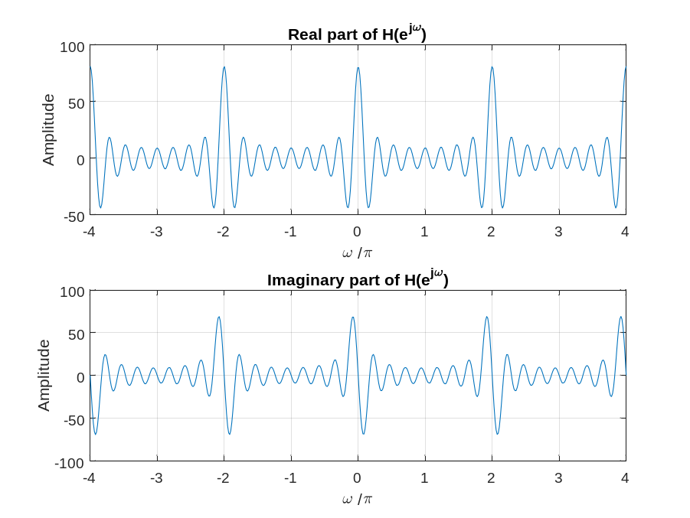
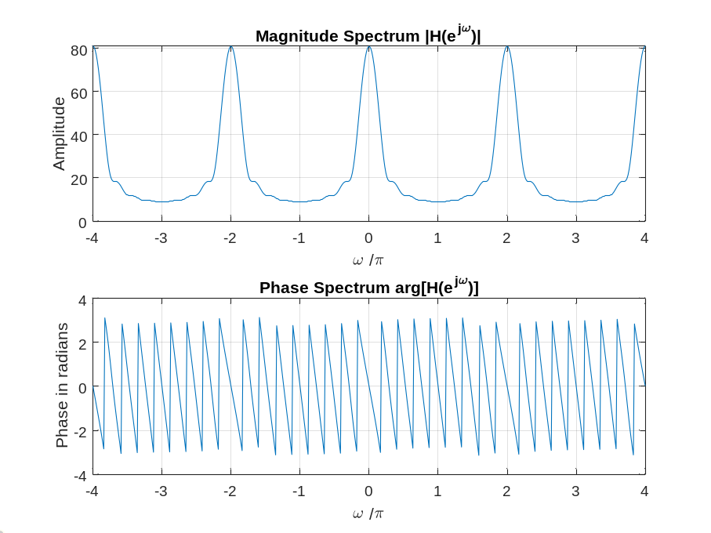
The DTFT is a __periodic___ function of ω.
Its period is - 2π
The jump in the phase spectrum is caused by - abrupt change of the phase value of the transfer function (transfer function) H(e^(jω)) when the input frequency changes
Q3.5 The required modifications to Program P3_1 to plot the phase in degrees are indicated below:
subplot(2,1,2)
plot(w/pi,angle(h));grid
title('Phase Spectrum arg[H(e^{j\omega})]')
xlabel('\omega /\pi');
ylabel('Phase in radians');
Project 3.2 DTFT Properties
Answers:
Q3.6 The modified Program P3_2 created by adding appropriate comment statements, and adding program statements for labeling the two axes of each plot being generated by the program is given below:
% Program P3_2B
% Time-Shifting Properties of DTFT
clf;
w = -pi:2*pi/255:pi; % freqency vector for evaluating DTFT
D = 10; % Amount of time shift in samples
num = [1 2 3 4 5 6 7 8 9];
% h1 is the DTFT of original sequence
% h2 is the DTFT of the time shifted sequence
h1 = freqz(num, 1, w);
h2 = freqz([zeros(1,D) num], 1, w);
subplot(2,2,1)
% plot the DTFT magnitude of the original sequence
plot(w/pi,abs(h1));grid
title('Magnitude Spectrum of Original Sequence','FontSize',8)
xlabel('\omega /\pi');
ylabel('Amplitude');
% plot the DTFT magnitude of the shifted sequence
subplot(2,2,2)
plot(w/pi,abs(h2));grid
title('Magnitude Spectrum of Time-Shifted Sequence','FontSize',8)
xlabel('\omega /\pi');
ylabel('Amplitude');
% plot the DTFT phase of the original sequence
subplot(2,2,3)
plot(w/pi,angle(h1));grid
title('Phase Spectrum of Original Sequence','FontSize',8)
xlabel('\omega /\pi');
ylabel('Phase in radians');
% plot the DTFT phase of the shifted sequence
subplot(2,2,4)
plot(w/pi,angle(h2));grid
title('Phase Spectrum of Time-Shifted Sequence','FontSize',8)
xlabel('\omega /\pi');
ylabel('Phase in radians');
The parameter controlling the amount of time-shift is - D = 10
Q3.7 The plots generated by running the modified program are given below:
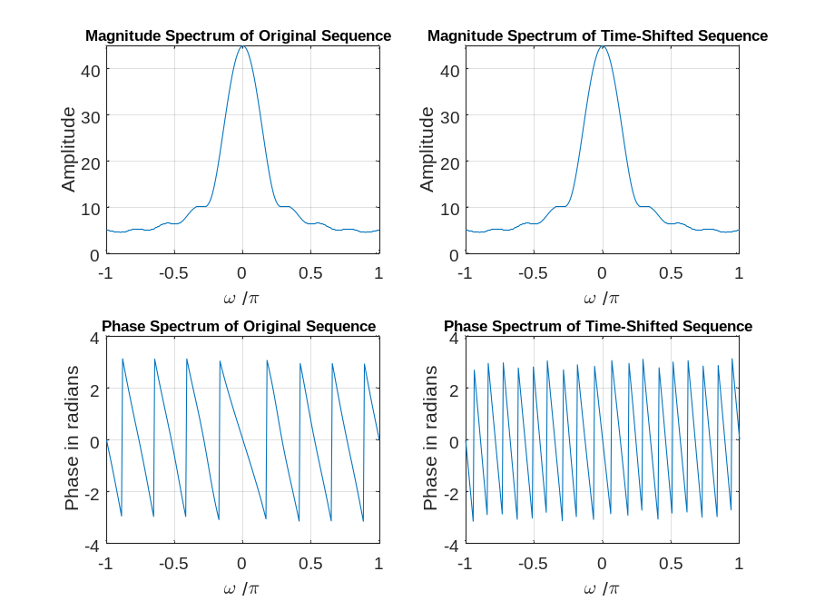
From these plots we make the following observations: The time shift does not have any
effect at all on the magnitude spectrum. However, it has a significant effect on the
phase spectrum. The effect is to add phase, which makes the slope of the phase
function steeper (more negative in this case).
Q3.8 Program P3_2 was run for the following value of the time-shift - D = 7
The plots generated by running the modified program are given below:
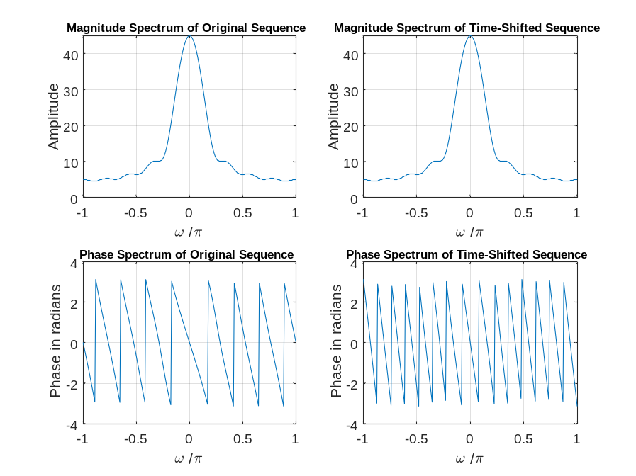
From these plots we make the following observations: The time shift does not have any
effect at all on the magnitude spectrum. However, it has a significant effect on the
phase spectrum. The effect is to add phase, which makes the slope of the phase
function steeper (more negative in this case).
Q3.9 Program P3_2 was run for the following values of the time-shift and for the following values of length for the sequence -
The plots generated by running the modified program are given below:
D = 3
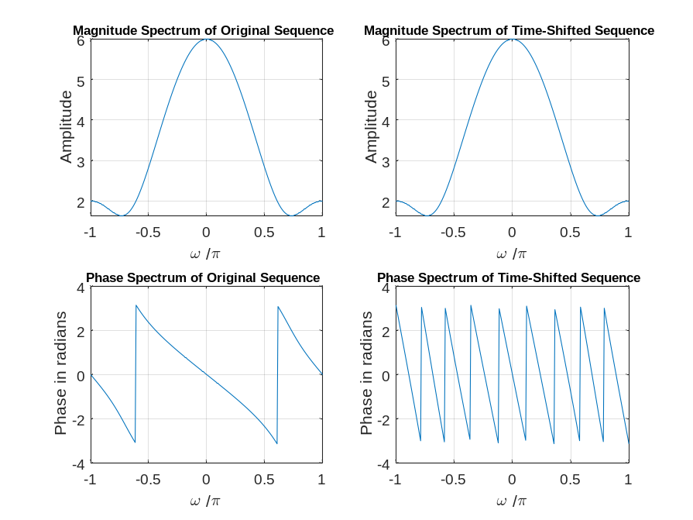
D = 15
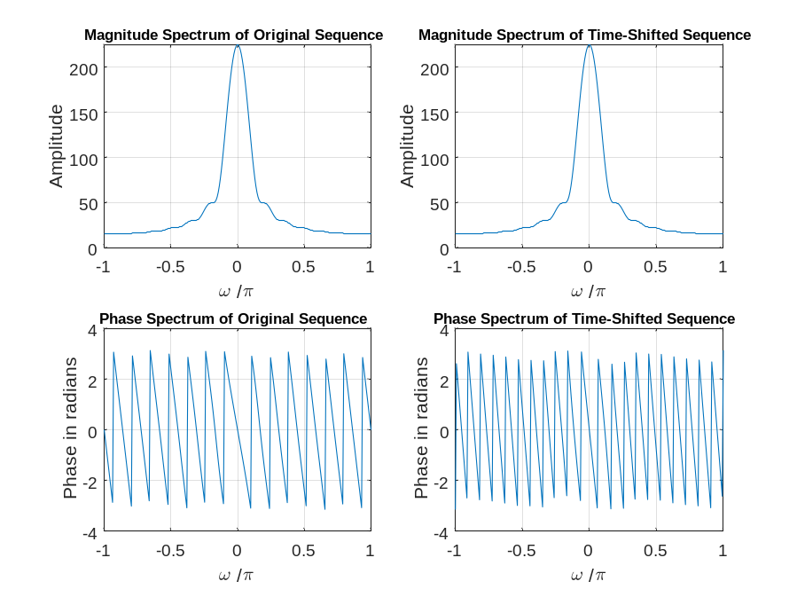
From these plots we make the following observations: Increasing the length makes the
magnitude spectrum more narrow (i.e., makes the signal more “low pass”). It also
makes the phase steeper (i.e., the slope more negative). This is because, if we think of
the sequence as the impulse response of an LTI system, increasing the length adds more delay between the input and output of the system. As before, the time shift does not
have any effect on the magnitude spectrum. However, it makes the slope of the phase
spectrum more negative. The larger the value of the delay, the more negative slope is
added to the phase spectrum
Q3.10 The modified Program P3_3 created by adding appropriate comment statements, and adding program statements for labeling the two axes of each plot being generated by the program is given below:
% Program P3_3B
% Frequency-Shifting Properties of DTFT
clf;
w = -pi:2*pi/255:pi; % freqency vector for evaluating DTFT
wo = 0.4*pi; % Amount of frequency shift in radians
% h1 is the DTFT of the original sequence
% h2 is the DTFT of the frequency shifted sequence
num1 = [1 3 5 7 9 11 13 15 17];
L = length(num1);
h1 = freqz(num1, 1, w);
n = 0:L-1;
num2 = exp(wo*i*n).*num1;
h2 = freqz(num2, 1, w);
% plot the DTFT magnitude of the original sequence
subplot(2,2,1)
plot(w/pi,abs(h1));grid
title('Magnitude Spectrum of Original Sequence','FontSize',8)
xlabel('\omega /\pi');
ylabel('Amplitude');
% plot the DTFT magnitude of the freq shifted sequence
subplot(2,2,2)
plot(w/pi,abs(h2));grid
title('Magnitude Spectrum of Frequency-Shifted Sequence','FontSize',8)
xlabel('\omega /\pi');
ylabel('Amplitude');
% plot the DTFT phase of the original sequence
subplot(2,2,3)
plot(w/pi,angle(h1));grid
title('Phase Spectrum of Original Sequence','FontSize',8)
xlabel('\omega /\pi');
ylabel('Phase in radians');
% plot the DTFT phase of the shifted sequence
subplot(2,2,4)
plot(w/pi,angle(h2));grid
title('Phase Spectrum of Frequency-Shifted Sequence','FontSize',8)
xlabel('\omega /\pi');
ylabel('Phase in radians');
The parameter controlling the amount of frequency-shift is -wo
Q3.11 The plots generated by running the modified program are given below:
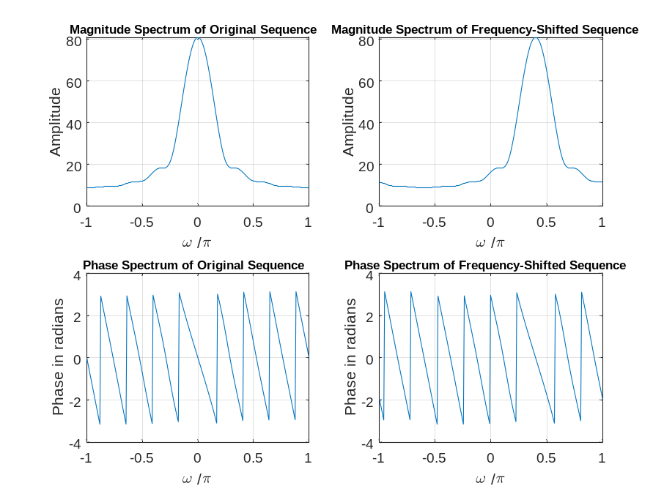
From these plots we make the following observations: Both the magnitude and phase
spectra are shifted right by wo, which is given by 0.4π in this case. Note that the
frequency shifted signal was obtained by multiplying the original sequence pointwise
with a complex-valued exponential sequence. Thus, the frequency shifted sequence is
also complex-valued and it’s DTFT does not have conjugate symmetry
Q3.12 Program P3_3 was run for the following value of the frequency-shift -wo = -0.5π.
The plots generated by running the modified program are given below:
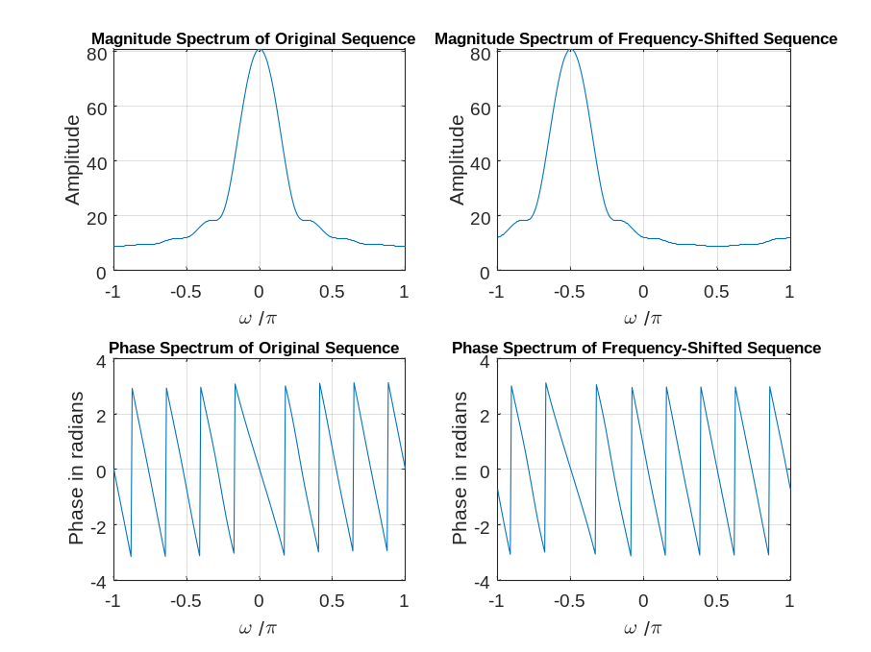
From these plots we make the following observations: In this case, the magnitude and
phase spectra are shifted left by π/2 rad. As before, the frequency shifted signal is
complex-valued, so the frequency shift causes a loss of the conjugate symmetry that
was present in the spectrum of the original signal.
Q3.13 Program P3_3 was run for the following values of the frequency-shift and for the following values of length for the sequence –
Length 5, frequency shift wo = 0.7π.
Length 10, frequency shift wo = -0.5π.
The plots generated by running the modified program are given below:
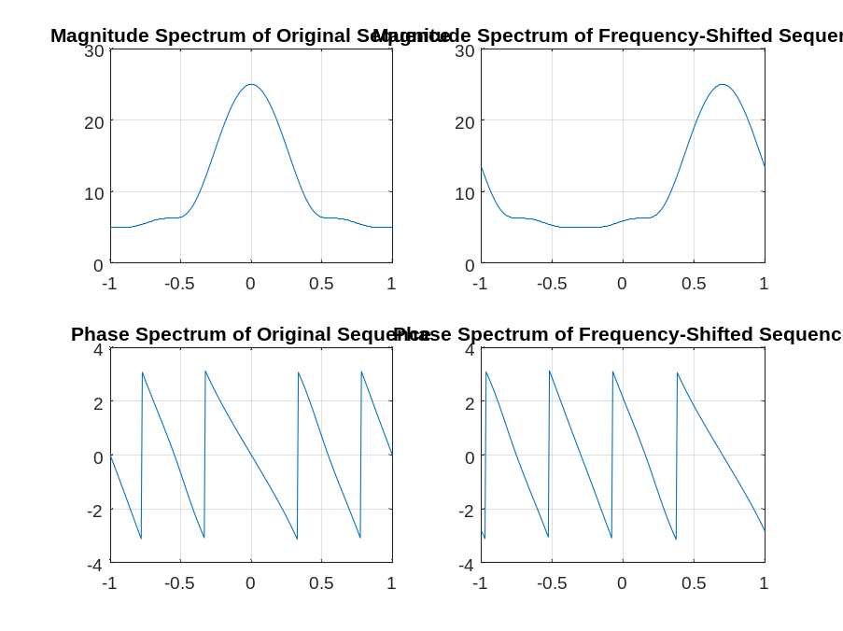
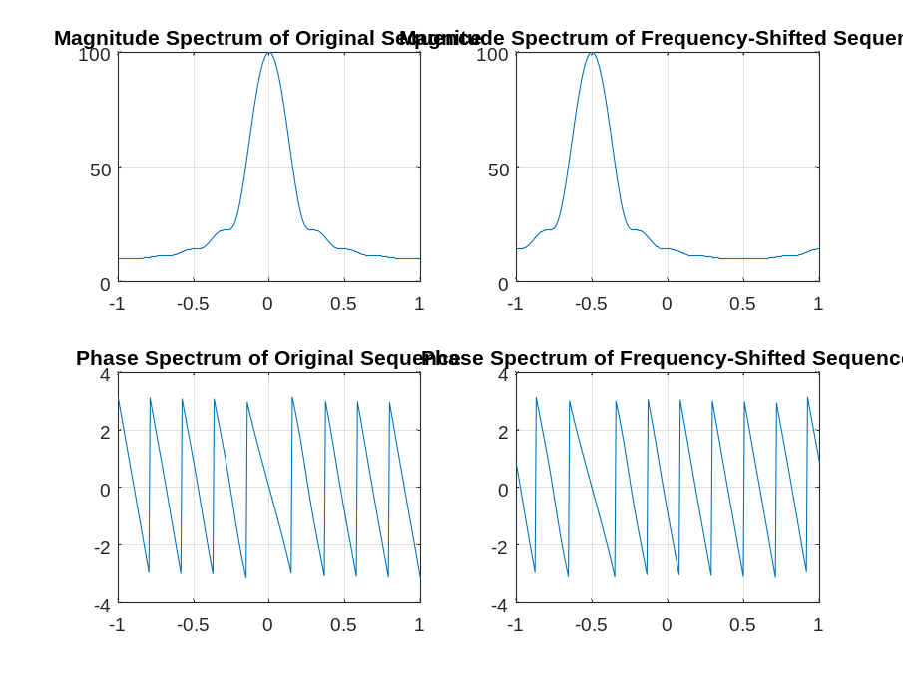
From these plots we make the following observations: The original sequences have a low
pass characteristic. As before with the time shift property, a shorter length gives a
broader low pass magnitude spectrum, whereas a longer length results in a low pass
magnitude spectrum that is more narrow. Also, if we consider these sequences to be the impulse responses of LTI systems, then a shorter length implies a smaller delay
between the input and output of the system, which corresponds to a phase spectrum
with a negative slope that is less steep. Likewise, a longer length implies a longer delay
between the input and output, which corresponds to a phase spectrum with a negative
slope that is steeper. In both cases shown here, the effect of the frequency shift is to
translate both the magnitude and phase spectrum by wo radians. Whereas the original
sequences are real-valued and hence have conjugate symmetric spectra, the frequency
shifted sequences are complex-valued and do not exhibit any inherent spectral
symmetry
Q3.14 The modified Program P3_4 created by adding appropriate comment statements, and adding program statements for labeling the two axes of each plot being generated by the program is given below:
% Program P3_4
% Convolution Property of DTFT
clf;
w = -pi:2*pi/255:pi;
x1 = [1 3 5 7 9 11 13 15 17];
x2 = [1 -2 3 -2 1];
y = conv(x1,x2);
h1 = freqz(x1, 1, w);
h2 = freqz(x2, 1, w);
hp = h1.*h2;
h3 = freqz(y,1,w);
subplot(2,2,1)
plot(w/pi,abs(hp));grid
title('Product of Magnitude Spectra')
subplot(2,2,2)
plot(w/pi,abs(h3));grid
title('Magnitude Spectrum of Convolved Sequence')
subplot(2,2,3)
plot(w/pi,angle(hp));grid
title('Sum of Phase Spectra')
subplot(2,2,4)
plot(w/pi,angle(h3));grid
title('Phase Spectrum of Convolved Sequence')
Q3.15 The plots generated by running the modified program are given below:
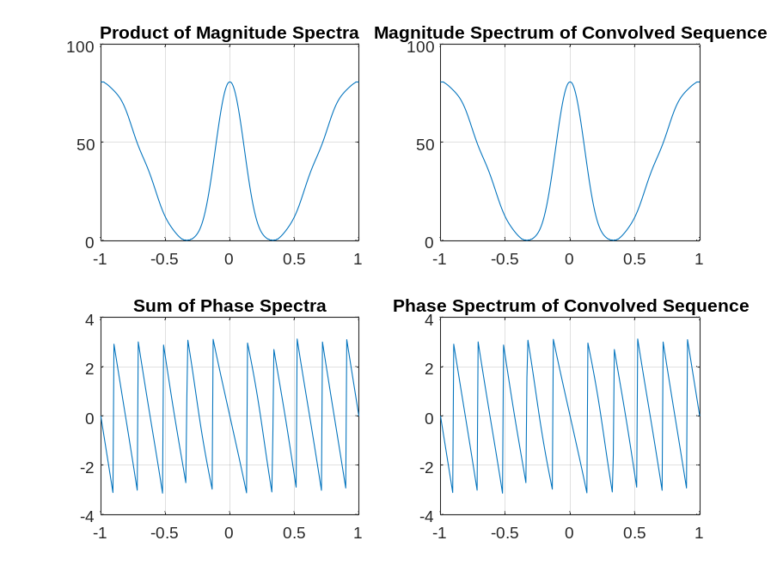
From these plots we make the following observations: The DTFT phase and intensity spectra obtained by performing the dimensional multiplication of the two DTFTs of the original sequences are identical to those obtained by performing the time domain convolution of the two original sequences; this verifies the convolution property of the DTFT.
Q3.16 Program P3_4 was run for the following two different sets of sequences of varying lengths -
The plots generated by running the modified program are given below:
- Length of x1 = 8; x1[n] = (1/2)^{n} for 0 ≤ n ≤ 7;
Length of x2 = 4; x2[n]= [0.25 0.25 0.25 0.25]
- Length of x1 = 16; x1[n] = (-3/4)^{n} n for 0 ≤ n ≤ 15;
Length of x2 = 9; x2[n]= [1 3 5 7 9 11 13 15 17]
From these plots we make the following observations:
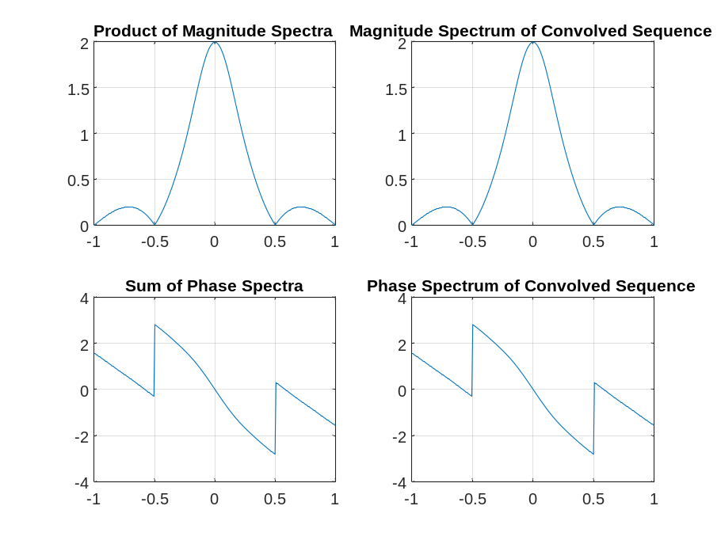
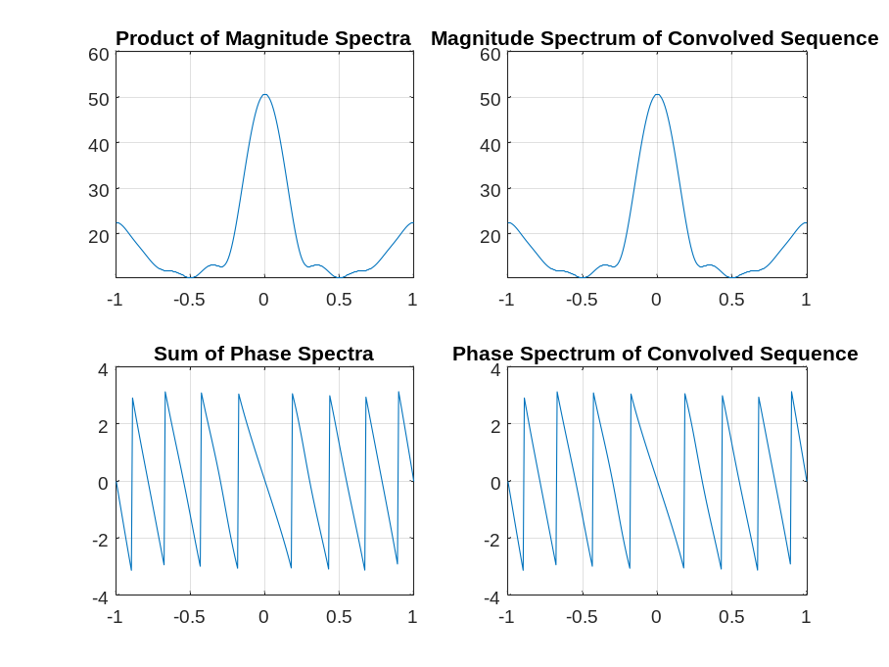
Q3.17 The modified Program P3_5 created by adding appropriate comment statements, and adding program statements for labeling the two axes of each plot being generated by the program is given below:
% Program P3_5
% Modulation Property of DTFT
clf;
w = -pi:2*pi/255:pi;
x1 = [1 3 5 7 9 11 13 15 17];
x2 = [1 -1 1 -1 1 -1 1 -1 1];
y = x1.*x2;
h1 = freqz(x1, 1, w);
h2 = freqz(x2, 1, w);
h3 = freqz(y,1,w);
subplot(3,1,1)
plot(w/pi,abs(h1));grid
title('Magnitude Spectrum of First Sequence')
subplot(3,1,2)
plot(w/pi,abs(h2));grid
title('Magnitude Spectrum of Second Sequence')
subplot(3,1,3)
plot(w/pi,abs(h3));grid
title('Magnitude Spectrum of Product Sequence')
Q3.18 The plots generated by running the modified program are given below:
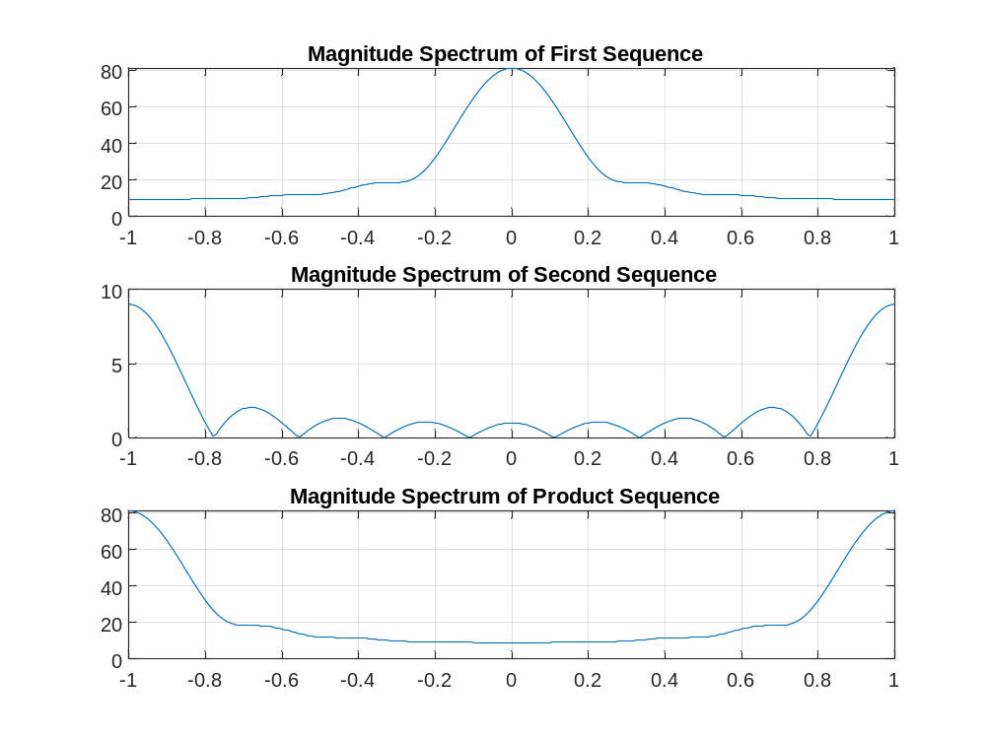
From these plots we make the following observations: The DTFT of the product sequence
y is 1/2π times the convolution of the DTFT’s of the two sequences x1 and x2, as
expected. The low-pass mainlobe of the DTFT of x1 combines with the high-pass
mainlobe of the DTFT of x2 to produce a high-pass mainlobe centered at ±π in the
magnitude spectrum of the product signal. The low-pass mainlobe of the DTFT of x1
combines with the low-pass sidelobes of the DTFT of x2 to produce a low-pass smooth region of relatively lower gain centered at DC in the magnitude spectrum of the product signal.
Q3.19 Program P3_5 was run for the following two different sets of sequences of varying lengths –
- Length of x1 = 8; x1[n] = (1/2)^{n} for 0 ≤ n ≤ 7;
Length of x2 = 8; x2[n]= [0.25 0.25 0.25 0.25 0.25 0.25 0.25 0.25]
- Length of x1 = 9; x1[n] = (-3/4)^{n} n for 0 ≤ n ≤ 8;
Length of x2 = 9; x2[n]= [1 3 5 7 9 11 13 15 17]
The plots generated by running the modified program are given below:
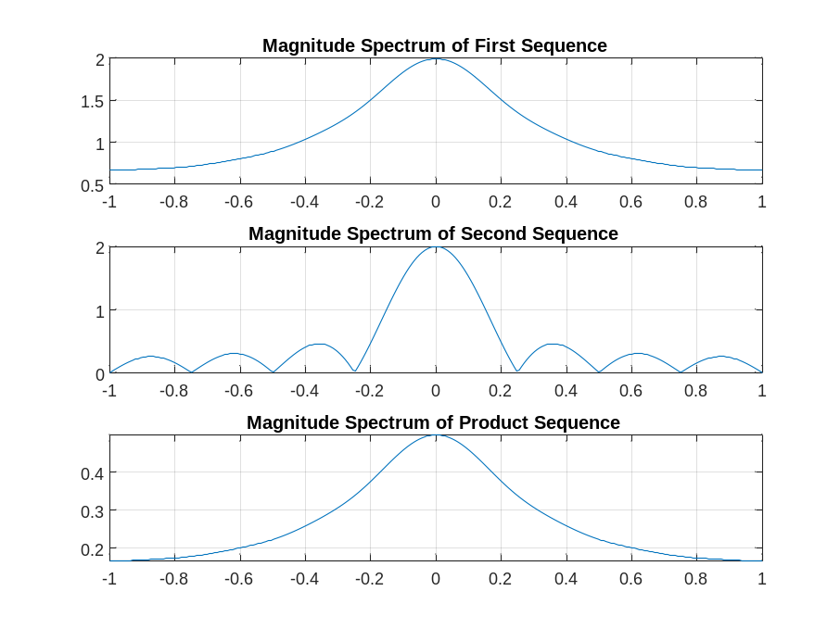
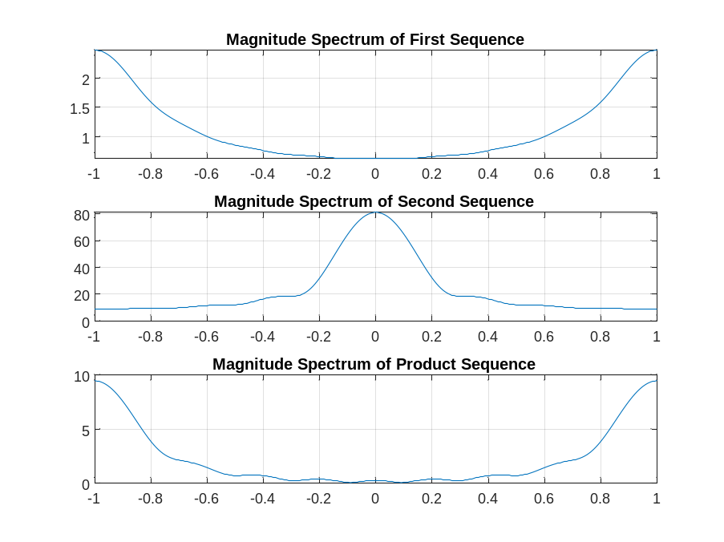
From these plots we make the following observations: In the first example, both x1 and x2 are low pass sequences. Moreover, the DTFT of x2 is a sync pulse. Taking the product of these two sequences produces a new sequence y that is also low pass in
character. The magnitude spectrum of y has a shape that is very similar to that of x1,
but with some averaging. The spectral magnitude of y is reduced compared to that of
x1, primarily due to the division by 2π that is inherent in the DTFT frequency
convolution (time modulation) property. In the second example, x1 is high pass while
x2 is low pass. As before in Q3.18, we see that magnitude spectrum of y is essentially high pass in character as a result of the low pass mainlobe of the DTFT of x2 being convolved with the high pass mainlobe of x1.
Q3.20 The modified Program P3_6 created by adding appropriate comment statements, and adding program statements for labeling the two axes of each plot being generated by the program is given below:
% Program P3_6
% Time Reversal Property of DTFT
clf;
w = -pi:2*pi/255:pi;
num = [1 2 3 4];
L = length(num)-1;
h1 = freqz(num, 1, w);
h2 = freqz(fliplr(num), 1, w);
h3 = exp(w*L*i).*h2;
subplot(2,2,1)
plot(w/pi,abs(h1));grid
title('Magnitude Spectrum of Original Sequence')
subplot(2,2,2)
plot(w/pi,abs(h3));grid
title('Magnitude Spectrum of Time-Reversed Sequence')
subplot(2,2,3)
plot(w/pi,angle(h1));grid
title('Phase Spectrum of Original Sequence')
subplot(2,2,4)
plot(w/pi,angle(h3));grid
title('Phase Spectrum of Time-Reversed Sequence')
The program implements the time-reversal operation as follows – The original ramp
sequence is nonzero for 0 ≤ n ≤ 3. A new sequence is formed by using fliplr; this
new sequence contains the samples of the original ramp sequence in time reversed
order. However, the new sequence is still nonzero for 0 ≤ n ≤ 3, whereas the time
reversed ramp sequence must be nonzero for -3 ≤ n ≤ 0. This required left shift in time
is accomplished in the frequency domain using the time shift property of the DTFT as
follows. First, freqz is called to set h2 equal to the DTFT of the new sequence
obtained from calling fliplr on the original ramp sequence. Finally, h3 is set equal
to the DTFT of the time reversed ramp by multiplying h2 times a linear phase term to
implement the required left shift in the time domain.
Q3.21 The plots generated by running the modified program are given below:
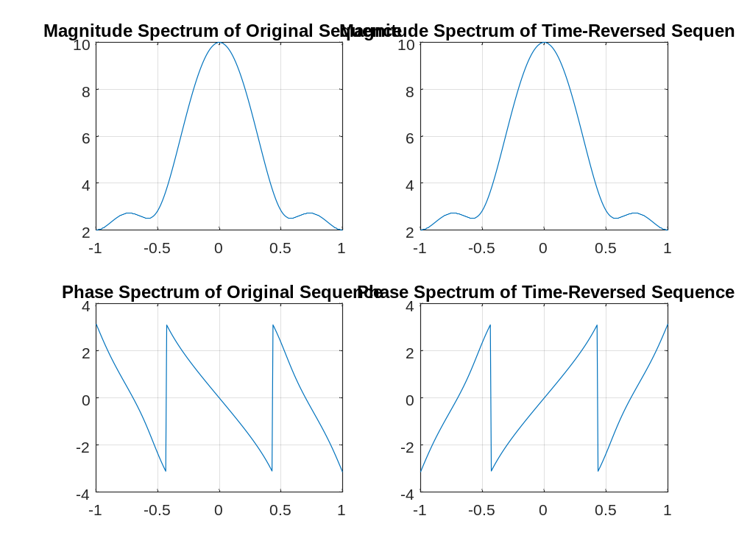
From these plots we make the following observations: Both the original and time reversed
ramp sequences are real-valued. Therefore, they have conjugate symmetric DTFT’s.
For both sequences, this implies that the magnitude spectrum is even symmetric and the
phase spectrum is odd symmetric. Now, the DTFT of the time reversed ramp (h3) is
equal to a frequency reversed version of the DTFT of the original sequence (h1). Since
“flipping” an even function has no net effect, we see in the graphs above that both the
original and time reversed sequences have identical magnitude spectra. However, since
the phase spectra are odd symmetric, the phase spectrum of the time reversed sequence
is a frequency reversed version of the phase spectrum of the original sequence.
Q3.22 Program P3_6 was run for the following two different sets of sequences of varying lengths –
1. Length of num = 8; num = (1/2)^{n} for 0 ≤ n ≤ 7
2. Length of num = 16; num = (-5/7)^{n} n for 0 ≤ n ≤ 15
The plots generated by running the modified program are given below:
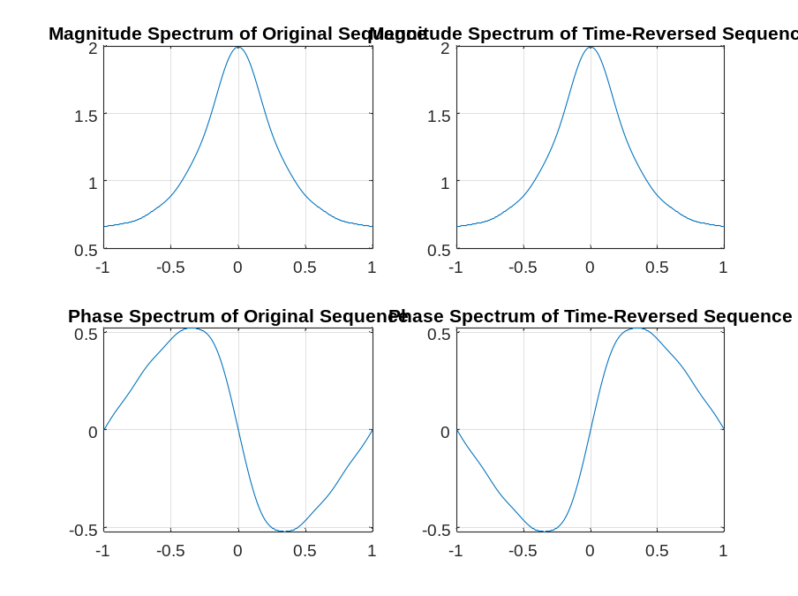
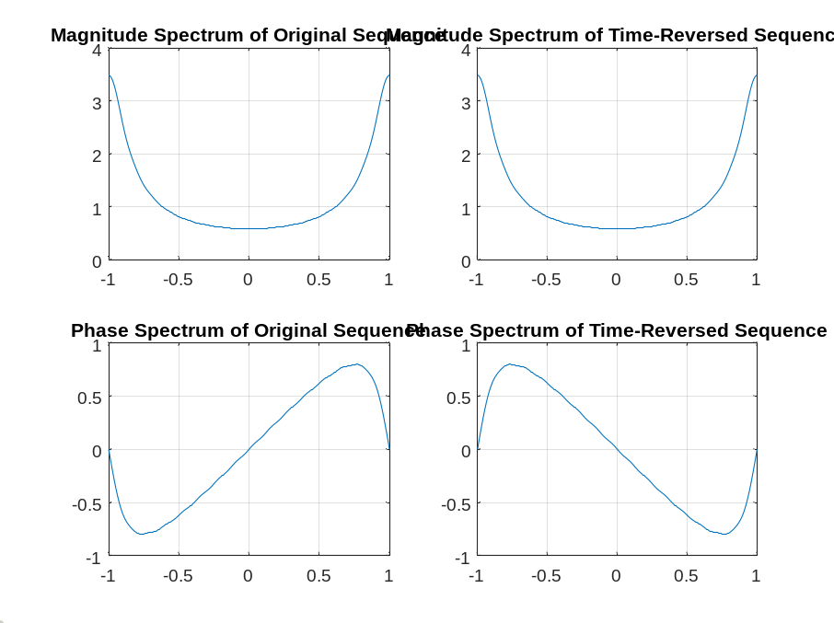
From these plots we make the following observations: As before in Q3.20, we see that the
DTFT of the time reversed sequence is a frequency reversed version of the DTFT of the
original sequence. In particular, because these are real-valued sequences with even
magnitude spectra and odd phase spectra, the magnitude spectra of the original and
time reversed sequences are the same. However, the phase spectrum of the time
reversed sequence is a frequency reversed version of the phase spectrum of the original
sequence.
3.2 DISCRETE FOURIER TRANSFORM
Project 3.3 DFT and IDFT Computations
Answers:
Q3.23 The MATLAB program to compute and plot the L-point DFT X[k] of a length-N sequence x[n] with L N and then to compute and plot the IDFT of X[k] is given below:
% Q3_23
% Compute and plot the L-point DFT of an N-point signal, L >= N.
clf;
%Initialize
N=200; % length of signal
L=256; % length of DFT
nn = [0:N-1];
kk = [0:L-1];
% the signal x
xR = [0.1*(1:100) zeros(1,N-100)]; % real part
xI = [zeros(1,N)]; % imag part
x = xR + i*xI;
% DFT
XF = fft(x,L);
% plot xR and xI
subplot(3,2,1);grid;
plot(nn,xR);grid;
title('Re\{x[n]\}');
xlabel('Time index n');
ylabel('Amplitude');
subplot(3,2,2);
plot(nn,xI);grid;
title('Im\{x[n]\}');
xlabel('Time index n');
ylabel('Amplitude');
% plot real and imag parts of DFT
subplot(3,2,3);
plot(kk,real(XF));grid;
title('Re\{X[k]\}');
xlabel('Frequency index k');
ylabel('Amplitude');
subplot(3,2,4);
plot(kk,imag(XF));grid;
title('Im\{X[k]\}');
xlabel('Frequency index k');
ylabel('Amplitude');
% IDFT
xx = ifft(XF,L);
% plot real and imaginary parts of the IDFT
subplot(3,2,5);
plot(kk,real(xx));grid;
title('Real part of IDFT\{X[k]\}');
xlabel('Time index n');
ylabel('Amplitude');
subplot(3,2,6);
plot(kk,imag(xx));grid;
title('Imag part of IDFT\{X[k]\}');
xlabel('Time index n');
ylabel('Amplitude');
The DFT and the IDFT pairs generated by running the program for sequences of different lengths N and for different values of the DFT length L are shown below:
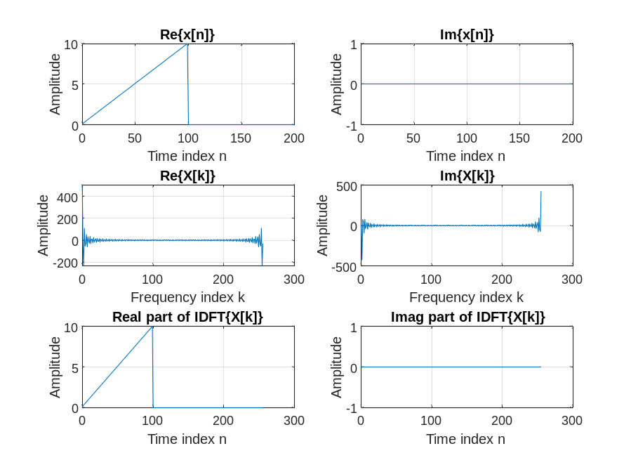
From these plots we make the following observations: The signal is a
real-valued ramp of length 100 zero padded on the right for a total signal length of
N=200. The length of the DFT is L=256. We see that the 256-point DFT is conjugate
symmetric as expected. The signal obtained from the IDFT has a length of L=256, but
is otherwise identical to the original signal up to roundoff.
Q3.24 The MATLAB program to compute the N-point DFT of two length-N real sequences using a single N-point DFT and compare the result by computing directly the two N-point DFTs is given below:
% Q3_24
% Use a single N-point DFT to compute simultaneously the N-point
% DFT's of two real-valued N-point sequences.
clf;
%Initialize
N=256; % length of signal
nn = [0:N-1];
ntime = [-N/2:N/2-1];
g = (0.75).^abs(ntime); % signal g
h = (-0.9).^ntime; % signal h
% DFT's of g and h
GF = fft(g);
HF = fft(h);
x = g + i*h; % the composite signal x
% DFT of composite signal
XF = fft(x);
% DFT of g derived from composite DFT XF
XFstar = conj(XF);
XFstarmod = [XFstar(1) fliplr(XFstar(2:N))];
GF2 = 0.5*(XF + XFstarmod);
HF2 = -i*0.5*(XF - XFstarmod);
abs(max(GF-GF2))
abs(max(HF-HF2))
% plot real and imag parts of direct computation of GF
figure(1);clf;
subplot(2,2,1);grid;
plot(nn,real(GF));grid;
title('Two N-point DFT''s');
xlabel('Frequency index k');
ylabel('Re\{G[k]\}');
subplot(2,2,2);
plot(nn,imag(GF));grid;
title('Two N-point DFT''s');
xlabel('Frequency index k');
ylabel('Im\{G[k]\}');
% plot real and imag parts of composite computation of GF
subplot(2,2,3);grid;
plot(nn,real(GF2));grid;
title('Single N-point DFT');
xlabel('Frequency index k');
ylabel('Re\{G[k]\}');
subplot(2,2,4);
plot(nn,imag(GF2));grid;
title('Single N-point DFT');
xlabel('Frequency index k');
ylabel('Im\{G[k]\}');
% plot real and imag parts of direct computation of HF
figure(2);clf;30
subplot(2,2,1);grid;
plot(nn,real(HF));grid;
title('Two N-point DFT''s');
xlabel('Freq index k');
ylabel('Re\{H[k]\}');
subplot(2,2,2);
plot(nn,imag(HF));grid;
title('Two N-point DFT''s');
xlabel('Freq index k');
ylabel('Im\{H[k]\}');
% plot real and imag parts of composite computation of HF
subplot(2,2,3);grid;
plot(nn,real(HF2));grid;
title('Single N-point DFT');
xlabel('Freq index k');
ylabel('Re\{H[k]\}');
subplot(2,2,4);
plot(nn,imag(HF2));grid;
title('Single N-point DFT');
xlabel('Freq index k');
ylabel('Im\{H[k]\}');
The DFTs generated by running the program for sequences of different lengths N are shown below:
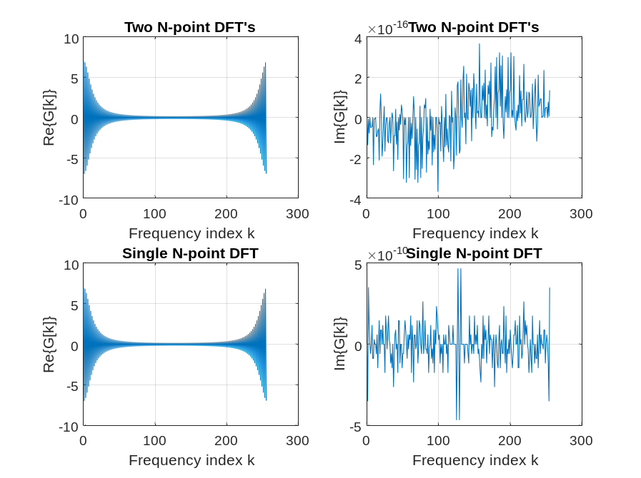
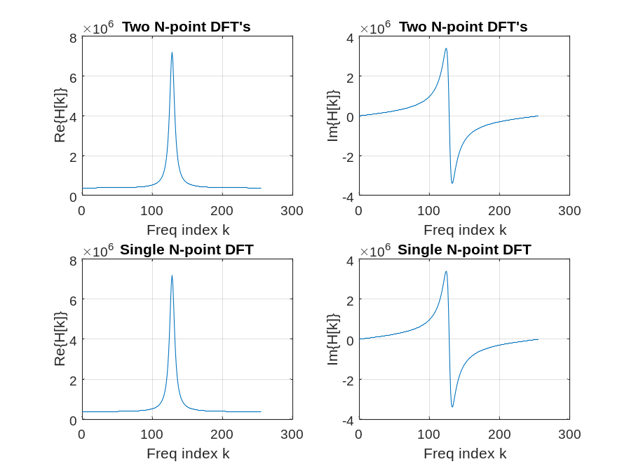
From these plots we make the following observations: the length is
N=256. The sequence g[n] is real and even and the sequence h[n] is real but has no
inherent symmetry. The DFT G[k] is real and even to within numerical roundoff; it is
important to realize in the plots that Im{G[k]} is zero to within floating point precision.
Q3.25 The MATLAB program to compute the 2N-point DFT of a length-2N real sequence using a single N-point DFT and compare the result by computing directly the 2N-point DFT is shown below:
% Program Q3_25A
% Use a single N-point complex-valued DFT to compute the 2N-point
% DFT of a 2N-point real-valued sequence.
%
clf;
%Initialize constants
N = 128; % length of the complex-valued DFT
TwoN = 2*N; % length of the real-valued sequence
W2N = exp(-i*pi/N);
k = [0:TwoN-1];
% create 2N-point signal v[n]
v = (-0.7.^k);
% create two N-point signals
g = downsample(v,2); % g[n] = v[2n]
h = downsample(v,2,1); % h[n] = v[2n+1]
% N-point complex-valued composite signal x[n]
x = g + i*h;
% Use one N-point complex DFT to compute simultaneously
% G[k] and H[k] as in Q3.24.
XF = fft(x); % N-point complex DFT of x[n]
% DFT's G[k] and H[k] derived from composite DFT X[k]
XFstar = conj(XF);
XFstarmod = [XFstar(1) fliplr(XFstar(2:N))];
GF = 0.5*(XF + XFstarmod);
HF = -i*0.5*(XF - XFstarmod);
% 2N-point DFT V[k]
VF = [GF GF] + (W2N.^k).*[HF HF];
% For Comparison, compute directly the 2N-point DFT V[k]
VF2 = fft(v);
% Print Sanity Check
abs(max(VF-VF2))
% plot real and imag parts of V[k] computed by complex N-point DFT
subplot(2,2,1);
plot(k,real(VF));grid;
title('Complex N-point DFT');
xlabel('Frequency index k');
ylabel('Re\{V[k]\}');
subplot(2,2,2);
plot(k,imag(VF));grid;
title('Complex N-point DFT');
xlabel('Frequency index k');
ylabel('Im\{V[k]\}');
% plot real and imag parts of V[k] computed by 2N-point DFT
subplot(2,2,3);
plot(k,real(VF2));grid;
title('Real 2N-point DFT');
xlabel('Frequency index k');
ylabel('Re\{V[k]\}');
subplot(2,2,4);
plot(k,imag(VF2));grid;
title('Real 2N-point DFT');
xlabel('Frequency index k');
ylabel('Im\{V[k]\}');

The DFTs generated by running the program for sequences of different lengths 2N are shown below:
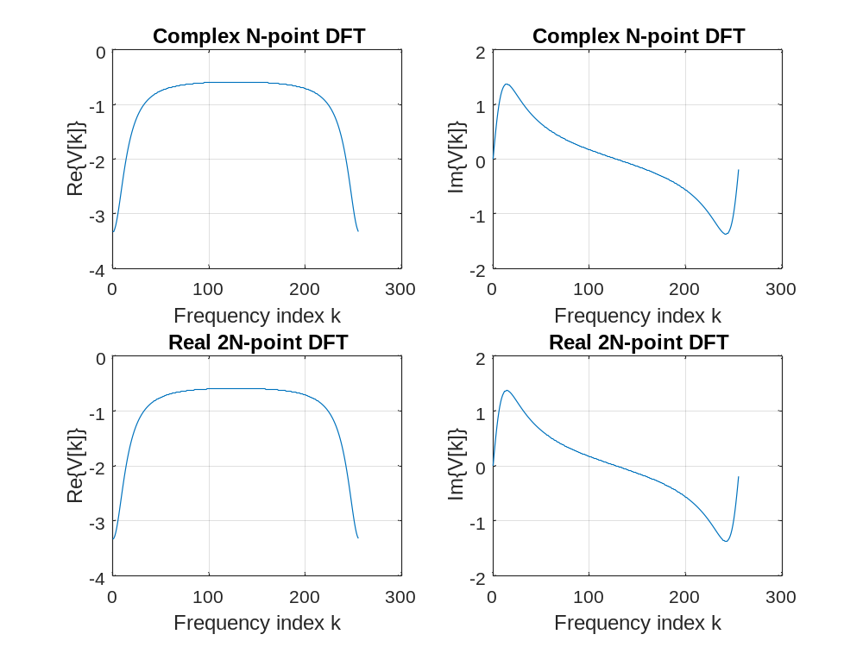
From these plots we make the following observations: the length of v[n] is 256 and V[k]is computed using a complex valued 128-point DFT. The signal is v[n] = (-0.7)^{n}.

Project 3.4 DFT Properties
Answers:
Q3.26 The purpose of the command rem in the function circshift is – Shift positions of elements circularly.
Q3.27 The function circshift operates as follows: The input sequence x is circularly shifted left by M positions. If M > 0, then circshift removes the leftmost M elements from the vector x and appends them on the right side of the remaining elements to obtain the circularly shifted sequence. If If M < 0, then circshift first complements M by the length of x, i.e., the rightmost length(x)-M samples are removed from x and appended on the right of the remaining M samples to obtain the circularly shifted sequence
Q3.28 The purpose of the operator ~= in the function circonv is – This is the binary relational NOT EQUAL operator. A ~= B returns the value 1 if A and B are unequal and the value 0 if A and B are equal.
Q3.29 The function circonv operates as follows: The input is two vectors x1 and x2 of equal length L. To understand how circonv works, it is useful to think in terms of the periodic extension of x2. Let x2p be the infinite-length periodic extension of x2.Conceptually, the routine time reverses x2p and sets x2tr equal to elements 1 through L of the time reversed version of x2p. Elements 1 through L of the output vector y are then obtained by taking the inner product between x1 and a length L vector sh obtained by circularly shifting right the time reversed vector x2tr. For the output sample y[n], 1 ≤ n ≤ L, the amount of the right circular shift is n-1 positions.
Q3.30 The modified Program P3_7 created by adding appropriate comment statements, and adding program statements for labeling each plot being generated by the program is given below:
% Program P3_7
% Illustration of Circular Shift of a Sequence
clf;
M = 6;
a = [0 1 2 3 4 5 6 7 8 9];
b = circshift(a,M);
L = length(a)-1;
n = 0:L;
subplot(2,1,1);
stem(n,a);axis([0,L,min(a),max(a)]);
title('Original Sequence');
subplot(2,1,2);
stem(n,b);axis([0,L,min(a),max(a)]);
title(['Sequence Obtained by Circularly Shifting by ',num2str(M),' Samples']);

The parameter determining the amount of time-shifting is - M
If the amount of time-shift is greater than the sequence length then - The circular shift
actually implemented is rem(M,length(a)) positions left, which is equivalent to
circularly shifting by M positions (more than once around) and also to shifting left by
M the periodic extension of the sequence.
Q3.31 The plots generated by running the modified program are given below:
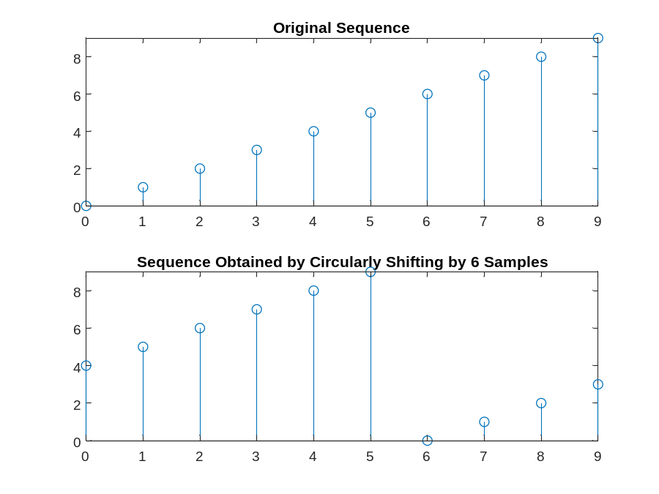
From these plots we make the following observations: Here, the length of the sequence is
10 samples and we have M=12. This may be interpreted alternatively as a circular shift
left by 12 positions (more than once around), as a circular shift left by 12-10 = 2
positions, or as a linear shift left by 2 or by 12 of the periodic extension of the
sequence.
Q3.32 The modified Program P3_8 created by adding appropriate comment statements, and adding program statements for labeling each plot being generated by the program is given below:
% Program P3_8
% Circular Time-Shifting Property of DFT
clf;
x = [0 2 4 6 8 10 12 14 16];
N = length(x)-1; n = 0:N;
y = circshift(x,5);
XF = fft(x);
YF = fft(y);
subplot(2,2,1)
stem(n,abs(XF));grid
title('Magnitude of DFT of Original Sequence');
subplot(2,2,2)
stem(n,abs(YF));grid
title('Magnitude of DFT of Circularly Shifted Sequence');
subplot(2,2,3)
stem(n,angle(XF));grid
title('Phase of DFT of Original Sequence');
subplot(2,2,4)
stem(n,angle(YF));grid
title('Phase of DFT of Circularly Shifted Sequence');
The amount of time-shift is - 5 samples to the left.
Q3.33 The plots generated by running the modified program are given below:
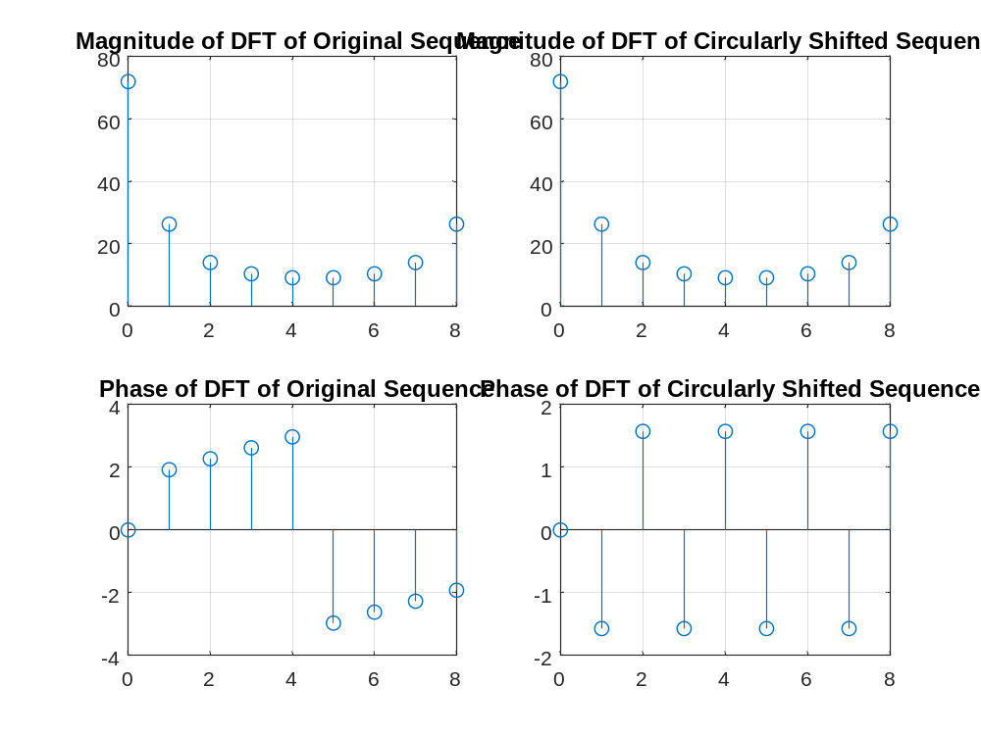
From these plots we make the following observations: The length of the sequence is N=8
and the time shift is an advance by five samples to the left. The phase term introduced
by this time shift is . This is a substantial shift that
dramatically increases the slope of the spectral phase. Whereas the original phase
function has only one branch cut, there are five branch cuts in the spectral phase of the
shifted signal.
Q3.34 The plots generated by running the modified program for the following two different amounts of time-shifts, with the amount of shift indicated, are shown below:
M=2
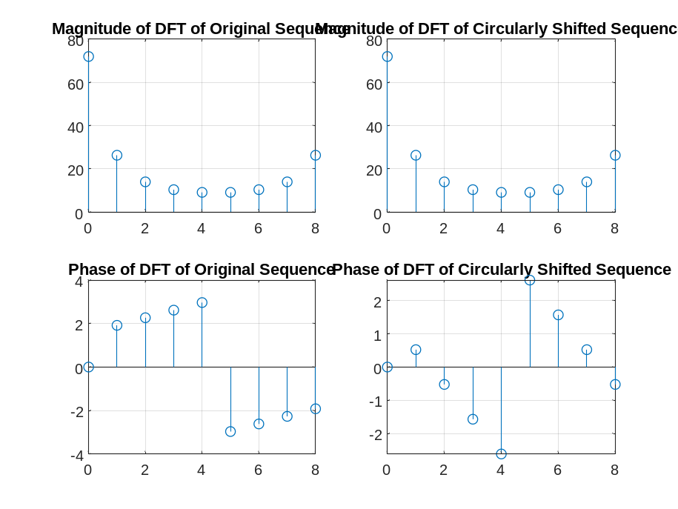
M=-2
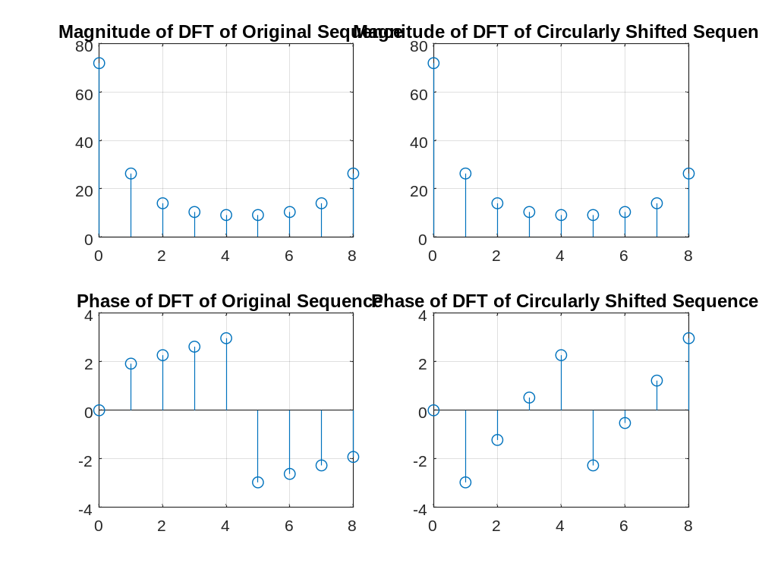
From these plots we make the following observations: In all cases, the spectral magnitude
is not affected by the shift. For the first example, the time shift is a circular shift left by
2 samples. This introduces an increased slope to the spectral phase that is significantly
less than what we saw in Q3.33. In the second example, the shift is circular shift right
by 2 samples (M=-2). This cancels the positive slope seen in the spectral phase of the
original sequences and results in a moderate negative slope
Q3.35 The plots generated by running the modified program for the following two different sequences of different lengths, with the lengths indicated, are shown below:
LENGTH =15
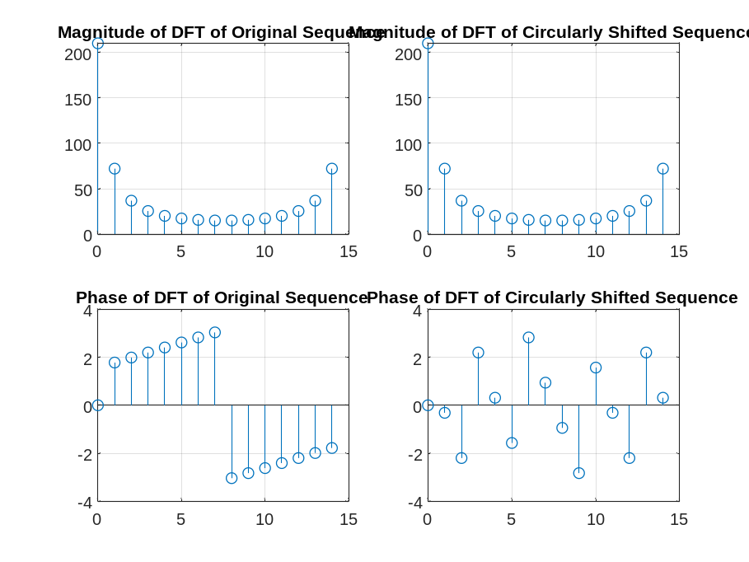
From these plots we make the following observations: In the first example, the sequence is
real and periodically (circularly) even, so the phase takes only the two values zero and
π. The shift is a circular shift to the left by 5 (M=5), which is seen to induce a
negative slope to the phase. In the second example, the signal is given by ( 0.75) − n and
the shift is again M=-2 which again introduces a negative slope in the phase.
Q3.36 A copy of Program P3_9 is given below along with the plots generated by running this program:
% Program P3_9
% Circular Convolution Property of DFT
g1 = [1 2 3 4 5 6]; g2 = [1 -2 3 3 -2 1];
ycir = circonv(g1,g2);
disp('Result of circular convolution = ');disp(ycir)
G1 = fft(g1); G2 = fft(g2);
yc = real(ifft(G1.*G2));
disp('Result of IDFT of the DFT products = ');disp(yc)
Result of circular convolution =
12 14 16 0 14 28

Result of IDFT of the DFT products =
12 28 14 0 16 14
From these plots we make the following observations: The DFT of a circular convolution is
the pointwise products of the DFT’s.
Q3.37 Program P3_9 was run again for the following two different sets of equal-length sequences:
The plots generated are shown below:
Result of circular convolution =
9 2 -7 6 9 4
Result of IDFT of the DFT products =
9.0000 2.0000 -7.0000 6.0000 9.0000 4.0000
From these plots we make the following observations:
Q3.38 A copy of Program P3_10 is given below along with the plots generated by running this program:
% Program P3_10
% Linear Convolution via Circular Convolution
g1 = [1 2 3 4 5];g2 = [2 2 0 1 1];
g1e = [g1 zeros(1,length(g2)-1)];
g2e = [g2 zeros(1,length(g1)-1)];
ylin = circonv(g1e,g2e);
disp('Linear convolution via circular convolution = ');disp(ylin);
y = conv(g1, g2);
disp('Direct linear convolution = ');disp(y)
Linear convolution via circular convolution =
2 6 10 15 21 15 7 9 5
Direct linear convolution =
2 6 10 15 21 15 7 9 5
From these plots we make the following observations: zero padding to the appropriate
length does indeed make it possible to implement linear convolution using circular
convolution.
Q3.39 Program P3_10 was run again for the following two different sets of sequences of unequal lengths: g1 = [3 1 4 1 5 9 2];g2 = [1 1 1 0 0];
The plots generated are shown below:
Linear convolution via circular convolution =
3 4 8 6 10 15 16 11 2 0 0
Direct linear convolution =
3 4 8 6 10 15 16 11 2 0 0
Linear convolution via circular convolution =
-10 -3 8 22 38 30 20 11 4 0
Direct linear convolution =
-10 -3 8 22 38 30 20 11 4 0
From these plots we make the following observations: You can implement the linear
convolution of two sequences by zero padding them to the sum of their lengths less one
and then invoking circular convolution on the zero padded sequences.
Q3.40 The MATLAB program to develop the linear convolution of two sequences via the DFT of each is given below:
% Program Q3_40
% Linear Convolution via Circular Convolution
g1 = [1 2 3 4 5];
g2 = [2 2 0 1 1];
g1e = [g1 zeros(1,length(g2)-1)];
g2e = [g2 zeros(1,length(g1)-1)];
G1EF = fft(g1e);
G2EF = fft(g2e);
ylin = real(ifft(G1EF.*G2EF));
disp('Linear convolution via DFT = ');disp(ylin);
The plots generated by running this program for the sequences of Q3.38 are shown below:
Linear convolution via DFT =
2.0000 6.0000 10.0000 15.0000 21.0000 15.0000 7.0000 9.0000

From these plots we make the following observations: The result is the same as before in
Q3.38; in other words, it works as advertised.
The plots generated by running this program for the sequences of Q3.39 are shown below:
Linear convolution via DFT =
Columns 1 through 9
3.0000 4.0000 8.0000 6.0000 10.0000 15.0000 16.0000 11.0000 2.0000
Columns 10 through 11
0.0000 0.0000
Linear convolution via DFT =
Columns 1 through 9
-10.0000 -3.0000 8.0000 22.0000 38.0000 30.0000 20.0000 11.0000 4.0000
Column 10
-0.0000
From these plots we make the following observations:
Q3.41 A copy of Program P3_11 is given below:
% Program P3_11
% Relations between the DFTs of the Periodic Even
% and Odd Parts of a Real Sequence
x = [1 2 4 2 6 32 6 4 2 zeros(1,247)];
x1 = [x(1) x(256:-1:2)];
xe = 0.5 *(x + x1);
XF = fft(x);
XEF = fft(xe);
clf;
k = 0:255;
subplot(2,2,1);
plot(k/128,real(XF)); grid;
ylabel('Amplitude');
title('Re(DFT\{x[n]\})');
subplot(2,2,2);
plot(k/128,imag(XF)); grid;
ylabel('Amplitude');
title('Im(DFT\{x[n]\})');
subplot(2,2,3);
plot(k/128,real(XEF)); grid;
xlabel('Time index n');ylabel('Amplitude');
title('Re(DFT\{x_{e}[n]\})');
subplot(2,2,4);
plot(k/128,imag(XEF)); grid;
47
xlabel('Time index n');ylabel('Amplitude');
title('Im(DFT\{x_{e}[n]\})');

The relation between the sequence x1[n] and x[n] is - a periodically time
reversed version of x[n].

Q3.42 The plots generated by running Program P3_11 are given below:
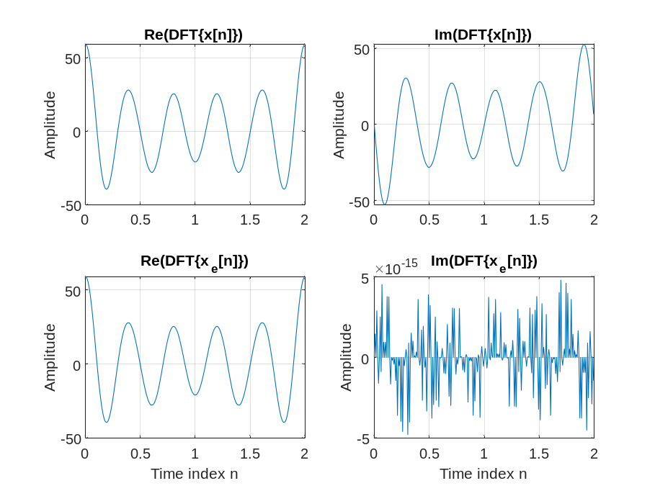
The imaginary part of XEF is/is not equal to zero. This result can be explained as follows: The real part of the transform of x[n] is the transform of the
periodically even part of x[n]. Therefore, the DFT of the periodically even part of x[n]
has a real part that is precisely the real part of X[k] and an imaginary part that is zero.
Q3.43 The required modifications to Program P3_11 to verify the relation between the DFT of the periodic odd part and the imaginary part of XEF are given below along with the plots generated by running this program:
% Q3_43
% Relations between the DFTs of the Periodic Even
% and Odd Parts of a Real Sequence
x = [1 2 4 2 6 32 6 4 2 zeros(1,247)];
x1 = [x(1) x(256:-1:2)];
xo = 0.5 *(x - x1);
XF = fft(x);
XOF = fft(xo);
clf;
k = 0:255;
subplot(2,2,1);
plot(k/128,real(XF)); grid;
ylabel('Amplitude');
title('Re(DFT\{x[n]\})');
subplot(2,2,2);
plot(k/128,imag(XF)); grid;
ylabel('Amplitude');
title('Im(DFT\{x[n]\})');
subplot(2,2,3);
plot(k/128,real(XOF)); grid;
xlabel('Time index n');ylabel('Amplitude');
title('Re(DFT\{x_{o}[n]\})');
subplot(2,2,4);
plot(k/128,imag(XOF)); grid;
xlabel('Time index n');ylabel('Amplitude');
title('Im(DFT\{x_{o}[n]\})');
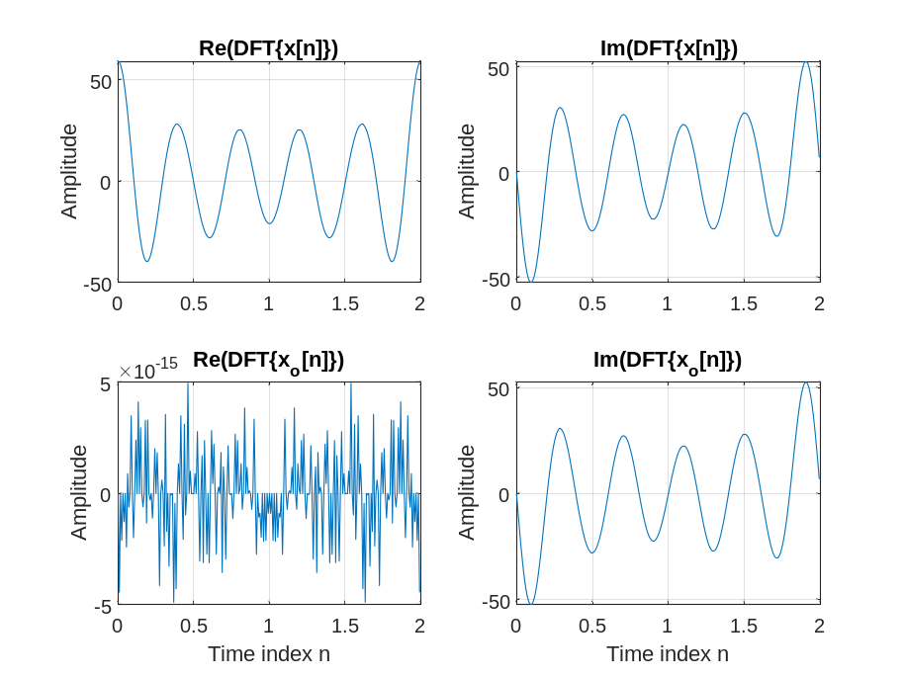
From these plots we make the following observations: The DFT of the periodically odd part
of x[n] is precisely the imaginary part of the DFT of x[n]. Therefore, the DFT of the
periodically odd part of x[n] has a real part that is zero to within floating point precision
and an imaginary part that is precisely the imaginary part of the DFT of x[n]
Q3.44 A copy of Program P3_12 is given below:
% Program P3_12
% Parseval's Relation
x = [(1:128) (128:-1:1)];
XF = fft(x);
a = sum(x.*x)
b = round(sum(abs(XF).^2)/256)
The values for a and b we get by running this program are - a =1414528 b = 1414528
Q3.45 The required modifications to Program P3_11 are given below:
% Q3_45
% Parseval's Relation
x = [(1:128) (128:-1:1)];
XF = fft(x);
a = sum(x.*x)
b = round(sum(XF.*conj(XF))/256)
3.3 z-TRANSFORM
Project 3.5 Analysis of z-Transforms
Answers:

Q3.46 The frequency response of the z-transform obtained using Program P3_1 is plotted below:
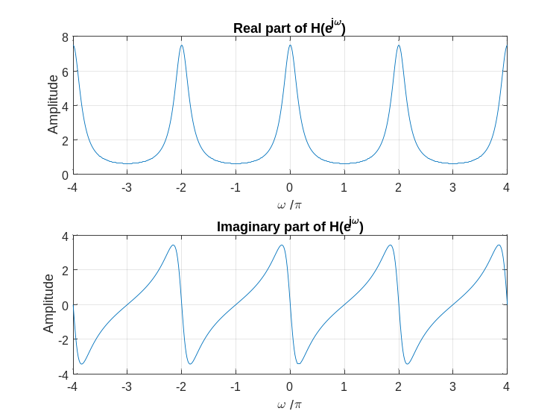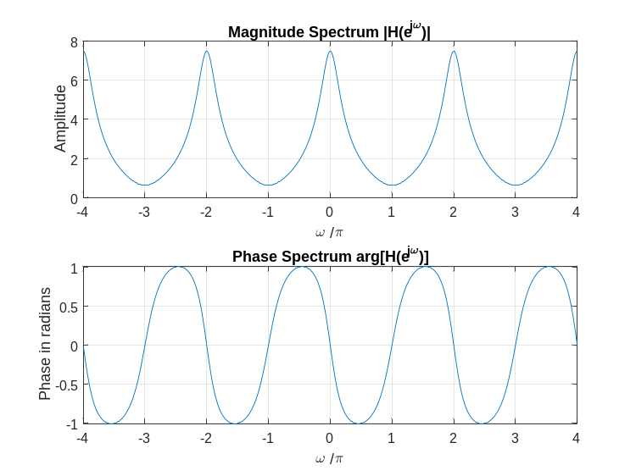
Q3.47 The MATLAB program to compute and display the poles and zeros, to compute and display the factored form, and to generate the pole-zero plot of a rational z-transform is given below:
% Program Q3_47
clf;
num = [2 5 9 5 3];
den = [5 45 2 1 1];
% compute poles and zeros and display
[z p k] = tf2zpk(num,den);
disp('Zeros:');
disp(z);
disp('Poles:');
disp(p);
% compute and display factored form of G(z)
[sos k] = zp2sos(z,p,k)
% generate pole-zero plot
zplane(z,p);
Using this program we obtain the following results on the z-transform G(z) of Q3.46:
Zeros:
-1.0000 + 1.4142i
-1.0000 - 1.4142i
-0.2500 + 0.6614i
-0.2500 - 0.6614i
Poles:
-8.9576 + 0.0000i
-0.2718 + 0.0000i
0.1147 + 0.2627i
0.1147 - 0.2627i
sos =
Columns 1 through 5
1.0000 2.0000 3.0000 1.0000 9.2293
1.0000 0.5000 0.5000 1.0000 -0.2293
Column 6
2.4344
0.0822
k = 0.4000
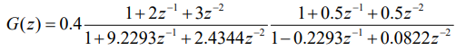
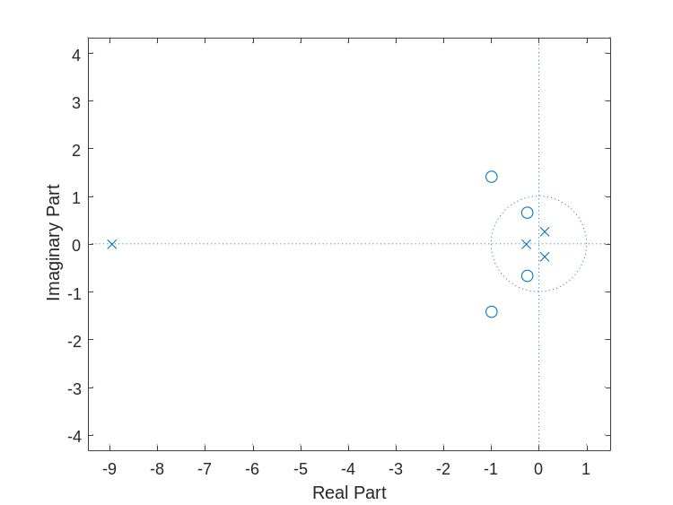
Q3.48 From the pole-zero plot generated in Question Q3.47, the number of regions of convergence (ROC) of G(z) are - 4
All possible ROCs of this z-transform are sketched below:
All possible ROCs of this z-transform are sketched below:
R1: | z | < 0.2718 (left-sided, not stable)
R2 : 0.2718< | z|< 0.2866 (two-sided, not stable)
R3 : 0.2866< |z |< 8.9576 (two-sided, stable)
R4 : |z | < 8.9576 (right-sided, not stable)
From the pole-zero plot it can be seen that the DTFT - You cannot tell if the DTFT exists from the pole zero plot alone. In order to know this, the region of convergence must be specified. The DTFT does exist for the sequence obtained by using the ROC R3 shown above. This would be a stable system with a two-sided impulse response.

Q3.49 The MATLAB program to compute and display the rational z-transform from its zeros, poles and gain constant is given below:
% Program Q3_49
% Given the poles and zeros of G(z), compute and display the rational
% z-transform.
clf;
% initialize
z = [0.3 2.5 -0.2+i*0.4 -0.2-i*0.4]';
p = [0.5 -0.75 0.6+i*0.7 0.6-i*0.7]';
k = 3.9;
% find numerator and denominator polynomial coefficients
[num den] = zp2tf(z,p,k)
The rational form of a z-transform with the given poles, zeros, and gain is found to be –
num = 3.9000 -9.3600 -0.6630 -1.0140 0.5850
den = 1.0000 -0.9500 0.1750 0.6625 -0.3187
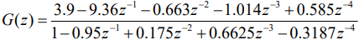

Project 3.6 Inverse z-Transform
Answers:
Q3.50 The MATLAB program to compute the first L samples of the inverse of a rational z-transform is given below:
% Program Q3_50

clf;
% initialize
num = [2 5 9 5 3];
den = [5 45 2 1 1];
% Query user for parameter L
L = input('Enter the number of samples L: ');
% find impulse response
[g t] = impz(num,den,L);
%plot the impulse response
stem(t,g);
title(['First ',num2str(L),' samples of impulse response']);
xlabel('Time Index n');
ylabel('h[n]');
The plot of the first 50 samples of the inverse of G(z) of Q3.46 obtained using this program is sketched below:
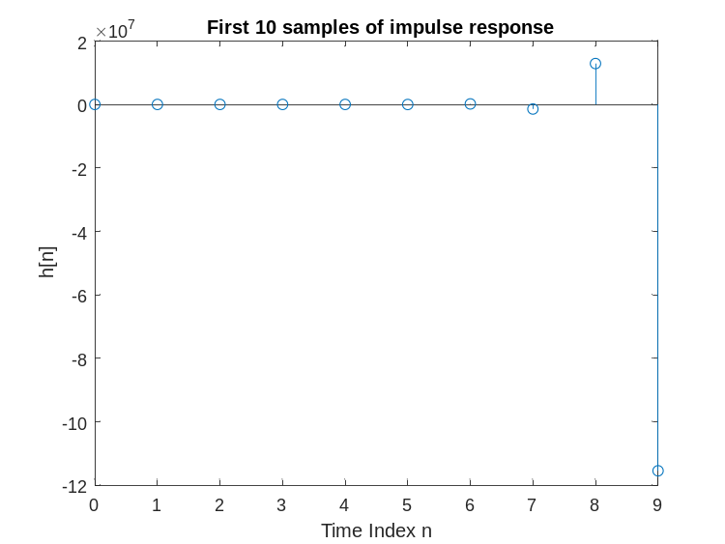
Q3.51 The MATLAB program to determine the partial-fraction expansion of a rational z-transform is given below:
% Program Q3_51
clf;
% initialize
num = [2 5 9 5 3];
den = [5 45 2 1 1];
% partial fraction expansion
[r p k] = residuez(num,den)
The partial-fraction expansion of G(z) of Q3.46 obtained using this program is shown below:
r =

0.3109 + 0.0000i
-1.0254 - 0.3547i
-1.0254 + 0.3547i
-0.8601 + 0.0000i

p =

-8.9576 + 0.0000i
0.1147 + 0.2627i
0.1147 - 0.2627i
-0.2718 + 0.0000i

k =

3.0000
From the above partial-fraction expansion we arrive at the inverse z-transform g[n] as shown below:
Date:14/5 Signature:

