Assignment 1: Intro to STM32CubeIDE
The following will document completion of the first assignment for ECE-40291, with the stated goals of:
- Download and install STM32CubeIDE
- Use STM32CubeIDE to generate the default code for the STM32 Discovery Board
- Use STM32CubeIDE to build and run the default code for the STM32 Discovery Board

- Download and install STM32CubeIDE
This process was fairly straightforward: using a Windows 10 PC, download and follow the installer prompts as one would using the standard install wizard format. Upon completion of the install and a PC reboot for good measure, the IDE can be loaded and opens to Welcome dashboard, as seen below.
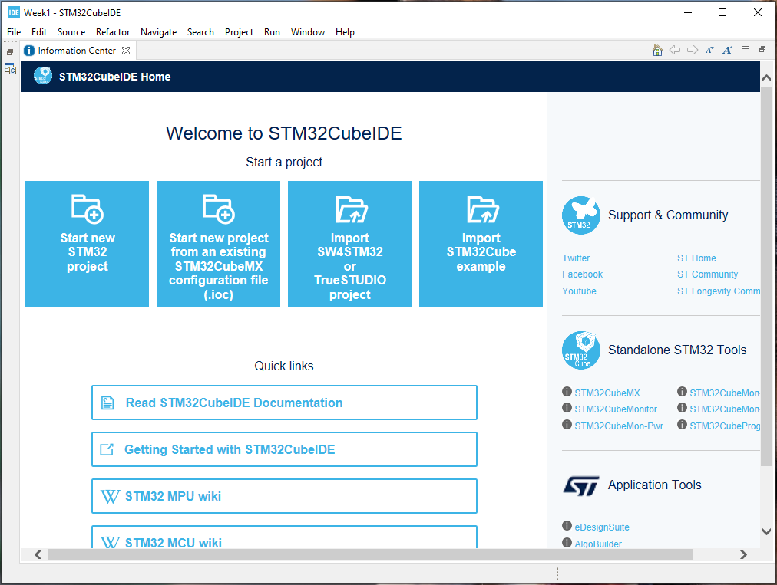

- Use STM32CubeIDE to generate the default code for the STM32 Discovery Board
At this point, the “Start New STM32 Project” option may selected, which loads the Target Selection dashboard, where we will navigate to the Board Selector tab and enter the name of our dev board and select it from the interface.
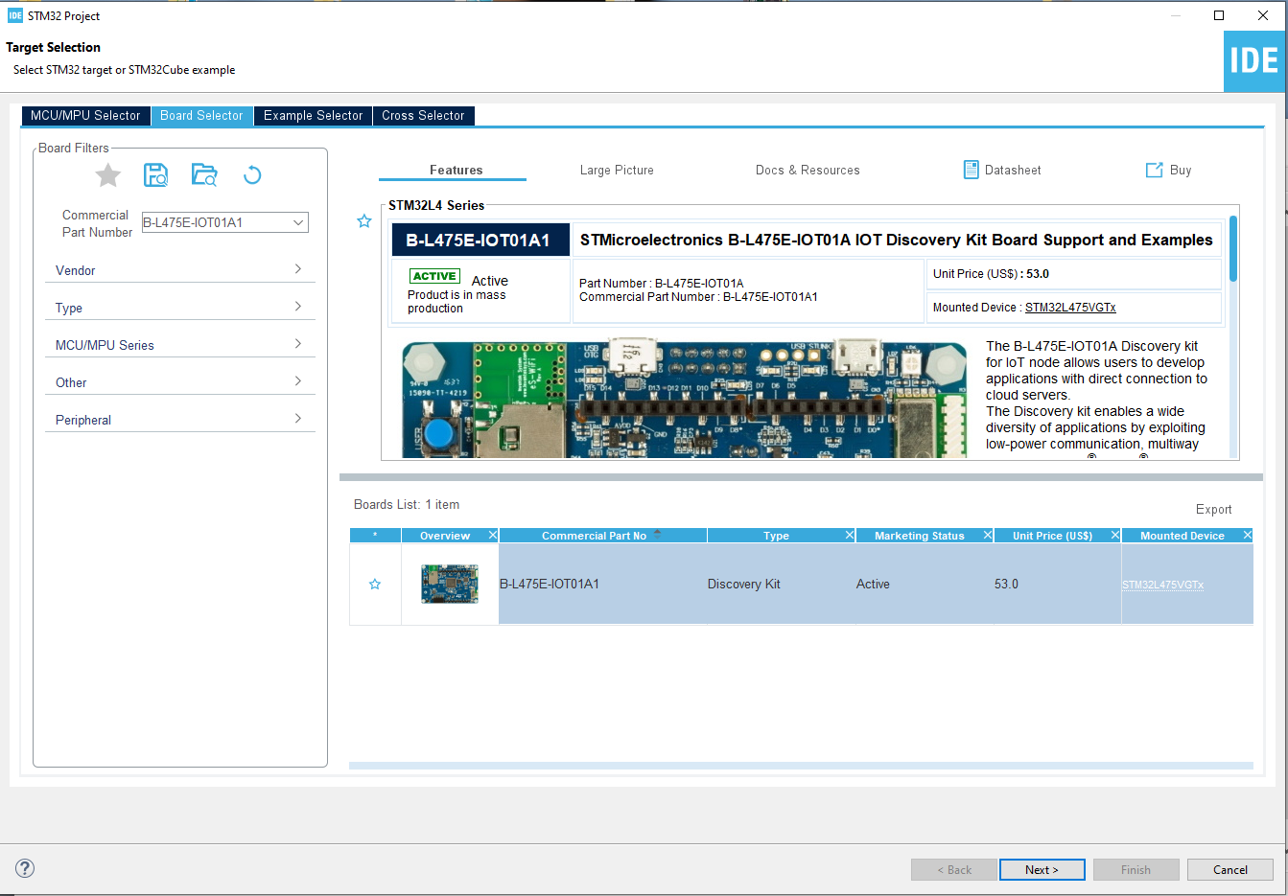
From here, a pop-up will open, allowing definition of a project name and target location. On clicking “Finish” a dialog will also open, asking if all peripherals should be initialized to their default Mode. For the scope of this assignment, click yes. The project will then proceed to build.
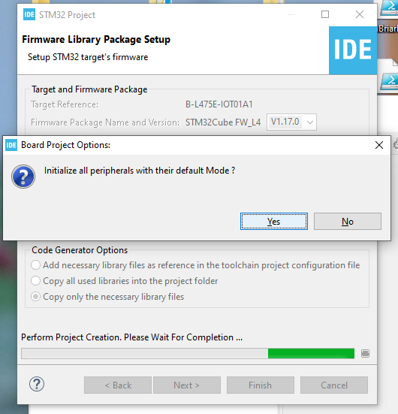
For a first time use of a specific target, the IDE will proceed to download any necessary support files not already present, and will then open into a pinout & configuration interface.
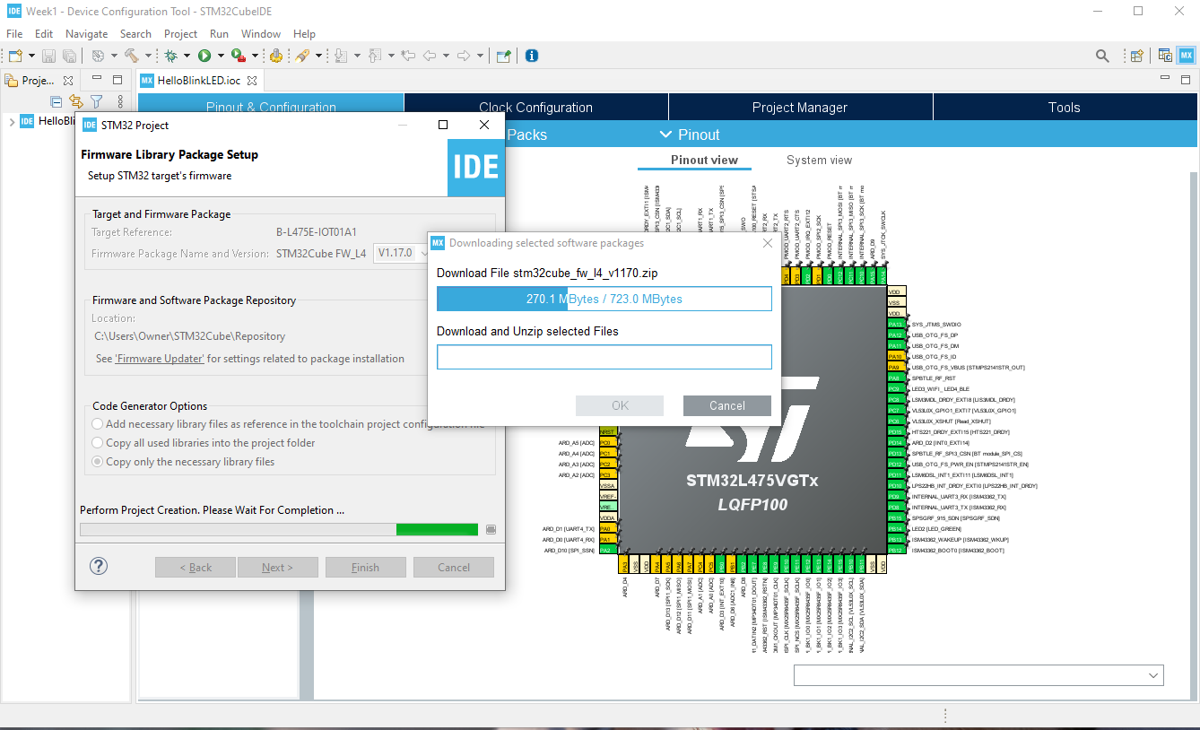
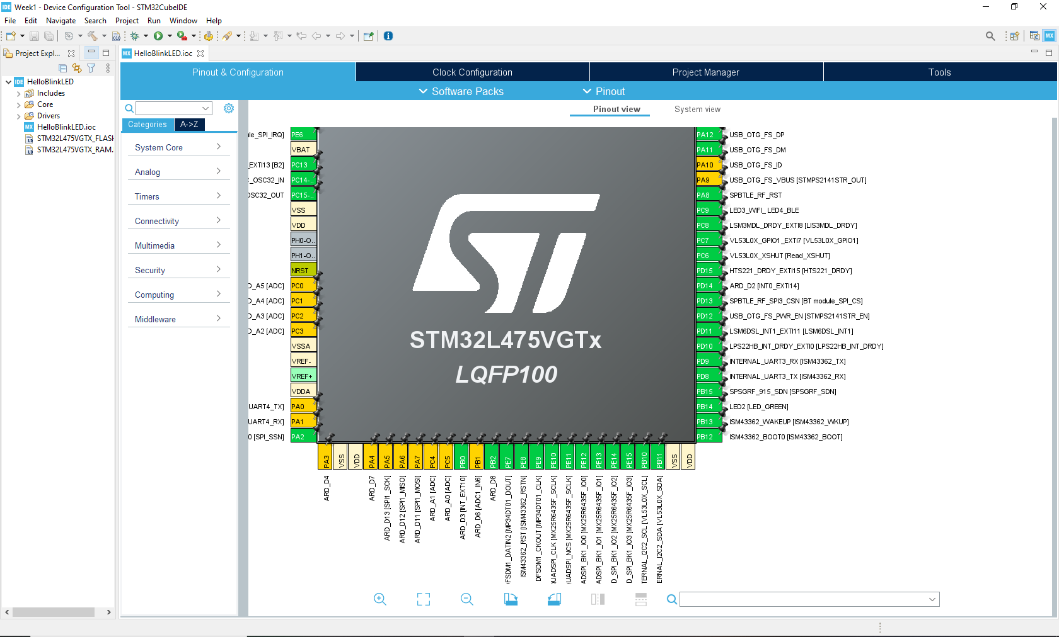

3. Use STM32CubeIDE to build and run the default code for the STM32 Discovery Board
From this point, we could define pin configs as needed or open the text editor interface to define additional code. However, the default config is sufficient for our goal and the project can be compiled and the flashed. Select the “Build” option from the control bar or shortcut Ctrl+B, and verify in the console output that the project does successfully compile.
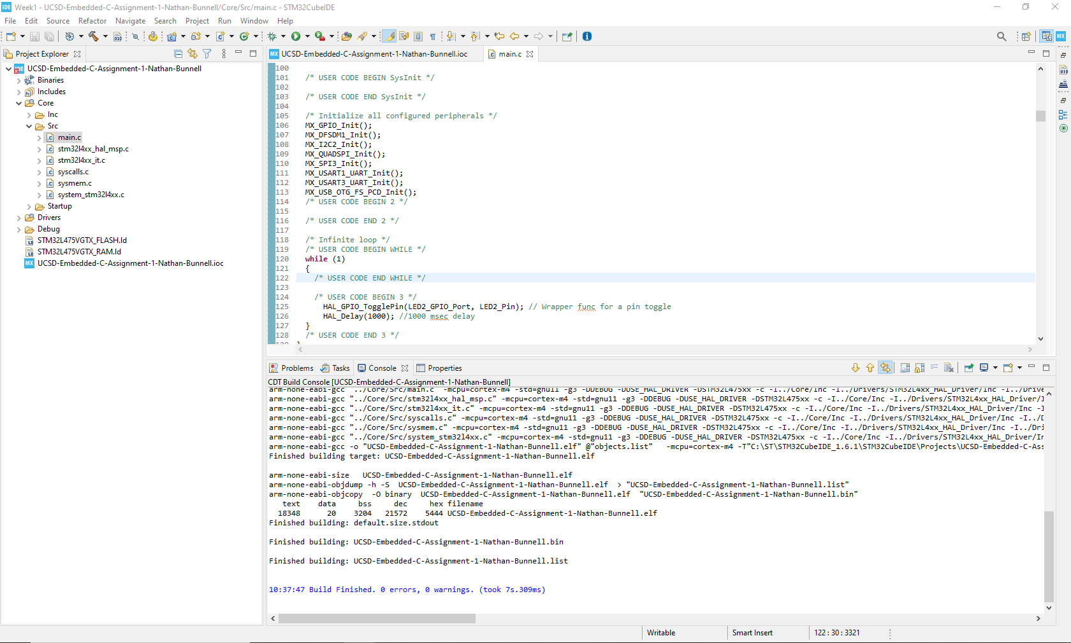
Then, with the dev board connected via USB cable to the development PC, select Run from the control bar and it will connect to the on-board ST-Link and load the program onto the target device’s flash.
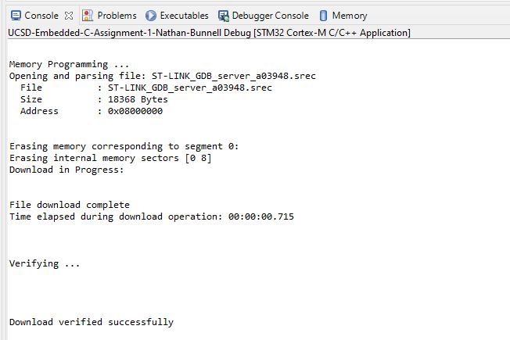
At this point, we have everything needed to develop and deploy applications on the target dev board. Even though this default code doesn’t really do anything useful, the tools are there to create anything within the limits of the hardware.

