Assignment 3: HAL API Usage
The following will document completion of the third assignment for ECE-40291, with the stated goals of:
- Use STM32CubeIDE to generate the default code for the STM32 Discovery Board, being sure to include the HAL when generating the code.
- Add code to blink the LED2 at 250 ms when the Blue Push Button in GPIO_PIN_SET condition
- Add code to blink the LED2 at 1000 ms when the Blue Push Button is in GPIO_PIN_RESET condition
- Use HAL to read the state of the Blue Push Button, hence changing the rate of LED flash (as in #2 and #3)
- Use STM32CubeIDE to generate the default code for the STM32 Discovery Board, being sure to include the HAL when generating the code.
To begin, load the IDE and generate a default project for the IOT Disco board using the same process as seen in the previous assignments. While selecting the configuration options, ensure that the GPIO configuration is set to the “HAL” option as opposed to the “LL” selection made in the previous assignment.
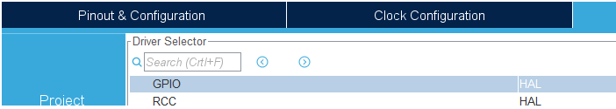
- Add code to blink the LED2 at 250 ms when the Blue Push Button in GPIO_PIN_SET condition
At this point, we can begin to develop our application code as needed. This serves as an excellent example of what makes the HAL so useful and easy to develop with. To accomplish the blink function, we can leverage the built in HAL_GPIO_ReadPin(), HAL_GPIO_TogglePin() and HAL_Delay() functions, providing the appropriate GPIO information and a time delay in milliseconds, as seen below.
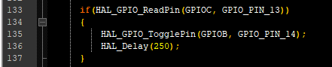

- Add code to blink the LED2 at 1000 ms when the Blue Push Button is in GPIO_PIN_RESET condition
In the same manner, those functions can be applied for the other state of the button not being pressed.
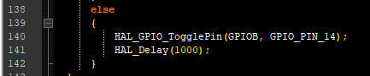
- Use HAL to read the state of the Blue Push Button, hence changing the rate of LED flash (as in #2 and #3)
With this simple code written, it can all be tied together in the main() while(1) loop.
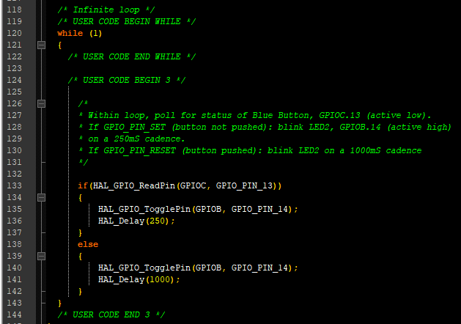
As an example of what makes the HAL APIs so easy to use, one can use the GPIO macros as seen above that call out the ports and pins, or the names assigned by the pin mapping graphical interface could also be used, such as in the below example.
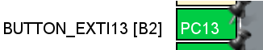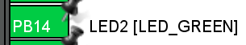

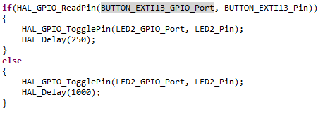
So, with the application code written and compiling without errors or warnings, we can flash the Disco board and run the program. With the debugger running, we can step through the code and monitor the status of GPIOC’s IDR register, seeing when the button is pushed:
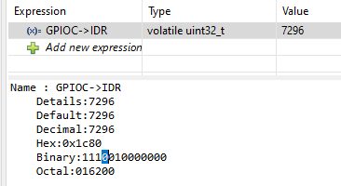
Or not pressed:
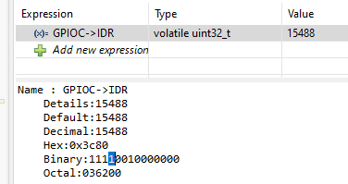
From her, we can also run the program as normal and monitor the blink rate visually.
In closing, this short introduction to the HAL APIs has displayed how easy it is to quickly develop application code with a minimal amount of extra effort. It also displayed the flexibility built in to the HAL and IDE, allowing the use of either the GPIO or the default & user assigned names via the GUI.

