Course Final Project
The following will document completion of the final project for ECE-40291, with the stated goals of:
- LL APIs: (a) get flash size LL_GetFlashSize(); (b) get the device unique ID, LL_GetUID_Wordn(); 3) toggle the LED, LL_GPIO_TogglePin() at a 1 second rate. Display the Flash Size and GUID only when demo begins, but keep flashing the LED every 1 second until the Blue Button is pressed to advance to next demo
- HAL APIs: (a) get the device ID, HAL_GetDEVID(), (b) read the device unique ID, HAL_GetUIDwn(), and (c)toggle the LED, HAL_GPIO_TogglePin() at a 2 second rate, using HAL_Delay() to sleep for the 2 seconds. Display the Dev ID info only when demo 2 begins, but keep flashing the LED every 2 second until the Blue Button is pressed to advance to next demo.
- BSP APIs: (a) read the temperature, BSP_TSENSOR_ReadTemp() (b) turn the LED on every 3 seconds with BSP_LED_On() (c) turn LED off, every 3 seconds with BSP_LED_Off(). In other words the LED should blink on/off at a 3-second rate (3 seconds on, 3 seconds off). Continue this until the Blue Button pressed to advance to the next demo.
- Bonus Demo: demonstrate an optional I/O device that is on the STM board. Or, connect additional I/O devices to the Arduino connectors

Prior to deploying any of the demos, we will build our default project, enable UART4 to our standard 115.2, 8, N, 1 config, and then follow the process worked out in previous assignments to add the BSP packages to our project structure. We’ll also need to pull in the LL header files in our #includes section to allow use of both the default HAL config as well as the LL calls later.
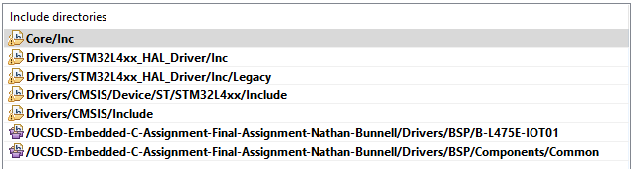
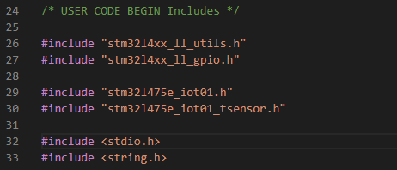

Next, we can build the infrastructure to call and move between demos. We’ll manage that via a callback function tied to the blue user button as an external interrupt. When the button is pressed, the demoCount variable will be incremented, rolling around from 4 to 1. We’ll also print a message to the console with the value of the counter.
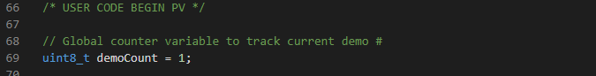
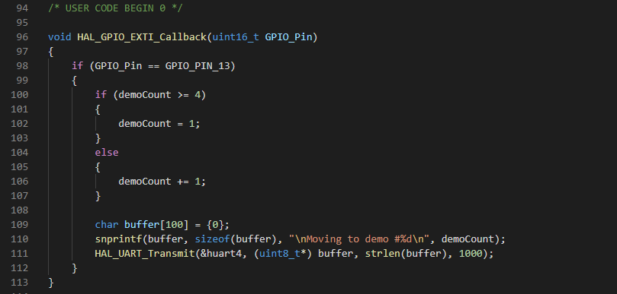

The final piece of infrastructure will be within the main while(1) loop, where we pass the value of demoCount into a simple switch structure and then print out the associated demo title before calling it.
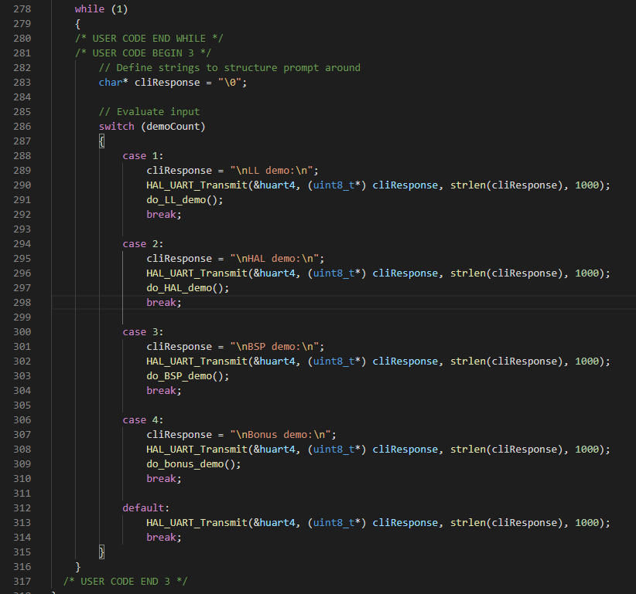

- LL API Demo
On boot, we’ll default to the LL demo. In this mode, we leverage those APIs to get and print the device’s flash size, unique ID number, and then jump into a loop where we blink LED2 at a one second rate until the user button is pressed.
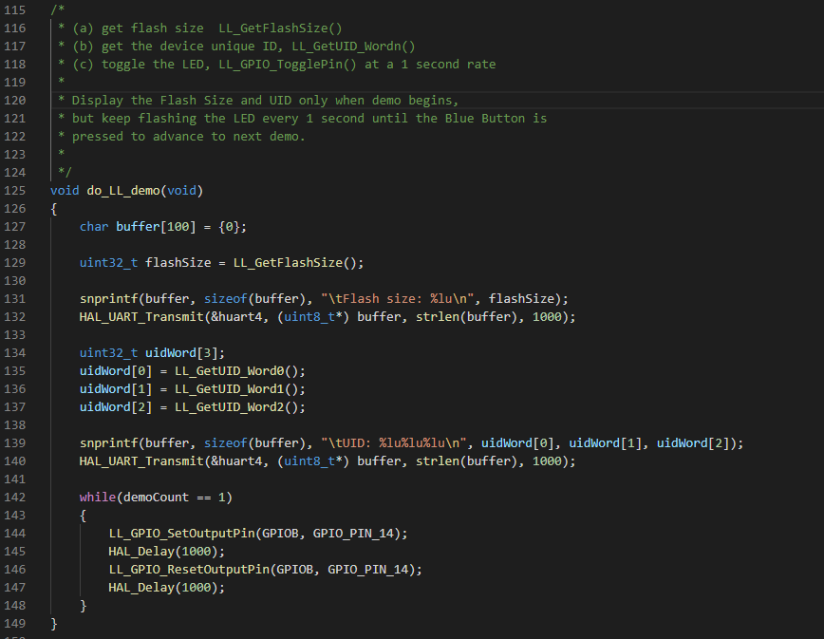
- HAL API Demo
The second demo will get the device ID value and then call for the unique ID number again, printing them then jumping into another blinky loop at a two second rate until the user button is pressed again, this time with the HAL APIs.
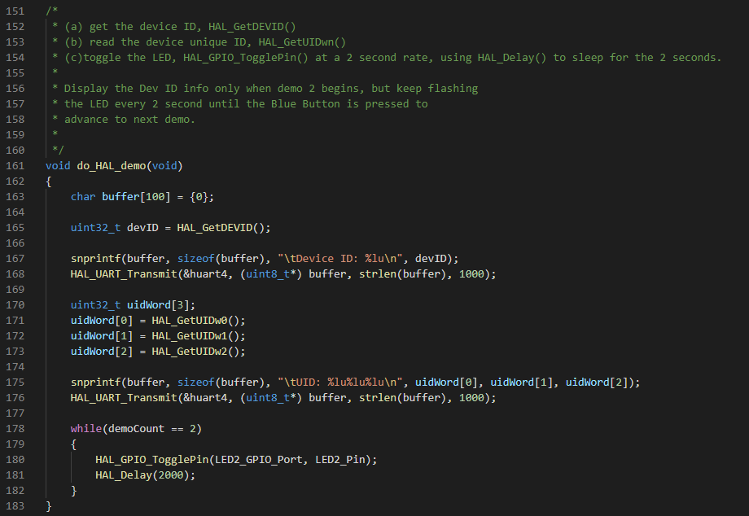
- BSP API Demo
The third demo will leverage the BSP interface, so assuming that it was added at the beginning of the project, we can trim out the unnecessary files to and ensure that we do call the appropriate init() function prior to reading from the sensor.
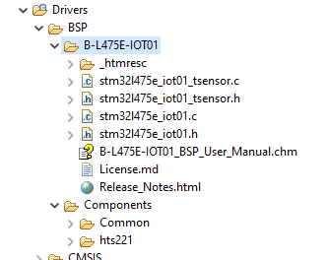
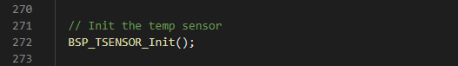

The do_BSP_demo is structured similarly to the previous two, in this case calling the BSP_TSENSOR_ReadTemp() function, trimming the value to be an integer, and then entering another blink loop, this time at a three second rate.
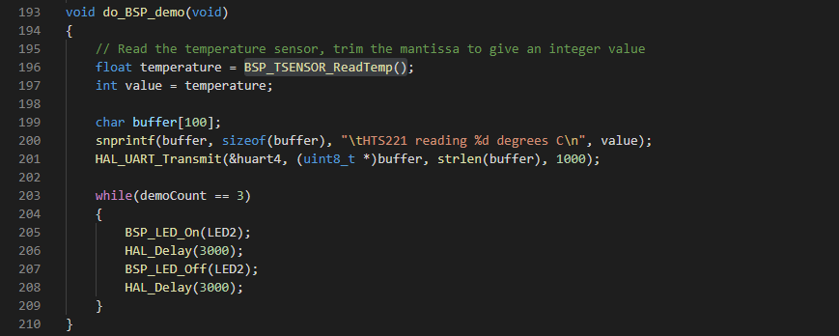
- Bonus Demo
While not currently implemented, the target for the bonus demo would be to read values from an RTC module over the I2C2 interface broken out on the Arduino connectors. If implemented within the course’s time constraints, this placeholder code will be updated to reflect that interaction.
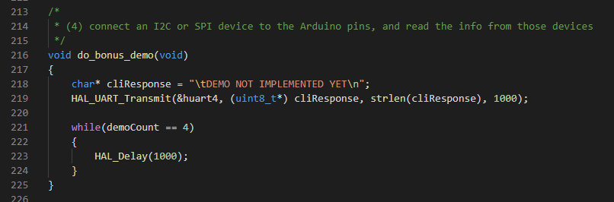

With our demos defined, we can compile and flash to our board and then connect to the serial port. Cycling through with the blue button, we can observe LED2 changing its frequency as we also see each demo print out its results.
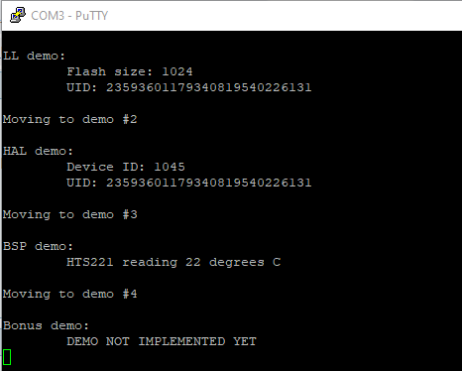
And I actually hadn’t planned on including this feature under this project, but I decided that since the code was already built, I would prove the concept. Disconnecting my USB-serial UART adapter and replacing it with an HC-06 based Bluetooth-serial adapter, I re-flashed the project with UART4 configured to 9600 baud and was able to run the same demos from a terminal app on my phone, with minor formatting issues. This was actually intended to be deployed in the final project for ECE-40293, but again, it that my effort wouldn’t be wasted in case this module, which has been sitting in my parts bin for probably six or seven years, wouldn’t work.
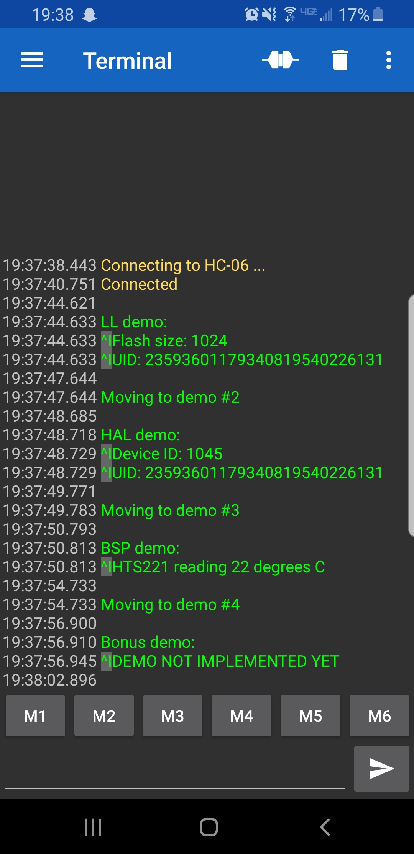

Closing Thoughts
This course has been a fantastic learning experience for me. I was initially leery of using a vendor supplied IDE but after having spent the past nine weeks working with it, I can appreciate the value it would offer to a professional developer, especially in areas like the BSP or HAL interfaces to the various peripherals. I still scratch my head at some of the behaviors exhibited by the IDE but maybe that’s part of using a new tool. Additionally, being able to spend time constantly developing and deploying code for this piece of hardware has just been fun. As I’ve discussed before, I spend all day with either ladder logic or scripting languages. While all of my PLCs are tied directly to real world I/O, everything about working with them is so abstracted and virtualized away from the processor-level that it was a refreshing change of pace to interact with the real hardware on the Discovery board.

