Bonus Assignment
See below for the terminal output of the methods defined for this assignment. Please see attached files for full comments within function prototypes.

Full prompt developed with the HAL_UART_Transmit_DMA() call and unknown character response. logMsg() and logGetMsg() implemented the DMA call by enabling DMA for each UART channel, defining callbacks similar to the interrupt version, and*critically*, ensuring that the MX_DMA_Init() call occurs prior to the MX_USART1_UART_Init() call. Researching into why this order matters didn’t provide much info other than an ST forum post where an employee indicated that it was a known issue that should have been fixed in a later release of the IDE.
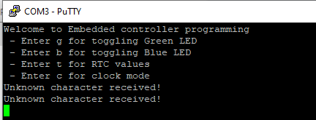

Blue/ green LED toggle. DMA behavior was similar to the interrupt example used in the final, much more responsive than standard polling.
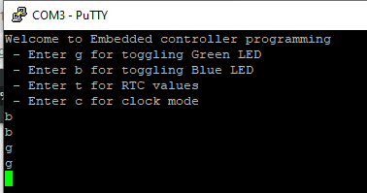

Modify MX_RTC_Init() to set current date and time in main.c
Date/ time config from MX_RTC_Init():
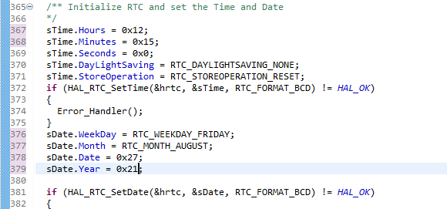
Print current date/time from console code. I don’t recall it being noted in the lecture, apparently the HAL_RTC_GetTime () function call must be followed by the HAL_RTC_GetDate() call in order for the clock registers to continue to update. I finally found the resolution to a “stuck” RTC in an ST forum and then within the comments in stm32l4xx_hal_rtc.c.
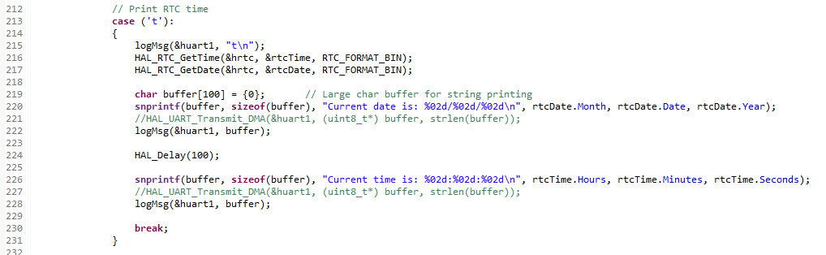

Reading the current time on the console:
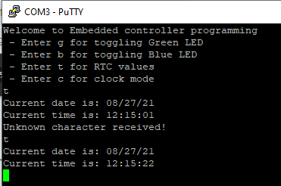
I also implemented a “clock display” function, where the controller would go into a while(1) loop and print the time every 5 seconds, proving that the registers will update in real time. This did require a controller reset, although in hindsight I could have used the blue user button or another interrupt to exit in a more graceful manner.
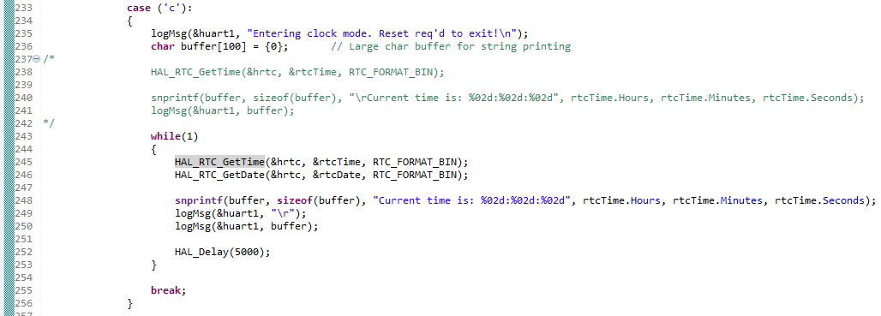

Console output:
