Final Assignment
See below for the terminal output of the methods defined for this assignment. Please see attached files for full comments within function prototypes.
Full prompt developed with the HAL_UART_Transmit_IT() call.
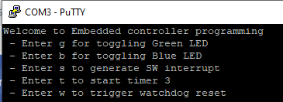
Unknown character input:
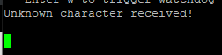

Create a software interrupt and use one of the non-used IRQ.
Using the FMC IRQ, the below handler was defined in stm32l4xx_it.c.
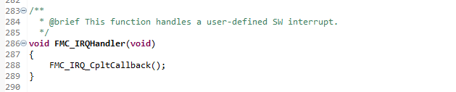

From there, the below init and callback functions were also define in main.c, along with the accompanying logic in the main() input-handler switch. FMC_IRQn_Init() was deployed external to MX_GPIO_Init() to prevent being overwritten any time changes were made in the Device Configuration tool.
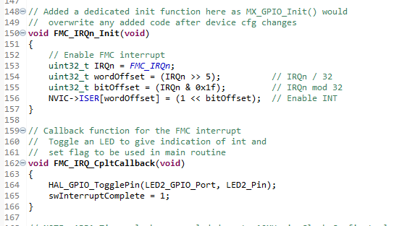
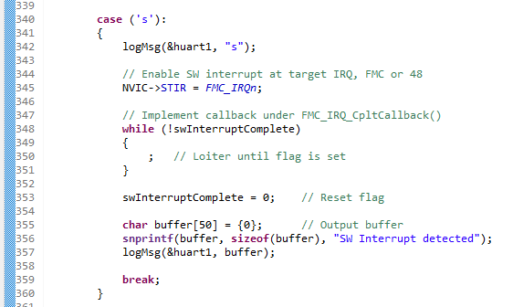
Entering option ‘s’ presented the below output on the console:
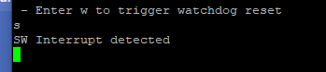
Create a method myDelay1() using timer2, which will take input in millisecond.
Function definition for myDelay1() is below. Configuration numbers are noted in line comments.
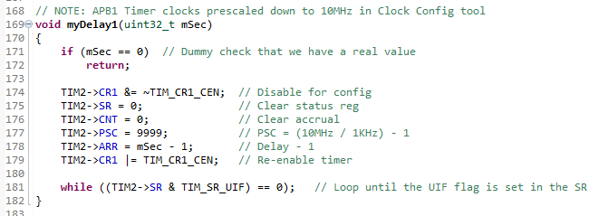
Accompanying logic in the main() input-handler switch:
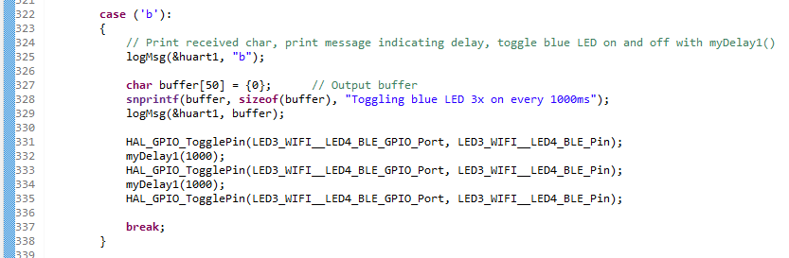
Console output from option ‘b’:
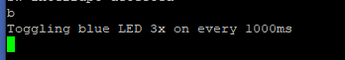

Create a method myDelay2() using SysTick, which will take input in millisecond.
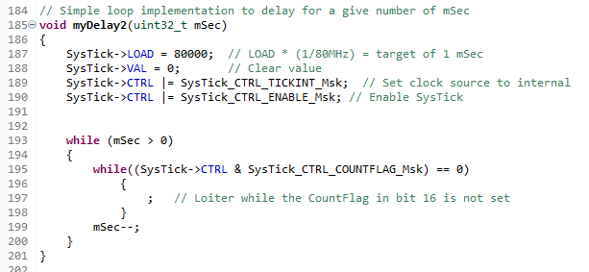
Accompanying logic in the main() input-handler switch:
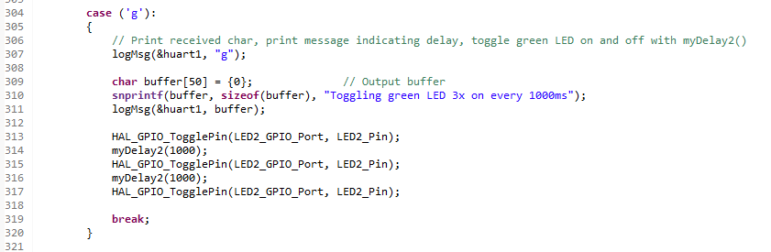
Console output from option ‘g’:
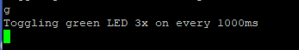
Use Timer 3 to count events.
Timer 3 config below, followed by callback definition:
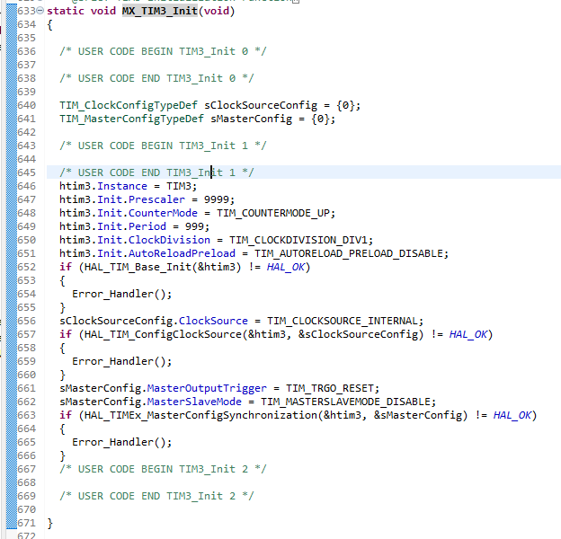
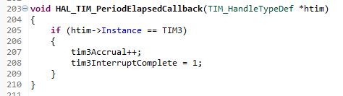
Pairing the above callback with the below logic in the main() input-handler switch resulted in the results in the console:
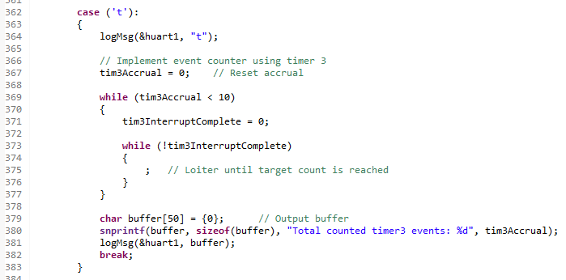
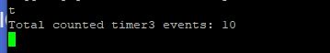

Uncomment MX_IWDG_Init() code to test the watchdog.
Calculating the reload value using the formula defined by ST seen below, we end up with an IWDG_RLR value of 3999.
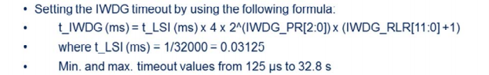
Using the below variables:
- t_IWDG = 500
- t_LSI = 0.03125
- Prescaler of 4 or IWDG_PR = 0
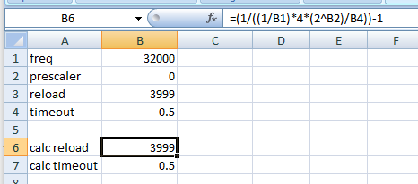
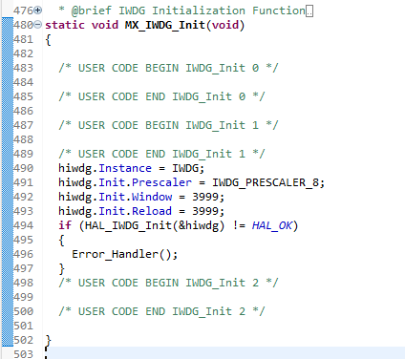
Implementation of this in the main switch could have been better handled, the blocking nature of the logGetMsg() call meant that if an input was not given in that reset window, the board would reset on its own, as expected but difficult for the purpose of generating an example here.
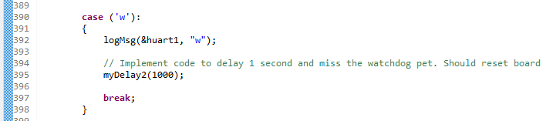
Holding down “w” on reset would produce the expected results though.
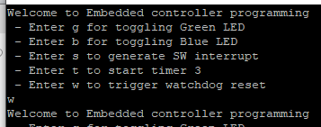

Uncomment MX_RTC_Init() to test RTC Alarm
Unfortunately, I was unable to get the alarm portion of the RTC to work. I successfully programmed it to the current time and was able to implement a simple loop to show it was ticking but never saw the alarm callback triggered, despite being able to capture the RTC TR and ALRMAR registers matching while single stepping in the debugger. In the below example, I was testing for an alarm on the 10 second mark and did note that the HAL-provided alarm masks left a value of 0x173010, thus the custom mask set below the commented out section.
