Midterm

See below for the terminal output of the methods defined for this assignment. Please see attached files for full comments within function prototypes.

Full prompt developed with the HAL_UART_Transmit_IT() call.
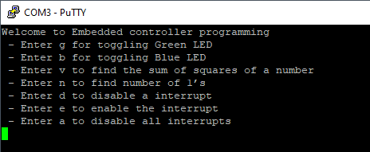

Unknown character input:
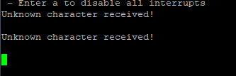

Toggle green or blue LEDs via software and interrupts. With regard to question #1.6, this method would not display the system “freeze” behavior that would occur under polling with a rapid number of inputs.
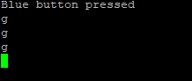
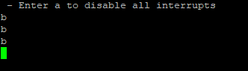

Toggle blue LED via an external interrupt on GPIO 13. I should note that in the GPIO EXTI callback function, I was unable to successfully call the logMsg() function without the processor freezing and had to use the standard HAL_UART_Transmit() call to transmit the button press message. I suspect this has to do with the interrupt’s prioritization levels but did not have time to sufficiently test this theory out.
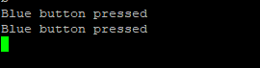
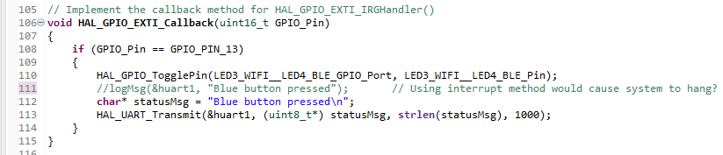

Enable or disable the external interrupt:
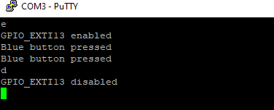

Disable all interrupts, requiring a hardware reset:
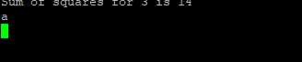
Calculate the sum of squares in a given number, hardcoded to 14 in this example:
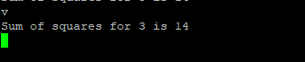

Calculate the number of ones in a given number, hardcoded to 7 in this example:
