Assignment 5: Queues
The following will document completion of the fifth assignment for ECE-40290, with the stated goals of:
- Create "Queue1" that is length of five to hold up to five uint32_t values.
- Create "Task 1" that will run every 2 seconds, increment a count, then send the count to the queue. Use a value of portMAX_DELAY when writing to the queue.
- Create "Task 2" that will receive from the queue, then display the count received from the queue. Use a value of portMAX_DELAY when reading from the queue.
- Run this on the STM32CubeIDE (with IoT Discovery Board or equivalent) and observe the result.
- Create "Queue1" that is length of five to hold up to five uint32_t values
To start, we’ll generate a default project as before. Under the FreeRTOS configuration window, select the Task and Queues tab. Create Queue1 of size 5 * uint32_t as described.
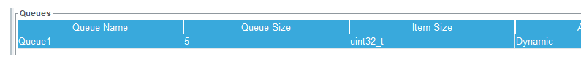

- Create "Task 1" that will run every 2 seconds, increment a count, then send the count to the queue. Use a value of portMAX_DELAY when writing to the queue.
Next create Task1 as in previous assignments.
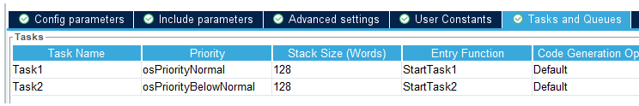

Within main.c, we can define StartTask1() as seen below, where a counter value is declared and initialized to zero in the setup area. Within the for(;;) section, the value is sent to the queue created previously, an error me sage will be printed if necessary, then the counter is incremented before the task delays for two seconds.
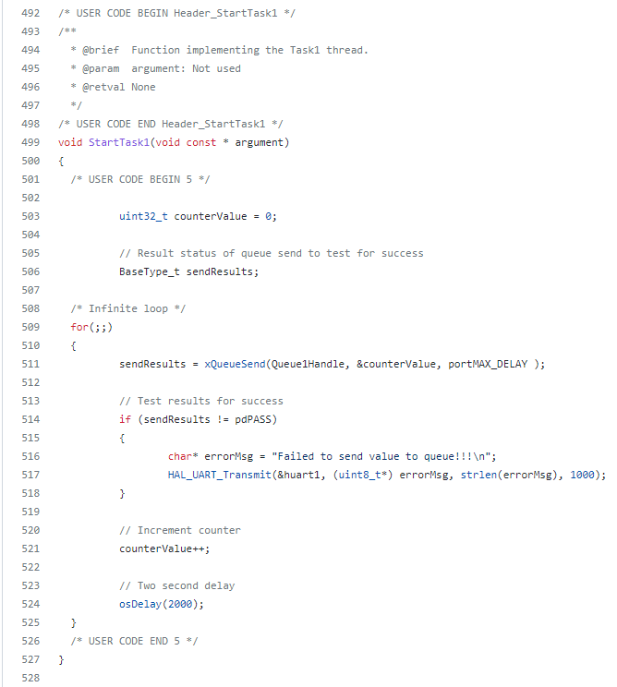
- Create "Task 2" that will receive from the queue, then display the count received from the queue. Use a value of portMAX_DELAY when reading from the queue.
Repeat creation process for Task2. StartTask2() will be configured to receive the counter value out of the queue and print it on the UART1 console, or an error message if necessary.
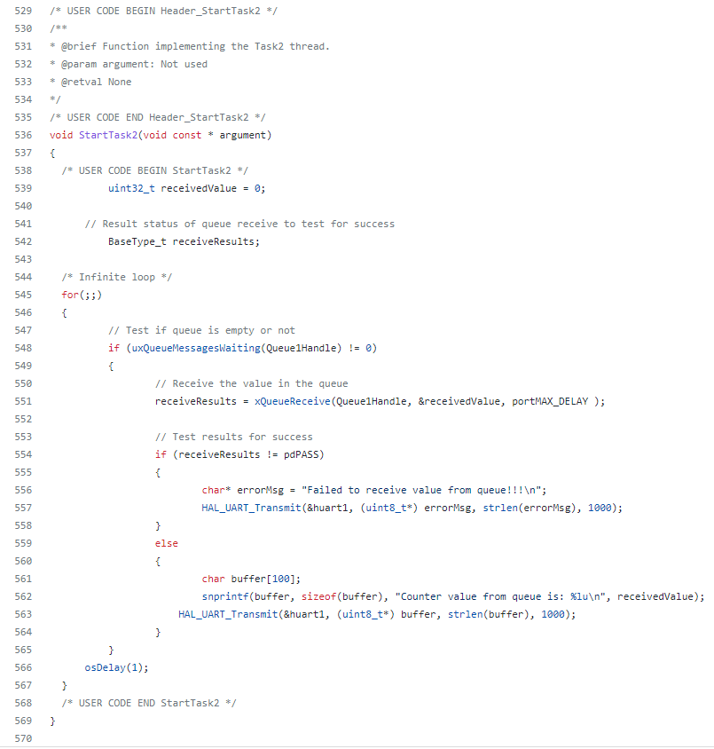
- Run this on the STM32CubeIDE (with IoT Discovery Board or equivalent) and observe the result.
With the program loaded to the dev board, the console can be opened and the counter value will be seen printing.
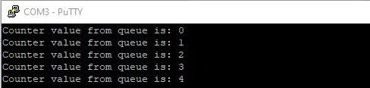

Closing Thoughts
AS I’ve noted in other assignments, this example took what could be a frustrating idea to implement, and wraps it up in a nice and easy to use abstraction. I’ll be interested to see how this concept is applied in creating the ping-pong feature in the final.

