Assignment 8: Event Groups
The following will document completion of the eighth assignment for ECE-40290, with the stated goals of:
- An ISR will be triggered by the blue user button and set one of three bits in an event group.
- A task will wait on this ISR bit to be set, then will delay 1 second, set a second bit, followed by another 1 second delay and then setting the third bit.
- A second task will wait till all three bits are set, clear them, turn the LED2 on, delay a second, then turn it off and wait for the bits to be set again.

Initial setup will be as all other projects: selecting FreeRTOS from the config menu, selecting a clock source, etc. We will define two tasks, the one to wait for the bit being set in the ISR, and another to wait on the second pair of bits that will toggle the LED.
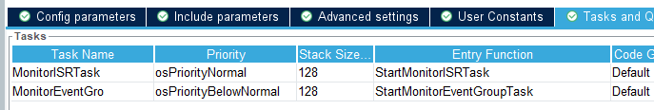
Additional steps specific to this assignment included setting the configUSE_TIMERS option to enabled as well as setting xTimerPendFunctionCall and xEventGroupSetBitFromISR options to enabled under the Include options tab of the FreeRTOS configuration.

I didn’t dig in enough to find out why, but I was unable to add an event group from the Events tab so in addition to defining the names of bitmasks used in reference to the group, it was declared manually in main.c and initialized in main():
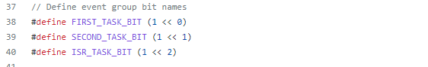



- An ISR will be triggered by the blue user button and set one of three bits in an event group.
Setup complete, we can define a simple ISR callback using the xEventGroupSetBitsFromISR() call to set the ISR_TASK_BIT:
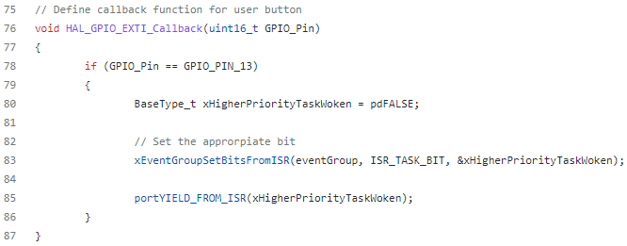

- A task will wait on this ISR bit to be set, then will delay 1 second, set a second bit, followed by another 1 second delay and then setting the third bit.
The task to monitor for that ISR_TASK_BIT can then be configured to check the value of the event group against that bitmask, and once it is made, delay, set the FIRST_TASK_BIT, delay, then the SECOND_TASK_BIT, seen here:
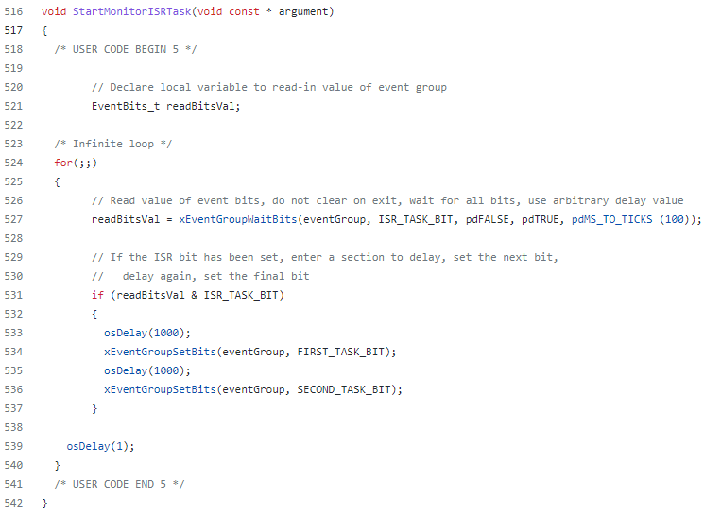

- A second task will wait till all three bits are set, clear them, turn the LED2 on, delay a second, then turn it off and wait for the bits to be set again.
In similar fashion, the second task will monitor for all three bits to be set then proceed with a delay/toggle operation. Re-reading the assignment in writing this report, I realized the specification was actually for delay, LED on, delay, LED off. I think the difference is negligible enough to not bother rewriting with the correct HAL API calls.
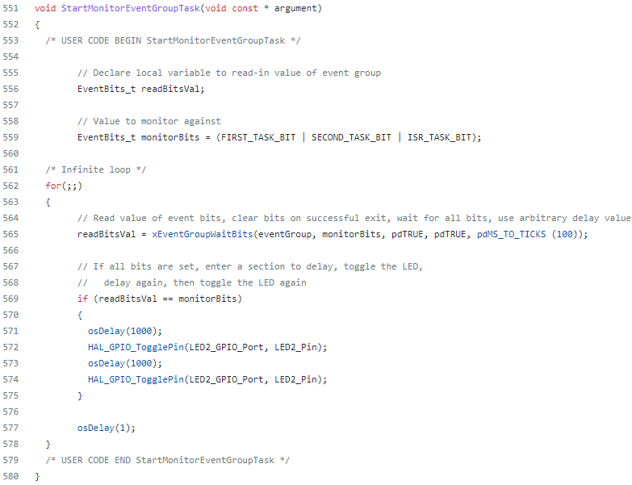
Closing Thoughts
Yet again, a concept that was well represented and simple to execute but that has potential for lots of critical use in a “real” project for task management and synchronization. It’s obviously a different implementation of an RTOS but I use bit-flags for sequence control frequently in my PLC programs so this felt very natural to pick up.

