Final Assignment 8
The following will document completion of the final assignment for ECE-40290, with the stated goals of:
- TaskLED: This LED will be controlled by a free running "LED Task" that will flash the LED at a given rate.
- PeriodicTimerLED: This LED will flash at a rate controlled by a periodic timer.
- OneShotTimerLED: This LED will be triggered by the press of the blue button on the STM board. It will cause a one-shot timer to flash the LED on, then off.
- QueueLEDs: Here you will create two tasks that "ping pong" back and forth, via a queue, to turn their respective LEDs on/off. Using a queue, the "ping" task will send a command to the "pong" task to flash it's LEDs. In return, the "pong" task will send, via another queue, a command back to the "ping" task to flash it's LED.

Initial setup will include several steps covered in previous assignments. After the generic FreeRTOS setup steps, we will configure TaskLED:
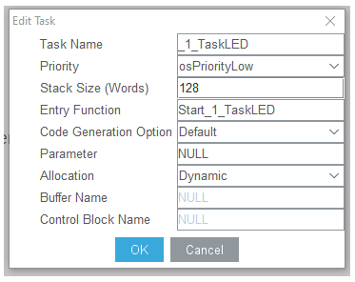

Next will be the task pair for QueueLEDs, _4_QueueLEDPing & _4_QueueLEDPong:
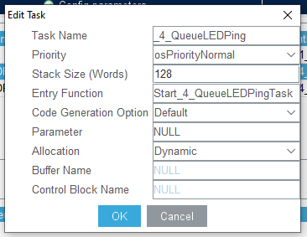
Along with their associated queues, PingRxQueue & PongRxQueue:
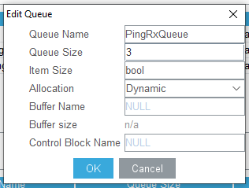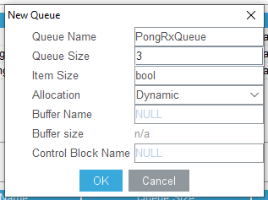

Next is the timer configuration for PeriodicTimerLED & OneShotTimerLED, ensuring that configUSE_TIMERS is enabled:
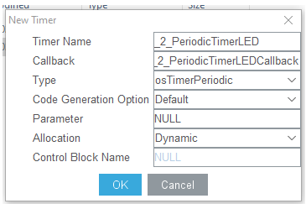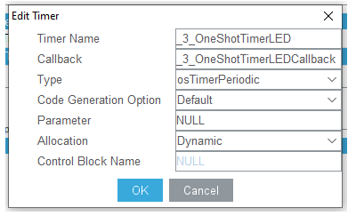

As a final step in the IDE setup, I disabled all non-used peripherals and relabeled the GPIO that would be used for this assignment:
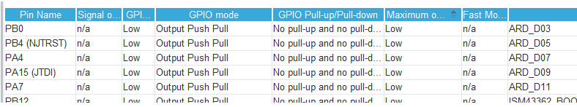
Moving over to the hardware side, I used the Arduino GPIO D3, 5, 7, 9, & 11 as opposed to those strictly specified in the requirements. This choice was made because I also employed an Adafruit Proto Shield instead of a breadboard and these allowed for a very clean layout in the final build.
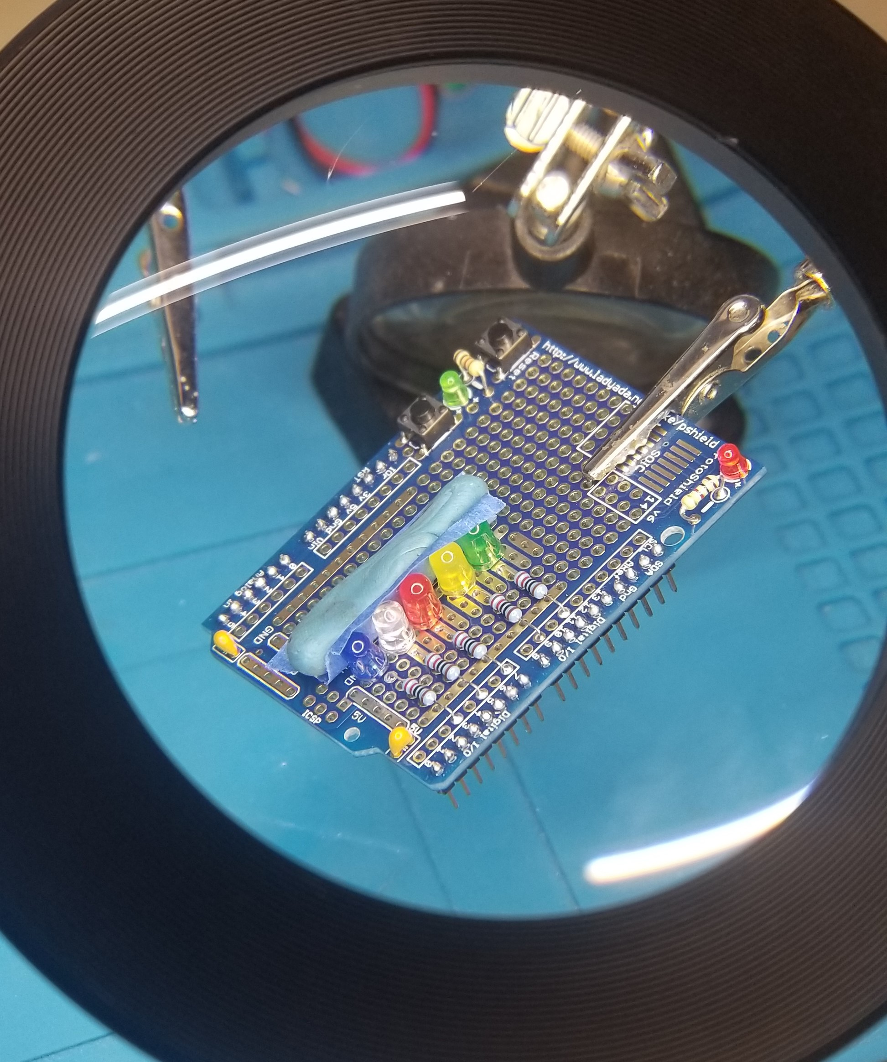

I was pretty pleased with how clean this came out until I plugged the shield in and ran a simple test program to toggle each GPIO when I realized I’d made that rookie mistake: inverting the polarity on ALL FIVE of LEDs… what should have been a 10-minute job turned into an hour of work removing the diodes, cleaning remaining solder out of each via with a braid and vacuum, then starting over. On a second test, I also discovered a short between the 5v and GND rails but couldn’t trace it down and ended up cutting the 5v trace to that section of the board. Finally, hardware is assembled and ready to go and we can move to programming.
- TaskLED: This LED will be controlled by a free running "LED Task" that will flash the LED at a given rate.
This task is extremely straightforward: simply toggle the LED tied to Arduino Digital 3 on a 2.5 second cadence.
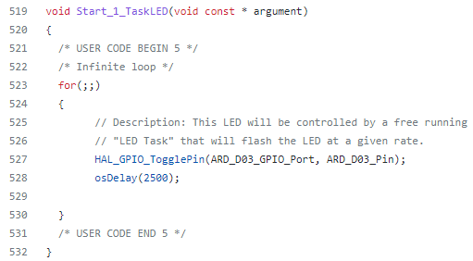

- PeriodicTimerLED: This LED will flash at a rate controlled by a periodic timer.
Again, pretty simple: configure the timer’s period in main() and then define a callback function to toggle the LED on Arduino Digital 5:
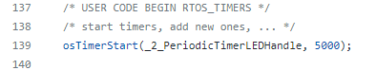
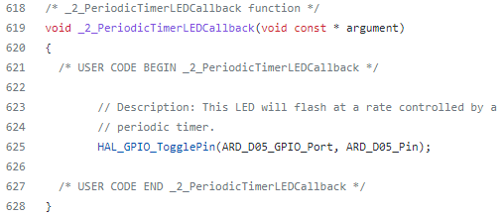

- OneShotTimerLED: This LED will be triggered by the press of the blue button on the STM board. It will cause a one-shot timer to flash the LED on, then off.
Here we first define an interrupt callback to define how the button press is handled, which will server to start the timer, then a callback for the timer, which will toggle the LED on Arduino Digital 7:
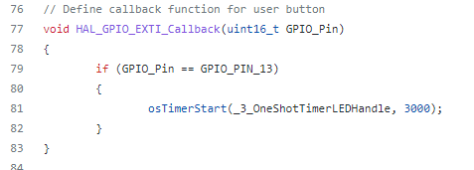
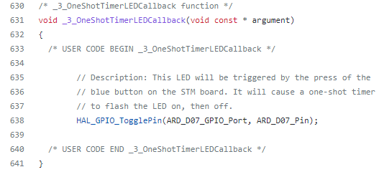

- QueueLEDs: Here you will create two tasks that "ping pong" back and forth, via a queue, to turn their respective LEDs on/off. Using a queue, the "ping" task will send a command to the "pong" task to flash it's LEDs. In return, the "pong" task will send, via another queue, a command back to the "ping" task to flash it's LED.
This portion was easily the most complicated to implement. The premise is that the Ping and Pong tasks will each read from their respective receive-queues. Each queue is configured to contain Boolean flags equal to either pdTRUE or pdFALSE. The main body of each task is essentially the same: if there is something to be read in the queue, store it as the associated received flag and test it for true or false. If true, toggle the associated LED, either Arduino Digital 9 or 11, then return a pdTRUE as a transmit flag to the other’s receive-queue. If false, return the same. Of note, one of the tasks, Ping in this case, needs to provide the initial serve to start the back and forth interaction. Reviewing this code the day after writing it, I think the else{} section is probably unnecessary, as the receive-queue will either have a value or it won’t, and sending a false could possibly start a chain where neither would ever send a true again. A simpler version is probably just to receive, toggle, & send. Either way, this worked without issue in my testing.
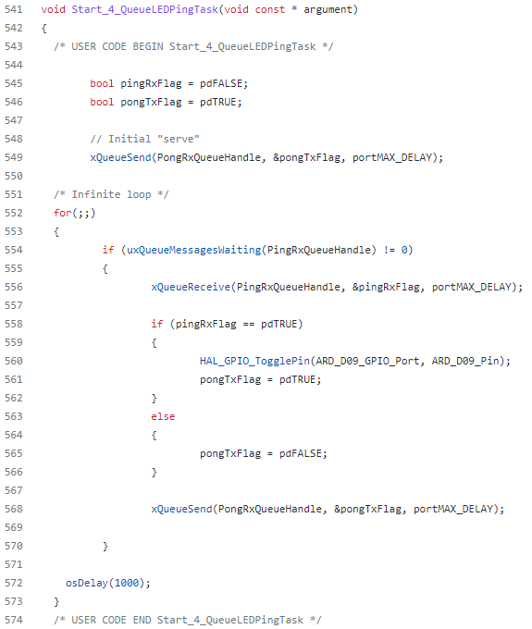
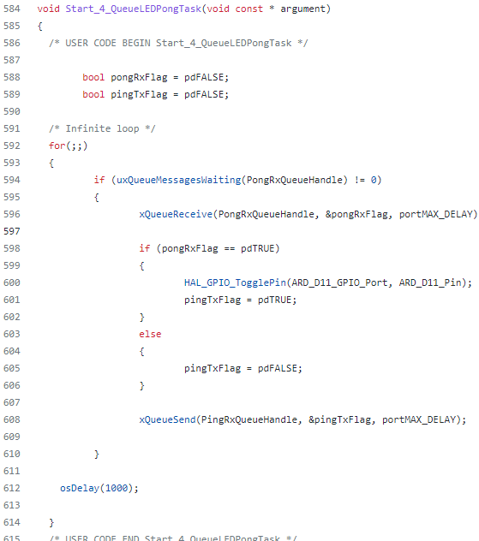

Closing Thoughts
This was a great wrap up to the course. The first three sections were simple to implement, and I think more importantly, easy to do from memory, which reinforces how easy this course made the learning to be. The fourth component was a bit more difficult but fun to put together, especially considering the table tennis analogy. I didn’t want to risk running out of time to implement it but I actually spent lunch on Tuesday at work sketching out how I’d create a one-dimensional ping-pong game between two players on that proto board with a report on scoring and a play clock reported over serial or a small display. Maybe a project for the future…
I can see a lot of potential to applying these skills in other areas; one I’m particularly interested in experimenting with is the FreeRTOS port to the RP2040 and implementing one core to handle the real-time interactions and another to handle the various task management.

