Course Final
The following will document completion of the final assignment for ECE-40293, which will include the following goals:
For your final project, combine at least THREE of the projects from the previous nine lessons into a single project.
To accomplish this, I had planned on developing a project that leveraged the onboard sensors and a connected RTC over I2C, a Bluetooth connection over UART4, and the HAL GPIO API to interact with the LEDs, with the overall idea being that this would be an battery powered, embedded device similar to the cheap temp/ humidity sensors^{[1]} that I had used as a reference point throughout this course and ECE-40291. I was able to accomplish most of this but failed in implementing some aspects of the external connections within the time remaining before the course ends. Rather than focusing on that aspect as a negative, this report will serve both as documentation of what it took to get to the final (mostly) functional version, as well as the issues I was unable to overcome, the methods I used to troubleshoot, and my thoughts on next steps.
Generating a default project as in previous courses, we’ll want to ensure that peripherals I2C1 and I2C2 are enabled, which will be used for connecting to the external bus broken out on the Arduino headers as well as the internal bus to connect to the HTS221 sensor. Additionally, we’ll enable UART4, which will need to be set to 9600 baud to interact with the HC-06 Bluetooth dongle^{[2]} I had selected for this task.
A fair amount of the code in this project is re-used from earlier projects, for example the HTS221-related functions are identical to those developed in my ECE-40291 I2C project. We’ll also see re-use with slight modifications to the CLI used heavily through both that and this course. My vision for this was to all interact over a BT-serial app on a cell phone or other mobile device, again, emulating these cheap little import sensor modules. I planned on having four functional aspects to that interface, being
- Toggle the BLE/WiFi LEDs, as a sort of “wink” function to indicate device activity, in function do_toggle_LED()
- Read the temperature and humidity from the HTS221 with HTS221_pwr_en(), HTS221_get_cal_data (), HTS221_get_sensor_data()
- Get the current time from the RTC, in function do_get_time()
- Set the time from the RTC, in function do_set_time(). This was implemented as a hardcoded “00:00:00 on Monday, 01/01/2021”, with the idea being that a set/get operation would at least indicate that the device was ticking away. A second iteration of this project would include an actual programmable interface.
With the core concept fleshed out, lets jump into the code and then look at roadblocks and troubleshooting techniques employed.
As mentioned earlier, this project involved a lot of reuse, or reuse with only slight modification. We start with the standard includes of stdio.h & string.h for working with the serial port. We then define the addresses of our target devices, noting that I maintained the standard of a separate R/W address for the DS3231 RTC module^{[3]}, even though it only has the single address for both operations.
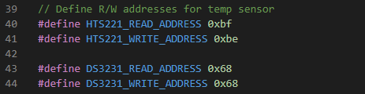

Next we’ll define the globals used in the HTS221 calibration process. I wont go into great detail on reviewing the temperature sensor code as it has previously received a full write up. Moving on to the function prototypes and definitions, we see do_toggle_LED() implemented as a very simple blinky loop, again, used as an indicator that you are connected and can communicate with the device from your mobile.
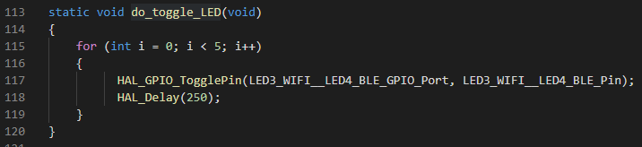

Moving to do_get_time(), we’ll see an excerpt below from the data sheet showing the time-related device registers within the RTC.
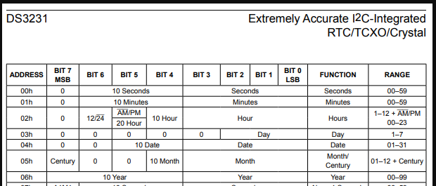
Noting the way that each digit is encoded within its respective register, such as 0x00[6:4] for the ten seconds digit and [3:0] for the ones second digit, this function was implemented to write the target register to the device and then read back the register value, then bit mask each digit out, as seen below for reading seconds and minutes.
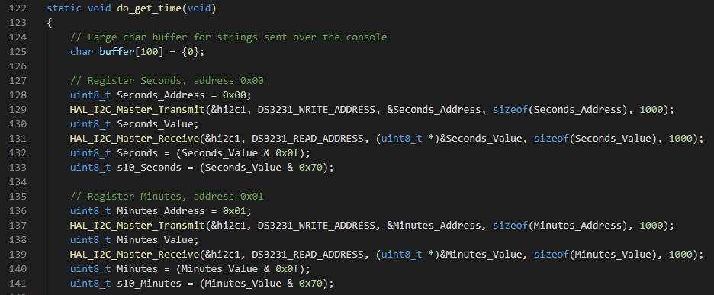
Once registers 0x00- 0x06 were read in, they were formatted into a “HH:MM:SS on MM:DD:YY” string and printed out over the console connection.
do_set_time() is implemented in similar fashion, except as previously mentioned where the time and date were hardcoded in this proof-of-concept iteration.
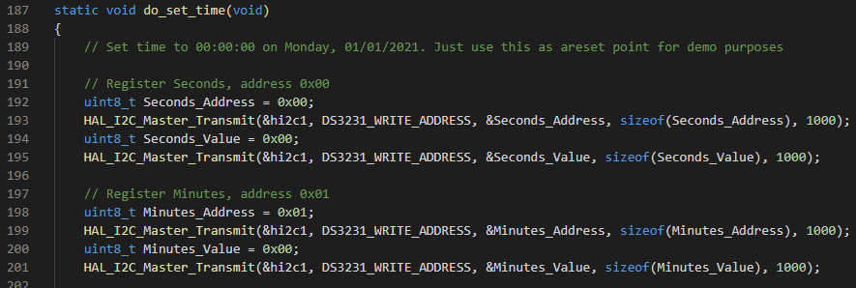
Neither of these functions seem to work as this point, again, we’ll explore that aspect later.
Moving to the CLI, we again see re-use of the style developed in earlier projects, with appropriate modifications to represent each functional aspect.
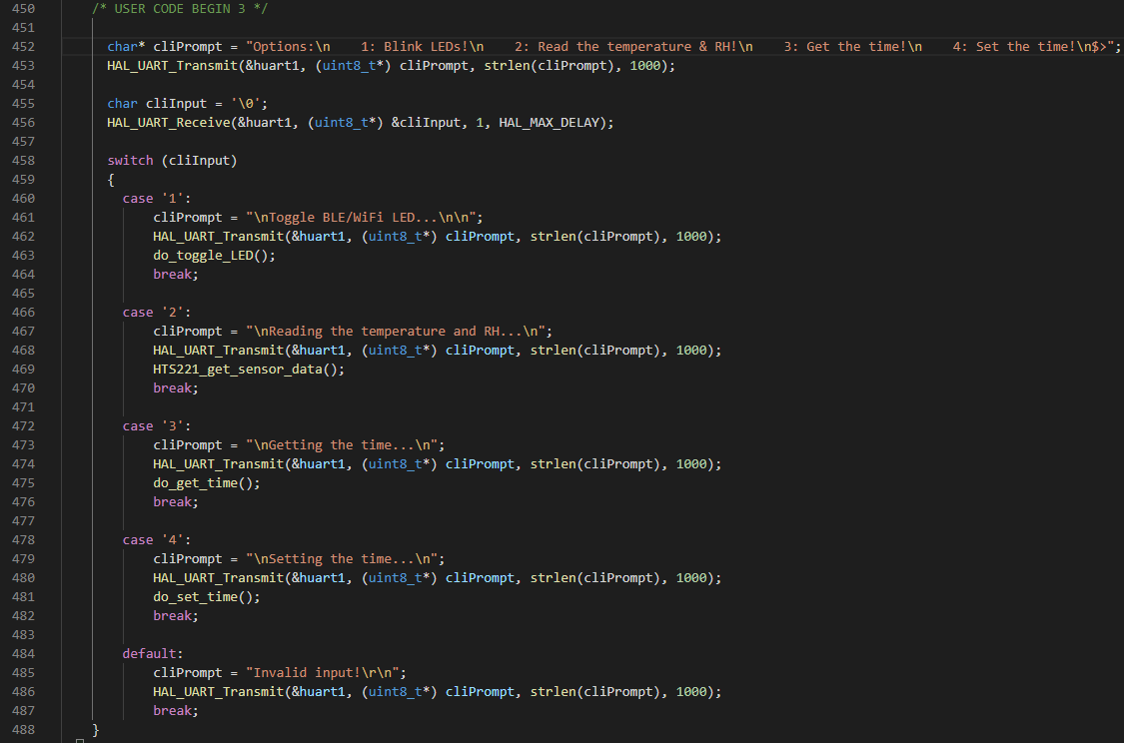

You might notice all of the UART calls are to UART1 in the above, this is a good transition into the roadblocks I found while developing this project. To commuincate with the BT module, I downloaded “Serial Bluetooth Terminal” from the app store and scanned for available modules, finding and connecting to the HC-06 witout issue. So far, perfect. Having already flashed the program to the Disco board, I reset it and was presented with the CLI prompt. Excited by how smooth everything had gone thus far, I slammed into a wall when I discovered that any entry to the cLI from my side resulted in hitting the default case of “Invalid Entry”, seen on the next page. Deciding to first verify that my CLI architecture was sound, I quickly switched the function calls from UART4 to UART1, reflashed the board, and opened Putty. Seelct option 1 and the LEDs blink away happily. Scratch head, back to UART4 and another flash and open the debugger, stepping up to the entry into the switch and monitoring the value fo char cliInput, I see that it remains ‘\0’.
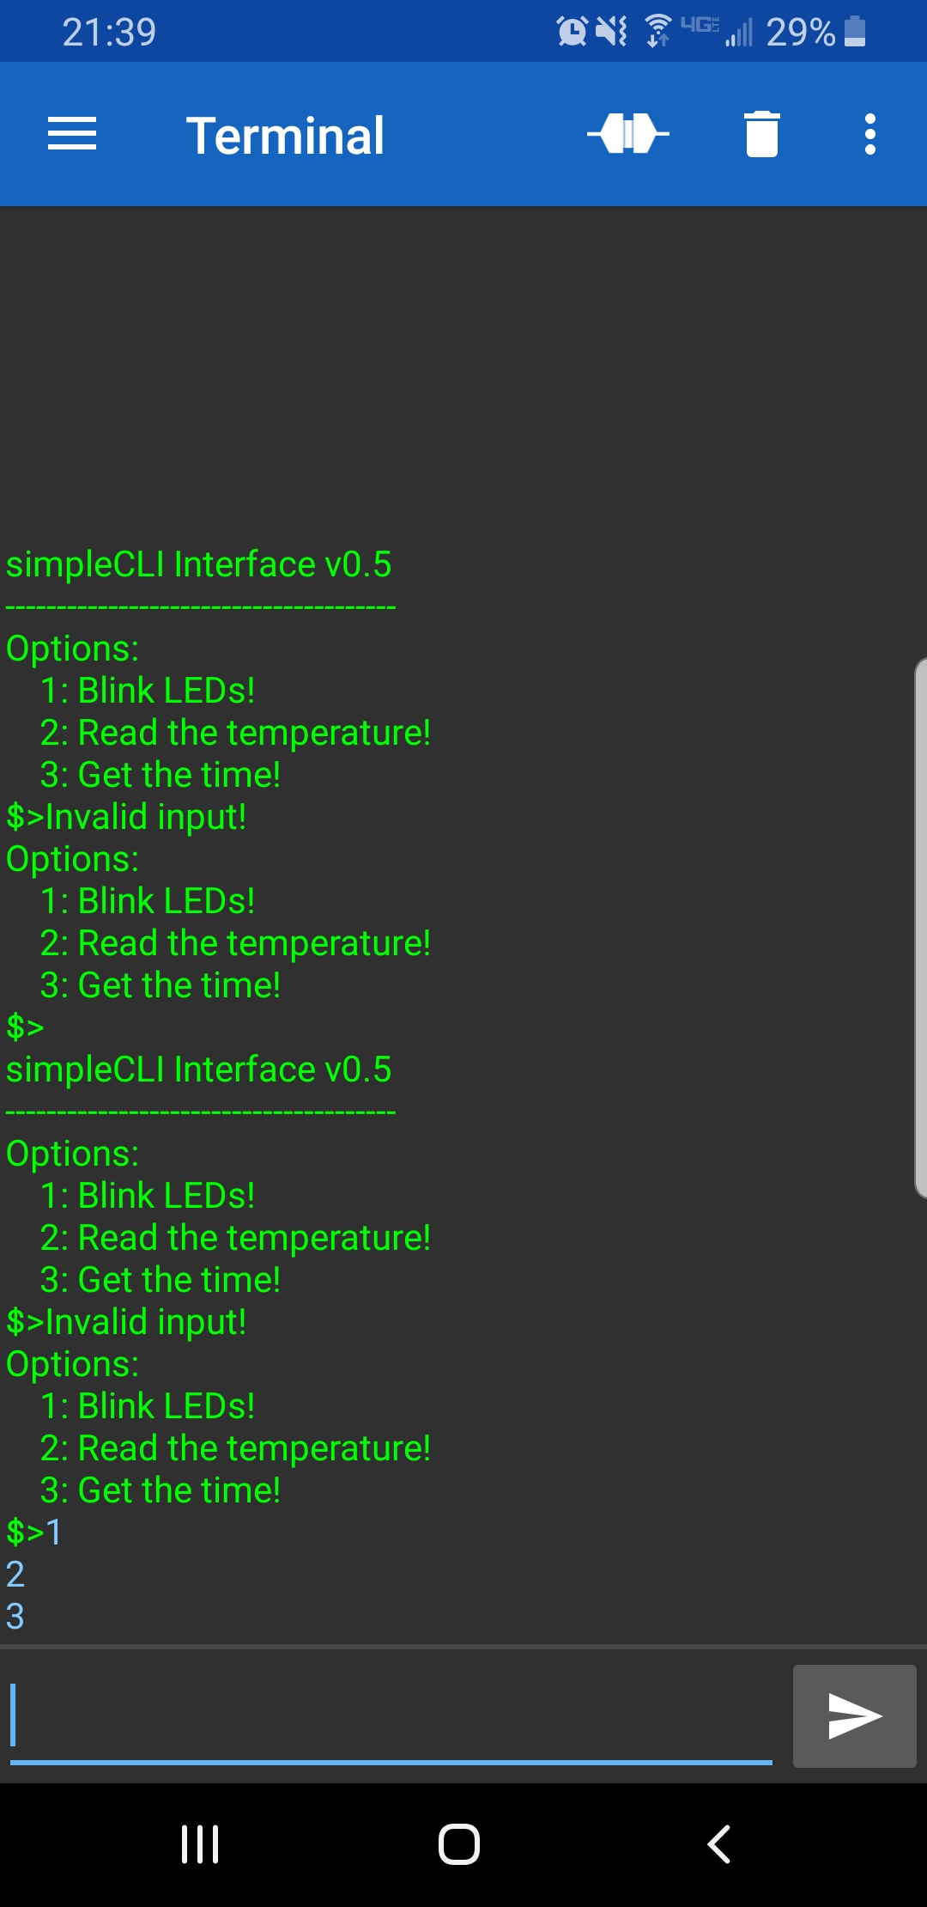

“Ok, it has to be something with the BT module then? Let’s try loopback mode and see if Tx->Rx works!”
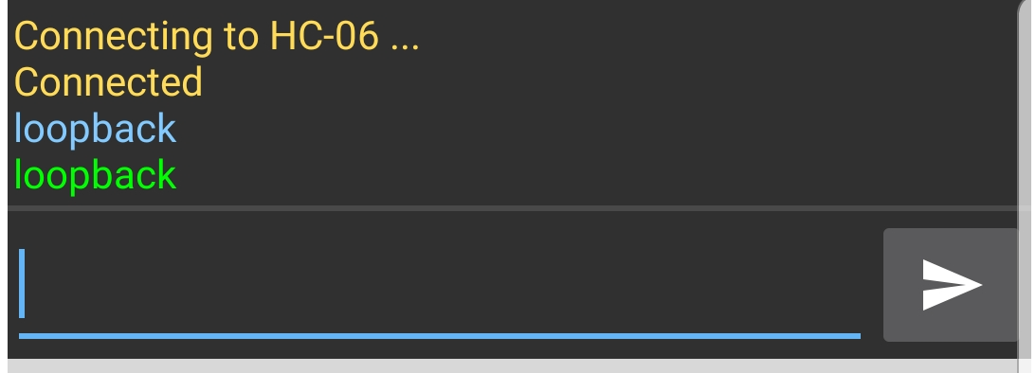
Okay, time to break out the logic analyzer…
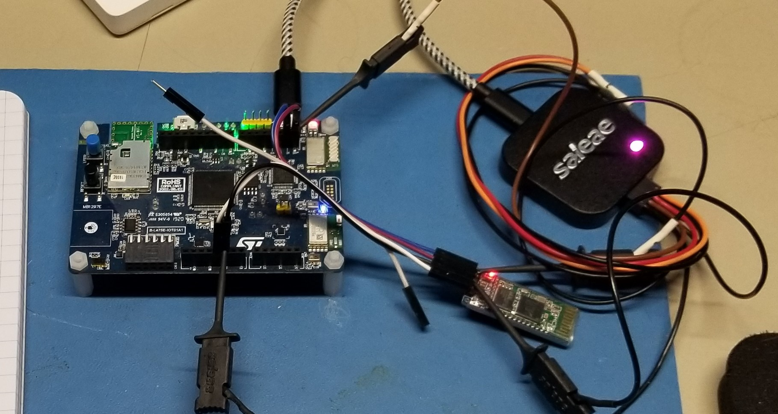
Hooking up CH0 to the BT Tx line and CH1 to the RX line, we’ll start gathering sample, hit reset, and then enter something from the CLI on the phone.
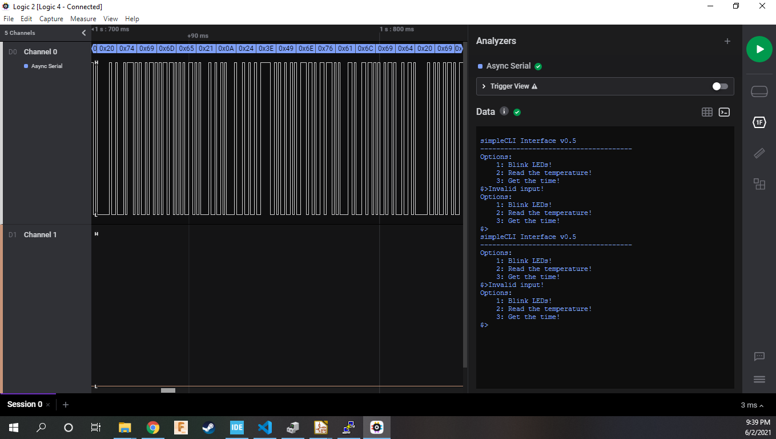
And CH0 looks perfect, while we see nothing on CH1. Additionally, something about this setup causes the HC-06 to lock up, as can be seen in the phone screen shot of 1, 2, 3 entered with no response. Being almost midnight and still needing to test the RTC, I decide to admit defeat (for now) and changed the function calls back to UART1.
Re-flashed, connected to PuTTY, and rebooted, we see the console come up, and again, the LEDs toggle and the temp humidity sensor works as expected.
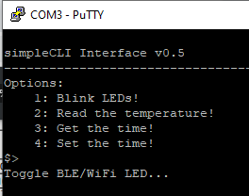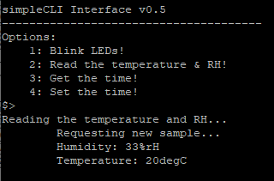

To test the RTC module, I used my I²CMini^{[4]} connected directly to the RTC module. The Mini offers both Python and C APIs, as well as a GUI and CLI toolset. Opening the GUI, I was able to see a device at address 0x68, as expected from the DS3231 datasheet, and then in the CLI tool, I was able to read register data from it. I’m still new to using this tool but was able to write and read back the value 0x21 to 0x06, indicating the year of 2021. However, when I tried to set registers 0x00- 0x05, I read back all 0xff. Undeterred, I chalked this up to using the tool wrong and decided to move on to testing with the board and CLI.
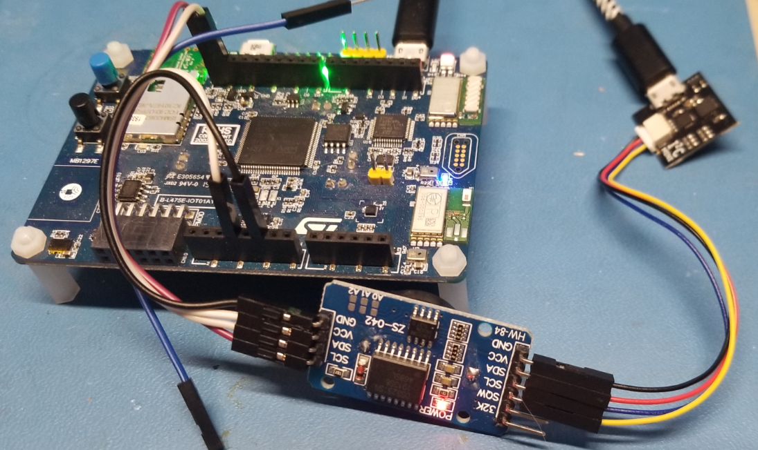
Running the set time option, everything looks good. You might have noticed in my function def earlier though, that I omitted the use of HAL_StatusTypeDef status in my I2C Tx/Rx calls. At the time, I was just rushing and feeling the looming submission deadline. On getting the time though, I see that being under pressure shouldn’t be an excuse for cutting corners…
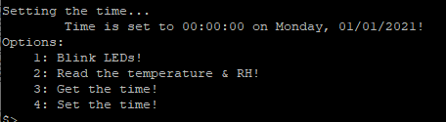
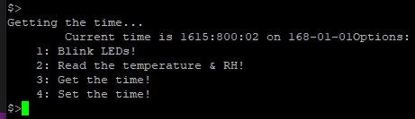
Another feature of the I2CMini is monitor mode, where it logs all activity on the bus to a .csv file for later processing. So, in similar fashion to the BT debug, I opened monitor mode and began making set/get calls. Closing monitor mode reported 28 captures mad, so opening the log file, I see there were indeed captures made, but nothing of any real use in debugging other than repeated NACKs, which seem to indicate that the RTC is not responding:
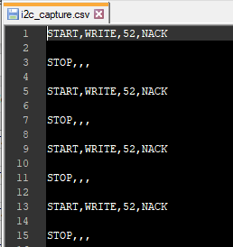
Its well past 1am at this point so I don’t reach for the logic analyzer, though I am hoping to squeeze in time bfore the submission deadline to get this issue sorted out.
Final Thoughts
Between the LEDs, the HTS, and the CLI, I technically completed all of the proscribed requirtements for this assignment. With the failure to get the BT or RTC modules functional though, I feel that my design’s implementation is lacking some of the most critical features. Judging by how the BT module was locking up, I’m inclined to think there is a hardware issue at play, or perhaps something related to power limitations. Given time to do so, my next step would be to power it from a bench supply instead of the Arduino headers and repeat my earlier experiments. The RTC is feel is entirely in software, and despite through the data sheet, I havent found the problem yet, though I do intend to spend more time with the I2CMini and my logic analyzer to see if I can get the module to respond.
On the course, it has been a great learning experience to dive deeper into these various protocols than I have in the past and even to be challenged and fail in certain areas like this project. Beyond that, while taking this course along side ECE-40291 and still working in a full time roll at work and trying to juggle a 4-month old at home, it has been a challenge to make the time I would have really liked to devote to going beyond what is presented in the lectures or required for each assignment, again as seen in this project. Finally, its just been plain fun. Between the interactions with the rest of the class and getting to experiment with hardware I’ve not been able to before, I enjoyed all of it despite any struggles. As discussed in some of the follow-ups to assignment submissions, any one of these topics could easily be a course unto themselves and I’d happily take any of them in a heartbeat.

